Image Build Logs

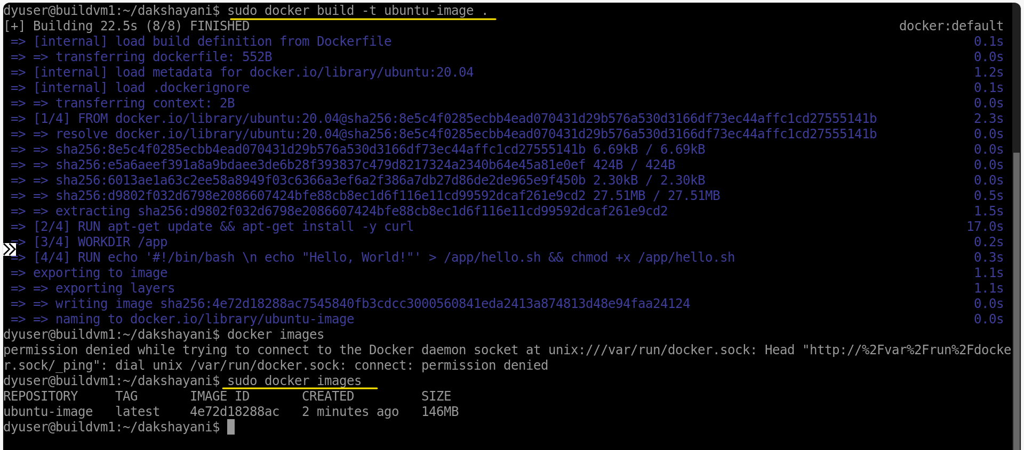

Image Push to ACR logs

az login

az acr login --name f2bosubcr

docker tag ubuntu-image f2bosubcr.azurecr.io/ubuntu-image:1.0.0

docker push f2bosubcr.azurecr.io/ubuntu-image:1.0.0

