**LogiWord**

**Brain training Android Application**

**Bachelor’s degree in software engineering**

**Project report**

**Group:**

**Akos Faddi – 253992**

**David Kabaly – 253785**

**Krzysztof Majcher – 253784**

**Supervisor:**

**Kasper Knop Rasmussen**



**Characters with spaces ‘unknown for now’**

**Software Engineering**

**Bachelor**

**20-12-2019**

**Table of contents**

Appendix A – Use case descriptions 3

Appendix B – Client Class Diagram 7

Appendix C – Server Class Diagram 8

Appendix D – Package Diagram 9

Appendix E – Sequence Diagram 10

Appendix F – Architecture Diagram 11

Appendix G – Predesign Figma plans 12

Appendix H – Scrum 13

# Appendix A – Use case descriptions

|  |  |
| --- | --- |
| Use Case | Multiplayer Match |
| Actor | User |
| Description | The user will compete against an opponent to complete a word and achieve more points than the enemy. |
| Precondition | The user logged in and is online |
| Postcondition | The user played a multiplayer match and gets a score |

|  |  |
| --- | --- |
| Use Case | Challenge a friend |
| Actor | User |
| Description | The user can select an opponent from the friend list to play a match against each other. They will get a word and should make the most points out of the word based on mathematical calculations. |
| Precondition | The user logged in and is online |
| Postcondition | The user played a multiplayer match against a friend |

|  |  |
| --- | --- |
| Use Case | Random Match |
| Actor | User |
| Description | The user will get a random opponent to play a match against. They have to earn the most points with limited mathematical signatures. |
| Precondition | The user logged in and is online |
| Postcondition | The user played a multiplayer match against a random opponent |

|  |  |
| --- | --- |
| Use Case | Classic Mode |
| Actor | User |
| Description | The user will get limited resources like few numbers and operations and tries to get as many points as possible |
| Postcondition | The user played a single-player match and gets a score |

|  |  |
| --- | --- |
| Use Case | Daily Challenge |
| Actor | User |
| Description | The user will get a word daily that needs to be completed with the given resources |
| Precondition | The user logged in and is online |
| Postcondition | The user played a daily challenge and gets a score |

|  |  |
| --- | --- |
| Use Case | Multiplayer Scores |
| Actor | User |
| Description | The user can see a ranking list based on the scores in multiplayer. |
| Precondition | The user is online and logged in |
| Postcondition | The ranking list is displayed |

|  |  |
| --- | --- |
| Use Case | Single Player Scores |
| Actor | User |
| Description | The user can check the single-player scores what have been achieved. |
| Postcondition | The single-player scores are displayed |

|  |  |
| --- | --- |
| Use Case | Tutorial |
| Actor | User |
| Description | User can access the prepared form of a tutorial that explains the basics mechanics of the application. This option will be highlighted if the user is using the system for the first time. |
| Postcondition | The user played the tutorial match |

|  |  |
| --- | --- |
| Use Case | Friend List |
| Actor | User |
| Description | User can access the friend list where all other players will be displayed what the user added. The online or offline status also will be shown in there and the invites from other users. It is possible to add a friend based on the given email address in the system. In this menu, the user can also remove a friend. |
| Precondition | The user is online and logged in |
| Postcondition | The user managed the friend list |

# Appendix B – Client Class Diagram

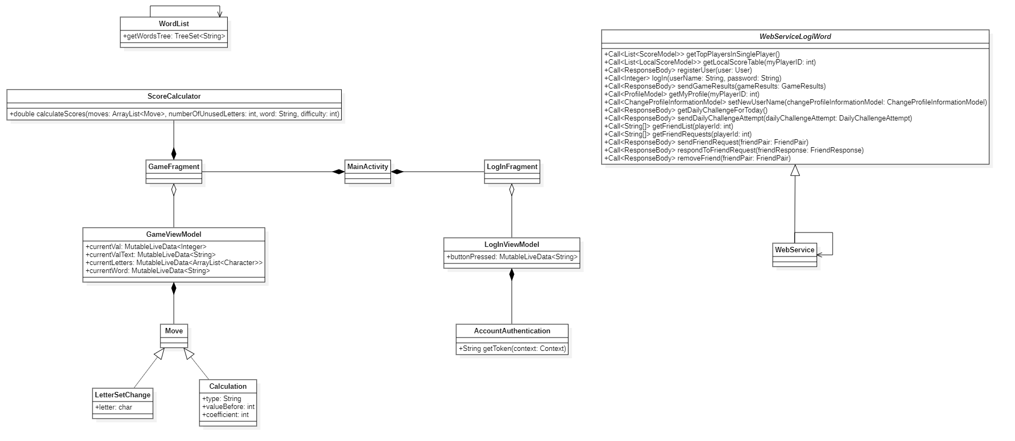

# Appendix C – Server Class Diagram

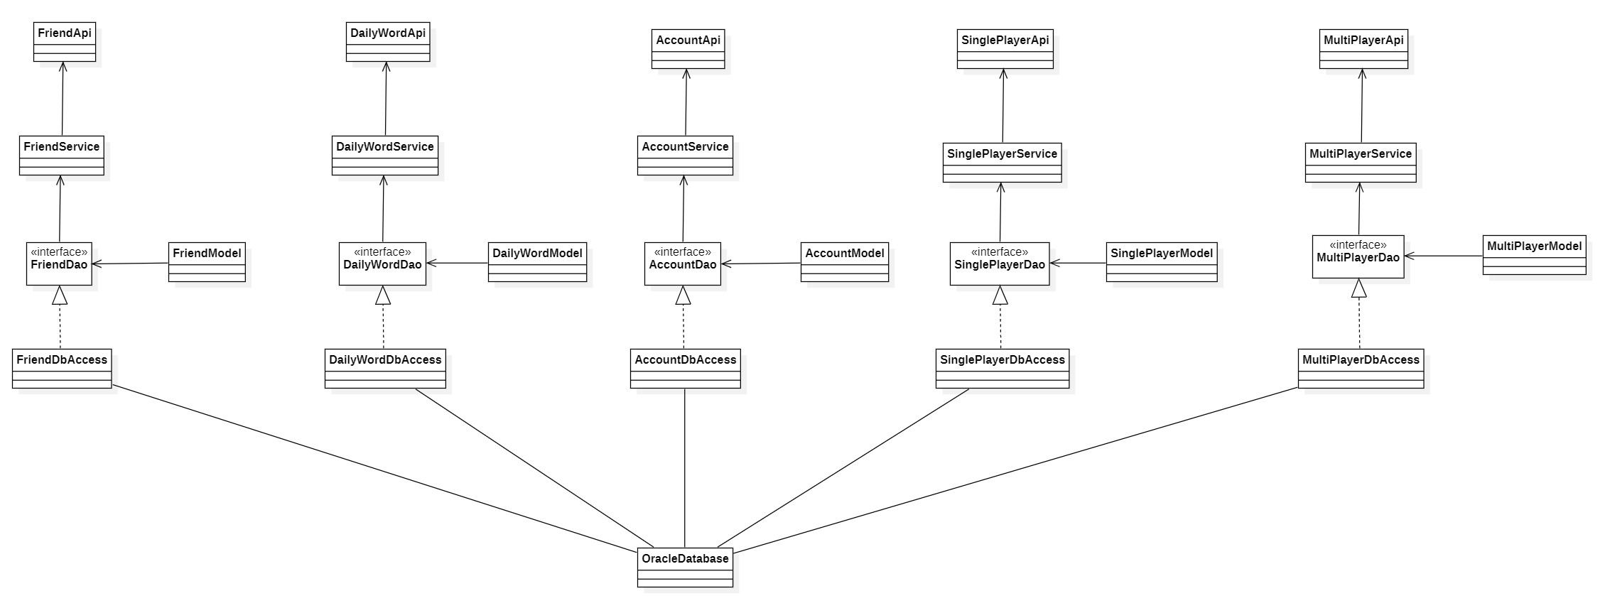

# Appendix D – Package Diagram

# Appendix E – Sequence Diagram

# Appendix F – Architecture Diagram

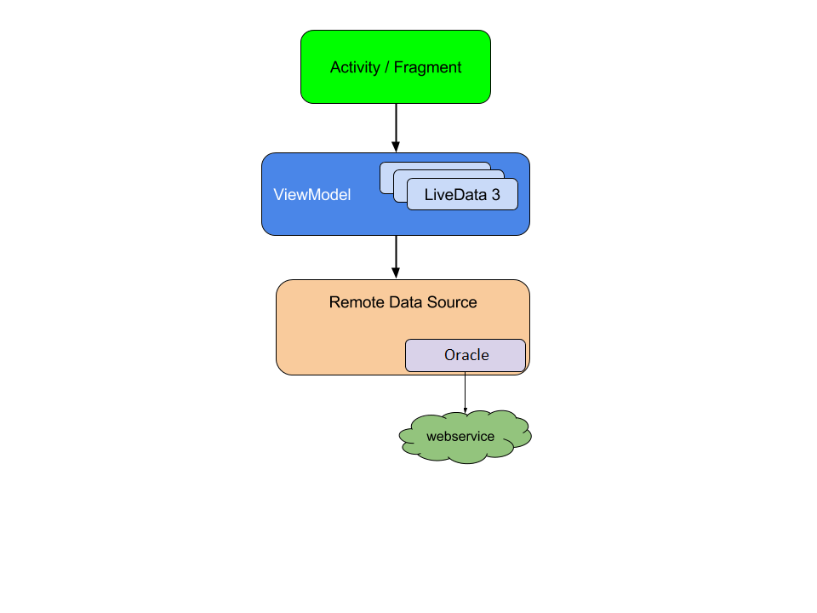

# Appendix G – Predesign Figma plans

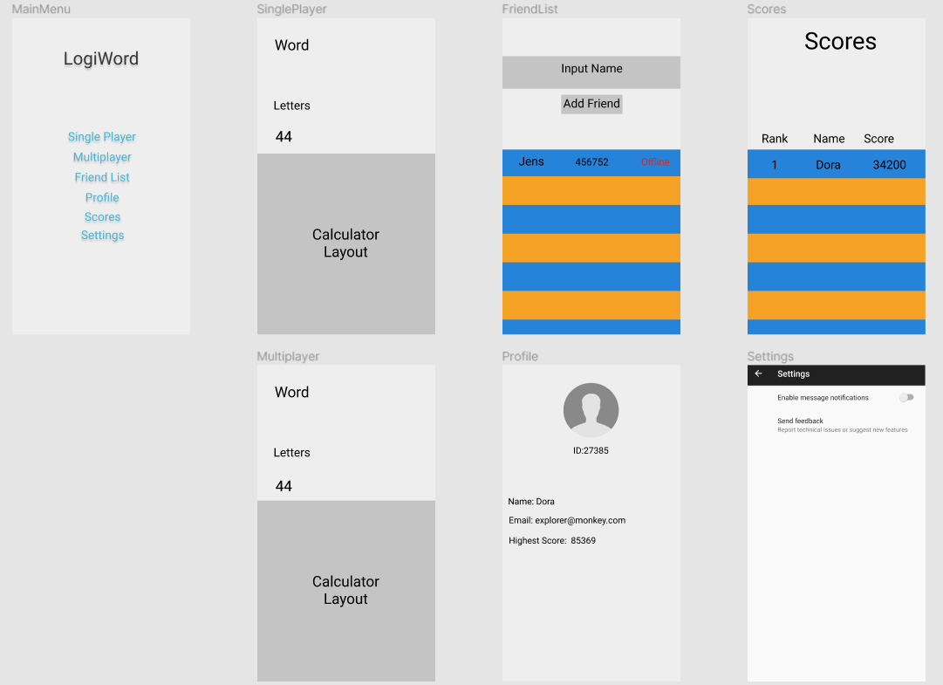

# Appendix H – Scrum

Please refer to the Appendix_H folder, Scrum.pdf