File permissions in Linux

Project description
This is a simple project walking through the basics of changing file permissions amongst file owner types in linux via the linux CLI. Keep in mind, there are three owner types: “user’, “group”, and “other”.

Check file and directory details
Normally, the way to check files in linux would be via the ls command.
Here we check the file and directory contents AS WELL AS the permissions. Here, ls -la was used, this works similarly to ls -l which lists files and directories of the current working directory in a long list format. ls -la has the same output but also includes hidden files: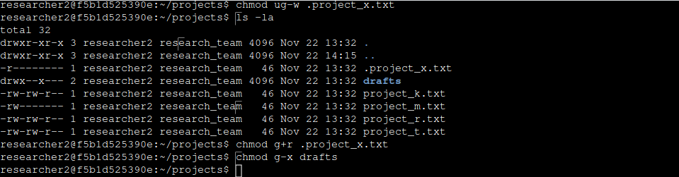

Describe the permissions string
The string you see all the way to the left describes the user, group and other permission types and in some cases this string starts with a “d” to tell us that this particular item is a directory and not an individual file. Please notice the makeup of the permissions string. You’ll notice those bits like “-rw-r-xrwx” etc. This is the permissions string.

Change file permissions
This is an example of changing file permissions. Here we change “group” and “other” permissions for reading and writing using the “chmod” command:
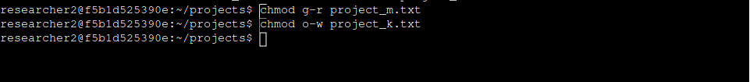

Change file permissions on a hidden file
Changing permissions on a hidden file with “chmod” is similar to doing so on that of a standard file, but includes a “.” at the beginning of the file name.
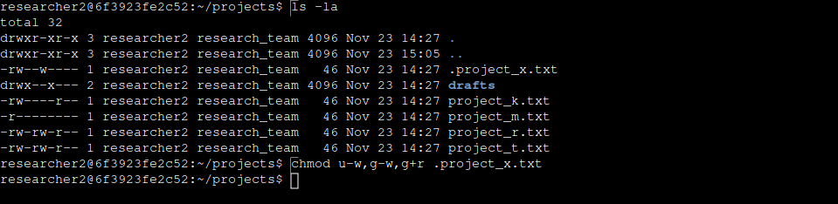

Change directory permissions
Using the chmod to change permissions for directories or subdirectories works similarly for changing file permissions, simply include the directory name rather than a file name. Here we’ll remove user write permissions from a subdirectory called “drafts”, while adding group read permissions:

Summary

In this example project, we showed proficiency and managing file permissions via using commands in the Linux command line. Understanding commands like ls, ls -l, ls -la, chmod, are instrumental in this process and make it quite streamlined and simple. We also displayed that understanding of the 10 digit string displaying user, group and other permissions is instrumental in this process. For instance:

rwxrw-r-- shows us that the user has read, write and execute permissions, the group has read and write permissions, while the “other” type has read only permissions.
A “d” at the beginning of this string means that it is a directory rather than a file.

Things to keep in mind:

The ls -la command is necessary for displaying hidden files with a directory’s contents.
When changing a hidden file’s permissions with chmod, you must include a “.” at the beginning of the file name.

