Module 9: APIs Assignment
Kao Yang | CSD-325 | Assignment 9
Purpose
The goal of this assignment was to learn how to send HTTP requests with Python, check whether an API connection works, read the original response, and format JSON data so it is easier to understand. I completed the astronaut API exercise and then created a second program using PokéAPI from the assigned API list.

Part 1: Connection Test and Astronaut API

Initial HTTP connection test
I began by using the requests library to send a GET request to https://www.google.com. The terminal returned “Connection Status: 200” and “Connection successful!” This confirmed that Python could send a request and receive a successful HTTP response before I moved on to processing API data.
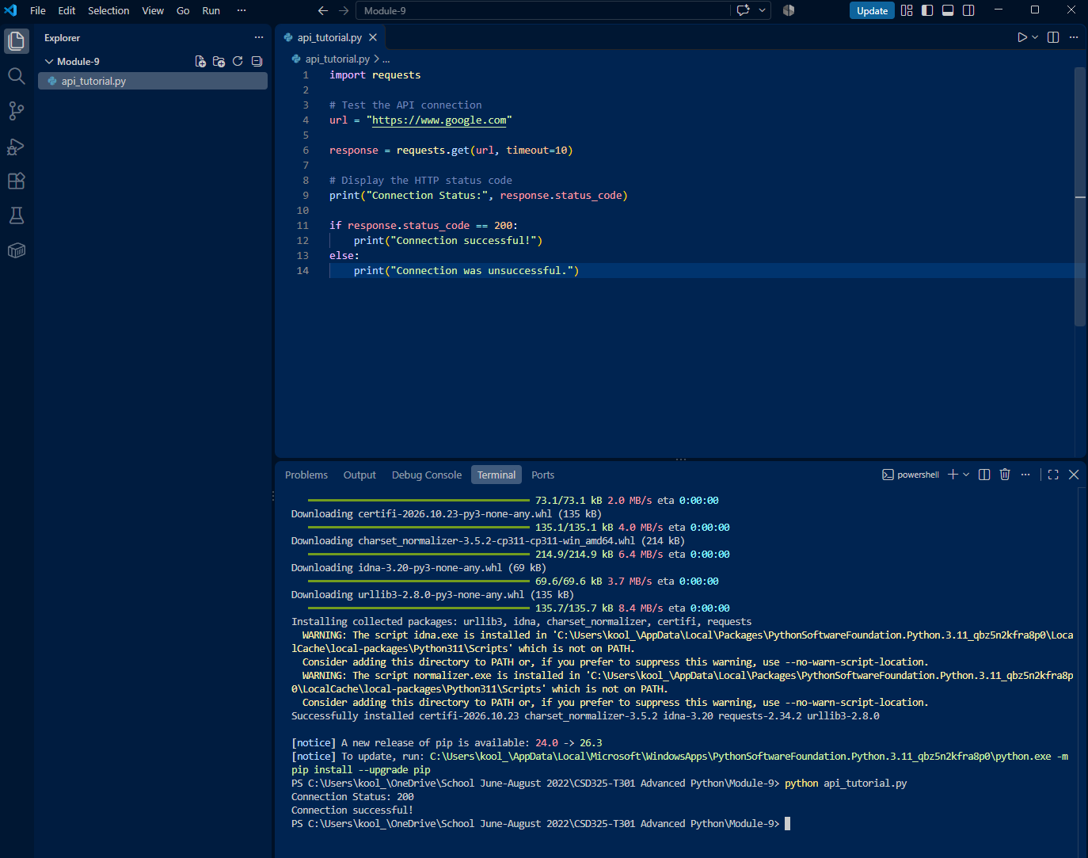
Figure 1. Successful preliminary HTTP connection test (status 200).

Part 1: Open Notify Astronaut API (continued)
For the astronaut activity, I used the endpoint http://api.open-notify.org/astros.json listed in the course reading. My program requested data, displayed the original response, converted it using response.json(), and then used json.dumps(data, indent=4) to format the JSON output. It also looped through the “people” data to print each person’s name and spacecraft.
The screenshots below document the formatted API response and the final list printed by the program. The API returned a total of 12 people in this run. This is the value returned by the service when I tested it, not independently verified live astronaut information.
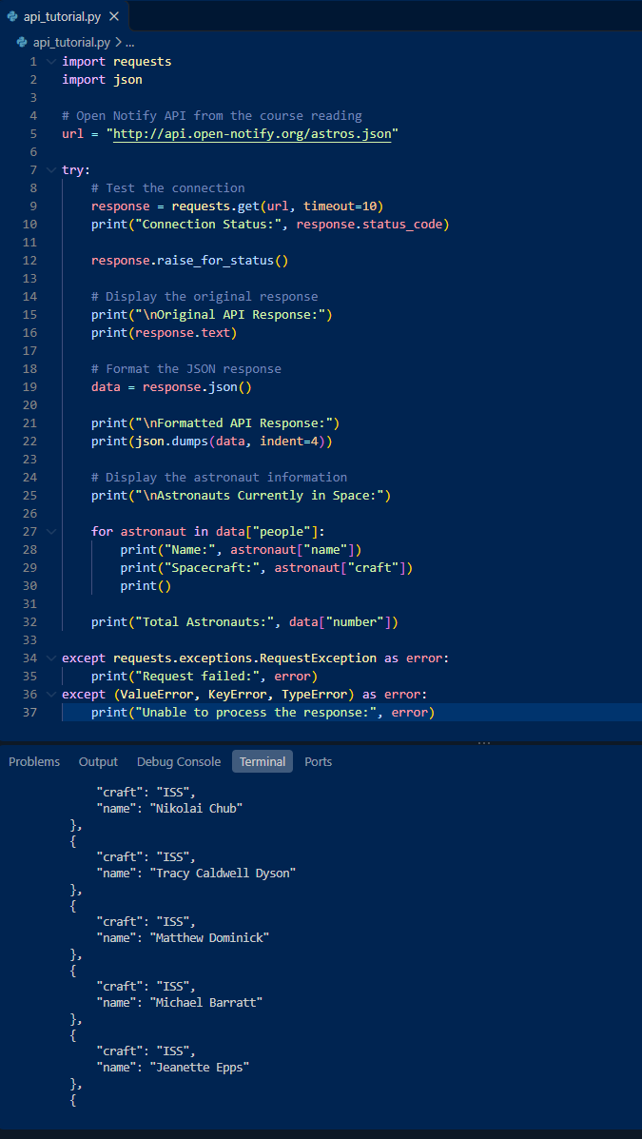
Figure 2. Python code and a portion of the JSON response from Open Notify.

Part 1: Astronaut Output (continued)
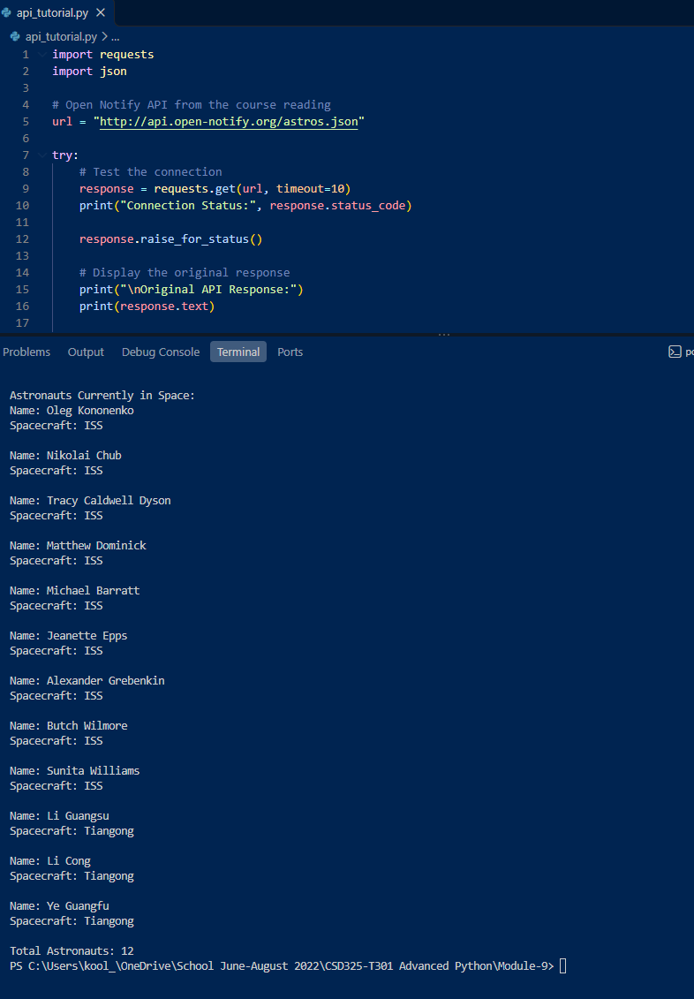
Figure 3. Astronaut names, spacecraft assignments, and the total of 12 returned by the API.
This part of the assignment showed me that raw API data can be useful, but formatting and selecting specific fields makes it much easier to read. Printing the names and spacecraft separately gave the response a clearer structure.

Part 2: Independent API Program — PokéAPI
For my second program, I selected the PokéAPI example from the assigned API list. I used https://pokeapi.co/api/v2/generation/?limit=2 to retrieve the first two Pokémon generations. The program tested the connection, printed the original response without formatting, formatted the same JSON response with indentation, and printed each generation name with its URL.
The program returned status code 200 and showed “generation-i” and “generation-ii.” This demonstrated the difference between a compact raw response and a formatted JSON response, along with how to pull individual fields from the data.
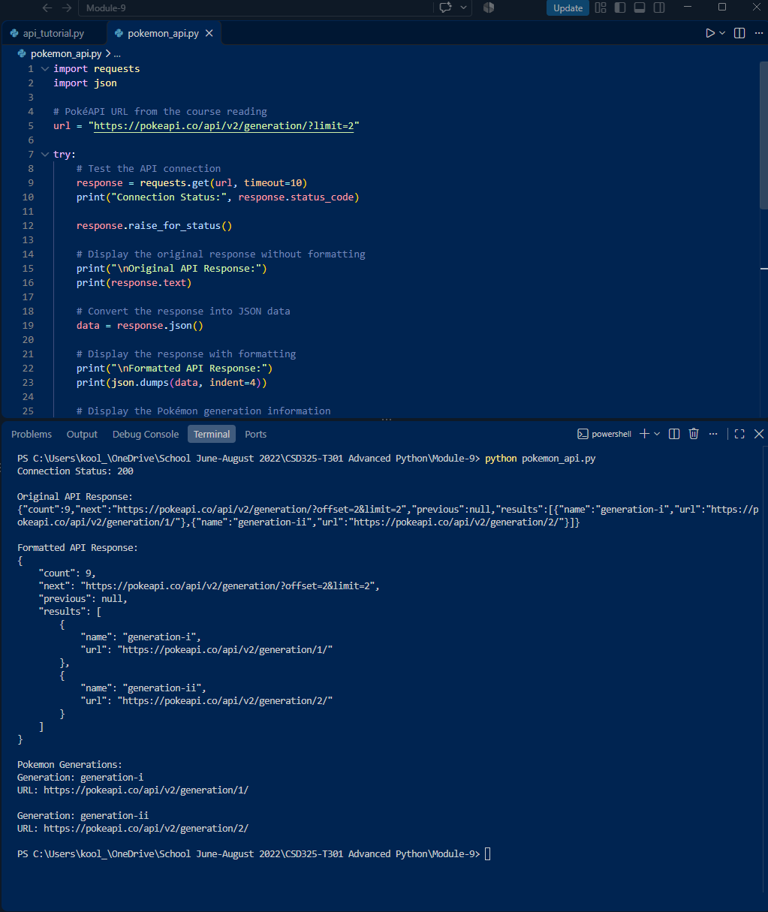
Figure 4. PokéAPI connection status, raw JSON, formatted JSON, and two generation records.

Conclusion
Completing these programs helped me understand the basic steps for working with APIs in Python. I learned to test the connection first, check the HTTP status code, view the response as it arrives, and use JSON formatting to make the results easier to follow. I also practiced using loops to display selected information instead of printing only the entire response. Both programs produced output in VS Code, and the screenshots document the results.

Files to save in the module-9 directory
- api_tutorial.py — astronaut API program
- pokemon_api.py — independent API program
- Module_9_API_Report.docx — this report

Reference
Russell, L. (2020, July 8). Just a simple API: List of APIs with fun data for quick mock-ups. Stoplight Blog. https://blog.stoplight.io/just-a-simple-api

