CSD-325 Module 8: JSON Practice
Kao Yang | Module 8

Program Flowchart
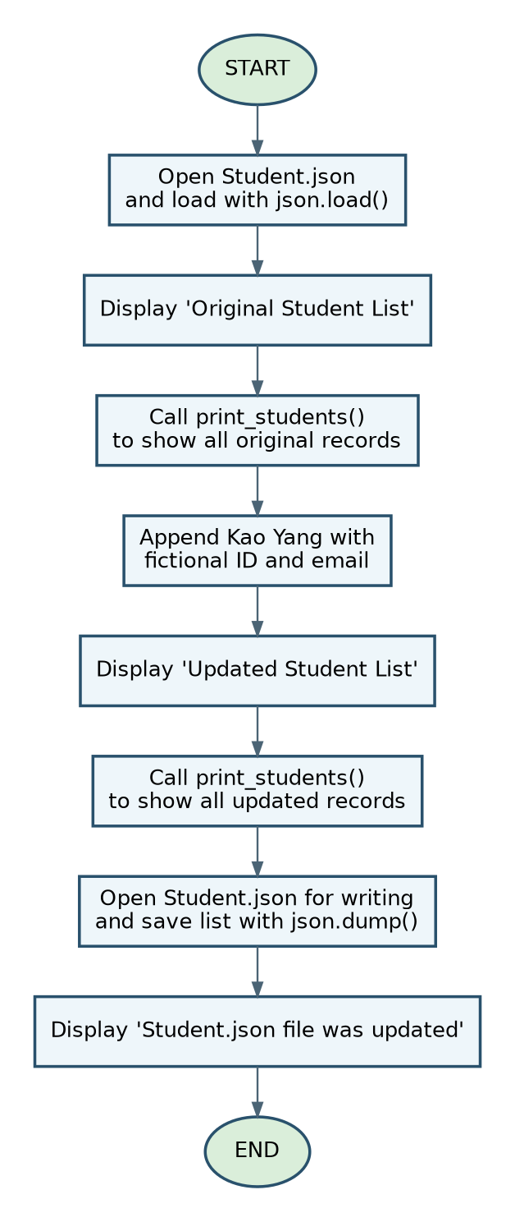

Python Program Results
The program loaded the original four student records, added a new student with append(), displayed the updated list, and saved Student.json using json.dump().
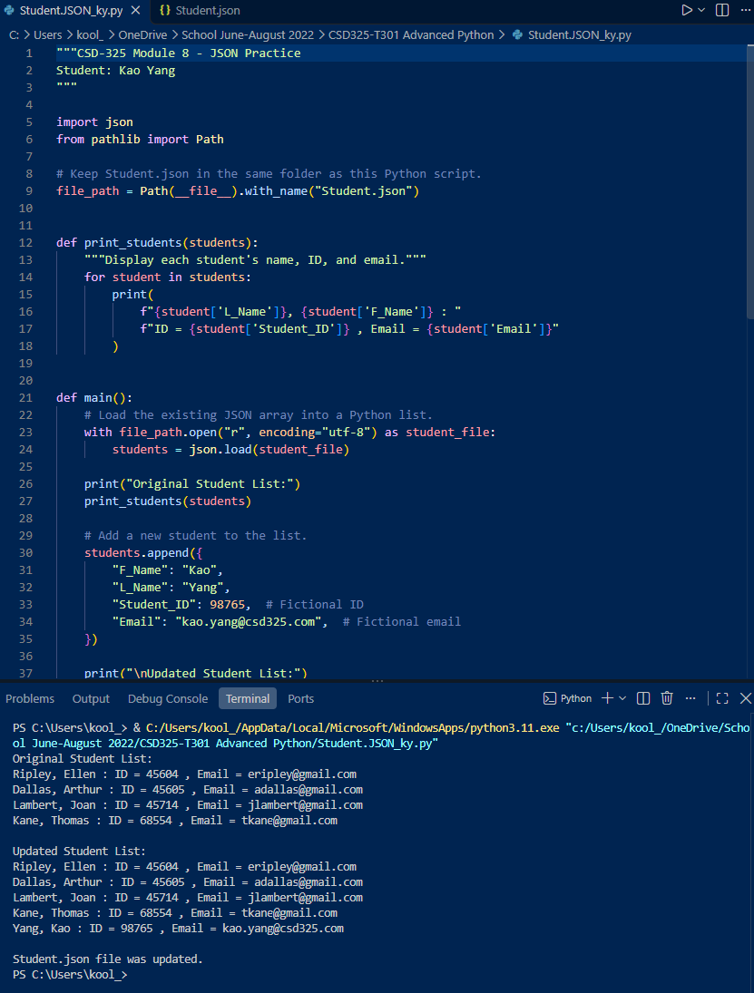

Updated Student.json Screenshot
The updated JSON file shows all four original records and the new Kao Yang record. The terminal also confirms that the file was updated.
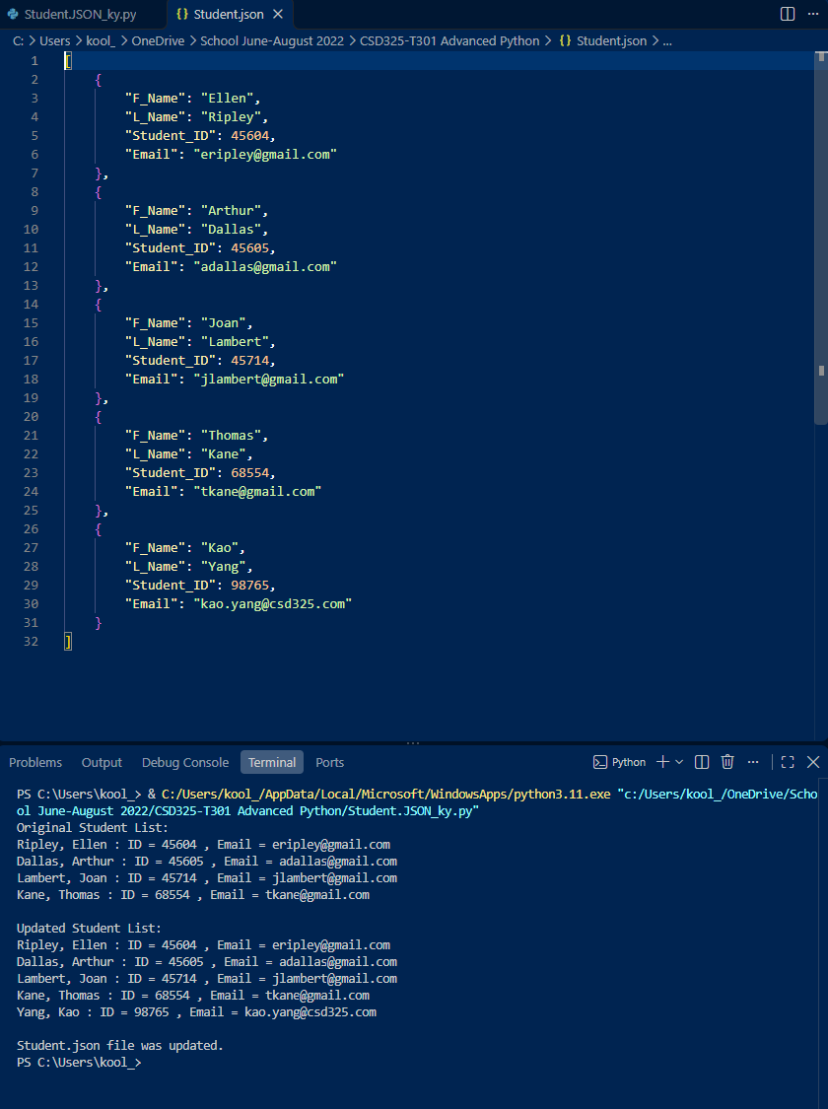

Updated Student.json Contents
[
{
"F_Name": "Ellen",
"L_Name": "Ripley",
"Student_ID": 45604,
"Email": "eripley@gmail.com"
},
{
"F_Name": "Arthur",
"L_Name": "Dallas",
"Student_ID": 45605,
"Email": "adallas@gmail.com"
},
{
"F_Name": "Joan",
"L_Name": "Lambert",
"Student_ID": 45714,
"Email": "jlambert@gmail.com"
},
{
"F_Name": "Thomas",
"L_Name": "Kane",
"Student_ID": 68554,
"Email": "tkane@gmail.com"
},
{
"F_Name": "Kao",
"L_Name": "Yang",
"Student_ID": 98765,
"Email": "kao.yang@csd325.com"
}
]

File Modification Notification
VS Code did not display a notification that Student.json was modified outside the editor. After running the program, I opened Student.json and confirmed that the new student record was saved. The program-results screenshot and updated JSON screenshot document the successful change.
Note: The notification screenshot requested in the assignment could not be captured because no notification appeared.

