Request Description:
Home Page | Replace app with Car and Driver.

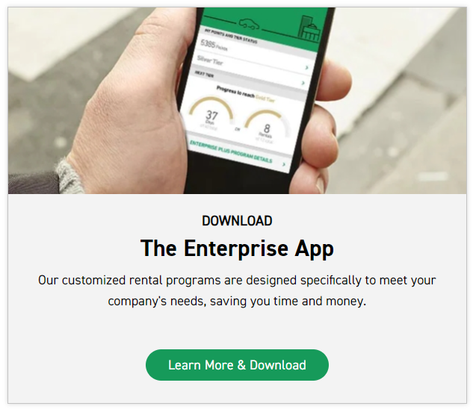
Instructions:
- Replace the current photo with the one attached.
- Remove the word "download.
- Replace "The Enterprise App" with "The Limousine Service."
- Replace the current content with "Our car with driver service offers personalized transportation solutions tailored to your requirements, ensuring convenience and efficiency for your travels."
- Remove the word "download" from "learn more and download," keeping "learn more" only.
- Activate the link "learn more" to direct the user to the "Car with Driver service new page."

