Request Description:
Home Page | Inspiration

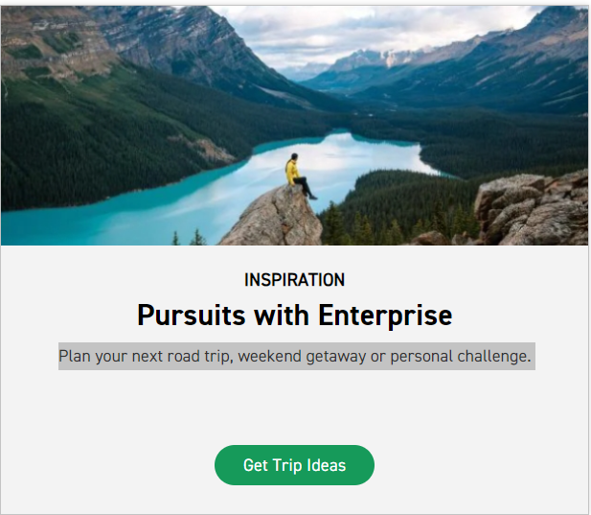
Instructions:
- Replace the current photo with the one attached.
- Keep the word "Inspiration”.
- Replace "Pursuits with Enterprise" with "Explore Jordan with Enterprise."
- Replace the current content with "Embark on a journey through Jordan's stunning landscapes, ancient wonders, and vibrant culture. Let Enterprise help you create unforgettable memories."
- Keep “Get Trip Ideas”.
- Activate the link "Get Trip Ideas" to direct the user to the next page.
- Next Page content will be shared as soon as possible.

