**A)**

**# Query 1**

select a,count(distinct d)

from wa1_data

group by a

order by a asc;

**FD:** A->D

**# Query 2**

select c,count(distinct b)

from wa1_data

group by c

order by c asc;

**FD:** C->B

**# Query 3**

select a,b,count(distinct d)

from wa1_data

group by a,b

order by a,b asc;

**FD:** A,B->D

**# Query 4**

select a,c,count(distinct d)

from wa1_data

group by a,c

order by a,c asc;

**FD:** A,C -> D

**# Query 5**

select c,d,count(distinct b)

from wa1_data

group by c,d

order by c,d asc;

**FD:** C,D -> B

**# Query 6**

select a,b,c,count(distinct d)

from wa1_data

group by a,b,c

order by a,b,c asc;

**FD:** A,B,C -> D

Intermediate step for BCNF:

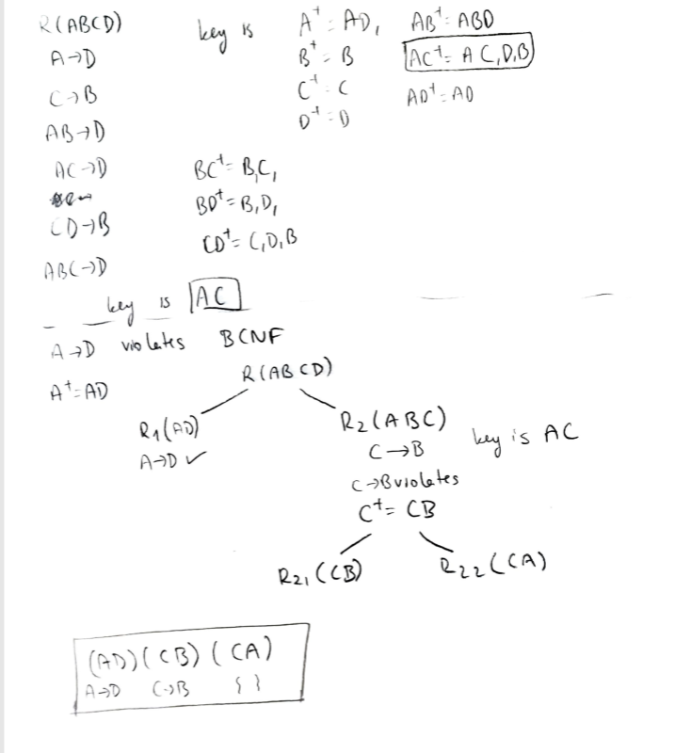

**B)**

Create Table AD(

a VARCHAR(255),

d int,

primary key (a));

Create Table CB(

c VARCHAR(255),

b int,

primary key (c));

Create Table CA(

c VARCHAR(255),

a VARCHAR(255),

primary key (a,c),

foreign key (c) references cb(c),

foreign key (a) references ad(a)

);

**C)**

INSERT INTO ad (a,d)

SELECT a,d

From wa1_data

group by a

INSERT INTO cb(c,b)

SELECT c,b

from wa1_data

group by c;

INSERT INTO CA(c,a)

Select c,a

from wa1_data

**To evaluate correctness of the tables:**

**1) Both query return 36 equal rows**  
  
select *

from ad;

select a, count(distinct d)

from wa1_data

group by a

order by a asc;

**2) Both query return 12 equal rows**

select *

from cb;

select c, count(distinct b)

from wa1_data

group by c

order by c asc;

**3) Both return equal 12 rows**

select c, count(distinct a)

from ca

group by c

order by c asc;

select c, count(distinct a)

from wa1_data

group by c

order by c asc;