Module Elaborated Design

Project file link: <https://github.com/KZTam/Elevator_controller_prototype>

1. Prescaler_2sec module

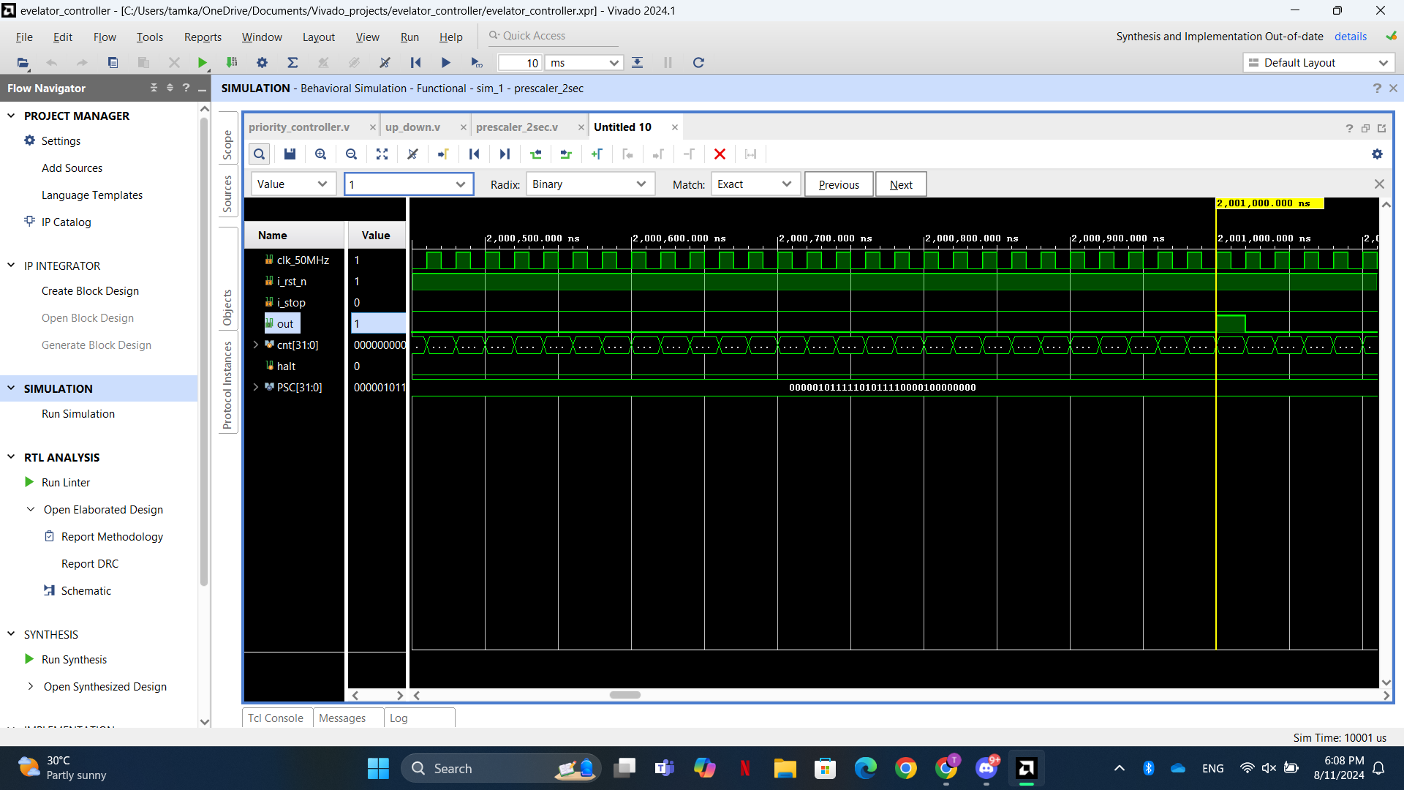The module converts the clock frequency (50MHz) to a periodic pulse generated in 2 seconds interval, below is the simulation of the module: (Note: to speed up the simulation process, the pulse is changed to 2ms interval, which can be configured in its parameters variable)

1. A computer screen shot of a computer screen

   Description automatically generatedUp down module

This module decides whether the lift needs to be going up, down, or stop (open the door) by receiving the target floor from priority controller module.

Below is the simulation of the up down module. The elevator is initially at 1st floor, and the 5th floor external button is pressed (and hold): (Note: to speed up the simulation process, the pulse is changed to 2ms interval, which can be configured in its parameters variable at prescaler_2sec module)

Based on the simulation above, the elevator starts to move when request (floor_next) is received. The lift reaches 5th floor at 8ms mark (since I use 2ms pulse interval). Elevator door will open at 10ms mark. And since the request button keep pressing, the door will keep open and elevator will not move.

1. 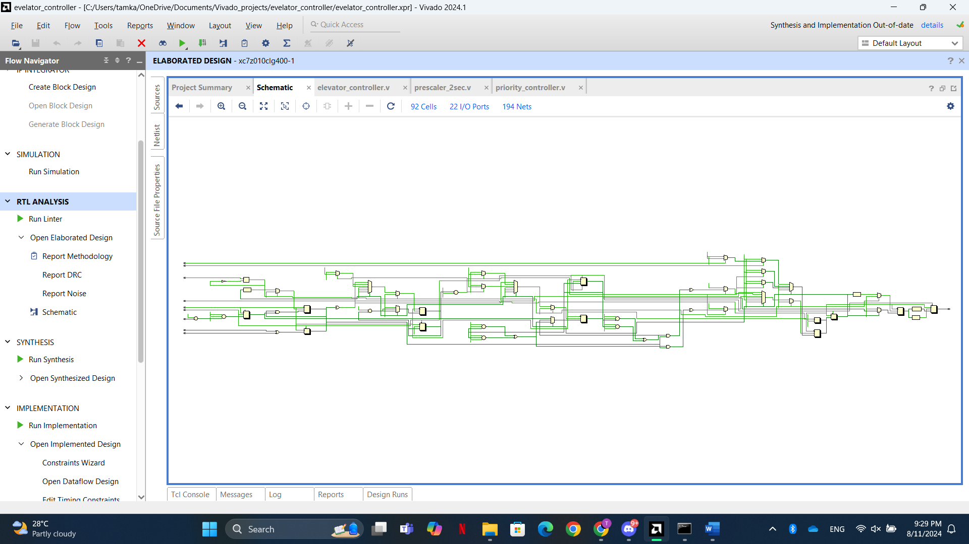Priority controller module

This module will implement the priority algorithm (for more information of how it work, refer to the documentation pdf).

Below is the example of how the simulation of priority controller module, provided that the elevator is at 5th floor, and there’s a simultaneous request from 2nd and 1st floor.:

Based on the figure above, 2nd floor is chosen as the most priority floor, which fulfil the requirement. It needs 5 clock cycle (100 nanoseconds) to determine the priority floor. Although there is some latency, however it will not cause any severe effect since the elevator moving operation is in 2nd environment. In other words, the module is done determining the priority before the elevator starts moving.

Top Level Design

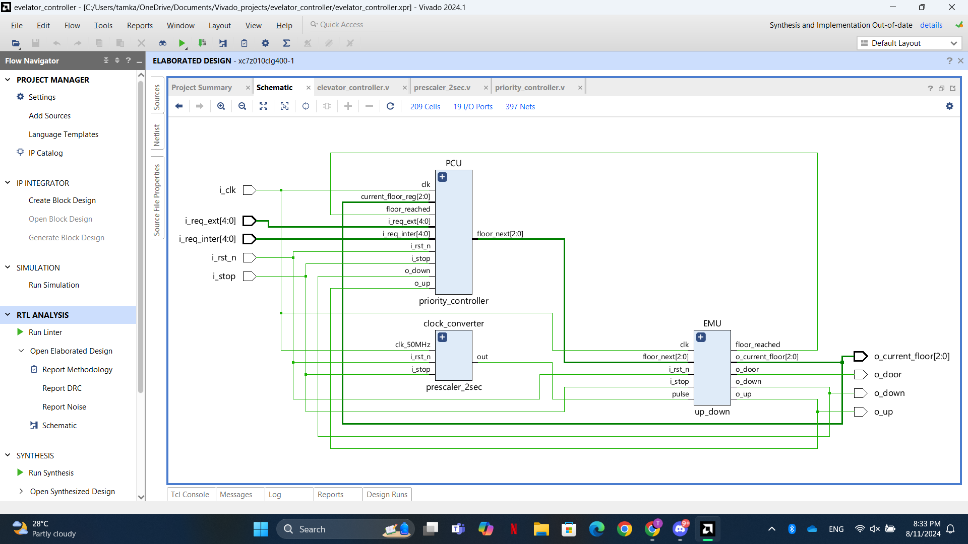All the modules designed are connected as combinational circuit below to form the elevator controller.