EDGECUBE

uStar Assembly Guide v2.0.0

Doc #: NA

___________________________________________________________________

Prepared By: Kevin Zack

Date: 1/4/2018

___________________________________________________________________

Sonoma State University

THIS PAGE LEFT INTENTIONALLY BLANK

Table of Contents

1 Scope 4

2 Parts List 4

3 Assembly Notes 4

4 Board Layout Top 5

5 Board Layout Bottom 5

# Scope

This document describes assembly of the uStar v2.0 board for EDGECUBE.

# Parts List

|  |  |  |  |  |
| --- | --- | --- | --- | --- |
| # | QTY | PART_NUMBER | Description | REF DES |
| 1 | 2 | 311-1523-1-ND | 0.1 uF CAP 0603 | C1, C5 |
| 2 | 1 | 587-2984-1-ND | 1uF CAP 0603 | C6 |
| 3 | 1 | 478-3281-1-ND | 10uF CAP 0805 TANT | C7 |
| 4 | 1 | 541-10.0KHTR-ND | 10K Ohm 0603 | R6 |
| 5 | 2 | 541-51.0KHCT-ND | 51K Ohm 0603 | R4,R5 |
| 6 | 1 | 311-160KHRCT-ND | 160 kOhm 0603 | R3 |
| 7 | 1 | P17371CT-ND | 1 Ohm 0603 | R2 |
| 8 | 1 | RFM22BP | 433MHz Radio | RADIO |
| 9 | 2 | S7V8F3 | Regulator | U3,U7 |
| 10 | 1 | BOB-00544 | SD CARD | U8 |
| 11 | 1 | 296-17936-1-ND | Current Sense | IC1 |
| 12 | 1 | |  | | --- | | TMP36GRTZ-REEL7CT-ND | |  | | Temp Sense | TMP36 |
| 13 | 1 | A97594-ND | SMA Connector | X2 |
| 14 | 1 | CDBA340L-G | Diode | D2 |

# Assembly Notes

For Reference the Top side of the board is the side with the Radio silkscreen. The Regulator boards need to be installed on the bottom side of the board. Take note on the orientation, the components on the breakout board should be visible when installed. The SD Card is soldered on the bottom of the board. TMP 1 and TMP 2 require wire jumpers to the TMP36 temperature sensors. The 4 holes toward the edge of the board from the radio labeled NIRQ, NSEL, RXANT, TXANT require a wire jumper to the App board. The FTDI and 1WR require 0.1” pitch headers for non-flight boards. The two heatsink holes for the Radio need to be soldered after the 16 side solder joints are completed. T

# Board Layout Top

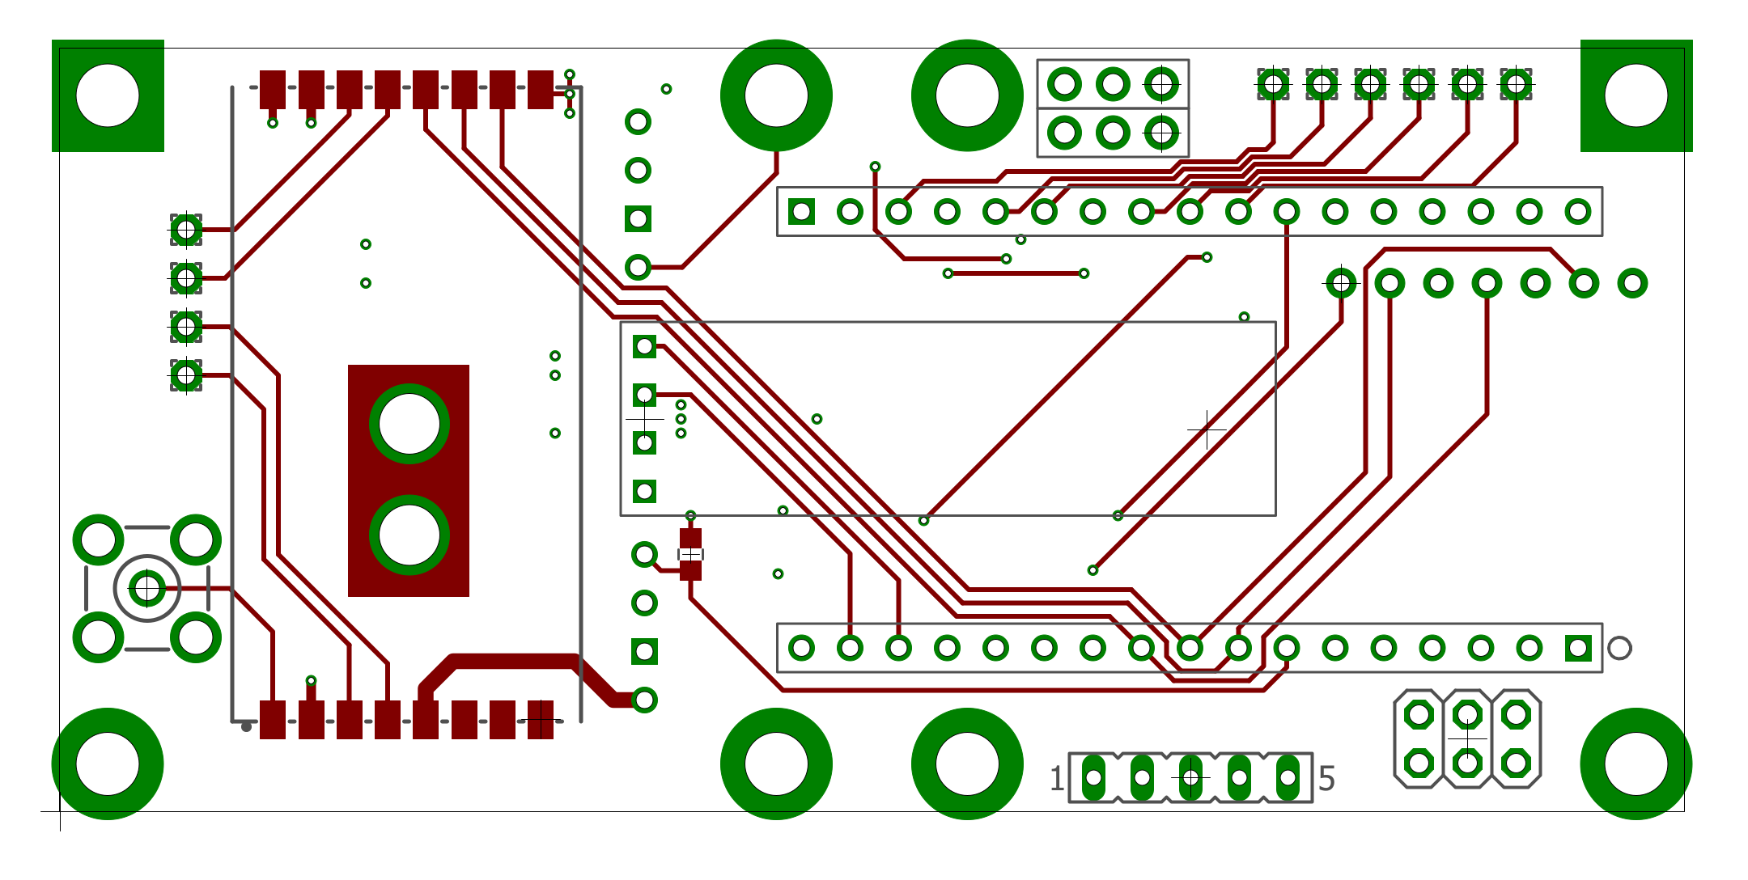

Figure 1

# Board Layout Bottom

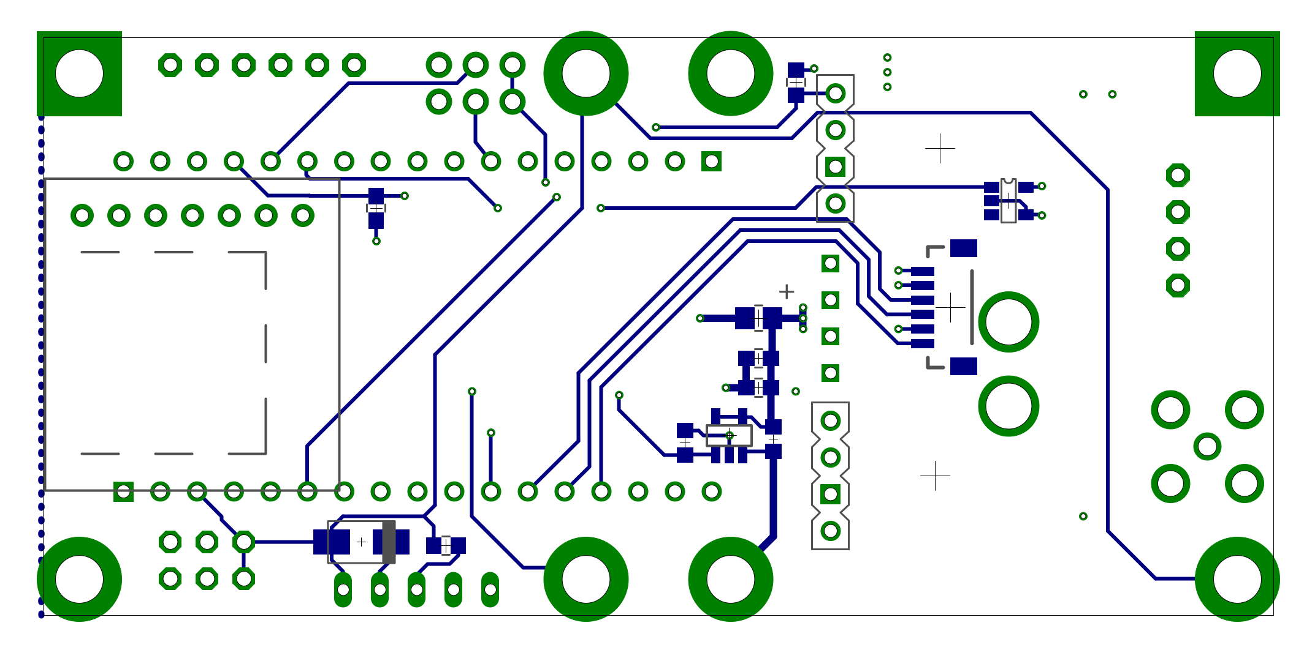

Figure 2