CIT336 Midterm Exam Spring 2018

Code/Database will be 50% of the total grade, and the questions will be the other 50%, with each question having a value of 5 points.

We’re going to create an application that allows us to keep track of assignments for our classes, so that we have a list of all of the assignments we’ve done for all of our classes over time.

We want to know the course number (CIT336, CIS101, ENG210 etc.), the name of the assignment, and the due date.

So first, we will create a database to store this information.

We need one table, called ‘assignments’, that will store each assignment, including the class, name, and due date.

1. What would be the SQL to create this database and table?

CREATE DATABASE SchoolAssignments;

CREATE TABLE assignments (

Assignment VARCHAR(255),

Course VARCHAR(255),

dueDate VARCHAR(255)

);

Now that we have a database set up, we need to create a form to enter each assignment. It should look like this:

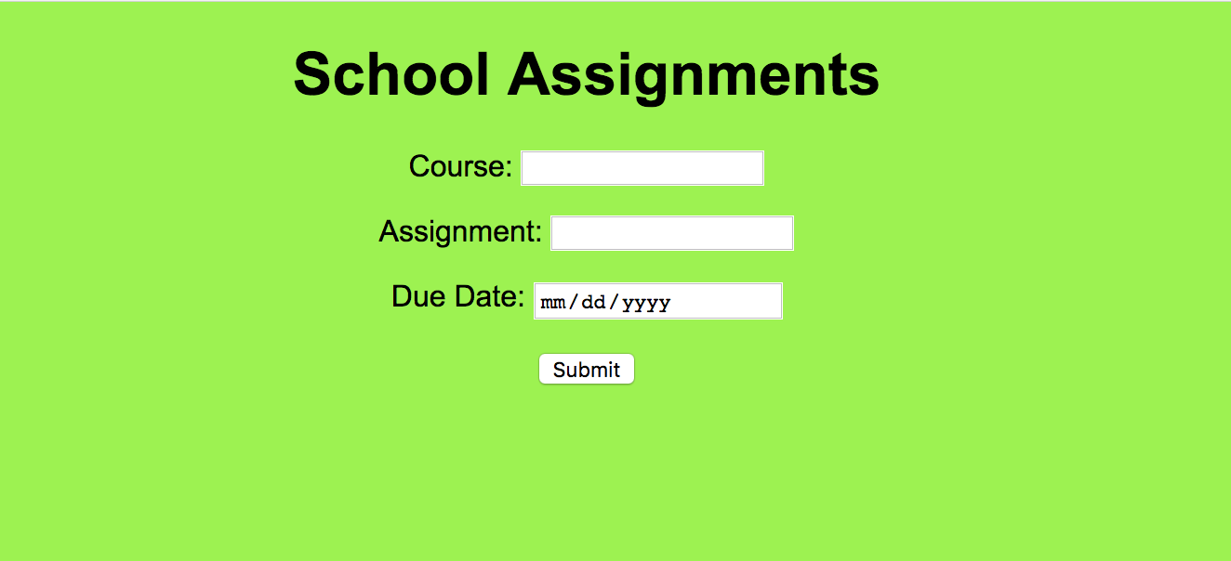

(Font is Arial, text is black, background color is #9bf442)

Now we need to write a PHP file that will allow us to add the information from the form to the database.

2. What type of software do we need to have running on our computers to run PHP?

Because PHP is a server-side scripting language, we need a web server to run PHP

3. What type of variable must $link be if we’re using it **throughout the document**?

If we are using it throughout the document, $link must be a static variable.

Now we will write an AJAX function to send that data to the database without refreshing the page.

4. We’re using a GET request in this situation. In what situations might we choose to use a POST request instead?

You would use POST for HTTP requests, sensitive data, sending a lot of data, or when you need advanced features.

5. What is AJAX and why are we using it?

AJAX stands for Asynchronous JavaScript and XML. Asynchronous means that it updates the webpage without reloading. It exchanges small pieces of data with the server, so that parts of the webpage can be updated without reloading the whole page, which is why we are using it.

6. What is an HTTP request?

An HTTP request calls to the server to ‘request’ data from the server, such as a specific file, and the HTTP response is the server’s response to the client’s request, containing status information about the request and may also contain the requested content.

7. Where do we tell the client-side code what to do with the response from the server?

After we send the form and the transmission of the form to the server is successful.

8. Is the AJAX on the server-side or client-side? Is the PHP on the client-side or server-side?

The AJAX is client-side, and the PHP is server-side.

Double-check in your database that the information is being submitted.

Make a few assignment entries.

Now we just want to take a quick peek at the assignments we’ve had. Write a PHP file that displays a table that shows all of those assignments. Add a link to this page from the form page, and a link to this the form from this page.

It should look like this:

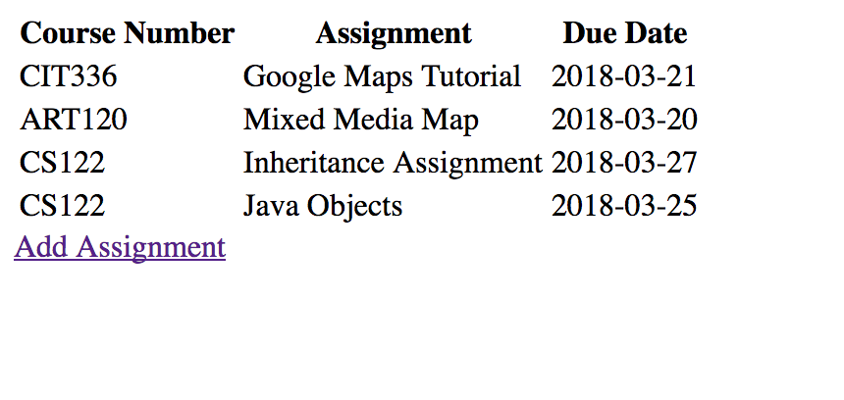

9. This application now does two of the functions of CRUD. Which two functions?

INSERT and UPDATE

10. Give me an example of 3 key-value pairs from your data.

11. If you were going to add this application to Github, what would be the steps to do that? Include the commands.

Put all of the files involved in a subdirectory, then in gitbash/terminal enter

**git add .**

**git commit –m “I completed my midterm!”**

**git push origin master**

12. What would be the benefits of using Github?

You won’t lose your work; any mistakes are easily reversible; you can develop in a separate branch so that you don’t break the production code; You can work on a project simultaneously as a team; you can find out who broke things, when and how they did it; Employers will look at your code samples on your GitHub account.

Did you document your code? Put in comments that explain what your code is doing.

Zip up a file with all of your code and this document and upload it to Blackboard.

Great job! Next week we are going to look at what we can add to make this a little more useful, as well as some Python.