**Request for Quotation (RFQ)**

**Document**

**For the Provision of**

**Easy Finance (i.e. eApplication) V1.2**

Amendent log:

|  |  |  |  |
| --- | --- | --- | --- |
| Version | date | author | Changes |
| 0.1 | 2018-09-09 | Bai Tao | nitial version |
| 0.2 | 2018-09-17 | JiChao | update sla |
| 1.0 | 2018-10-19 | jichao | update user stories |
| 1.1 | 2018-10-26 | Bai Tao | Updated requirements for Agile |
| 1.2 | 2018-11-12 | Bai Tao | Update sub-contracting for FR, ORC and CA related parts |

# Contents

Contents 3

Section 1: TENDER INSTRUCTIONS 4

Section 2: Specification 15

# Section 1: TENDER INSTRUCTIONS

|  |
| --- |
| **VENDOR should read all the instructions carefully before responding. Failure to comply with these requirements may result in the rejection of a Tender response.** |

## BMW AFC overview

BMW Automotive Finance (China) Co., Ltd. (hereinafter referred to as “BMW AFC”), founded in 2010, is a joint venture between the BMW AG and BMW Brilliance. BMW is committed to providing customers with intimate financial products and high-end, professional services. BMW finance will provide "one-stop" Car Buy-ing and loan services to customers, allow customers to enjoy financial products but also to experience BMW Automotive financial service.

## Confidentiality/Copyright

This Request for Quotation (RFQ) document and its associated annexes and schedules are subject to the laws of copyright and must not be reproduced in whole or in part without the prior written consent of BMW AFC. Furthermore, all information contained within the document, its associated schedules and any electronic attachments are given in strict confidence.

This RFQ should not be divulged to any third party without the prior written authority of BMW AFC. If the VENDOR provides information to a notified third party for the purpose of receiving quotations for parts of the products or services not covered in house, the VENDOR is responsible for ensuring that his subcontractor also treats this information as “Commercial in Confidence.”

All information submitted by VENDORS in response to this Invitation to tender will be treated as “Commercial in Confidence.”

This RFQ document remains the sole property of BMW AFC and should be returned with the VENDOR’s Tender response.

## Use of Trademarks

The BMW AFC trademarks should not be re-produced anywhere in your RFQ response.

## General Instructions

* 1. All information in this Request for Quotation is provided in good faith and represents BMW AFC’s view of the service BMW AFC requires. However, BMW AFC relies on the VENDORS to inform BMW AFC about the most efficient and cost-effective methods of delivering these services. BMW AFC therefore welcomes questions or advice on any area of BMW AFC’s specification. It will be at BMW AFC’s discretion as to whether replies to particular queries are communicated to other respondents. BMW AFC reserves the right to amend the specification at any time during the Tender process.

4.2 Detailed terms and conditions of business will be agreed before contracts are awarded.

4.3 As a Tender from vendor, provides services for competing brands, including Mercedes Benz, Audi, Volvo and Lexus at the same time, (BMW AFC reserves the right to add other competing brands to this list): Please disclose the names of your automotive customers and describe the services rendered, respectively, in your Tender. Please let us know how you can protect BMW AFC customer data and how you ensure the service/manpower/software/hardware, etc is separated absolutely from different clients.

4.4 The BMW AFC will only establish contract relationship with final selected vendor, and such vendor shall be fully liable for any loss arisen from itself and its assigned third-party service provider.

4.5 Tender costs should be fixed for the **3 (THREE) YEARS** duration of the contract, which will commence on 1st Jan, 2019 and conclude on 31th Dec, 2021.

4.6 Tenders may be rejected if the complete information requested is not given at the time of Tendering. Supporting literature may accompany the Tender, but answers to the questionnaire should be in the Tender response itself, with reference to accompanying literature kept to a minimum.

4.7 BMW AFC reserves the right to accept or reject any Tender and to annul the Tender process and reject all Tenders at any time prior to the award of contract without incurring any liability to the affected VENDORS.

4.8 BMW AFC will not be liable for any costs incurred by VENDORS in the preparation and submission of their Tender nor for costs that arise out of any site visits or presentations requested by BMW AFC.

4.9 BMW AFC reserves the right to award all or part of the services to the VENDOR and reserves right to distribute the award on a regional basis.

4.10 BMW AFC requests full onsite support during project execution on time setup, all the quotation and related activities should consider for this, and resources for onsite support should qualified for Agile team requirements, in case of any team number who is not qualified, BMＷ AFC reserve the right to request to change resource unitl resource is qualified, and anything impact projecte delivery the because of this should be bear by Supplier.

4.11 Requirements briefing within RFQ documentation are only for general working scope for cost and effort estimation, BMW AFC reserves the right to change and modify and expand each user stories and Epics supplier cannot based on this as final SOW.

4.12 Contract Scope not only include one time setup for Easy Finance application operaition maintainance, but also include handover existing and also future application Applcation Operaiton and Maintenance for digital products and systems please reference details scope in below.

4.13 BMW AFC requests to have Face recognition, ORC scanning, CA Authenticaiton etc. in e-authentication in case supplier doesn’t own this technology, supplier should browse on market based on BMW recommandations to verify technical feasibility to select the suiltable products(BMW is open for other products as well which can reach BMW requirements, but require to highlight if the product is not recommended by BMW), and negotiate to come with the final quotation, and BMW will sign the contract with the product company. And the final pricing will be calculated together with the quoation from E-Application supplier for the final bidding result.

BMW requirements:

- On premise deployment is mandatory.

- (No sperate hardware) software solution is recommend.

Face Recognition, requires the product to provide NCIIC Interface to do photo comparison, including:

a. Compare the photo on ID with the stored photo in NCIIC.

b. Camera Captured Photo with the Stored Photo in NCIIC. Or send photo (PRC ID photo or/and Camera Captured photo) to NCIIC and get a comparison score.

In another way, it is Not enough to Only verify the camera captured photo with the photo on PRC ID for E-authentication Solution.d

4.14 BMW AFC request supplier to have rich Agile working experiances and full Agile development team onsite through Dev-Ops model and Micro services to complete project execution.

Full automention process during project execution especially for

* Automated testing reach 80% above.

- Continuous integration, continuous deployment, Continuous delivery.

- Source code management

- Auto code quality control(e.g. SonarQube)

- Full code management within BMW tool chain according to BMW guidelines

Iteration circle less then one month WITH good quality. .

BMW Agile Toochain landscape.

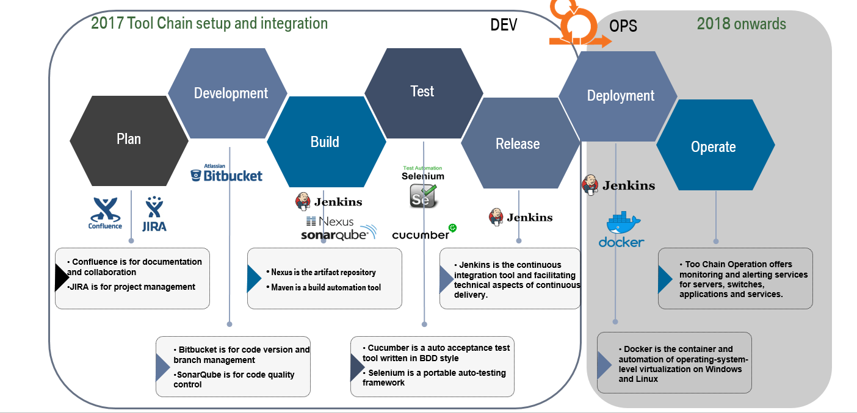

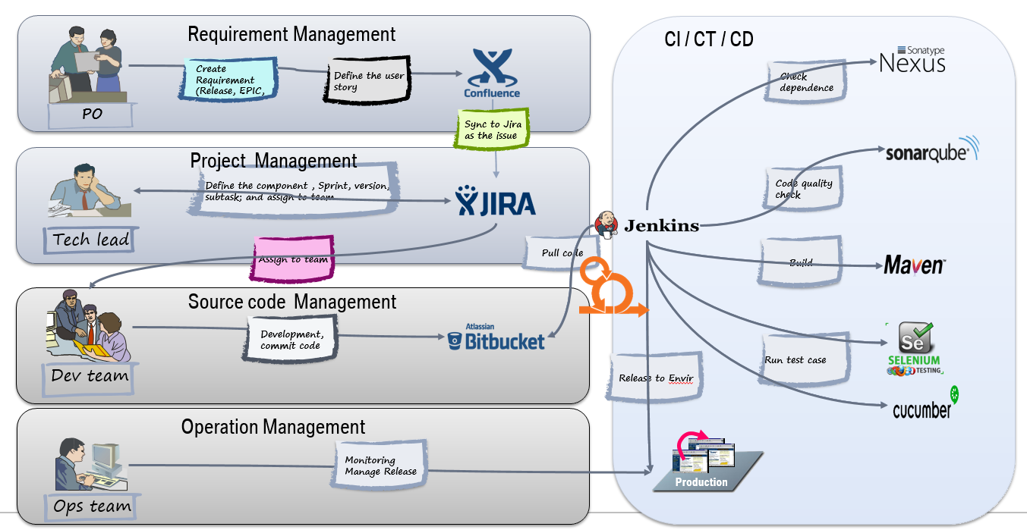

4.15 BMW AFC requests working scope also including UI and UX design and development.

4.16 Supplier should commit on agreed timeline and delivery scope, in case of any exception cause by supplier impact project delivery timeline, BMW AFC will depends on the impact to make the penalty( from 5% to 30%) of ontime setup cost.

4.17 All the sub-contracts to purchase products (OCR scanning, Face recognition, CA authentication) should satify with BMW requirements.

4.18 E- Application should support IOS 9.0 (including and above, Android 4.4 Including and above and should be responsive design.

## Tender Response

5.1 Please submit a response to this Tender document by **19th Nov, 2018**. If your Tender document is not received by the date above, your Tender submission will be disregarded.

Please send your Tender the attention to:

|  |  |
| --- | --- |
| BMW AFC, Digitalization  **Dee Wu**  Dee.Wu@bmw.com | BMW AFC, Digitalization  **Befelein Maximilian**  Maximilian.Befelein@bmw.de |
| BMW AFC, Purchasing  **Xu Daniel**  Daniel.Xu@bmw.com | BMW AFC, IT  **Tao Bai**  Tao.bai@bmw.com |

5.2 BMW AFC still retain right to release the updates and clarifications as a supplement. With a mutual agreement, VENDOR should be able to update your proposal or quotation accordingly, and turn in Tender submission timely.

5.3 All questions during the Tender process must be sent to BMW AFC **in one single document** to the individuals noted above. This document should include a versioning for all updates. This document will also be used to provide the respective answers from BMW AFC. For all other questions via email, phone or other channels BMW AFC cannot guarantee that the answer is binding.

5.4 We understand vendor may need to submit supplementary response during the tender process, and if the content of two response conflict, then the latter one shall prevail.

5.5 All the cost should be proper documented into the Quotation template, BMW will not pay addtiona cost which is outside of Quotaiton template besides change of request.

## Selection Criteria & Tender Timeline

* 1. BMW AFC will make the final VENDOR selection based on the following criteria:
     + The level to which the proposed response meets the business and the commercial requirements.
     + The degree to which the proposed response meet acceptable levels of performance.
     + The VENDOR's capability to fully support its proposal.
     + The competitiveness of the price quoted for all services.
     + The acceptability of the VENDOR's legal and financial standing.
     + Compliance to BMW AFC’s Terms and Conditions.
     + Other value-added services can be provided.
     + The appropriate emergency response plan and business continuity plan, also necessary fines and penalties.
     + The appropriate transition plan to guarantee enough time for seamless transition when the contract comes to the end of the term.

6.2 Detailed timeline (please be noted below timeline is still flexible subject to BMW AFC adjustment)

|  |  |
| --- | --- |
| **Project milestone** | **Time** |
| Biz & IT RFQ Release | Nov 5th 2018 |
| Bidding Briefing Meeting & Supplier Q&A | Nov 6th 2018 |
| Vendor the 1st draft Proposal to BMW | Nov 19th 2018 |
| BMW feedback to 1st draft proposal | Nov 21st 2018 |
| Vendor Presentation with updated version | Nov 22th 2018 |
| Q&A & on-site visit (if needed) | NA |
| Vendor provide the final proposal and quotation | Nov 23th 2018 |
| Evaluation + TSR | Dec 7th 2018 |
| Supplier Contract Sign off | Dec 31st 2018 |

## Notification

BMW AFC will notify acceptance in writing to the successful VENDOR. After the contract is agreed, BMW AFC will notify each unsuccessful VENDOR as soon as is reasonably practicable. BMW AFC reserves the right to nominate VENDOR for all or just specific elements of this Tender.

## 8. Tender Feedback Requirement

Tender feedback must be received by BMW AFC on or before **19th Nov, 2018, 03:00 PM.**

Tender including all attached documents must be in English. Chinese version is optional. A Template Tender Feedback is available at the end of this section. The same Template must be used by each applicant with the following criteria:

Tender including all attached documents must be in English.

Documents must be in PDF or MS WORD 2007 or 2010 format.

Sample reports must be in MS Excel 2007 or 2010 format.

Quotation must be strictly prepared in BMW AFC template.

Any plan timing must be in MS Excel or MS Project format.

Tender should definitely conform to the Tender Feedback.

8.3 Tender feedback should include:

**Company profile**

History

Licenses (Please list all the mandatory and non-mandatory licenses and certificates you have obtained related to current project.)

Ownership

Reference projects (Client, description, solution, size of the operation, number of communications per month, reference contacts)

Operation KPIs and performance

Experience of providing similar to other Automotive or non-Automotive groups.

**Proposed solution**

Communications matrix to BMW AFC

Named person with profiles and experience

Understanding of BMW AFC Tendering requirements and proposal (organization, process, governance, etc)

Proposed organization structure supporting BMW AFC business.

Respectively proposed processes including but not limited to IT, system support, business continuity plan, operational support and transition plan.

Respectively proposed KPIs including but not limited to system response time, recovery time and reporting time.

Respectively proposed KPIs including OCR and face recognization accurancy and response time.

Respectively proposed KPIs including NCIIC interface to do photo comparison.

Respectively proposed KPIs including CA authentication.

Proposed customer notification and communication processes.

Daily maximum volume of request processed.

Data store plan for BMW AFC Easy Finance and any data which happened in the user journey.

Respectively proposed business support organization account for BMW AFC.

Respectively proposed IT solution and project management team which can integrate with BMW AFC system.

Respectively proposed security solution especially BMW AFC customer data protection.

Account receivable monitoring solutions (Real-time reporting and historical reports).

Quality controls and system availability assurance.

Urgent regulation alert mechanism.

Price

Providing details and breakdown of quotation, refer to the quotation template.

Other available services offered

Description

Access to additional valuable information about BMW AFC customers.

Pricing examples if applicable

IT SYSTEM SUPPORT

Supplier provide delegate IT resource during project period and after go-live

SLA needs to be provided and sign off by both BMW AFC IT and business.

Emergency solution to be provided to ensure daily business operation will not be impacted by any system issues.

Level Support

SLA needs to be provided and sign off by both BMW AFC IT and business.

Emergency solution to be provided to endure daily business operation will not be impacted by any system issues.

Data security

A clear infrastructure and architecture diagram with necessary information description is highly recommended.

Deviation from the attached “Tender Feedback” can have a negative effect on the evaluation of a tender.

In the “Cost Criteria” of “Tender Feedback”, please specify the cost between each project milestone and the respective daily rate. In the “Tender Structure”, please also specify the rate and cost for future case by case maintenance.



## 9. Sourcing Scenarios

9.1 BMW AFC is evaluating the following scenarios for BMW AFC Easy Finance project. And the project would be run by agile methodology.

9.3 For future scenario, BMW AFC may at its own discretion to decide how much more user stories will be additional. All change request related requirement for this project will be included in this project.

9.4 Sub-Provider Management

Supplier may subcontract or delegate any of its obligations with confirmation by BMW AFC in advance. Supplier shall always be responsible for all obligations performed by subcontractors to the same extent as if such obligations were performed by Supplier.

# Section 2: Specification

## Overview

Currently, for BMW AFC China, customer can only apply loan in dealership and the information input and documents uploads are done by F&I in DFE. There is no platform to support customer apply loan by themselves via mobile devices. Meanwhile, customer can’t timely view application status by themselves.

Easy Finance project aims to develop a platform to support customer apply for BMW Financial services by themselves via mobile devices.

This Tender document outlines the requirements for the provision of BMW AFC for BMW AFC China.

Rationale for project:

* Open a new applicaiton channel to BMW AFC customers
* Decrease customer effort and improve customer experience
* Support sales to increase the application volumes
* Better control operational cost by Innovation & Digitalization

## Requirement

### Easy Finance Requirements: Epics and User Stories

**\* the requirements below are only for reference, detail requirements may have changes and updates during requirement clarification phase and development phase.**

(Business requirements should contain both AFC and HIL in scope, HIL is part of BMW group and maybe have some differents process compare with AFC.)

1. Entry Point: Stand alone

As BMW SF eAPP owner, I want to deploy a standalone entry point for eAPP, so that eAPP user can select dealer, vehicle and SF product directly from eAPP.

1. App download: QR Code
2. As a user of eAPP (applicants) I want to scan a QR code so that I can download and open the APP to start the application.
3. As a user, I want to scan a QR code in app, so that I can get information prefilled.
4. As an F&I, I want to generate the QR code for user, so that they can have a application with prefilled information.
5. Registration
6. As a New user to BMW Easy Finance APP I should be able to Register with password for creating a new Account.
7. As a New user to BMW Easy Finance APP I should be able to Register with temp. pwd for creating a new Account.
8. As a Existing User of Easy Finance Application When I trying to Register with Easy Application Finance, I should be prompted to login.
9. As a Existing User to BMW Easy Finance APP I should be able to Login with password successfully.
10. As a Existing User to BMW Easy Finance APP I should be able to Login with temp. PWD(OTP) successfully.
11. As a Existing User of Easy Finance Application When I forget my password I should be allowed to login by resetting my password.
12. Products Selection (Dealer & Vehicle)
13. As a user I want to select the vehicle So that I can start the finance application process
14. As a user I want to have the information of the vehicle displayed (pictures, options,...)So that I can see which car I want to purchase / finance.
15. As a user I want to choose the dealership of the car I would like to purchase / finance. So that I can continue the process later on in my next visit
16. As a userI want to choose the dealership of the car I would like to purchase / finance. So that I can get the dealer specific vehicle / finance product
17. As a userI want the Dealer automatically pre-filled So that I don't have to search for the specific dealer
18. As a user I want to adjust the MSRP to the agreed quotation price So that I can finance the quotation price
19. As a user I want to adjust the MSRP to the agreed quotation price So that I can get a binding offer from the dealer
20. As a user I want to add associated products to the car. So that I can add vehicle accessories and etc. to the to be financed amount
21. As a user I want to select the SF Product and adjust the parameter to my needs. So that I can get the SF Product that fits my personal needs
22. As a user I want to add associated products to the finance offer so that I can add vehicle accessories and etc. to the to be financed amount
23. As a user I want to select Herald Leasing products so that i can chose leasing products
24. As an existing customer and eApp user I want to be able to select the loyalty SF offer so that I can enjoy the loyalty program interest rate subsidy.
25. As a user I want to select the SF Product and adjust the parameter to my needs so that I can get the SF Product that fits my personal needs
26. As a user I want to add associated products to the finance offer so that I can add vehicle accessories and etc. to the to be financed amount.
27. As a user I want to select Herald Leasing products so that I can chose leasing products
28. As a existing customer and eApp user I want to be able to select the loyalty SF offer so that I can enjoy the loyalty program interest rate subsidy.
29. As a user, I want to be notified in how many days the offer is expired.
30. As a user, I want to be select dealer specific SF products so that i can enjoy dealer specific SF campaigns.
31. Binding Offer Management (DFE Review and Audit)
32. As a user, I want to get confirmation of my quotation by F&I, and the quotation information couldn’t be changed by myself after quotation submitted, so that I'm able to proceed with the loan application.
33. As a user of DFE, I want to review & audit the quotation which is selected by the applicants, if all information is correct, click "confirmed", then follow existing process. if it’s incorrect, I will help to change to correct.
34. As a user,  I want to be notified the quotation information which has been confirmed by F&I, following the comment which F&I left,  so that I'm able to proceed to E-authentication.