- Recording Meta Information
Name | Description
Location ID | A01
Location Name | Zhongxiao Rd and Zhongzheng Rd, Xinhua Dist., Tainan City, Taiwan
Lat Coordinates | 23.038471 ºN
Lon Coordinates | 120.307175 ºE
Drone | Autel EVO II Pro
Flight altitude | 120 m
Frame Rate | 30 fps (actual 29.97 fps)

- Lane Configuration
Approach | Lane 1 | Lane 2 | Lane 3 | Lane 4
A | LT | TR | - | -
B | LTR | - | - | -
C | LT | TR | - | -
D | LTR | - | - | -

- Speed limit
Approach A: 50km/h
Approach B: 50km/h
Approach C: 50km/h
Approach D: 50km/h

- Signal Timing Plan
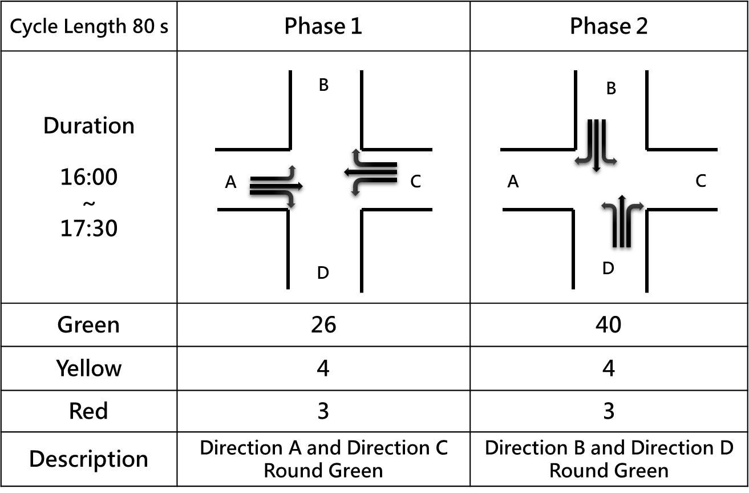

- Each Video Recording Information
Name | Description
Video | A01-01 | A01-02 | A01-03 | A01-04
Record Time | 2023-07-04 16:08:49 | 2023-07-04 16:43:09 | 2023-07-04 17:04:26 | 2023-07-04 17:29:05
Duration | 1199 s | 951 s | 1252 s | 1248 s
Ground Sample Distance (GSD) | 0.0785 | 0.0791 | 0.079 | 0.0792

