- Recording Meta Information
Name | Description
Location ID | A02
Location Name | Sec. 1, Beiyi Rd. & Wenzhong Rd., Xindian Dist., New Taipei City, Taiwan
Lat Coordinates | 24.957001 ºN
Lon Coordinates | 121.538295 ºE
Drone | Autel EVO II Pro
Flight altitude | 120 m
Frame Rate | 30 fps (actual 29.97 fps)

- Lane Configuration
Approach | Lane 1 | Lane 2 | Lane 3 | Lane 4
A | T | TR | - | -
B | LTR | - | - | -
C | T | TR | - | -
D | LTR | - | - | -

- Speed limit
Approach A: 50km/h
Approach B: 50km/h
Approach C: 50km/h
Approach D: 50km/h

- Signal Timing Plan
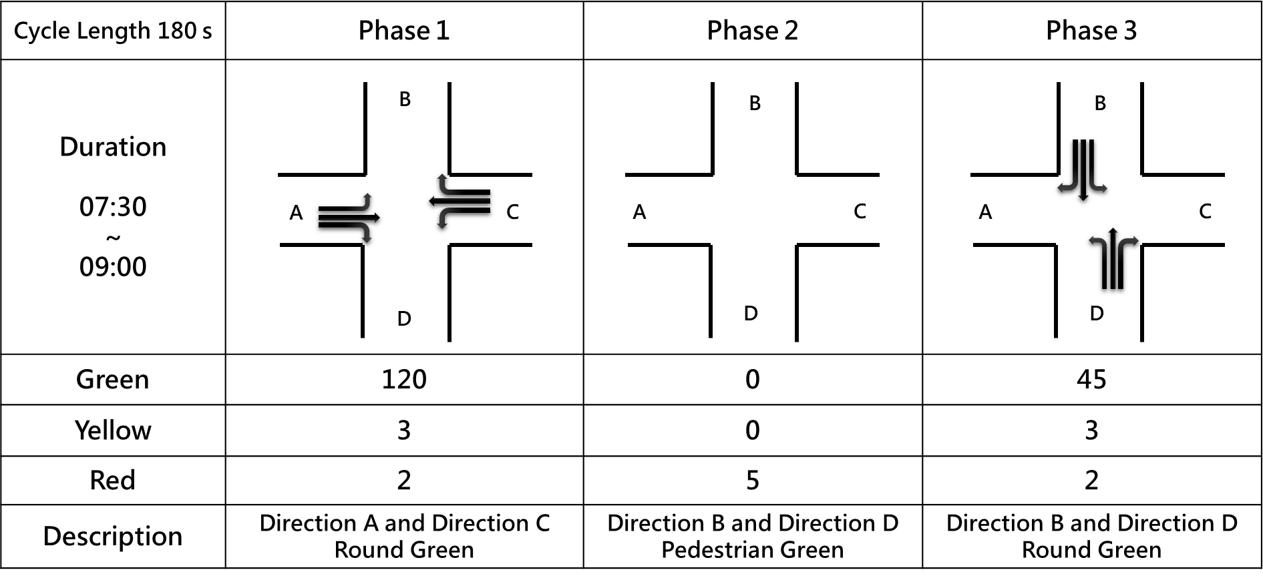

- Each Video Recording Information
Name | Description
Video | A02-01 | A02-02 | A02-03
Record Time | 2022-07-07 07:55:30 | 2022-07-07 08:21:22 | 2022-07-07 08:49:07
Duration | 1199 s | 1412 s | 1357 s
round Sample Distance (GSD) | 0.0798 | 0.0797 | 0.0791

