- Recording Meta Information
Name | Description
Location ID | A03
Location Name | Xinzhong N. Rd. & Rongmin Rd. & Rongmin S. Rd., Zhongli Dist., Taoyuan City, Taiwan
Lat Coordinates | 24.956953 ºN
Lon Coordinates | 121.259198 ºE
Drone | Parrot ANAFI
Flight altitude | 70 m
Frame Rate | 30 fps (actual 29.97 fps)

- Lane Configuration
Approach | Lane 1 | Lane 2 | Lane 3 | Lane 4
A | LTR | - | - | -
B | LTR | - | - | -
C | LTR | - | - | -
D | LTR | - | - | -

- Speed limit
Approach A: 50km/h
Approach B: 50km/h
Approach C: 50km/h
Approach D: 50km/h

- Signal Timing Plan
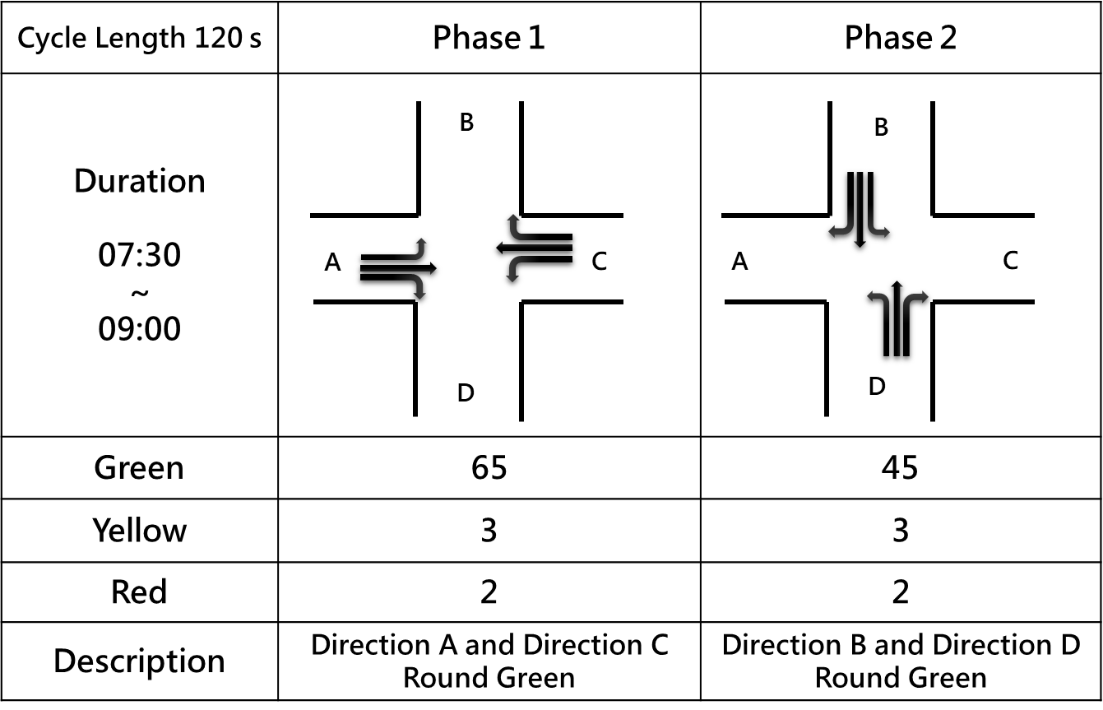

- Each Video Recording Information
Name | Description
Video | A03-01 | A03-02 | A03-03
Record Time | 2021-08-10 07:46:43 | 2021-08-10 08:08:56 | 2021-08-10 08:39:23
Duration | 831s | 719 s | 826 s
round Sample Distance (GSD) | 0.0539 | 0.055 | 0.0543

