- Recording Meta Information
Name | Description
Location ID | A04
Location Name | Jingwu Rd. & Bo'ai Rd., Fengshan Dist., Kaohsiung City, Taiwan
Lat Coordinates | 22.630463 ºN
Lon Coordinates | 120.362867 ºE
Drone | Parrot ANAFI
Flight altitude | 80 m
Frame Rate | 30 fps (actual 29.97 fps)

- Lane Configuration
Approach | Lane 1 | Lane 2 | Lane 3 | Lane 4
A | L | T | TR | -
B | LT | TR | - | -
C | L | T | TR | -
D | LT | TR | - | -

- Speed limit
Approach A: 50km/h
Approach B: 50km/h
Approach C: 50km/h
Approach D: 50km/h

- Signal Timing Plan
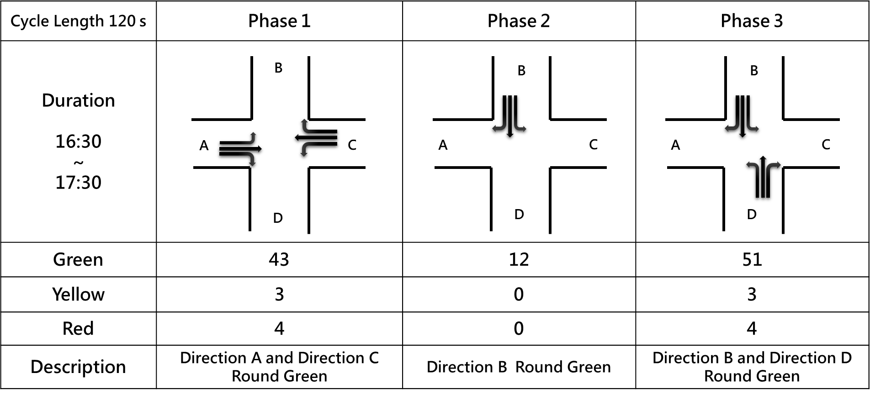

- Each Video Recording Information
Name | Description
Video | A04-01 | A04-02 | A04-03
Record Time | 2021-08-25 16:39:26 | 2021-08-25 17:01:35 | 2021-08-25 17:23:24
Duration | 904 s | 883 s | 980 s
round Sample Distance (GSD) | 0.0614 | 0.0613 | 0.0618

