- Recording Meta Information
Name | Description
Location ID | A05
Location Name | Minguang E. Rd. & Chunri Rd., Taoyuan Dist., Taoyuan City, Taiwan
Lat Coordinates | 25.006206 ºN
Lon Coordinates | 121.312167 ºE
Drone | Autel EVO II Pro
Flight altitude | 120 m
Frame Rate | 30 fps (actual 29.97 fps)

- Lane Configuration
Approach | Lane 1 | Lane 2 | Lane 3 | Lane 4
A | LT | T | TR | -
B | LTR | - | - | -
C | LT | R | - | -
D | LT | T | TR | -

- Speed limit
Approach A: 50km/h
Approach B: 50km/h
Approach C: 50km/h
Approach D: 50km/h

- Signal Timing Plan
A05-01
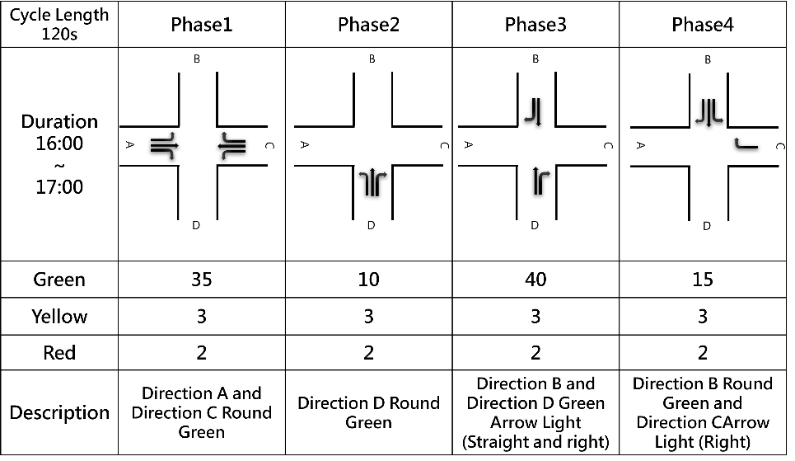D
A05-02~04
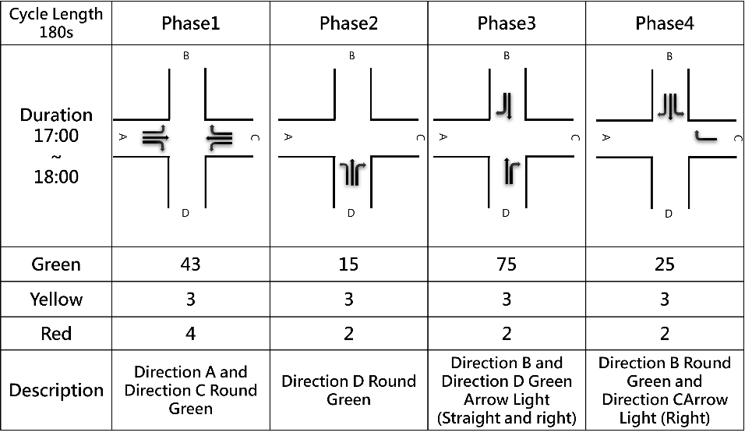

- Each Video Recording Information
Name | Description
Video | A05-01 | A05-02 | A05-03 | A05-04
Record Time | 2023-06-19 16:09:56 | 2023-06-19 16:33:57 | 2023-06-19 17:09:03 | 2023-06-19 17:35:32
Duration | 1186 s | 1230 s | 1336 s | 1180 s
round Sample Distance (GSD) | 0.08 | 0.08 | 0.08 | 0.08

