- Recording Meta Information
Name | Description
Location ID | A06
Location Name | Zhonghua Rd. & Fuxing Rd. & Guangming 11th Rd., Zhubei City, Hsinchu County, Taiwan
Lat Coordinates | 24.828772 ºN
Lon Coordinates | 120.999785 ºE
Drone | Autel EVO II Pro
Flight altitude | 120 m
Frame Rate | 30 fps (actual 29.97 fps)

- Lane Configuration
Approach | Lane 1 | Lane 2 | Lane 3 | Lane 4
A | L | T | T | R
B | LT | R | - | -
C | L | T | T | R
D | LT | TR | - | -

- Speed limit
Approach A: 50km/h
Approach B: 50km/h
Approach C: 50km/h
Approach D: 50km/h

- Signal Timing Plan
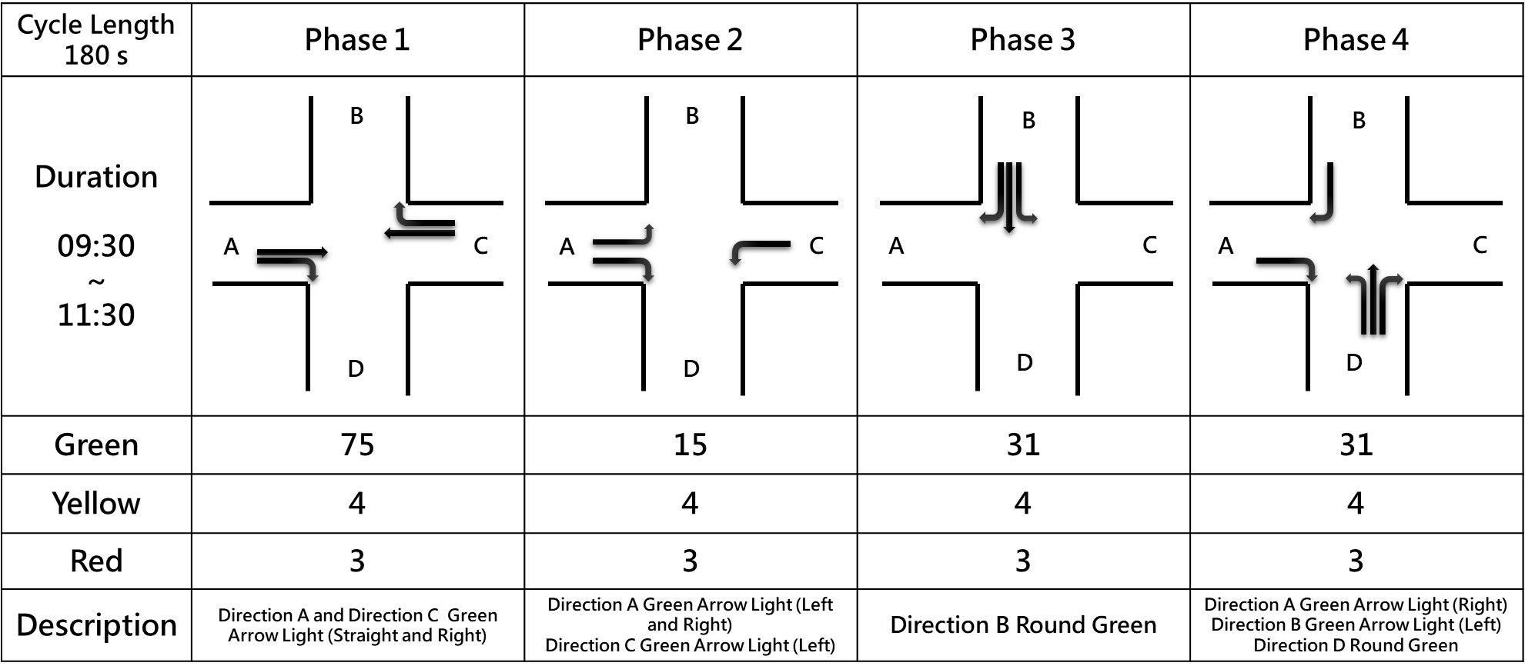

- Each Video Recording Information
Name | Description
Video | A06-01 | A06-02 | A06-03 | A06-04
Record Time | 2022-06-23 09:48:06 | 2022-06-23 10:11:09 | 2022-06-23 10:53:03 | 2022-06-23 11:20:44
Duration | 1161 s | 900 s | 1364 s | 1383 s
round Sample Distance (GSD) | 0.0801 | 0.0798 | 0.0795 | 0.0796

