1. Select all the data of passengers whose last name is same as first name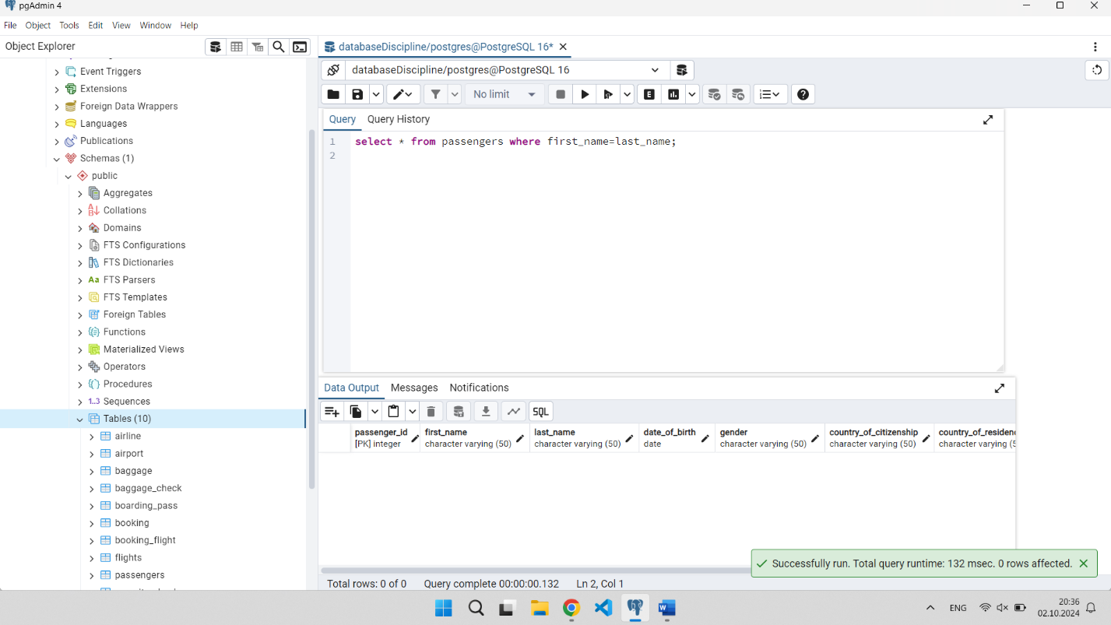
2. Select the last name of all passangers without duplicates.A screenshot of a computer

   Description automatically generated
3. Find all male passengers born between 1990 and 2000.(10%)A screenshot of a computer

   Description automatically generated
4. Find price of tickets sold for each month in sorted way.(10%)A screenshot of a computer

   Description automatically generated
5. Create a query that shows all flights flying to ‘China’.(10%)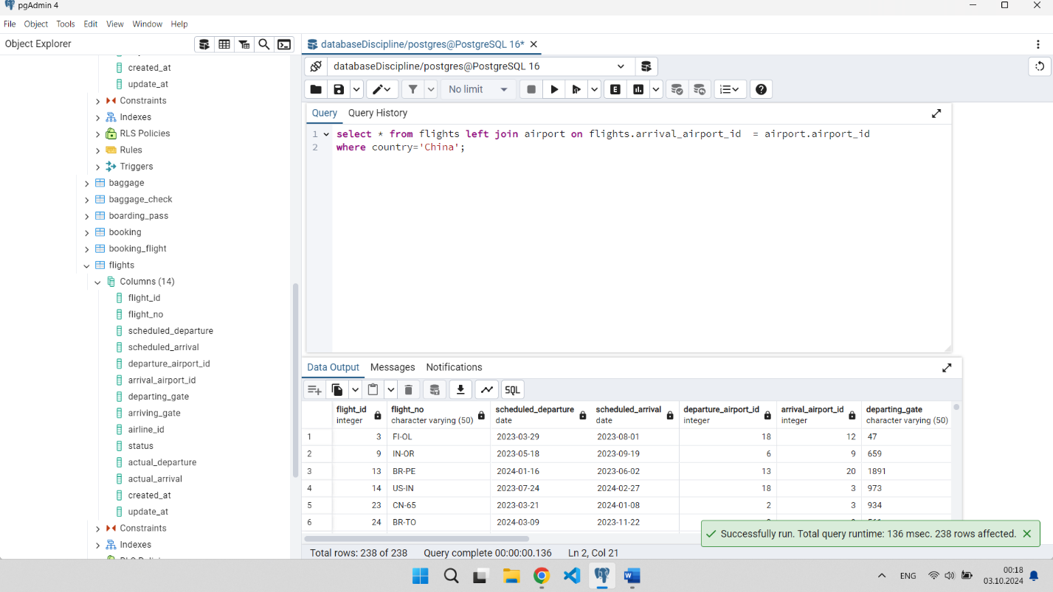
6. Find all airline names based in Kazakhstan.(10%)A screenshot of a computer

   Description automatically generated
7. Reduce the cost of booking price by 10% created before ’12-12-2010’ .(10%)A screenshot of a computer

   Description automatically generated
8. Find top3 overweighted baggage with more than 25kg.(10%)A screenshot of a computer

   Description automatically generated
9. Find the youngest passengers’ full name.(10%)A screenshot of a computer

   Description automatically generated
10. Find the cheapest booking price in each booking platform.(10%)A screenshot of a computer

    Description automatically generated