封面

论文题目 政务云统一身份认证与权限控制系统设计与实现

姓 名 徐黎科

学 院 软件学院

专 业 软件工程

指导教师 宋杰 尹可挺

备 注

2016 年 6 月 10日

政务云统一身份认证
与权限控制系统设计与实现

作者姓名： | 徐黎科
校内指导教师： | 宋 杰 | 副教授
企业指导教师： | 尹可挺 | 讲 师
单位名称： | 软件学院
专业名称： | 软件工程

东 北 大 学
2016年6月

Design and Implementation of the Unify Identity Authentication and Access Control System
in E-government Cloud

by Aaron.L.Xu

Supervisor: | Associate Professor Song Jie
Associate Supervisor: | Lecturer Yin Ke Ting

Northeastern University

June 2016

毕业设计（论文）任务书

毕业设计（论文）题目：
政务云统一身份认证与权限控制系统的设计与实现
基本内容：
调查政务私有云的业务需求，通过接入统一身份认证系统实现政务应用的单点登录和用户认证的统一化管理；同时统一身份认证系统支持与已有的认证系统对接，通过对应用和已有的认证系统的少量修改实现已有认证系统的用户可登录统一身份认证系统的应用，同样，统一身份认证系统的用户可登录已有认证系统的应用，在单点登录后能够对访问资源进行一定程度上的管理，提供对一些关键度量进行监控和管理，主要使用Java开发并对所实现的部分进行测试和评价。翻译一篇与毕设内容相关的外文资料，译文汉字字数不少于4000字。
学生接受毕业设计（论文）题目日期

第 1 周
指导教师签字：
2016 年 3 月 20 日

Design and Implementation of the Unify Identity Authentication and Access Control System in E-government Cloud

Abstract
Index subsystem is the most important part of a modern search engine. The main function of the index subsystem is to build up the index file from the mass original data in order that the query subsystem can quickly obtain the related data by using the indexes. The performance of the index file is a key factor to the whole search engine.
This article focuses mainly on how to design and implement an efficient data structure of the index and how to build up the index files from an original web page library. The author uses inverted index as index data structure, which is the most popular and widely used in modern search engine. After preprocessing the original web page library which includes filtering the content of Chinese characters text in html body and segmentation, the author builds up the forward index; then the author recognizes the forward index to get the inverted indexes; at last, as a demo and a test of the index subsystem, a simple query function is implemented.
Tianwang web page library is used as original data. Based on it, the system builds up four indexes: web page index, URL index, forward index and inverted index. Proved by tests, this article draws the conclusion that index subsystem can build up the indexes which provide high efficiency for the query subsystem.

Key words: Chinese Search Engine, Index Subsystem, Chinese Text Filtering, Chinese Characters Segmentation, Forward Index, Inverted Index
政务云统一身份认证与权限控制系统设计与实现

摘要
索引子系统是现代搜索引擎中最重要的模块之一。索引子系统的主要功能是：基于海量的原始网页库建立索引文件，以便于为查询子系统能够利用这些索引文件迅速得到相关数据。索引文件的效率是影响整个搜索引擎效率的最关键因素之一。
本文主要讨论如何设计和实现一个高效的索引数据结构，如何基于某个原始网页库建立这些索引文件。作者采用了倒排索引结构作为搜索引擎索引文件的数据结构，该结构是现代搜索引擎中最流行和应用最广泛的索引结构。在经过正文过滤，中文分词等预处理阶段之后，得到了正向索引文件；然后重新组织正向索引，得到了倒排索引；最后作为索引子系统的一个测试，还设计并实现了一个简单的查询子系统。
本系统所使用的原始网页库为Tianwang。基于该网页库，一共建立了四个索引：网页索引库，URL索引库，正向索引以及倒排索引。经过测试，本文得出结论，该索引子系统能够建立高效的索引文件，并能很好的为查询子系统服务。

关键词：中文搜索引擎，索引子系统，中文正文过滤，中文分词，正向索引，倒排索引

Contents
Abstract I
摘要 II
Chapter 1 Introduction - 1 -
1.1 Introduction to Modern Search Engine - 1 -
1.2 Introduction to Existing Work - 1 -
1.2.1 About the Popular Architecture - 1 -
1.2.2 About the State-of-the Art Technology in IR and SE - 4 -
1.3 My Work - 4 -
Chapter 2 A Simplified SE - 6 -
2.1 The Workflow of Simplified SE - 6 -
2.2 Architecture of Simplified SE - 7 -
Chapter 3 System Analysis - 9 -
3.1 Architecture Summarize - 9 -
3.1.1 Function Architecture - 9 -
3.1.2 Description of Module Function - 9 -
3.2 Non-functional Requirements - 10 -
3.3 Development Environment - 11 -
Chapter 4 System Design - 12 -
4.1 Preliminary Design - 12 -
4.1.1 The Architecture and Module - 12 -
4.1.2 The Storage of Index - 13 -
4.1.3 Page Index - 14 -
4.1.4 Forward Index - 15 -
4.1.5 Inverted Index - 15 -
4.1.6 Query Module - 16 -
4.2 Detailed Design - 16 -
4.2.1 Data Structure Design - 16 -
4.2.2 Algorithms Design - 18 -
Chapter 5 Implementation - 21 -
5.1 IDE Configuration - 21 -
5.2 Core Code and Important Flow - 21 -
5.2.1 Dictionary - 22 -
5.2.2 Segmentation - 24 -
5.2.3 Tags-filter Algorithms - 26 -
5.2.4 The Query Module - 27 -
Chapter 6 Test and Performance Estimate - 30 -
6.1 Overall Analyze - 30 -
6.2 Test - 30 -
6.3 Modeling the Performance of the Inverted Index - 33 -
6.3.1 Concepts and Definitions - 34 -
6.3.2 Model Assumption - 35 -
6.3.3 Modeling the Performance - 35 -
Chapter 7 Conclusion - 39 -
Reference - 41 -
Acknowledgements - 42 -

Chapter 1 Introduction
The production, spread, collection and query of information is one of the most important activities of human beings. The development of computer science changes the carrier of information from paper to the electron on the disk. It also brings us mass information data, useful and redundant. So how to find useful information becomes a rather important work.

1.2 Research Significance
This section will present the existing related work of how to organize the entire SE system.

1.2.1 About the Popular Architecture
Many of the search engines use well-known information retrieval (IR) algorithms and techniques. However, IR algorithms were developed for relatively small and coherent collections such as newspaper articles or book catalogs in a (physical) library. The Web, on the other hand, is massive, much less coherent, changes more rapidly, and is spread over geographically distributed computers. This requires new techniques, or extensions to the old ones, to deal with gathering information, making index structures scalable and efficiently updateable, and improving the ability of search engines to discriminate. For the last item, the ability to discriminate, it is possible to exploit the linkage among web pages to better identify the truly relevant pages.
Before we describe search engine techniques, it is useful to understand how a SE is typically put together. Figure 1.1 shows such an engine schematically. Every engine relies on a crawler module to provide the grist for its operation (shown on the left in figure 1.1). Crawlers are small programs that browse the Web on the search engine’s behalf, similarly to how a human user follows links to reach different pages. The programs are given a starting set of URLs whose pages they retrieve from the Web. The crawlers extract URLs appearing in the retrieved pages and give this information to the crawler control module. This module determines what links to visit next and feeds the links to visit back to the crawlers. (Some of the functionality of the crawler control module may be implemented by the crawlers themselves.) The crawlers also pass the retrieved pages into a page repository. Crawlers continue visiting the Web until local resources, such as storage, are exhausted.

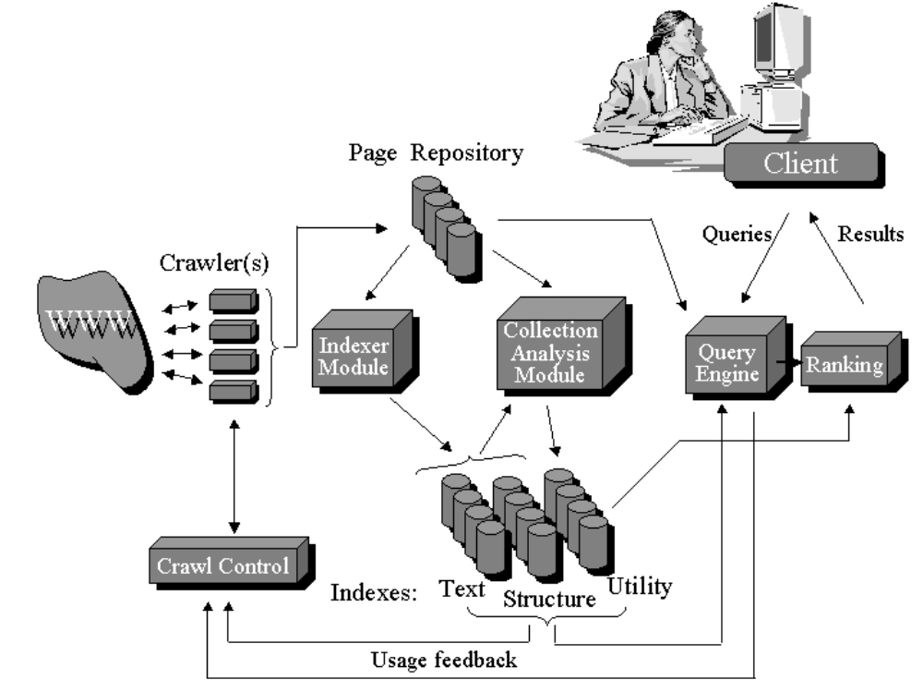
Figure 1.1 A Popular Architecture of SE

This basic algorithm is modified in many variations that give search engines different levels of coverage or topic bias. For example, crawlers in one engine might be biased to visit as many sites as possible, leaving out the pages that are buried deeply within each site. The crawlers in other engines might specialize on sites in one specific domain, such as governmental pages. The crawl control module is responsible for directing the crawling operation^{[2]}.
Once the search engine has been through at least one complete crawling cycle, the crawl control module may be informed by several indexes that were created during the earlier crawl. The crawl control module may, for example, use a previous crawl’s link graph (the structure index in figure 1.1) to decide which links the crawlers should explore and which links they should ignore. Crawl control may also use feedback from usage patterns to guide the crawling process (connection between the query engine and the crawl control module in figure 1.1)^{[3]}.
The indexer module extracts all the words from each page and records the URL where each word occurred^{[4]}. The result is a generally very large “lookup table” that can provide all the URLs that point to pages where a given word occurs (the text index in figure 1.1). The table is of course limited to the pages that were covered in the crawling process. As mentioned earlier, text indexing of the Web poses special difficulties, due to its size and its rapid rate of change. In addition to these quantitative challenges, the Web calls for some special, less common, kinds of indexes. For example, the indexing module may also create a structure index, which reflects the links between pages. Such indexes would not be appropriate for traditional text collections that do not contain links. The collection analysis module is responsible for creating a variety of other indexes.
The query engine module is responsible for receiving and filling search requests from users. The engine relies heavily on the indexes, and sometimes on the page repository. Due to the Web’s size and the fact that users typically only enter one or two keywords, result sets are usually very large. Hence the ranking module has the task of sorting the results such that results near the top are the most likely to be what the user is looking for. The query module is of special interest because traditional IR techniques have run into selectivity problems when applied without modification to Web searching: Most traditional techniques rely on measuring the similarity of query texts with texts in a collection’s documents. The tiny queries over vast collections those are typical for SEs prevent such similarity-based approaches from filtering sufficient numbers of irrelevant pages out of search results. When deployed in conjunction with the traditional IR techniques, these algorithms significantly improve retrieval precision in web search scenarios.

1.2.2 About the State-of-the Art Technology in IR and SE
As shown in 1.2.1, the crawler takes charge of downloading the web pages from the internet. After that the data of web page must be saved in the local host in some format as a web page library. Then a sequential work of analyzing the pages can be performed based on it. Because of the unpredictable internet condition, some of the web page information may be incomplete, or even damaged. So if one block is influenced because of the damages of other blocks, we can’t read many data. So we must choose a robust and relatively independent format. In this system, we use Tianwang format.
SEs are tools for finding the documents in a collection that are good matches to user queries. Typical kinds of document collection include web pages, newspaper articles, academic publications, company reports, research grant applications, manual pages, encyclopedias, parliamentary proceedings, bibliographies, historical records, electronic mail, and court transcripts.
Another issue is the parsing method used to extract terms from text. For example, when HTML documents are being indexed, should the markup tags be indexed? Or terms within tags? And should hyphenated terms be considered as one word or two? An even more elementary issue is whether to stem and case fold, that is, remove variant endings from words, and convert to lowercase. Choice of parsing technique has little impact, however, on indexing. On the other hand, the issue of stopping does affect the cost of indexing and removal of common words or function words such as the and furthermore can have a significant effect. Confusingly, in some information retrieval literature, the task of parsing is known as index term extraction or simply indexing. In this article, indexing is the task of constructing an index.

1.3 Main Works

1.4 Content Organization
A whole SE is a very large system. It consists of three main subsystems: crawler subsystem, index subsystem and query subsystem. In this article, we can’t cover all these three topics because of the limits of the time and knowledge. So we focus mainly on the index subsystem. In the rest of this article, we introduce the architecture, data structures and detailed algorithms. The subsystem is designed based on a stable, robust data set called Tiangwang^{[1]} web page library which is written in Tianwang format. I build up forward index and then reorganize the forward index into inverted index. At last, a simple inquire module based upon the inverted index is provided.
This is how this article is organized. Chapter 2 presents a brief introduction to architecture of a simple search engine which this article wants to implement. It is based on the popular architecture, but it is simplified in order to facilitating the implementation. Chapter 3 is the system analysis of the index subsystem we want to implement. The detailed design of each module in the index subsystem is presented in section 4. In Chapter 5, the implementation detail is introduced. And at last in Chapter 6 we draw the conclusion and directions for the future work.

Chapter 2 Background
In Chapter 1 some popular technology are introduced. But some of them are hard to implement. For this reason, a smaller, simplified SE system is introduced in this chapter.

2.1 Architecture Platform
This section will present the existing related work of how to organize the entire SE system.

1.2.1 About the Popular Architecture
Many of the search engines use well-known information retrieval (IR) algorithms and techniques. However, IR algorithms were developed for relatively small and coherent collections such as newspaper articles or book catalogs in a (physical) library. The Web, on the other hand, is massive, much less coherent, changes more rapidly, and is spread over geographically distributed computers. This requires new techniques, or extensions to the old ones, to deal with gathering information, making index structures scalable and efficiently updateable, and improving the ability of search engines to discriminate. For the last item, the ability to discriminate, it is possible to exploit the linkage among web pages to better identify the truly relevant pages.
Before we describe search engine techniques, it is useful to understand how a SE is typically put together. Figure 1.1 shows such an engine schematically. Every engine relies on a crawler module to provide the grist for its operation (shown on the left in figure 1.1). Crawlers are small programs that browse the Web on the search engine’s behalf, similarly to how a human user follows links to reach different pages. The programs are given a starting set of URLs whose pages they retrieve from the Web. The crawlers extract URLs appearing in the retrieved pages and give this information to the crawler control module. This module determines what links to visit next and feeds the links to visit back to the crawlers. (Some of the functionality of the crawler control module may be implemented by the crawlers themselves.) The crawlers also pass the retrieved pages into a page repository. Crawlers continue visiting the Web until local resources, such as storage, are exhausted.

Figure 1.2 A Popular Architecture of SE

This basic algorithm is modified in many variations that give search engines different levels of coverage or topic bias. For example, crawlers in one engine might be biased to visit as many sites as possible, leaving out the pages that are buried deeply within each site. The crawlers in other engines might specialize on sites in one specific domain, such as governmental pages. The crawl control module is responsible for directing the crawling operation^{[2]}.
Once the search engine has been through at least one complete crawling cycle, the crawl control module may be informed by several indexes that were created during the earlier crawl. The crawl control module may, for example, use a previous crawl’s link graph (the structure index in figure 1.1) to decide which links the crawlers should explore and which links they should ignore. Crawl control may also use feedback from usage patterns to guide the crawling process (connection between the query engine and the crawl control module in figure 1.1)^{[3]}.
The indexer module extracts all the words from each page and records the URL where each word occurred^{[4]}. The result is a generally very large “lookup table” that can provide all the URLs that point to pages where a given word occurs (the text index in figure 1.1). The table is of course limited to the pages that were covered in the crawling process. As mentioned earlier, text indexing of the Web poses special difficulties, due to its size and its rapid rate of change. In addition to these quantitative challenges, the Web calls for some special, less common, kinds of indexes. For example, the indexing module may also create a structure index, which reflects the links between pages. Such indexes would not be appropriate for traditional text collections that do not contain links. The collection analysis module is responsible for creating a variety of other indexes.
The query engine module is responsible for receiving and filling search requests from users. The engine relies heavily on the indexes, and sometimes on the page repository. Due to the Web’s size and the fact that users typically only enter one or two keywords, result sets are usually very large. Hence the ranking module has the task of sorting the results such that results near the top are the most likely to be what the user is looking for. The query module is of special interest because traditional IR techniques have run into selectivity problems when applied without modification to Web searching: Most traditional techniques rely on measuring the similarity of query texts with texts in a collection’s documents. The tiny queries over vast collections those are typical for SEs prevent such similarity-based approaches from filtering sufficient numbers of irrelevant pages out of search results. When deployed in conjunction with the traditional IR techniques, these algorithms significantly improve retrieval precision in web search scenarios.

1.2.2 About the State-of-the Art Technology in IR and SE
As shown in 1.2.1, the crawler takes charge of downloading the web pages from the internet. After that the data of web page must be saved in the local host in some format as a web page library. Then a sequential work of analyzing the pages can be performed based on it. Because of the unpredictable internet condition, some of the web page information may be incomplete, or even damaged. So if one block is influenced because of the damages of other blocks, we can’t read many data. So we must choose a robust and relatively independent format. In this system, we use Tianwang format.
SEs are tools for finding the documents in a collection that are good matches to user queries. Typical kinds of document collection include web pages, newspaper articles, academic publications, company reports, research grant applications, manual pages, encyclopedias, parliamentary proceedings, bibliographies, historical records, electronic mail, and court transcripts.
Another issue is the parsing method used to extract terms from text. For example, when HTML documents are being indexed, should the markup tags be indexed? Or terms within tags? And should hyphenated terms be considered as one word or two? An even more elementary issue is whether to stem and case fold, that is, remove variant endings from words, and convert to lowercase. Choice of parsing technique has little impact, however, on indexing. On the other hand, the issue of stopping does affect the cost of indexing and removal of common words or function words such as the and furthermore can have a significant effect. Confusingly, in some information retrieval literature, the task of parsing is known as index term extraction or simply indexing. In this article, indexing is the task of constructing an index.
A modern SE consists of three main subsystems: information collecting subsystem (crawling or spider), index subsystem and query subsystem. Note that, usually these three parts is independent relatively and their work of these three subsystems consist of the workflow of the whole SE. They are started-up manually. In the following part, we introduce these subsystems and how do they work together respectively.
A SE can receive a valid retrieve from the user through the browser, retrieve from a web page library and return a list of relative page information in acceptable time, see figure 2.1. Here the page information includes title, link, digest and so on. Note there must be a proper order of the pages because users can’t click every links to see if it is useful. So the most “important” page should be listed firstly. This rank method is the most important measure of the SE’s performance. A lot rank method is explored such as the famous Google PageRank algorithms^{[2]}.
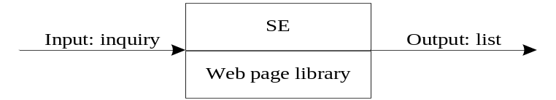
Figure 2.3 Search Engine Work Sketch
A modern SE with high quality usually uses three-stage workflow as figure 2.2, namely, collecting, indexing and query.
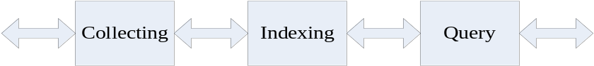
Figure 2.4 Three-stage Workflow Model
Collecting subsystem is also called crawler or spider. Its function is collecting the information of the web pages on the World Wide Web. The spider works as follow: first it sends requests to servers of the web sites; if the requests are accepted, it then downloads the web pages and stores them on the local host according to some format which is defined ahead of time. The point is that there are innumerable pages on the web. During the 10 years from 1994 to 2004, more than 4 billion web pages (According to the statistic of Google in 2004)! So it’s impossible to download every page and we need some strategy to follow so that we can get more useful information in bearable time.
Index subsystem is the main topic of this article. Generally speaking, its main function is builds up index for the pages downloaded by the spider. Specifically speaking, it first filters out the labels in a page to get the content of the text. Then it analyzes the content of the text and gets a list of key words to represent this page. At last it uses some data structure to store these key words for the work that follows. This data structure is important. A well-designed index structure can provide good performance to the query subsystem. The details of how to design and implement this efficient index will be presented in the rest of this article
Query subsystem is designed as a user interface. It’s usually presented as a web page which can be viewed in browsers. It gets the users’ retrieve, parses it into key words and retrieves these words according to the indexes to get a list of information of relative pages. Then it sorts these pages information according to their importance and returns the result to the users.

UAAACS

cfWeb

ESB

Symphony

2.2 Platform Target
In this section, a popular architecture of the whole SE will be introduced in order to show how the three subsystems work together, see figure 2.3 respectively. In this figure, the collector and controller belong to collecting subsystem, the indexer and analyzer belong to the index subsystem, the retriever and user interface belong to the query subsystem. The databases are shared by one or more subsystems.
The three main modules are collector indexer and retriever. As introduced in section 2.1, the three main modules play important role in the whole system^{[5]}. Besides, there is another module called controller. It works between the collector and the original web page library. Its main function is: control the collector and tell the collector when an how to collect the web pages, namely, the collecting strategy. Generally speaking, we need to collect the web pages parallel on many different computers. So the controller should schedule the collecting progress and make a decision that which pages should be downloaded and which shouldn’t.
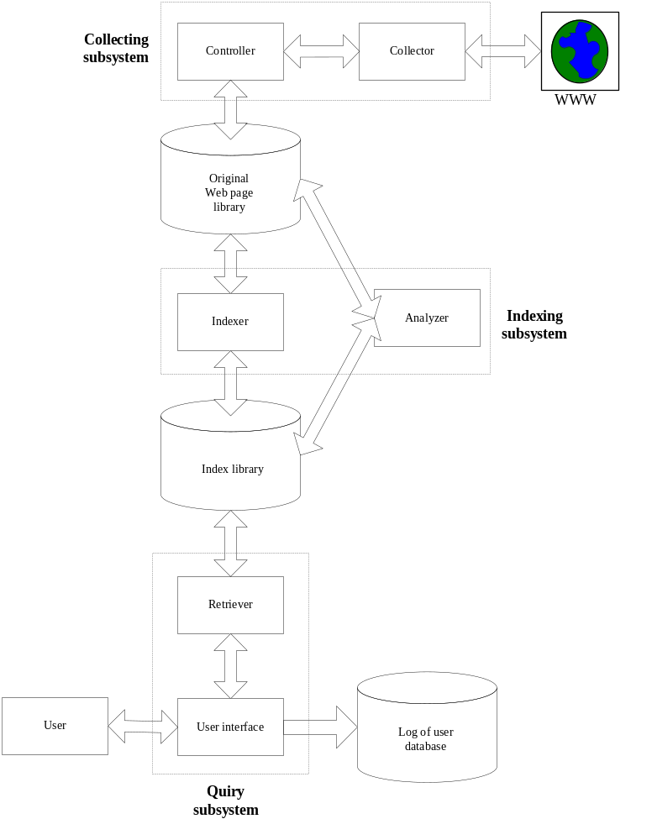Figure 2.5 Modules of This SE
As we mentioned, a whole SE is a very large system. A modern SE consists of three main subsystems: information collecting subsystem (crawling or spider), index subsystem and query subsystem. Note that, usually these three parts is independent relatively and their work of these three subsystems consist of the workflow of the whole SE. They are started-up manually. In the following part, we introduce these subsystems and how do they work together respectively.
To implement such a large system, we need a lot of work and perfect internet condition. But time and energy is limited, so in the rest of this article we focus on one of the three subsystem: index subsystem.

2.3 General Platform Requirements

Chapter 3 System Analysis
In this chapter, we introduce the functional and non-functional analyze of the index subsystem. The index subsystem is a inner system. It isn’t user oriented. So there is no user case in the index subsystem. So we can’t analyze the system form the requirement of the users. We will present the analysis from the functional and non-functional aspects. At last the development environment will be presented.

3.1 Architecture Summarize

3.1.1 Function Architecture
The main target is: implementing an index subsystem that can analyze the Chinese web pages or process the Chinese characters in web pages; building up the index that can provide efficient retrieve function; provide a simple query function. See figure 3.1.
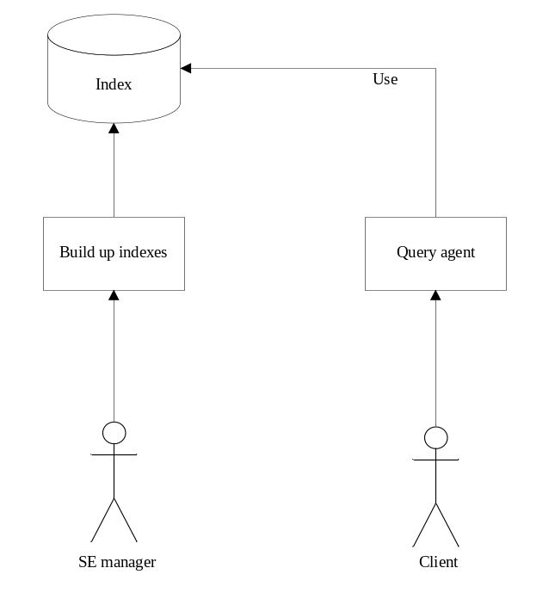
Figure 3.6 Functional Architecture

3.1.2 Description of Module Function
- Original web page library: a file that stores the original pages downloaded by crawler. In this system the pages are stored in a stable and robust format called Tianwang format. Is a 346 MB large file. But the original page library which is used by a practical SE is even much larger, 40GB or more maybe.
- Get location information of page: the original web page is very huge, if a certain page, say, the 100th page is need, we should find it quickly. Obviously, we can’t go through the entire library to check if the current page is the 100th, so we need to make an index to record the location information of every page. The information should include the offset of a page, length of this page and so on. This information is recorded in a index file called web page index .
- Build up forward index: this module first gets the location information of every page and locates the page in the original library quickly; then filters out the content of Chinese characters and analyzes them to get key words (Chinese characters).
- Build up inverted index: in this module the forward index is reorganized in order that if given a key word we can quickly find it appears in which web page.

统一认证

用户管理

3.2 Non-functional Requirements
(1) Feasibility analyze
The technology in the SE area is mature to some extent, including the architecture and the detailed data structure and the algorithms. In this system, we need to design a series of data structures and algorithms based upon them. So the task can be completed under current condition. As estimated, the code length should be controlled below 2000 lines. Anyway, the system is feasible.
(2) Performance
From the point of the users’ view, the browser of a SE should response his/her retrieve as soon as possible. Besides, the SE should provide function of parallel retrieves to deal with the mass huge internet requests.
As to the index subsystem, in should provide all needed kinds of indexes for the query subsystem. The query subsystem should quickly get the related pages and the positions of each item. Then it can return the query results using the dynamic web page creation algorithms.
Anyway, the speed of the system is the most important performance factor. We should take some strategy to get a higher speed.

3.3 Development Environment
Hardware condition:
- 40GB hard disk
- 1GB RAM
- Intel Pentium M730 1.6G Hz
Operating system:
- Microsoft Windows XP
IDE:
- Visio studio 2008

Chapter 4 System Design

4.1 Preliminary Design
According to the system analysis, the three modules in the system are: page index module, forward index module and inverted index module. These three parts are independent and sequential. The latter module uses the output of the former. So the design of three modules will be introduced respectively.

4.1.1 The Architecture and Module
After the information collection of the web page, the saved web page information is recorded as Tianwang format and saved in sequence. Next we need to pre-process the data. This kind of format is robust, one block of data is won’t be influenced because of the damage of the other blocks. So the damage is always local. But every coin has two sides; the shortcoming is we can’t get the respective page given the id or URL of a certain page because its position in the library is unknown. So the first step of the pre-process is to build up the page index for the original web page. Then with respect to the page library, the system converts each page to a set of word. At last the system converts the mapping from page to items to the mapping from items to the page, which forms the inverted index. The functional partition is shown in figure 4.1 and 4.2.
Note that in figure 4.1, arrows indicate the directions of the data flow:
Step 1: Original web page data from original web page library to location module.
Step 2: Output data of location module to form web page index.
Step 3(a): Forward index module read web page location information from web page index.
Step 3(b): Forward index module gets page from original library according to the location information got from 3(a)
Step 4: Output of forward index module.
Step 5: Inverted index module read forward index and build up inverted index
Step 6: Output of inverted index module.
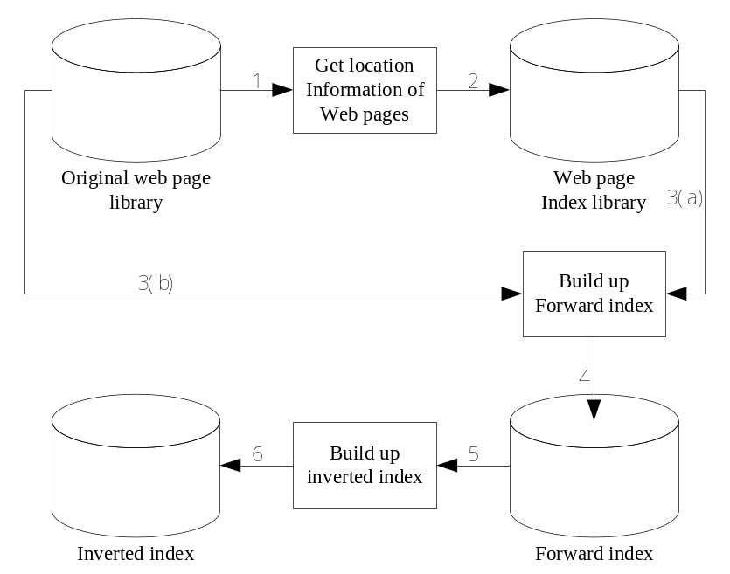
Figure 4.7 Module Function and Direction of Data Flow

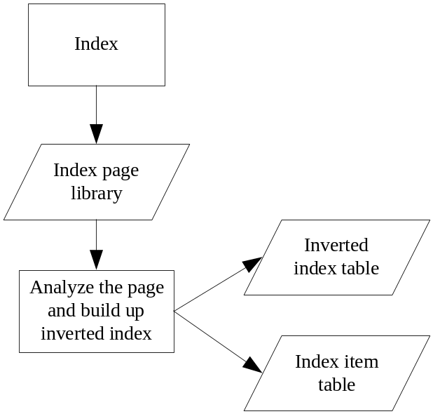
Figure 4.8 The Functional Partition

4.1.2 The Storage of Index
We use file to store and manage all the data of index, not the database. There are two main reasons for this: first, it needs good performance, but the operation of database wastes a lot of time. Second, the function of the system is to process and manage the data. It’s a main requirement of the system so we can’t use other tool to process and manage the data.
Form the next section, we begin to introduce the design of every indexes respectively.

4.1.3 Page Index
The function of this module is recording the offset and length of each page in the original page library into the web page index library so that we can quickly get the original page if given the id of this page.
The web pages are stored in the Tianwang format. This is a stable and robust format^{[6]}. Even if some part of one page is damaged, other pages won’t be influenced. A record in Tianwang format includes two parts: head and web page content. The detailed format is shown in the table 4.1. Line 1 to 8 is the head of record and the page content is from the 9th line to the end of each page.

Table 0.1 Tianwang Format
Line | Format meaning | Requisite? | Example
1 | format version | Y | version: 1.0
2 | url | N | url: http://www.tsinghua.edu.cn
3 | father link | N | origin: http://www.baidu.com
4 | Date information | N | data: Tue, 15 Apr 2004 08:13:06 GMT
5 | ip | N | ip:162.159.12.29
6 | unzip-length | N | unzip-length: 30233
7 | length | Y | length: 18133
8 | blank line | Y
9…n | web page content | N

We need to locate each page according to this information. We need an entity class to describe the location information and a control class to control the loop to process every page in the original page library as shown in figure 4.3.
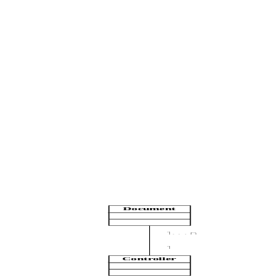
Figure 4.3 Class Graph of Web Page Index Module

4.1.4 Forward Index
In this module we use a control class to get the location of every page and locate the page in the original page library. Then analyze the web page and get the key words of the page. The classes of this module are shown in figure 4.4.
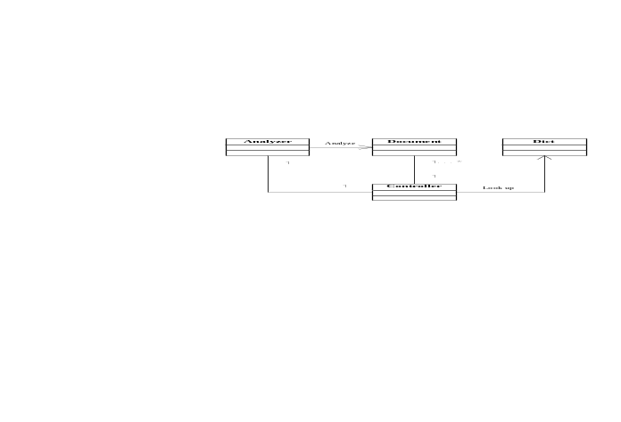
Figure 4.4 Class Graph of Forward Index Module

4.1.5 Inverted Index
The forward index which is the output of the forward index module is the input of this module. A controller class is used to read the forward index and an InvertIdx is used to model the inverted index. Another class InvertIdxItem is used to model each inverted index of web page. The classes are shown in figure 4.5.

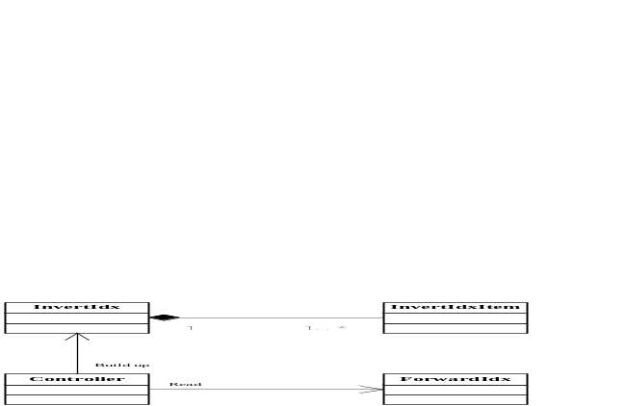
Figure 4.5 Class Graph of Inverted Index Module

4.1.6 Query Module
The query module is the downmost part in figure 2.3. It’s a user-oriented module. The former module – index module has pre-process the data of web pages and pass the data of web page index and the inverted index to this module.
In this module, a query agent accepts the requests from the users and segments it. After that, it retrieves the index to find out the information about all the related documents and sort them according to some score principle. At last, it returns the quest result to the users.

4.2 Detailed Design

4.2.1 Data Structure Design
There are four indexes: web page index, URL index, forward index and inverted index, see figure 4.6, 4.7, 4.8 and 4.9 respectively.
Page index is the first index. As we know, the original web page library is very large. If we want to get a certain page in the library, one simple but stupid method is to traverse the whole library to check whether the current page is the needed one. But it is terrible if the library is huge. The solution is to record the position of every page in the page index so that we can get the page directly if given the page id.
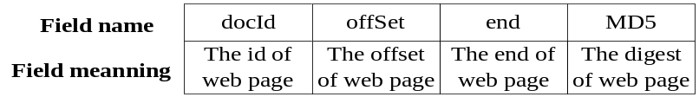
Figure 4.6 Data Structure of Web Page Index

The URL index is attached to the page index, if given URL, not page id, we can get the page id according to this index and then use the page index.

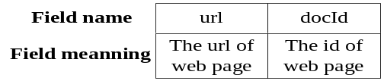
Figure 4.7 Data Structure of URL Index

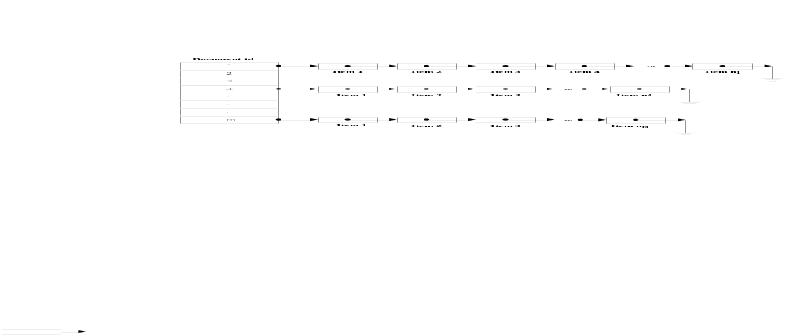Figure 4.8 Data Structure of Forward Index
A forward index records a mapping from a document id to the related items. So if we get the forward index, we can quickly get which key words a document includes. And combined with the web page index, the system can locate the index items of every document.
The forward index is the third index of the system. It is a kind of inner data, if no interface is provided this kind of index is hard to be used by others. It is not a kind of data production and can’t be used by other programs either
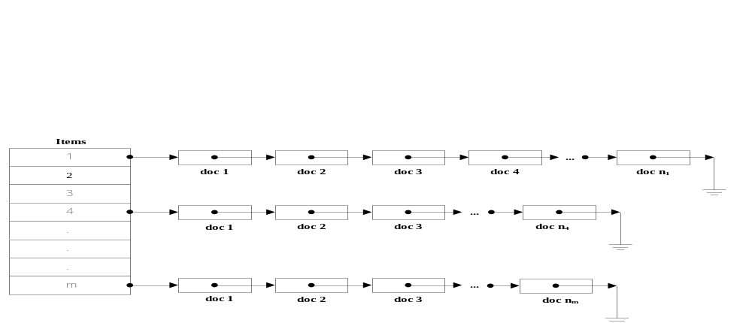Figure 4.9 Data Structure of Inverted Index

An inverted index is a kind of reorganization of the forward index. It tells which document a certain key word exists in. It’s simple in the theory, but its performance is good. In section 6.3 a model of the performance of the inverted index will be introduced in detail.

4.2.2 Algorithms Design
(1) The tags-filtering algorithms
We use finite automata to simulate the filtering progress, see figure 4.10.

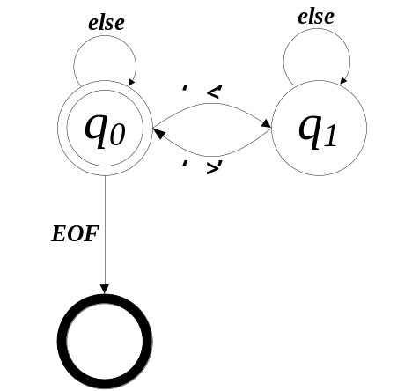
Figure 4.10 Automata of Tags-filter

(2) Chinese segmentation algorithms
Segmentation is the precondition of the whole analyze of the web pages. In a SE, a document consists of many items. The analysis of the web pages is defined as the progress of decomposing a document into items of characters.
As to the decomposing of a document, the Chinese and English page is different. There are natural separators - blanks between every two words but no such separators in Chinese. Chinese sentences are written in single Chinese characters in sequence. So before analyzing the whole sentences, the sentence must be decomposed into smaller unit called word items. This progress is called Chinese segmentation.
We use the forward-maximum-decrease algorithms^{[7]}. Forward means that the algorithms scan the sentence from the beginning to the end. Maximum means that it matches the word as long as possible. Decrease means that it tries the longer words before the shorter ones.
Input: the longest word L, the sentence to be segmented S, the dictionary D.
Output: a list of words L which is from S.
Description of pseudocode:
string Segment(string S, int L)
- string Seg=W=NULL
- while (S!=NULL) // S is not empty
- W= S.substr(0, L) // get the first L characters
- while(length(W)>1) // if W is not a single character
- if(!isWord(W)) // if W is not a word in D
- W.removeRight(1) // remove the right most character
- Seg+=W+”/t” // append W to Seg added a token
- S=S-W // update the sentence S
- return Seg // return the segmentation
(3) Query algorithms
The query function in this system is simple and used for demo and test. It’s far from the real query subsystem. Here we can reuse the segmentation algorithms to analyze the query of user.
Input: query sentence S.
Output: related page set R.
Description of pseudocode:
pageSet query(string S)
- pageSet R.empty(), weightCounter A = 0
- cut S into word items set q={q₁, q₂, q₃,…, q_{n}}
- for each q_{i} in q
- read the inverted list of q_{i}
- merge the inverted list of q_{i} and R
- update the weight of related pages
- sort and return R
Another important part in the query module is how the related documents are returned to the users. The order of the returned web page set is a key factor for the users. In practice, the users won’t go through all the returned related web links to see if they are interested in them. According to the statistical result, the average numbers of links the users are willing to check is only 2! So, most of the results are useless. For this reason, we must return the important documents first. So, before returning the results of query, we should sort them according to their importance.

Chapter 5 System Implementation

5.1 IDE Configuration
The integrated development environment is Microsoft Visual Studio 2008. The options of configuration are: “/Od /D "WIN32" /D "_DEBUG" /D "_CONSOLE" /D "_UNICODE" /D "UNICODE" /Gm /EHsc /RTC1 /MDd /Fo"Debug\\" /Fd"Debug\vc90.pdb" /W3 /nologo /c /ZI /TP /errorReport:prompt”. The concrete meanings are shown in table 5.1.
Table 5.2 Configuration and Meaning
Configuration | Meaning
/Od | option for code optimization (d-disabled)
/D[macro] | choose one or more preprocessor defines
/Gm | enable minimal rebuild
/EHsc | enable C++ exceptions
/MDd | runtime library: Multi-thread Debug dll
/RTC1 | basic runtime error checks
/Fo[name] | specifies a name to override the default object file name
/Fd[name] | specifies a name for a compiler-generated PDB file and IDB file
/nologo | suppress the display of the startup banner and information messages
/ZI | do not include the default library name in obj files
/TP | compile as .c(/TC) or .cpp(/TP)
/errorReport:prompt | define how internal tool errors should be report back to M.S.

5.2 Core Code and Important Flow
This section is mainly focus on some most important parts of code and how do they work. We use C++ STL to implement most of the complicated data structures to get a higher performance and a stable function.

5.2.1 Dictionary
Dictionary is used in this system as a analyze tool. Dictionary is used for segmentation to check if a word in a sentence is a word item that can be cut off. There are two common way to realize a dictionary: binary tree and hash table. In this system we use the hash table.
Hash table is an efficient data structure to implement a dictionary. It is a dynamic ser that supports only the dictionary operations insert, search and delete. Although searching for an element in a hash table can take as long as searching for an element in a link list – O(n) time in the worst case, but in practice, hashing performs extremely well. Under some reasonable assumptions, the expected time to search for an element in a hash table is O(1).
Here the first number is the id of word, then a blank, then a Chinese word, then a blank again, then the frequency of this word in the corpus, then a carriage return. So the system first uses fcsanf to read a line in the dictionary file, then inserts it into the variable dict which is a hash table.
…
34 阿 257
35 阿巴丹 1
36 阿巴岛 1
37 阿巴鸟 8
38 阿巴伊达 1
39 阿坝 2
40 阿爸 12
41 阿北乡 1
…
To implement a hash table we can use the STL hash_map template class. The template class describes an object that controls a varying-length sequence of elements that has bidirectional access. This system uses the container hash_map to manage a sequence of elements as a hash table, each table entry storing a bidirectional linked list of nodes, and each node storing one element. An element consists of a key, for ordering the sequence, and a mapped value, which goes along for the ride. The object allocates and frees storage for the sequence it controls as individual nodes in a bidirectional linked list. To speed access, the object also maintains a varying-length array of pointers into the list (the hash table), effectively managing the whole list as a sequence of sublists, or buckets. It inserts elements into a bucket that it keeps ordered by altering the links between nodes, never by copying the contents of one node to another. That means it can insert and remove elements freely without disturbing remaining elements. The object orders each bucket it controls by calling a stored delegate object of type hash_set::key_compare.
In the following piece of code, a flow of loading the dictionary is presented. The dictionary is recorded in a file. The format of the dictionary is like this:
while(fscanf(fp, "%d %s %d\n", &id, buf, &fre) != EOF)
{
string word(buf);
dict.insert(item(word, fre));
}
One can specify the stored delegate object when you construct the hash_set; if specifing no delegate object, the default is the comparison operator <= (key_type, key_type). You access the stored delegate object by calling the member function (). Such a delegate object must define equivalent ordering between keys of type hash_set::key_type. That means, for any two keys X and Y: key_comp()(X, Y) returns the same Boolean result on every call. If key_comp() (X, Y) && key_comp() (Y, X) is true, then X and Y are said to have equivalent ordering. Any ordering rule that behaves like operator <= (key_type, key_type), operator >= (key_type, key_type) or operator == (key_type, key_type) defines equivalent ordering. Note that the container ensures only that elements whose keys have equivalent ordering (and which hash to the same integer value) are adjacent within a bucket. Unlike template class hash_multimap, an object of template class hash_map ensures that keys for all elements are unique. (No two keys have equivalent ordering). The object determines which bucket should contain a given ordering key by calling a stored delegate object of type hash_set::hasher. One can access this stored object by calling the member function hash_set::hash_delegate() to obtain an integer value that depends on the key value. You can specify the stored delegate object when you construct the hash_set; if you specify no delegate object, the default is the function hash_value(key_type). That means, for any keys X and Y: hash_delegate() (X) returns the same integer result on every call. If X and Y have equivalent ordering, then hash_delegate() (X) should return the same integer result as hash_delegate() (Y). Each element contains a separate key and a mapped value.
The sequence is represented in a way that permits lookup, insertion, and removal of an arbitrary element with a number of operations that is independent of the number of elements in the sequence (constant time) -- at least in the best of cases. Moreover, inserting an element invalidates no iterators, and removing an element invalidates only those iterators which point at the removed element. If hashed values are not uniformly distributed, however, a hash table can degenerate. In the extreme - for a hash function that always returns the same value -- lookup, insertion, and removal are proportional to the number of elements in the sequence (linear time). The container endeavors to choose a reasonable hash function, mean bucket size, and hash-table size (total number of buckets), but you can override any or all of these choices. See, for example, the functions hash_set::max_load_factor and hash_set::rehash. A hash_map supports bidirectional iterators, which means you can step to adjacent elements given an iterator that designates an element in the controlled sequence. A special head node corresponds to the iterator returned by hash_map::end(). One can decrement this iterator to reach the last element in the controlled sequence, if present. You can increment a hash_map iterator to reach the head node, and it will then compare equal to end(). But you cannot dereference the iterator returned by end().The code for loading the dictionary is as follows. We use a while loop to read from the dictionary file, and invoke the function insert to insert it into a hash table. The hash table here is dict.

5.2.2 Segmentation
As introduced in 4.2.2, the segmentation algorithms based on key word matching can be classified as follows. According to the scan direction: forward matching and inverted matching. According to the matching length: maximum matching and minimum matching.
According to the statistic results, the accuracy of inverted matching is higher than the forward matching. Because the Chinese consists of single Chinese characters, the minimum matching is seldom used. So the inverted-scanning maximum matching algorithms is the best choice for Chinese segmentation. We describe this algorithm in detailed in figure 5.1.
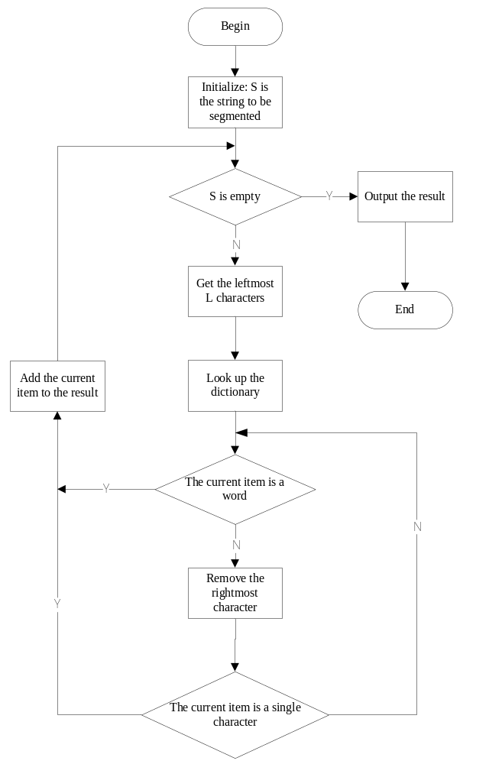
Figure 5.11 The Flow of Segmentation
We use the following piece of code to realize the segmentation algorithms. A while loop is used here to check if the sentence has been segmentation completely. Then we get the length of current item in integer len. Another while loop is used to check if current item is a single Chinese character. In this loop we loop up the dictionary by using the member function isWord of class dict. At last, the current item is added to the result if it is a single or a word in the dictionary. The detailed piece of code is listed as follows.
while (pos < CHNsentence.size())
{
len=MAX_WORD_LEN>(CHNsentence.size()-pos)? (CHNsentence.size() - pos) : MAX_WORD_LEN;
isW = false;
while(len > 2)
{
word = CHNsentence.substr(pos, len);
if(dict.isWord(word))
{
segment += word + DLIM;
isW = true;
pos += len;
break;
}
len -= 2;
}
if(len == 2 && !isW)
{
segment += CHNsentence.substr(pos, 2) + DLIM;
pos += 2;
}
}

5.2.3 Tags-filter Algorithms
In section 4.2.2 we introduce the automata to simulate the tags-filter algorithms. It’s easy to convert it into C++ code. A while loop controls the pointer to the current position. If the current character is a ‘<’, which means the following part is in the HTML tags, we simply ignore it. The character ‘>’ means the end of tags.
The following piece of code implements this function. Here p is the position pointer pointing out which character the algorithms is checking. And then a switch process is used to stimulate the automata choice. Tag is a flag of HTML tags. If tag is true, it means that the status in current position is in an HTML tag; if tag is true, then the status in current position is the text of HTML, the this current character is simply put into the filtered string. After all the character are checked, the filtered string is returned.
while(p < size)
{
switch(content[p])
{
case '<':
if(!tag) tag = true;
filtedContent += ' ';
break;
case'>':
if(tag) tag = false;
break;
default:
if(!tag)
{
if(content[p] == 10)
{
filtedContent += "\n";
break;
}
filtedContent += content[p];
}
break;
}
p++;
}

5.2.4 The Query Module
The whole query subsystem is very complicated. We only provide a very simple one to show how to use the indexes.
First we read the indexes into the memory. The index in this system is not so large. We can put all of them into memory. If the original web page library is too large to be read into memory, we can divide it into many blocks. If one of these blocks is needed, read it into memory while the others stay in the hard disk. The code loading the index is shown as follow. Here dcoIndex is a vector of C++ STL.

while(ifs >> docId >> offset >> end >> digest)
{
position pos;
pos.offset = offset;
pos.end = end;
docIndex.push_back(pos);
}

Here the union-find set is used. Union-find set is a framework for fast union-find data structures, where two union-find set instances can be merged into a single equivalence class and the canonical equivalence class representative can be determined from any member (find-set), in near-linear time. The parameter refers to the specific subclass of union-find set being manipulated, so that e.g. find-set on a specific subclass returns the same kind of specific subclass rather than a generic union-find set. When two union-find sets are merged, the helper function merge-set is called with the chosen representative as the first argument and the other representative as the other argument.
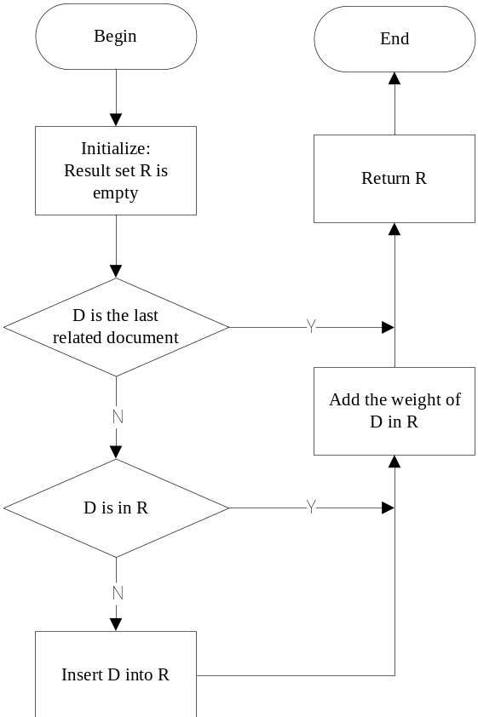
Figure 5.12 The Flow of Query

for(docItr = idxItr->second.begin();
docItr != idxItr->second.end();
docItr ++)
{
if(exist[docItr->docNum])
{
score[docItr->docNum] += docItr->fre*(-weight)* (int)(word.size()/2);
continue;
}
else
{
exist[docItr->docNum] = true;
record.push_back(docItr->docNum);
score[docItr->docNum] += docItr->fre * weight * (int)(word.size() / 2);
}
}

In the above piece of code is the implementation of the query module. A for loop is used here to find the related documents. If the current document already exists in the result set, we simply add its weight. Else it will first be inserted into the set and give it a initial score.

Chapter 6 Test and Performance Estimate
In a SE, the good performance is very important. The performance is mostly shown in the query speed. The function of the index is to provide an efficient So we design some different kind of testing data to check the performance of the index subsystem. After that, we introduce a model of the performance.

6.1 Overall Analyze
The Visual Studio 2008 provides a strong function of evaluating the performance of the system built upon it. We can use it to get an overall condition of the program. It helps us find the technique bottleneck. See in figure 6.1.
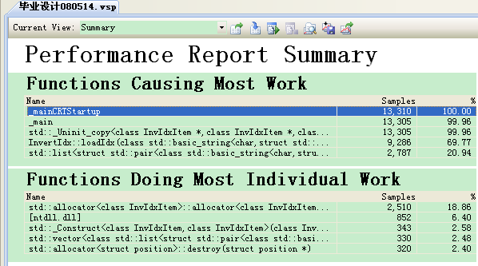
Figure 6.13 The Results of Visual Studio Performance Analysis
According to figure 6.1, we know that the function loadIdx does the most work. As to individual work, the constructor and destructor of invIdx do the most work. From the analyses above, we get to know that the performance of inverted index is very important to the whole system. So we can improve the performance of this function to improve the performance of the whole system.

6.2 Test
We launch the query module and input some random queries. The system must load the dictionary indexes into the memory first. After the preparations are done, the system output a hint line and wait for the input, see figure 6.2.

Figure 6.2 The System Begin to Wait for Input
The test results are returned as the following format: first output the hints – “Inquiry result:/n”. Then output in which document(s) the items are found and the position information of these files. At last, statistic the total counts – “Total: found in how many document(s)”. They are shown in figure 6.3, figure 6.4, figure 6.5 and figure 6.6.
Test case 1: Seldom used single word
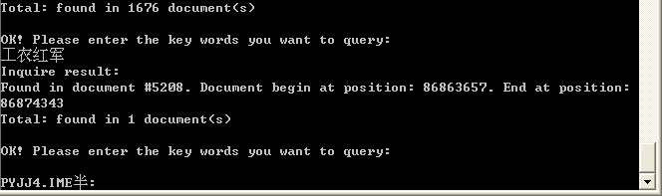
Figure 6.3 Test Case 1and Result
In this test case, the seldom used single words are tested, in order to check the accuracy of the system, if seldom used words can’t be found, it means the system miss some documents.
Test case 2: General single word
This is a random test case, testing the random query data and the performance of the random query.
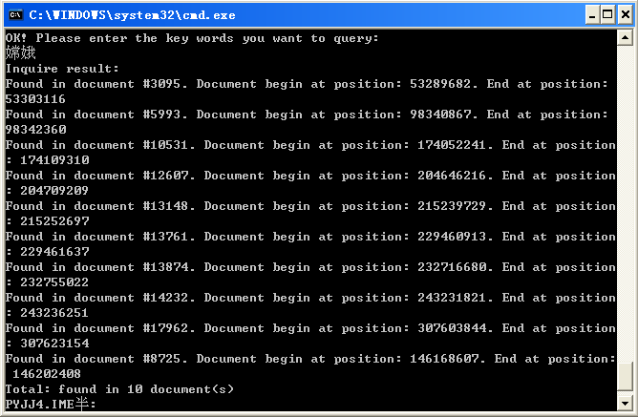
Figure 6.4 Test Case 2 and Result
Test case 3: English words only
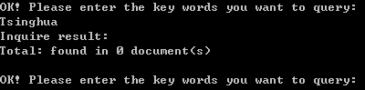
Figure 6.5 Test Case 3 (English Words Only) and Result
This test case is a invalid test case for the Chinese search engine because they can’t analyze the English sentences by English segmentation. But that work is easy compared with Chinese segmentation. English words are separated by blanks, so segment English web page only by blanks is just all right.
Test case 4: (a query mixed with English words)
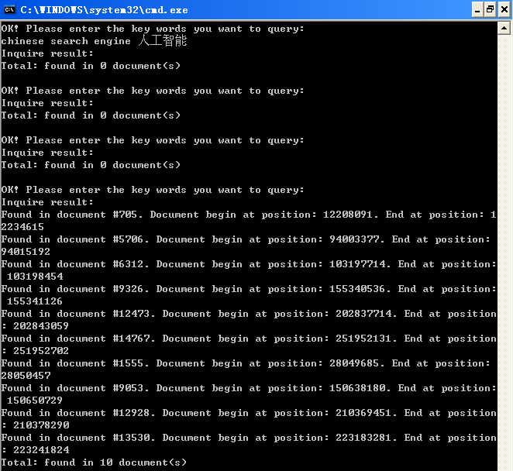
Figure 6.6 Test Case 4 (with English) and Result
This test case combines the English and Chinese in order to check the robustness of the system. The result is the system can pass this kind of test cases too.
The system passes all the tests above. The outputs of all the queries are right as expected. The respond time of each query is less than 1 second. So we draw the conclusion that the system is both reliable and efficient. In fact, we carried a lot more random tests on the system but the result set is too large to be presented here in this paper.

6.3 Modeling the Performance of the Inverted Index
Inverted index is the most important data structure in the indexing system. Also, it is the key technique of the modern search engine. Though the principle of inverted index is simple, it’s efficient and flexible. It can be modified according to the real condition to get a better performance. We study the performance of the inverted index and build up a mathematical model for it. This model provides a guiding significance while evaluating the performance of the indexing system^{[11]}. In the last section of this chapter we focus mainly on how to reason the mathematical model for the inverted index.

6.3.1 Concepts and Definitions
We need to consider two main aspects while evaluating an information retrieve system: effectiveness and efficiency. Effectiveness is the accuracy and integrality of the result set. Effectiveness has two indicators: precision ratio and recall ratio; while efficiency also has two indicators: response time and throughput. Response time is the time from when the users commit the request to when the results are returned. Throughput is the maximum retrieve times that the system can process in unit time (one second).
Inverted index file is a kind of data structure, it records the mapping between a set of terms and a set of documents. Formally, let
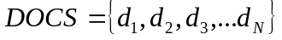,
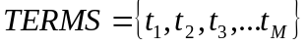,
where DOCS is the set of documents and TERMS is the set of terms. Note that a document consists of many terms, so we can simply assume that every term belongs to some document, namely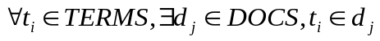. Let
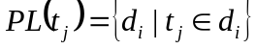,
we call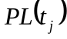 the inverted list of term t_{j}. We list all the rest notations in table 4.2.
Table 0.3 Notation
Notation/definition | Meaning
N | The size of document set
M | The size of term set
Table 0.4 Notation (continued)
Notation/definition | Meaning
s_{j} = |PL(t_{j})| | The number of documents that contain t_{j}
f_{i,j} | The times that term t_{j} appears in document d_{i}
p(i) | The statistical distributing of the length of inverted list
B | The maximum output bandwidth of system
d | The average value of the record size in the inverted list
r | Response time
k | The number of requests committed at one time
D | The data size as output caused by k requests

6.3.2 Model Assumption
The task of modeling the performance is to build up a certain relation between the variables in the system so that we can evaluate the throughput given some hardware condition. Before that we list some assumptions here.
(1) Assume that the length of the list satisfy the distributing function p(i), namely, 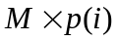is the number of inverted list with the length of i, here 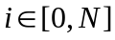. Letbe the mean length of the inverted list. So we get
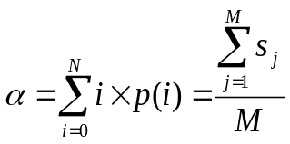 . (6.1)
(2) Assume that the requests arrive at the system is simple. We can just say that they are items come from the set TERMS and satisfy the random, independent distribution.

6.3.3 Modeling the Performance
We now consider the data size as output caused by k requests D. The thought is: we first compute D, and divide it by B to get the estimate of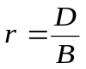.
Every request can be a random one of the M terms in the TERMS. So if k requests come together, the amount of related terms can be 1, 2, … k. Let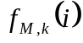be the probability that there are i related terms among the M terms caused by these k requests. The expectation of the amount of related terms caused by these k parallel requests is
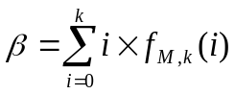. (6.2)
Then we get: D equals to average data size of single inverted list multiply the expectation of the amount of the related terms caused by the k parallel retrieve requests. According to (6.1), (6.2) that is
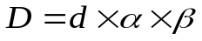
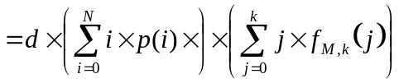. (6.3)
Let’s focus on the computing of 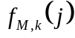 now. First for every retrieve, it can be ether of the M terms, so the total count of k choices is M^{k}. On the other hand, to assign these k retrieves to i different terms is equivalent to the i-partition of the set of {1, 2,…k}, namely, the Stirling number of the second kind S(k,i). These i terms are sequential, so the S(k,i) should be multiplied by the permutation number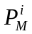. So we get:
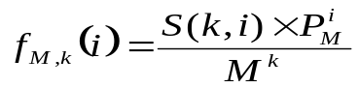, i = 1,2,…,k
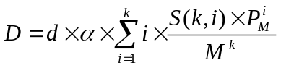 (6.4)
Note that
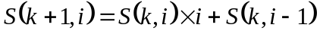, 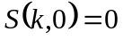, 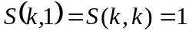. (6.5)
Besides,
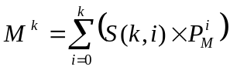. (6.6)
According to (6.4), (6.5), (6.6),
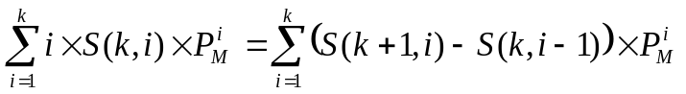
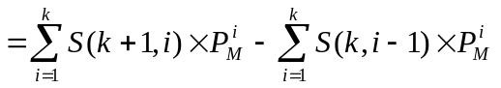
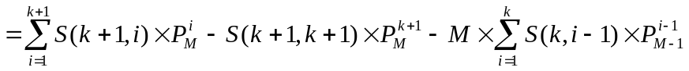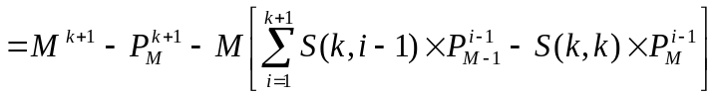
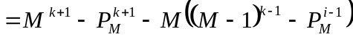
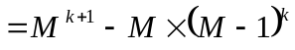
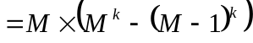.
So back to (6.4) we get,
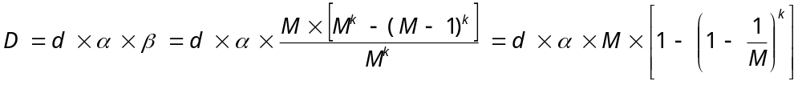. (6.7)
In this system we use Tianwang as web page library. The frequency of each word is recorded in the dictionary. According to the statistic, we get the order of magnitude of the parameters:
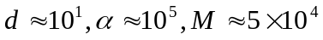,
Replace them in (6.7) we get
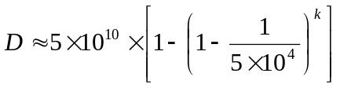 (6.8)
The meaning of (6.8) is the data need to be processed if k retrieves come together. If we can figure out the maximum output bandwidth of system B according to the concrete hardware condition, then we can estimate the response time
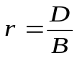. (6.9)
In this section, a mathematical model is built up to estimate the performance of inverted indexes. We study the performance of the inverted index and build up a mathematical model for it. This model provides a guiding significance while evaluating the performance of the indexing system.

Chapter 7 Conclusion
This system is a part of the study of the whole Chinese search engine. This article presents how to design and implement an index subsystem including the data structure of index and the index-building and other algorithms. The system is based on an original web page library. It builds up inverted indexes of key words for every web page in the library. These indexes can be used in the query subsystem to make the operation of query more efficient.
There are some good characteristics of this system: the author uses inverted index as index data structure, which is the most popular and widely used in modern search engine. It’s simple, easy to implement and very efficient; the author uses C++ STL a lot to ensure the performance, quality and safety of the code; the author uses flexible segmentation algorithms to analyze the web page and users’ queries, the weight of words in dictionary can be adjusted to make the segmentation suitable for the concrete circumstances and different applications.
There are also some shortcomings of the system. First, it’s all based upon library of Tianwang format, so is not expandable if the author wants to use other format. Second, all the indexes are internal data so they can’t be used in other system. Third, it’s a study project without accepting the test driven by mass-data. The whole subsystem is also internal module without user interface. So if no interfaces are provided, the whole system can’t be used as a data production.
The next step of the study can be explored from these two directions:
First, the author have put forward a solution when the indexes are too large to be read into the RAM together (in truth, it happens usually in the modern business SE), that is the author can divide the whole index into small blocks that can be put into RAM and build hierarchical indexes using B+ tree as external sorting data structure.
Second, the author can improve the data structure of index. In the resent years, the mixed index is often used. It is based on the inverted index technique. Furthermore, it scans the original library more than one time and mixes the different kinds of indexes. But it’s still a naive technique and need to be studied more.
Third, the author can use clustering algorithms of data mining to preprocess the original web page library. So when a retrieve is performed, the author can get a better accuracy according the classification result.

Reference
- 李晓明，闫宏飞，王继民．搜索引擎－原理技术与系统[M]，北京：科学出版社，2005，2-18，41-54．
- Page Lawrence, Brin Sergey, Motwani Rajeev. The PageRank Citation Ranking: Bringing Order to the Web. Stanford digital library Technologies Project [J]. 1998, 11: 17
- A.Rungsawang, N.Angkawattanawit. Learnable topic-specific web crawler. Journal of Network and Computer Applications[J].2005,28(2):4-5.
- Justin Zobel, Alistair Moffat. Inverted file for search engines. ACM Computing Serveys[J]. 2006,38(2): 2-3, 5-8
- 昝红英. 2004. 基于实体属性的中文网页检索研究. 北京大学,硕士论文.
- http://sewm.pku.edu.cn/src/ [EB/OL]. 2008.03.05
- 刘开瑛．中文文本自动分词和标注[M]，北京：商务印书馆，2000，1-17．
- http://www.stlchina.org/twiki/bin/view.pl/Main/STLDetailHashMap [EB/OL]. 2008.04.05
- http://www.sgi.com/tech/stl/ [EB/OL]. 2008.04.05
- http://msdn.microsoft.com/zh-cn/default.aspx [EB/OL]. 2008.04.05
- Meng Tao, Yan Hong Fei, Li Xiaoming. An evaluation model on information coverage of search engines. ACTA Electionica Sinaca[J]. 2003, 8(31):1168-1172.
- George Karypis, Eui-Hong (Sam) Han, Vipin Kumar. CHAMELEON: A hierarchical clustering algorithm using dynamic modeling. IEEE Computer[J]. 1999, 32: 68-75.

Acknowledgements
First and foremost, I want to express my heartfelt thankfulness and appreciation to Ms. Chunyan Han who is my supervisor in Northeastern University. It is her guidance that makes my poor paper a beautiful and normative one. I really can’t imagine how many difficulties I would have encountered without her help. Besides, I’m also impressed by her religious and earnest style of study. I think I will be influenced by her for a very long time.
Second, I sincerely thank Professor Chunping Li who is my advisor in Tsinghua University. He helped me so much while I was in Beijing doing research in his library. He will be my advisor in the future for another two or three years when I study in Tsinghua University for my master degree. I’m looking for the days when I’ll be there study from him again.
Besides, I give my everlasting gratefulness to my parents, especially for my mother. She spares nothing to do everything for me. She is the person who loves me the most in the world!
At last, I give my appreciation to all my good friends and my girl friend, for their company and encouragement during these four years in Northeastern University. I want to let all of you know that I appreciate it and won’t forget it forever and never.

