东北大学软件学院
毕业设计（论文）外文参考资料
（原文与译文）
外文题目：Guide to Attribute Based Access Control (ABAC)
Definition and Considerations
中文题目：深入浅出ABAC概念与定义
作 者：Vincent C. Hu, David Ferraiolo, Rick Kuhn
Adam Schnitzer, Kenneth Sandlin, Robert Miller
专 业：软件工程(国际(英语))
班 级：软英1201
学 号：20125121
姓 名： 徐黎科

2016年 4月 13日
Guide to Attribute Based Access Control (ABAC)
Definition and Considerations

1. Introduction

  - Purpose and Scope
  - Audience
  - Document Structure
  - Notes on Terminology

2. Understanding ABAC

Fully understanding ABAC requires understanding of the basic principles of logical access control. The purpose of logical access control is to protect objects—be they data, services, executable applications, network devices, or some other type of information technology—from unauthorized operations. These operations may include discovering, reading, creating, editing, deleting, and executing objects. These objects are owned by an individual or organization and have some inherent value that motivates those owners to protect them. As owners of the objects, they have the authority to establish a policy that describes what operations may be performed upon those objects, by whom, and in what context those subjects may perform those operations. If the subject satisfies the access control policy established by the object owner, then the subject is authorized to perform the desired operation on that object—better known as being granted access to the object. If the subject does not satisfy the policy, then it is denied access to the object.

Computer security architects and administrators deploy access control mechanisms (ACM) in logic aligned to protect their objects by mediating requests from subjects. These ACMs can use a variety of methods to enforce the access control policy that applies to those objects. The ACM can be defined as:

Access Control Mechanism (ACM): The logical component that serves to receive the access request from the subject, to decide, and to enforce the access decision.

How these ACMs function can be described in terms of various logical access control models. These access control models provide a framework and set of boundary conditions upon which the objects, subjects, operations, and rules may be combined to generate and enforce an access control decision. Each model has its own advantages and limitations but it is important to note the evolution of these models to fully appreciate the flexibility and applicability of the ABAC model.

MAC/DAC
An early application of logical access control was applied in Department of Defense (DoD) applications in the 1960s and 1970s with the emergence of the concepts of Discretionary Access Control (DAC) and Mandatory Access Control (MAC). These terms are further defined in the DoD Trusted Computer System Evaluation Criteria (TCSEC) or “Orange Book” [TCSEC]. The definition of DAC and MAC can be also found in [NIST800-53].

- Vincent C. Hu David Ferraiolo, Guide to Attribute Based Access Control (ABAC) Definition and Considerations [J], NIST Special Publication 800-162, January 2014.
- U.S. Department of Commerce, National Institute of Standards and Technology(NIST)

IBAC/ACLs
As networks grew, the need to limit access to specific protected objects spurred the growth of identity based access control (IBAC) capabilities. IBAC employs mechanisms such as access control lists (ACLs) to capture the identities of those allowed to access the object. If a subject presents a credential that matches the one held in the ACL, the subject is given access to the object. Individual privileges of the subject to perform operations (read, write, edit, delete, etc.) are managed on an individual basis by the object owner. Each object needs its own ACL and set of privileges assigned to each subject. In the IBAC model, the authorization decisions are made prior to any specific access request and result in the subject being added to the ACL. For each subject to be placed on an ACL, the object owner must evaluate identity, object, and context attributes against policy governing the object and decide whether to add the subject to the ACL. This decision is static and a notification process is required for the owner to reevaluate and perhaps remove a subject from the ACL to represent subject, object, or contextual changes. Failure to remove or revoke access over time leads to users accumulating privileges.

RBAC
Role-Based Access Control model (RBAC) [FK92, ANSI349, Sandhu96] employs pre-defined roles that carry a specific set of privileges associated with them and to which subjects are assigned. For example, a subject assigned the role of Manager will have access to a different set of objects than someone assigned the role of Analyst. In this model, access is implicitly predetermined by the person assigning the roles to each individual and explicitly by the object owner when determining the privilege associated with each role. At the point of an access request, the access control mechanism evaluates the role assigned to the subject requesting access and the set of operations this role is authorized to perform on the object before rendering and enforcing an access decision. Note that a role may be viewed as a subject attribute that is evaluated by the access control mechanism and around which object access policy is generated. As the RBAC specification gained popularity, it made central management of enterprise access control capabilities possible and reduced the need for ACLs.

ABAC
ACLs and RBAC are in some ways special cases of ABAC in terms of the attributes used. ACLs work on the attribute of “identity”. RBAC works on the attribute of “role”. The key difference with ABAC is the concept of policies that express a complex Boolean rule set that can evaluate many different attributes.While it is possible to achieve ABAC objectives using ACLs or RBAC, demonstrating AC requirements compliance is difficult and costly due to the level of abstraction required between the AC requirements and the ACL or RBAC model. Another problem with ACL or RBAC models is that if the AC requirement is changed, it may be difficult to identify all the places where the ACL or RBAC implementation needs to be updated.

One example of an access control framework that is consistent with ABAC is the Extensible Access Control Markup Language (XACML) [XACML]. The XACML model employs elements such as rules, policies, rule- and policy-combining algorithms, attributes (subject, (resource) object, action and environment conditions), obligations, and advice. Its reference architecture includes functions such as Policy Decision Points (PDPs), Policy Enforcement Points (PEPs), Policy Administration Points (PAPs), and Policy Information Points (PIPs) to control access. Another example is the Next Generation Access Control standard [ANSI499].

In general, ABAC avoids the need for capabilities (operation/object pairs) to be directly assigned to subject requesters or to their roles or groups before the request is made. Instead, when a subject requests access, the ABAC engine can make an access control decision based on the assigned attributes of the requester, the assigned attributes of the object, environment conditions, and a set of policies that are specified in terms of those attributes and conditions. Under this arrangement policies can be created and managed without direct reference to potentially numerous users and objects, and users and objects can be provisioned without reference to policy.

The Benefit of ABAC

In many AC systems, logical access control solutions have been based primarily on the identity of a subject requesting execution of an operation (e.g., read) upon an object (e.g., a file). Examples include IBAC or RBAC where access to an object has been individually granted to a locally identified subject, or when access to an object has been granted to locally defined roles that the subject is a member of. This approach to AC is often cumbersome to manage. In this non-ABAC multi-organizational access method example (illustrated below in Figure 1), authenticated access to objects outside of the subject’s originating organization would require the subject’s identity to be pre-provisioned in the target organization and pre- populated on an access list.

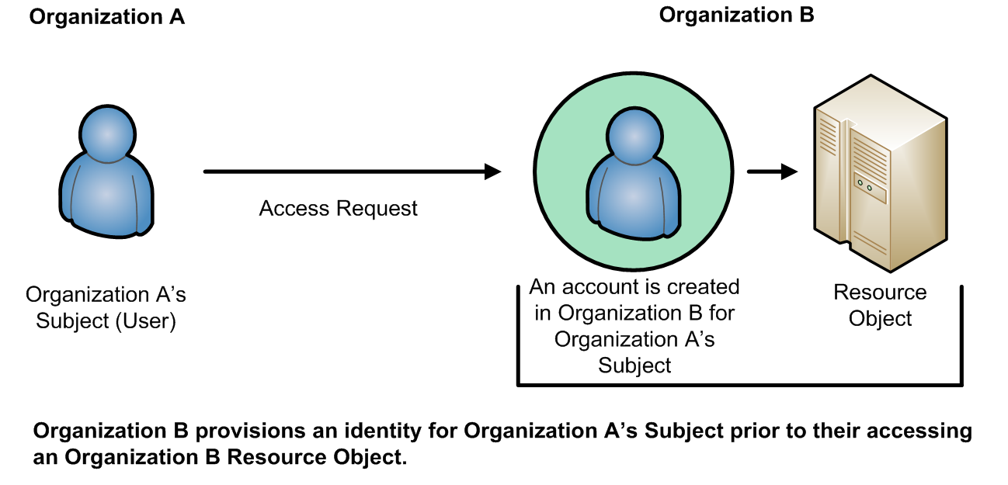
Figure 1: Traditional (Non-ABAC) Multi-Organizational Access Method

Additionally, the subject qualifiers, such as identity and roles, are often insufficient in the expression of real-world AC needs. RBAC makes a decision based on the subject’s association with a role. RBAC does not easily support multi-factor decisions (for example, decisions dependent on physical location, and specialized training such as for Health Insurance Portability and Accountability Act (HIPAA) records access; recent training on HIPAA data protection may be a prerequisite to view medical records.) RBAC role assignments tend to be based upon more static organizational positions, presenting challenges in certain RBAC architectures where dynamic access control decisions are required. Trying to implement these kinds of access control decisions would require the creation of numerous roles that are ad hoc and limited in membership, leading to what is often termed “role explosion”.

A method is needed to make AC decisions without previous knowledge of the object by the subject or knowledge of the subject by the object-owner. By relying upon the concepts of subject and object attributes consistently defined between organizations, ABAC avoids the need for explicit authorizations to be directly assigned to individual subjects prior to a request to perform an operation on the object.
Moreover, this model enables flexibility in a large enterprise where management of access control lists or roles and groups would be time consuming and complex. Leveraging consistently defined attributes that span both subjects and objects, authentication and authorization activities can be executed and administered in the same or separate infrastructures, while maintaining appropriate levels of security.

A Working Definition of ABAC

ABAC has been described in various ways. For example, one early paper on web services states that ABAC “grants accesses to services based on the attributes possessed by the requester” [WWJ04], while a discussion of security in geographic information systems describes ABAC as an approach in which “attribute values associated with users determine the association of users with privileges” [CGLO09].

Still another paper summarizes ABAC as a model that is “based on subject, object, and environment attributes and supports both mandatory and discretionary access control needs” [YT05]. In these and other definitions, there is a reasonable consensus that ABAC determines access (i.e., operations upon system
objects) by matching the current value of subject attributes, object attributes, and environment conditions with the requirements specified in access control rules. The following is a high-level definition of ABAC:

Attribute Based Access Control (ABAC): An access control method where subject requests to perform operations on objects are granted or denied based on assigned attributes of the subject, assigned attributes of the object, environment conditions, and a set of policies that are specified in terms of those attributes and conditions.

Attributes are characteristics of the subject, object, or environment conditions. Attributes contain information given by a name-value pair.

A subject is a human user or NPE, such as a device that issues access requests to perform operations on objects. Subjects are assigned one or more attributes. For the purpose of this document, assume that subject and user are synonymous.

An object is a system resource for which access is managed by the ABAC system, such as devices, files, records, tables, processes, programs, networks, or domains containing or receiving information. It can be the resource or requested entity, as well as anything upon which an operation may be performed by a subject including data, applications, services, devices, and networks.

An operation is the execution of a function at the request of a subject upon an object. Operations include read, write, edit, delete, copy, execute, and modify.

Policy is the representation of rules or relationships that makes it possible to determine if a requested access should be allowed, given the values of the attributes of the subject, object, and possibly environment conditions.

Environment conditions: operational or situational context in which access requests occur. Environment conditions are detectable environmental characteristics. Environment characteristics are independent of subject or object, and may include the current time, day of the week, location of a user, or the current threat level.

The high-level ABAC definition is depicted in Figure 2 where the ABAC ACM receives the subject’s access request, then examines the subject’s and object’s attributes against a specific policy. The ACM then determines what operations the subject may perform upon the object.
Access Control
Policy
Environment
Conditions
2a
2d
rules

Decision
1
Enforce
3
Object
Subject
2b
ABAC
Access Control Mechanism
2c
NameAffiliation
Type
Owner
Etc.
Clearance
Etc.
Classification
Subject Attributes
Object Attributes
Subject requests access to object
Access Control Mechanism evaluates a) Rules, b) Subject Attributes, c) Object Attributes, and
d) Environment Conditions to compute a decision
Subject is given access to object if authorized

Figure 2: Basic ABAC Scenario

Basic ABAC Concepts

In its most basic form, ABAC relies upon the evaluation of attributes of the subject, attributes of the object, environment conditions, and the formal relationship or access control rule or policy defining the allowable operations for subject-object attribute combinations. All ABAC solutions contain these basic core apabilities to evaluate attributes and enforce rules or relationships between those attributes (see Figure 3 below).

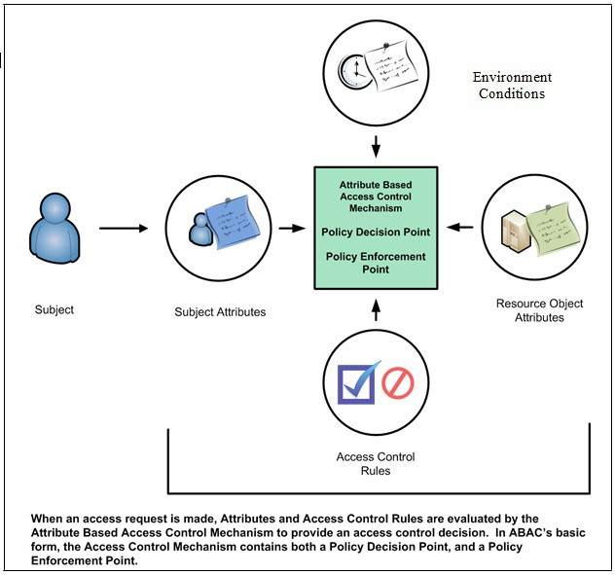
Figure 3: Core ABAC Mechanisms

Even within a small isolated system, ABAC relies upon the assignment of attributes to subjects and objects, and the development of policy that contains the access rules. Each object within the system must be assigned specific object attributes that characterize the object. Some attributes pertain to the entire instance of an object, such as the owner. Other attributes may only apply to parts of the object. For example, a document object could be owned by organization A, have a section with intellectual property from organization B, and be part of a program run by organization C. As another example, consider a document residing in a directory within a file management system. This document has a title, an author, a date of creation, and a date of last edit—all object attributes that are determined by the creator, author, or editor of the document. Additional object attributes may be assigned such as owning organization, intellectual property characteristics, export control classification, or security classification. Each time a new document is created or modified, these object attributes must be captured. These object attributes are often embedded within the document itself, but they may be captured in a separate table, incorporated by reference, or managed by a separate application.

Each subject that uses the system must be assigned specific attributes. Consider the example of a user accessing a file management system. The user is established as a subject within the system by an administrator and characteristics about that user are captured as subject attributes. This subject may have a name, a role, and an organization affiliation. Other subject attributes may include US Person status, nationality, and security clearance. These subject attributes are assigned and managed by an authority within the organization that maintains the subject identity information for the file management system. As new users arrive, old users leave, and characteristics of subjects change, these subject attributes may need to be updated.

Every object within the system must have at least one policy that defines the access rules for the allowable subjects, operations, and environment conditions to the object. This policy is normally derived from documented or procedural rules that describe the business processes and allowable actions within the organization. For example, in a hospital setting, a rule may state that only authorized medical personnel shall be able to access a patient’s medical record. In some system, if the object is a document with a Record Type Attribute of Patient Medical Record, then the Medical Record Rule will be selected and processed so that the subject with a Personnel Type Attribute value of Non-Medical Support Staff trying to perform the Read operation will be denied access and the operation will be disallowed. Note that this is only one approach to implementing the connection between attributes and rules.

The rules that bind subject and object attributes indirectly specify privileges (i.e., which subjects can perform which operations on which objects). Allowable operation rules can be expressed through many forms of computational language such as:
- A Boolean combination of attributes and conditions that satisfy the authorization for a specific operation
- A set of relations associating subject and object attributes and allowable operations

Once object attributes, subject attributes, and policies are established, objects can be protected using ABAC. Access control mechanisms mediate access to the objects by limiting access to allowable operations by allowable subjects. The ACM assembles the policy, subject attributes, and object attributes, then renders and enforces a decision based on the logic provided in the policy. ACMs must be able to manage the process required to make and enforce the decision, including determining what policy to retrieve, which attributes to retrieve in what order, and where to retrieve attributes. The ACM must then perform the computation necessary to render a decision.

The policies that can be implemented in an ABAC model are limited only to the degree imposed by the computational language and the richness of the available attributes. This flexibility enables the greatest breadth of subjects to access the greatest breadth of objects without having to specify individual relationships between each subject and each object. For example, a subject is assigned a set of subject attributes upon employment (e.g., Nancy Smith is a Nurse Practitioner in the Cardiology Department). An object is assigned its object attributes upon creation (e.g., a folder with Medical Records of Heart Patients). A designated authority creates rules to govern the set of allowable operations (e.g., all Nurse Practitioners in the Cardiology Department can View the Medical Records of Heart Patients). Adding to the flexibility, attributes and their values may then be modified throughout the lifecycle of subjects, objects, and attributes.

Provisioning attributes to subjects and objects governed by a ruleset that specifies what operations can take place enables an unlimited number of subjects to perform operations on the object—all without prior knowledge of the specific subject by the object-owner or rule-maker. As new subjects join the organization, rules and objects do not need to be modified. As long as the subject is assigned the attributes necessary for access to the required objects (e.g., all Nurse Practioners in the Cardiology Department are assigned those attributes), no modifications to existing rules or object attributes are required. This benefit is often referred to as accommodating the external (unexpected) user and is one of the primary benefits of employing ABAC.

Contrary to some other schemes, under the definition of ABAC presented here, operations do not have “attributes”. As defined “Attributes contain information given by a name-value pair”. For example, “read = all” (or “all = read”) is not appropriate. Operations can have many types or classes, which are not “attributes” but a fixed set of values. It would be possible to make operation itself an “attribute name”, such as “operation = read”, but this would then be the only attribute for operation, which would be redundant.

To meet accountability requirements, there will be a need to track accesses of objects to specific subjects linked to specific users. Accountability could be lost if access decisions are based on attributes, but subject or user IDs are not tracked to specific access requests and decisions.

3. ABAC Enterprise Considerations

  - Initiation Phase Considerations
  - Considerations during the Acquisition/Development Phase
  - Considerations during the Implementation/Assessment Phase
  - Considerations during the Operations/Maintenance Phase

4. Conclusion

深入浅出ABAC概念与定义
充分认识 ABAC 需要对逻辑访问控制基本原理的理解。逻辑访问控制的目的是要保护对象免于未授权操作，无论是数据，服务，可执行的应用程序，网络设备，还是从技术上其他类型的信息。这些操作包括发现，读取，创建，编辑，删除和执行对象。这些对象被个人或组织所拥有，其内部具有的价值驱动着业主需要保护他们。作为对象的拥有者，他们必须建立一个策略，用以描述哪些操作可能会在这些对象执行并由谁来执行，以及在什么情况下这些操作可以执行的上下文环境。如果请求者满足由对象所有者建立的访问控制策略，那么请求者则被授权执行关于该对象的其所需的操作，如果不符合策略，则它的访问请求将会被拒绝。
计算机安全架构师和管理员们会部署访问控制机制(ACM)来保护自己的对象。这些 ACMs 可以使用各种方法来管理执行适用于这些对象的访问控制策略。ACM 可以定义为：
访问控制机制(ACM): 接收访问请求并决定是否执行访问决策的逻辑组件。
这些 ACM 函数可以用各种逻辑访问控制模型来描述。这些访问控制模型提供了一个框架，其中设置了诸多边界条件包括保护对象、请求者、操作和规则组合生成一个可执行的访问控制决策。每个模型都有自己的优点和局限性，但要注意这些模型的演变历史，从而更好地领略 ABAC 模型的灵活性和适用性。
- MAC/DAC
20 世纪 60 年代至 70 年代，逻辑访问控制的一个早期应用是在美国国防部（DOD），其中首次提出了自主访问控制（DAC）和强制访问控制（MAC）的概念。这些术语在国防部可信计算机系统评估标准（TCSEC）或者 “橘皮书”[TCSEC] 进一步明确。 DAC 和 MAC 的定义可以在 [NIST800-53] 中查看。
- IBAC/ACLs
随着网络的普及，对特定保护对象的限制访问演变出了基于身份的访问控制（IBAC）模型。 IBAC 采用了这种访问控制列表（ACL）机制来描绘允许访问该对象的身份。如果请求者持有匹配 ACL 中的其中一个凭证，访问对象将会被其访问。对象不同操作权限（读，写，编辑，删除等）将由所有者个人进行单独管理。每个对象都需要自己的 ACL，并为每个请求者特权设置。在 IBAC 模型中，授权决策之前，请求者的任何具体访问请求和期望结果需要被添加到 ACL 的。对于放置在每个 ACL 列表中的请求，对象所有者必须根据身份、具体对象以及上下文背景属性，来决定是否添加其至相应的 ACL。这一决定是静态的，需要通知所有者重新评估并将变化反应到ACL中。随着时间的推移未能删除或撤销权限将会导致用户不断累积权限条例。
- RBAC
基于角色的访问控制模型（RBAC）[FK92，ANSI 349，Sandhu96] 使用了分别与特定权限相关联的预定义角色组。例如，被赋予经理角色的请求者将会获得一组与被赋予分析者角色的请求者所不同的权限。在这个模型中，访问被隐式地分配到每个单独和明确的对象角色中，角色与其相关联的特权是预先确定的。在接入请求时，访问控制机制在决定对象是否可执行操作之前会计算分配给请求者角色所拥有的权限。注意，一个角色可以被访问控制机制视为一种对象属性，并基于此产生相应访问策略。RBAC 规范的普及让企业级访问控制功的集中管理更加流行，并减少了访问控制列表的需要。
- ABAC
从属性使用角度看，ACL 和 RBAC 都是 ABAC模型的特殊情况。ACL 使用了 “身份” 的属性工作而 RBAC 使用了 “角色” 的属性。与 ABAC 的主要区别是策略概念，后者可以承载更多不同属性更复杂的布尔规则集。尽管使用ACL或RBAC也可以实现ABAC的目标，但是ACL与RBAC证明控制策略的有效性是困难的，从抽象层次上成本更高。另一个值得重视的问题是，也是ACL与RBAC模型的困境，权限控制需求改变时，难以找出该ACL 或 RBAC 需要更新的所有地方。
其中一个与ABAC理念保持一致的访问控制框架是可扩展访问控制标记语言（XACML）。XACML 模型使用的元素有如规则，策略，基于规则和策略的组合算法，属性（主体，（资源）对象，操作和环境上下文），义务和建议。它的参考架构包括了策略决策点（PDP），策略执行点（PEP），策略管理点（PAP），与政策信息点（PIP ）。另一个例子是下一代接入控制标准(NGACS) [ANSI499]。
总体上，ABAC 避免了在请求生产之前对操作/对象对或角色与用户组的预先设定。相反，当接受到对象请求访问时，ABAC 引擎可以基于访问请求对象所分配的属性、环境上下文，和一组基于这些属性与条件做出访问控制决策。不需要直接涉及潜在的众多用户和对象，基于设计好的策略可以来创建和管理实际权限控制策略。
- ABAC的优势
许多权限控制系统访问控制解决方案逻辑上讲大部分是对什么对象上的什么操作的确认。使用IBAC 一个操作的访问权会被单独确立在具体的对象中，而使用RBAC，一个操作的访问权会被单独确立在包含具体对象的角色中。这种权限控制方法往往造成管理上的笨重且繁琐。在非 ABAC 多组织访问案例中（下图为例），目标访问组织需要为目标请求对象在访问列表中预设好权限。
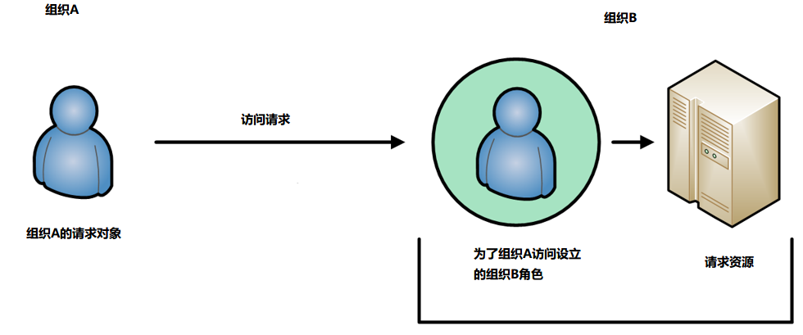
图1:传统非ABAC多组织访问模型
此外，诸如身份和角色的请求者限定符，往往在现实世界的 访问控制需求的表达力不充分。 RBAC 使策略决定与目标请求角色相关联，所以RBAC 不容易支持多因素决定（例如，依赖于物理位置的策略，如对医保法案（HIPAA）的专门医保记录的访问; 最新的 HIPAA 数据很有可能会是医疗诊断的重要记录）。RBAC 角色分配更加倾向基于固定组织结构的固定职位，这意味着在需要动态访问控制决策上RBAC模型显得力不从心。试图实现这些不同类型的访问控制决策将要求诸多临时性角色的创建，导致 “角色爆炸”。
这就要求有一种方法，不需要对请求对象或被请求对象的确切认知而能作出权限控制决定。通过对请求对象与被请求对象中属性的一致性定义，ABAC 避免了具体在什么对象上的什么操作的显示权限声明。此外，该模型能够在管理诸多权限控制列表或角色与角色组的企业级应用中保持灵活性。利用请求者与被请求者中一致定义的属性，认证和授权的活动可以在相同或不同的环境中执行，同时保持相应的安全级别。
- ABAC定义
ABAC 的使用已经通过各种方式进行了描述。例如，在 关于互联网服务的一篇早期文章指出 ABAC“是基于请求中所携带的属性判断对服务是否进行授予访问”[WWJ04]，而在关于地理信息系统安全中的讨论描述了 ABAC 作为利用用户关联属性确定用户使用权限的[CGLO09] 一种方法。
还有一篇文章总结ABAC 是基于请求者，被请求者，环境上下文同时支持强制性和自主访问控制需求的模型[YT05] 。通过这些定义，我们会达成一个合理的共识，即ABAC 通过具体的访问控制规则匹配请求者、被请求者属性与上下文属性确定是否允许访问。以下是 ABAC 的标准定义：
基于属性的权限控制(ABAC): 通过基于请求对象、被请求对象与环境上下文属性定义的策略组来允许或拒绝相关操作的一种访问控制方法。

属性：是请求者，被请求者，或环境上下的特性。属性的信息形式应该键值对。
请求者：应该是人类用户或 非人类实体(如发出访问请求的对象执行操作的装置)。被请求者可被分配一个或多个属性。在这个文档中，假定被请求者即为用户。
被请求者(对象)：是由 RBAC 系统管理的系统资源，如设备、文件、记录、表、程序、网络或任何包含接收信息的域。被请求者相对于请求者可以被后者实施某种操作。
操作：是请求者在被请求者上可执行的功能，包括读、写、编辑、删除、复制、执行和修改。
策略：是给定相关属性的值可以基于此判断是否允许或拒绝请求的相应属性规则或关系。
环境上下文：操作或访问请求发生的情景上下文。环境上下文是可检测的环境特征，独立于请求者与被请求者，并且可以包括当前时间、用户的位置，或者威胁级别。
ABAC 定义可用图 2 表示，其中 基于ABAC 的ACM 接收对象访问请求，然后检查请求与被请求者的属性策略，然后确定哪些操作可以被执行在相应的被请求者上。
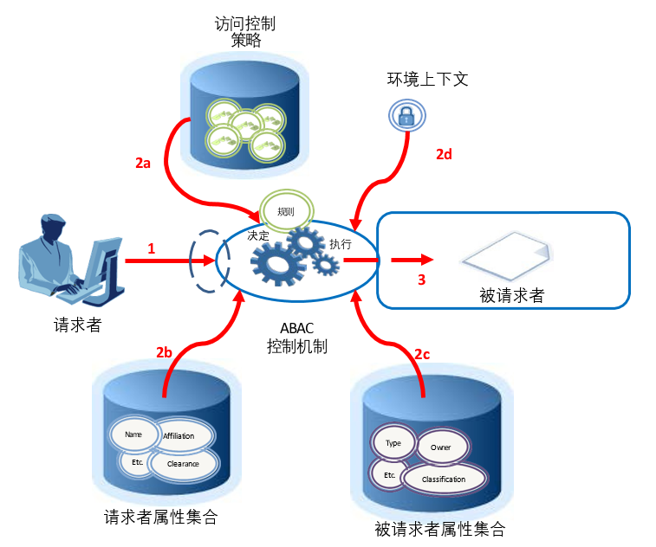
图2: 基本ABAC情景
1.请求者请求被请求者
2.访问控制机制将会评估
a) 规则, b) 请求者属性, c) 被请求者属性, 和d) 环境上下来计算出决定
3.如果被授权允许，请求者将会在被请求者执行操作

- ABAC基础概念
在最基本的形式中，ABAC依赖请求者、被请求者与环境上下文属性的条件评估，并根据访问控制规则或策略属性组合限定了相关操作。所有基于 ABAC的解决方案核心能力是评估相关属性以及这些属性之间的规则或关系（见下图 3）。
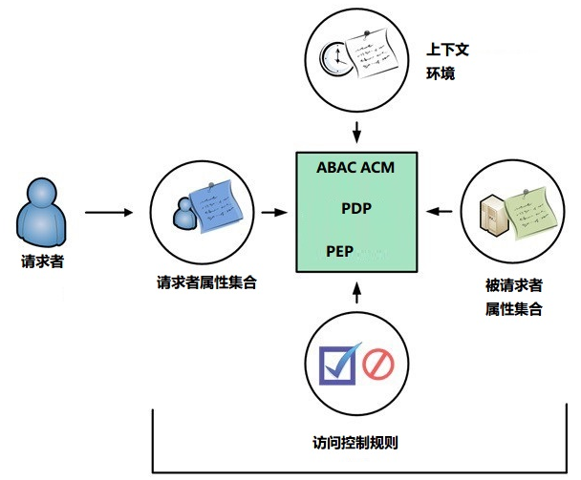
图 3: ABAC核心机制
即使在小型、独立的系统中，ABAC 的实施也依赖于请求者属性和被请求者属性的赋值，同时还有包含访问规则的策略开发。系统内的每个被请求者必须分配特定对象的属性值。一些属性属于一个对象的整个实例，被全局拥有，其他属性可能仅适用于对象的不同部分。举例而言，文档对象可以被一个组织A所拥有，有来自团队 B 的章节部分，也有团队C的一部分。另一个例子是，考虑一个文件管理系统在目录中的文件。这份文件有一个标题、作者、创建的日期，由创作者、作者或文档的编辑决定最后的内容。附加对象属性也可以被分配，如所属组织、知识产权类别、出口控制分类甚至安全分类。每一个新的文档被创建或修改，这些对象属性都必须被刷新。这些对象属性经常被嵌入在文档本身中，但它们也可能在一个单独的表中呈现，通过引用引入或被一个单独的应用程序来管理。

使用该系统的每个请求者必须分配特定属性。以用户访问文件管理系统为例，用户作为管理员的属性被系统认为请求者属性，这个请求者可能有一个名字、角色、以及机构说明。其他请求者属性可能包括美国公民资格、国籍和案件记录。这些请求者属性由维护它的文件管理系统的请求者身份信息组织赋值和管理。随着新用户的到达，老用户离开，用户属性发生变化，这些请求者属性可能需要随之更新。
系统内的每个被请求者必须具有至少一条包含它允许操作的请求者、操作和环境上下文等属性的访问规则中或策略。这一策略通常是从业务流程和其相关的操作记录演变出的。
例如，在医院环境中，规定只有医务人员应能够授权访问病人的医疗记录。在其中一些系统中，如果被请求对象是记录类型属性为医疗记录的文件，那么病历策略将被选中并匹配处理，人事类型属性为非医疗辅助人员的请求者请求的读操作将被拒绝。注意，这是只有一个方法建立属性和规则之间的连接。
策略规则可以通过这样的计算语言形式来表示：
• 满足特定授权操作的属性和条件的布尔组合
• 请求者和被请求者的属性和允许的操作的一组关系
一旦被请求者属性、请求者属性的策略得以建立，被请求者就可以使用 ABAC 进行保护。ACM 必须能够管理和执行策略，包括检索确定出什么策略，哪些属性以何种顺序进行匹配，并且定义其中检索属性所需的过程，ACM 必须执行作出裁决所必需的计算。
ABAC 模型解耦了请求者与被请求者的对应关系，任何属性及其值可在整个的生命周期修改，增加了灵活性。设置规则集可以指定无限数量的被请求者对象，而且完全不会先行定义权限关系。新加入请求或被请求者对象时，现有的规则或对象属性没有修改。这样做的好处被称为可容纳外部意外性，也是ABAC 的主要优点之一。在一些方案中，操作是没有属性，操作可以有多种类型，这不是属性，而是一个固定的值，这将有可能使操作本身具有“属性名”，如“操作=读”，但是这么做，是对操作的唯一属性，将是多余的。值得一提的是，基于属性的访问控制方式可能会丢失权限控制的对象跟踪链条。

