Dress Pattern Database App

# Project Description

An app which allows the user to catalogue patterns they own. The app would allow the user to search their catalogue for either specific pattern number or keyword in the description and/or category. While size range is recorded for each pattern, due to extreme variation in sizing between brand and type (male/female/junior etc), it is not included in the search function.

The app permits the user to easily add to or delete from their catalogue and edit the associated lists of categories and brands.

The possible option to store the database on a cloud service would enable easier synchronisation with a PC version.

# User Interfaces

Main Menu: Buttons - Add, Search, List Maintenance, Exit

Add/Edit/Delete Pattern: Fields for DB, Buttons - Save, Back, Scan Description (enabled when Back Image exists)

Search: Fields - Pattern Number, Keyword/s. Buttons - Search, Back

Search Results: List of Thumbnail of Cover image, Pattern Number & size range (click list item -> Pattern Detail). Buttons - Back

Pattern Detail: Fields - Pattern Number, Brand, Size Range, Description, Category/s. Buttons - Link to Cover Image, Link to Back Image, Delete, Edit, Back

Lists Menu: Buttons - Brands, Categories, Back

Add/Edit/Delete List: List of items with edit & delete buttons to right of item. At the end of the list is an empty field with an Add button. Additional Button - Back.

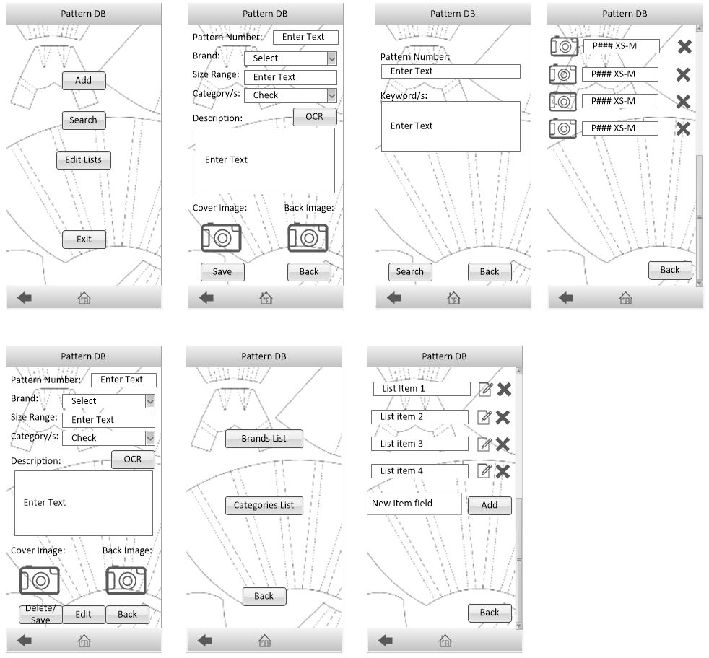

# Database Structure

PatternID: Primary Key, unique number

Pattern Number: as per the pattern packet

Brand: from a list as maintained by user

SizeRange: as per packet

Description: as sourced from blurb on back of packet

Category/s: none, one or many. From list as maintained by user

Cover Image (max size of screen): sourced from device camera, cropped by user and resized to match screen dimensions.

Back Image (readable): sourced from device camera, cropped by user, maintain maximum size to enable zoom to read details.

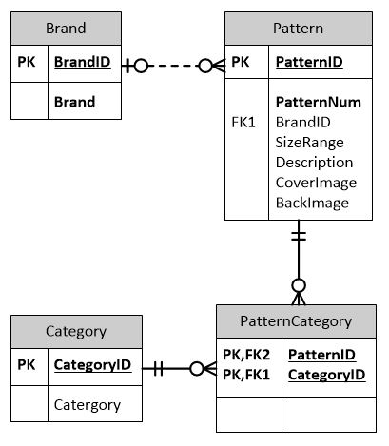

# Pseudocode

Start at main menu, user selects button

if Add

open Add/Edit Pattern screen

when cover image exists

resize to device screen size

when back image exists

enable option to select area to OCR scan for description

if Scan Description

open Back Image with select area tool enabled and instruction to

select description text to OCR

once selection ok'd, do OCR

end if

if Save

if Pattern Number incomplete

popup error message

highlight Pattern Number field

end if

if entry already exists

update entry

else

insert entry

end if

end if

if Back

return to main menu

end if

end if

if Search

open Search screen

if Search

search db on criteria in fields

return results and list them in Search Results screen

if tap list item

open Pattern Details screen

if tap image

display image in viewer (allows zoom function)

if tap back

return to Search Results screen

end if

end if

if tap back

return to Search screen

end if

end if

end if

if Back

return to main menu

end if

end if

if List Maintenance

open list menu

if Brands

open List of Brands

if Delete

if patterns associated with brand

popup warning

abort delete

else

popup to confirm

if ok

delete brand from db

else

abort delete

end if

end if

end if

if Edit

make field in list "live" for editing

enable buttons - Save, Back

if Save

update db

end if

if Back

revert to original entry and inactivate "live"

end if

end if

if Add

insert text from field into brand table

end if

end if

if Categories

open List of Categories

if Delete

if patterns associated with category

popup warning

abort delete

else

popup to confirm

if ok

delete category from db

else

abort delete

end if

end if

end if

if Edit

make field in list "live" for editing

enable buttons - Save, Back

if Save

update db

end if

if Back

revert to original entry and inactivate "live"

end if

end if

if Add

insert text from field into category table

end if

end if

end if

if Exit

Program ends

end if

# Issues to research

Reuse of pattern numbers after old ones are retired by the brand. What are the policies of each brand?

Sizes can be numerical or alphabetical and do not necessarily relate to each other but are consistent to the brand. For example: numerical sizes are 8, 10, 12, 14 etc but in mens are neck sizes. Alpha sizes are XS, S, M, L, XL etc. For searching purposes there may have to be a look up table for each brand that has the actual dimensions that each size refers to (bust, waist, hip, etc).

OCR to automatically fill the description field from the blurb on the back of the pattern.

Storage. How easy to store DB on cloud? Would make synchronising with a PC version of the DB easier.

Photo resizing options. Does the native photo management allow it?

# Results of Research

Reuse of pattern numbers. This should not be an issue as I have decided to use a unique number as primary key instead of the pattern number. I determined this would be best on two counts, owning two copies of the same pattern in different size range and the possible reuse of numbers by the brand.

Sizes. After reviewing the various brands and sub-brands it is apparent that there is too much variation in sizing to simply search the catalogue by entering one number. Men's and women's clothing is sized very differently and within women's there are variations between junior/petite/"normal"/plus-size. Therefore I have determined that for the purposes of this database the size range will be recorded in a single field and not be included in the search criteria but will be shown in the search results. I don't believe this will be adverse to the practical use of the catalogue.

OCR. There is a library that allows optical character recognition on the device. Ref: https://codelabs.developers.google.com/codelabs/mobile-vision-ocr/#0

Storage. This is not trivial. There does appear to be some services (AppEngine) that allow you to have a cloud server but it is not obvious if this app would remain in the free tier.

Photo resizing. There is documentation to aid in the use of the native camera, editing and album apps. Ref: https://developer.android.com/guide/topics/media/camera and https://developer.android.com/training/camera/photobasics