**NAME:** IAN LY S. SALUD **YEAR & COURSE:** 4TH YEAR - BSIT

**NO. OF HOURS FINISHED:** 147.5 HOURS **DATE STARTED:** 2/5//25 **DATE ENDED:** 2/25/25

No.3.e Part I. LEARNING OUTCOME

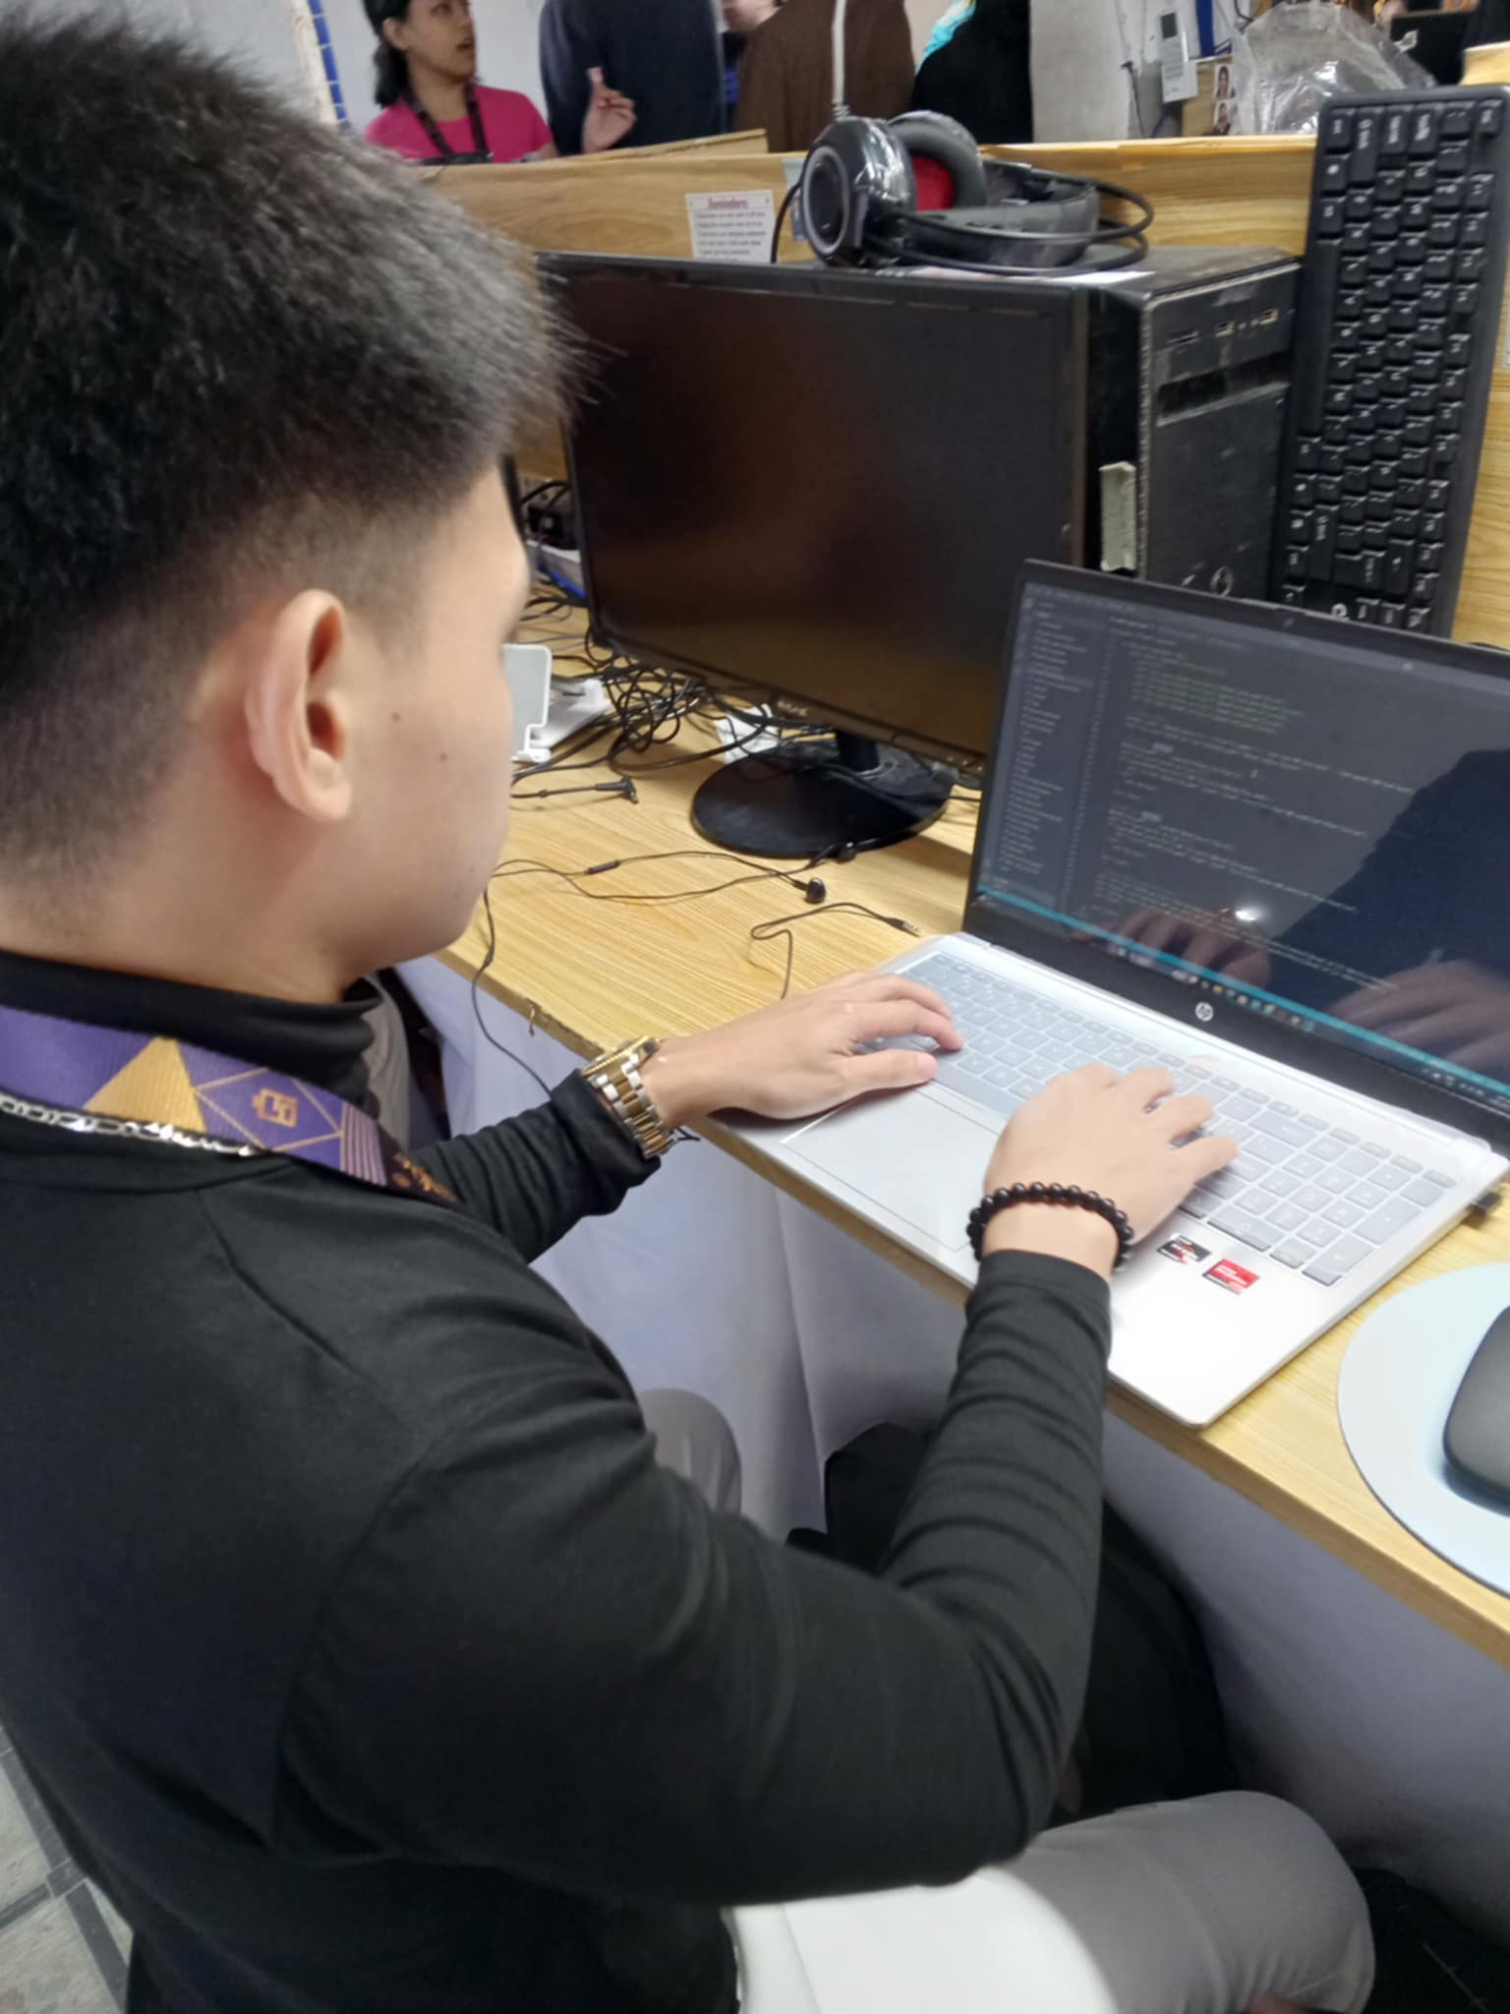

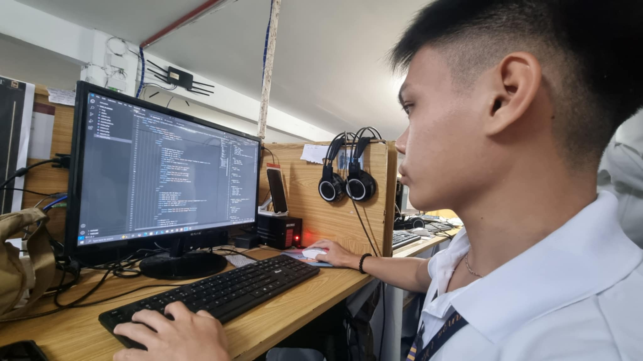

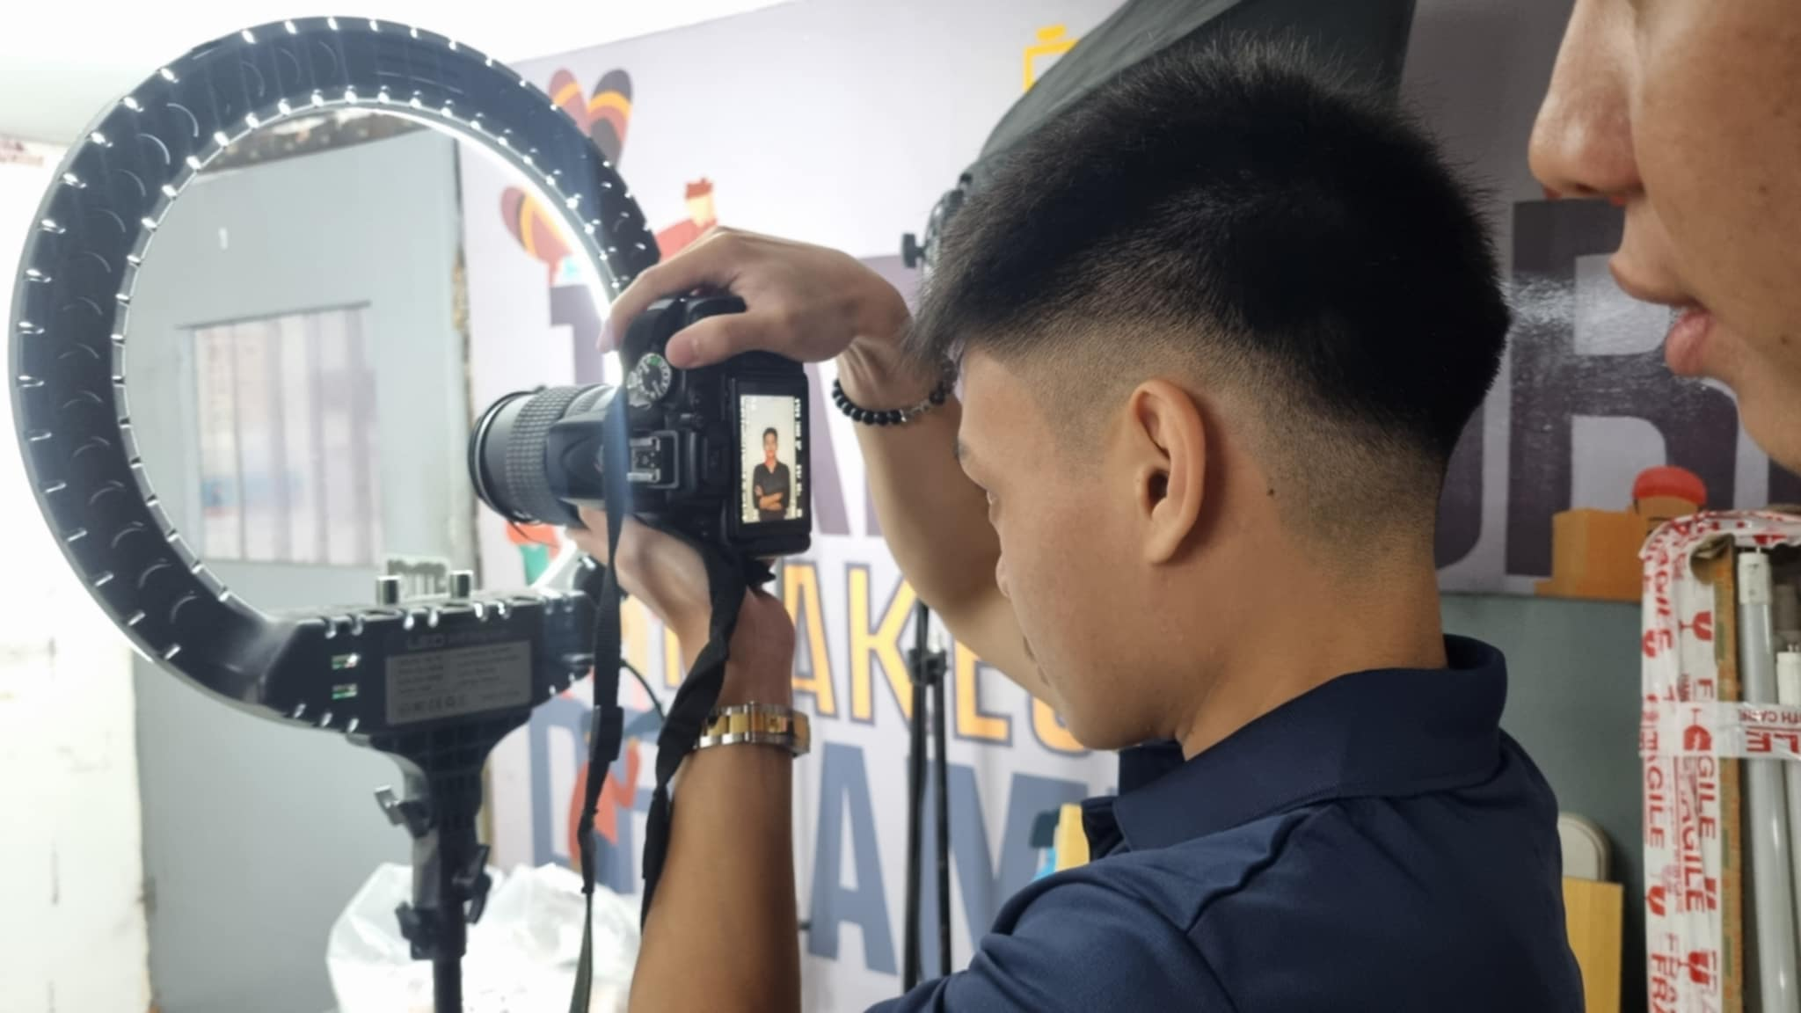

Programming Task: Task Planner

Programming Task: Redevelopment Task Planner

Practicing Photography: Taking Pictures

**PROBLEM(S) ENCOUNTERED**

While working on the task planner modifications, I faced challenges in understanding some aspects of the existing system. I had to consult my senior colleagues and research solutions to ensure accurate changes.

During the programming tasks, I encountered multiple system errors and lacking or missing files that required extensive debugging. Some issues took longer to resolve than expected, but through troubleshooting and problem-solving, I was able to fix them.

When creating the montage, I struggled with achieving the desired impact while keeping it minimal. Feedback from my supervisor and colleagues helped refine my approach.

**RESOLUTIONS (at least three alternatives)**

1. Improved System Familiarization: Since I faced difficulties in understanding the existing system, I could dedicate time to reviewing documentation, analyzing the system structure, and testing small modifications to gain better familiarity before making major changes.
2. Efficient Debugging Strategies: To address system errors and missing files, I could implement structured debugging techniques, such as logging errors, using debugging tools, and systematically checking dependencies to quickly identify and resolve issues.
3. Balanced Approach to Montage Design: Instead of struggling with the balance between impact and minimalism, I could experiment with different layouts and elements, gather early feedback, and use references or templates to guide the design process effectively.

**BEST SOLUTION TO THE PROBLEM**

The best solution to my problem is, first, self-management is important to make significant progress while working on or completing a task.

For the montage, it's essential to regularly check with my supervisor to ensure I'm doing things correctly. This way, I can identify what I've done well and what needs improvement, allowing for immediate corrections and guidance.

For programming, specifically my task planner project, the best approach is to first check the system for any missing elements, necessary changes, or additions. Once identified, I should work on them step by step, ensuring I understand the system's flow. It's also important to have my supervisor review it regularly in case they want changes or additions to improve the system.

Learning experiences within the period of this report (personal and relevant to the course)

For me, I have learned to further enhance my programming skills by giving my best every day in completing my tasks. This also adds to my experience, helping me improve even more in programming. I am also overcoming my weaknesses, which are now becoming my strengths because of the learnings and experiences I gain. I also attended a seminar conducted by the company. The seminar was about marketing strategies to gain more knowledge on how to use them properly and handle various strategies and techniques in marketing.

**DATE SUBMITTED: ________________ RECEIVED BY: _____________**