Supplementary Information for: Genome-wide methylation profiles of ribosomal DNA copy number at birth

Kathrin Barth; Rossella Alfano; Michelle Plusquin; Congrong Wang; Tim S. Nawrot; Dries S. Martens
Table of Contents
Table S1: Characteristics of the analyzed fraction of the ENVIRONAGE population and the Flanders population at large. 1
Table S2: ddPCR primer and probe sequences for rDNAcn measurements. 2
Table S3: EWAS of cord blood rDNAcn in 194 ENVIRONAGE participants using the EPIC discovery dataset. see Excel file
Table S4: Associations between rDNAcn and CpGs in the EPIC discovery dataset and 450k replication dataset. see Excel file
Table S5:EWAS of cord blood rDNAcn in 167 ENVIRONAGE participants using the 450K replication dataset. see Excel file
Table S6: DMR analysis of cord blood rDNAcn in 194 ENVIRONAGE participants using the EPIC discovery dataset. 3
Table S7: DMR analysis of cord blood rDNAcn in 167 ENVIRONAGE participants using the 450K replication dataset. 4
Table S8: Correlations between cord blood rDNAcn-associated CpGs from the EPIC discovery analysis and gene expression levels in 64 ENVIRONAGE participants. see Excel file
Table S9: Pathway analysis based on genes annotated to rDNAcn-associated DMRs from the EPIC discovery analysis. 5
Table S10: Pathway analysis based on genes annotated to rDNAcn-associated DMRs from the 450K replication analysis. see Excel file
Table S11: Pathway analysis based on annotated genes from the eQTM analysis between cord blood gene expression and rDNAcn-associated CpGs. see Excel file
Table S12: Associations between cord blood rDNAcn, global, promotor, gene-body, and intergenic DNA methylation within the EPIC discovery dataset. 6
Figure S1: Flowchart for ENVIRONAGE participant selection for the EPIC discovery and the 450K replication dataset. 7
Figure S2: DNA agarose electrophoresis. 8
Figure S3: Quantile-quantile plots of p-values obtained in the EPIC discovery EWAS. 9
Figure S4: Volcano plots for the EWAS between cord blood rDNAcn and DNA methylation using the EPIC discovery (A) and the 450K replication (B) dataset 10
Figure S5: Venn diagram of overlapping EWAS results obtained by different sensitivity analyses using the EPIC discovery dataset. 11
Figure S6: Ideogram of autosomes showing the position of cord blood rDNAcn-associated CpGs (from the EPIC discovery analysis) and NADs. 12
Figure S7: Ideogram of autosomes showing the position of cord blood rDNAcn-associated DMRs (from the EPIC discovery analysis) and NADs. 13
References 14

Table S1: Characteristics of the analyzed fraction of the ENVIRONAGE population and the Flanders population at large.
Characteristic | Analyzed  n= 361 | Flanders  n= 606877*
Newborn
Gestational age, weeks | 39 (37-41) | NA
Gestational age
<32 weeks | 1 (0.3%) | 0.6%
32-36 weeks | 21 (5.8%) | 5.3%
>36 weeks | 339 (93.9%) | 94.1%
Birth weight, grams | 3410 (2810-4005) | 3360 (2740-3965)
Sex
Boys, n | 185 (51.2%) | 51.4%
Girls, n | 176 (48.8%) | 48.6%
Ethnicity
European, n | 333 (92.2%) | 87.7%
Non-European, n | 28 (7.8%) | 12.3%
Maternal
Age, years | 30 (25-35) | 29.5 (23.5-35.8)
Pre-pregnancy BMI, kg/m² | 23.8 (19.9-30.5) | NA
Education at delivery
Low, n | 43 (11.9%) | 13.1%
Middle, n | 113 (31.3%) | 40.8%
High, n | 205 (56.8%) | 46.2%
Smoking |  | NA
Never smoked, n | 233 (64.5%)
Stopped smoking, n | 80 (22.2%)
Continued smoking, n | 48 (13.3%)
Parity
1 | 190 (52.6%) | 46.9%
2 | 124 (34.3%) | 34.7%
≥3 | 47 (13.1%) | 18.4%
Number (%) is given for the categorical variables, and median (10th-90th percentile) is reported for the continuous variables. *Data from the birth register that comprises all births from Flanders (Cox et al., 2013; Winckelmans et al., 2015) from 1999-2009, n= 606877, except for gestational age categories (n= 525635). Abbreviations: ENVIRONAGE: Environmental influence on early ageing birth cohort; BMI: body mass index

Table S2: ddPCR primer and probe sequences for rDNAcn measurements.
Gene | Primer | Sequence 5’ – 3’
45S rDNA | forward | 5’-AACGTGAGCTGGGTTTAG-3’
 | reverse | 5’-CTCGTACTGAGCAGGATTAC-3’
 | probe | 5’-/5HEX/TGGCAACAA/ZEN/CACATCATCAGT/3IABkFQ/-3’
TBP | forward | 5’-GATATGAGACTGTGGGTAAGT-3’
 | reverse | 5’-GATCCTTTGAACACCCTAATG-3’
 | probe | 5’-/56-FAM/ACAGAGATC/ZEN/ACTGCAGTTGC/3IABkFQ/-3’
Abbreviations: ddPCR: digital droplet polymerase chain reaction; rDNAcn: ribosomal DNA copy number; TBP: tata box binding protein

Table S3: EWAS of cord blood rDNAcn in 194 ENVIRONAGE participants using the EPIC discovery dataset.

Table S4: Associations between rDNAcn and CpGs in the EPIC discovery dataset and 450k replication dataset.

Table S5:EWAS of cord blood rDNAcn in 167 ENVIRONAGE participants using the 450K replication dataset.

Table S6: DMR analysis of cord blood rDNAcn in 194 ENVIRONAGE participants using the EPIC discovery dataset.
Chromosome | Start | End | Number of CpGs | FDR  P-value | Overlapping genes
4 | 53525403 | 53525407 | 2 | 5.68E-23 | USP46
3 | 52007678 | 52007747 | 2 | 5.68E-23 | ABHD14A, RP11-155D18.14, RP11-155D18.12, ABHD14B
1 | 92952440 | 92952641 | 8 | 5.68E-23 | …
3 | 238931 | 239036 | 2 | 2.20E-22 | CHL1, CHL1-AS2
2 | 27341893 | 27341901 | 3 | 2.77E-22 | CGREF1
7 | 65579933 | 65579946 | 3 | 9.99E-22 | AC068533.7, CRCP
4 | 77997182 | 77997201 | 4 | 3.97E-21 | …
7 | 134671225 | 134671357 | 5 | 1.19E-20 | AGBL3
3 | 184032882 | 184033015 | 4 | 3.09E-20 | EIF2B5, EIF4G1
19 | 42070671 | 42070764 | 3 | 2.27E-19 | CEACAM21
1 | 91172710 | 91172770 | 2 | 2.90E-19 | …
11 | 9113152 | 9113194 | 6 | 2.90E-19 | SCUBE2
1 | 89990806 | 89990868 | 3 | 2.95E-19 | LRRC8B
11 | 842517 | 842622 | 6 | 3.49E-19 | POLR2L
5 | 176074466 | 176074484 | 3 | 9.95E-19 | TSPAN17
19 | 45250987 | 45251058 | 2 | 1.03E-18 | BCL3
2 | 105489105 | 105489120 | 2 | 1.71E-18 | RP11-13J10.1
18 | 30050326 | 30050398 | 3 | 1.98E-18 | GAREM
15 | 75871799 | 75871813 | 4 | 6.87E-18 | CTD-2323K18.1
17 | 64188108 | 64188166 | 5 | 9.47E-18 | CEP112
3 | 126194923 | 126194934 | 2 | 9.47E-18 | …
17 | 42441259 | 42441302 | 2 | 4.70E-17 | …
2 | 37458536 | 37458543 | 2 | 4.92E-17 | CEBPZ
9 | 15422769 | 15422793 | 3 | 1.48E-15 | SNAPC3
3 | 127347876 | 127347978 | 4 | 3.20E-15 | …
1 | 179846920 | 179846929 | 2 | 8.29E-15 | TOR1AIP2
8 | 86089330 | 86089337 | 3 | 9.66E-13 | …
2 | 42721154 | 42721159 | 2 | 4.11E-11 | KCNG3
17 | 17942403 | 17942558 | 6 | 7.73E-11 | ATPAF2
11 | 130184747 | 130184756 | 3 | 3.20E-10 | …
17 | 16593589 | 16593613 | 3 | 4.35E-06 | CCDC144A, RP11-219A15.1
DMRs identified with DMRcate using the results from the cord blood rDNAcn EWAS (see Supplementary Table S3). DMRs were selected after correction for the false discovery rate (FDR), and genes overlapping the DMRs are provided. Abbreviations: rDNAcn: ribosomal DNA copy number; DMR: differentially methylated region

Table S7: DMR analysis of cord blood rDNAcn in 167 ENVIRONAGE participants using the 450K replication dataset.
Chromosome | Start | End | Number  of CpGs | FDR  P-value | Overlapping genes
1 | 41157553 | 41157659 | 2 | 4.80E-37 | NFYC, NFYC-AS1
11 | 9113146 | 9113194 | 7 | 9.92E-35 | SCUBE2
4 | 77997182 | 77997201 | 4 | 1.55E-34 | …
3 | 184032882 | 184033015 | 3 | 1.92E-31 | EIF2B5, EIF4G1
11 | 842517 | 842622 | 5 | 1.29E-30 | POLR2L
15 | 95870262 | 95870321 | 2 | 4.32E-29 | CTD-2536I1.1
20 | 61638420 | 61638588 | 7 | 1.68E-28 | …
2 | 27341795 | 27341901 | 4 | 1.07E-26 | CGREF1
7 | 134671225 | 134671357 | 5 | 3.43E-26 | AGBL3
20 | 56885003 | 56885090 | 2 | 3.30E-23 | RAB22A
5 | 71146767 | 71146779 | 2 | 5.08E-23 | …
17 | 42441243 | 42441302 | 4 | 9.47E-23 | FAM171A2
14 | 73392919 | 73392937 | 5 | 8.25E-21 | …
1 | 92952461 | 92952581 | 6 | 5.52E-19 | …
7 | 54826915 | 54826947 | 3 | 8.65E-18 | SEC61G
11 | 66036115 | 66036138 | 3 | 1.18E-17 | RAB1B
20 | 36156137 | 36156320 | 11 | 1.23E-16 | BLCAP
10 | 35416239 | 35416254 | 3 | 1.66E-16 | CREM
3 | 185826924 | 185826941 | 3 | 1.00E-15 | ETV5, DGKG
12 | 7023752 | 7023763 | 2 | 2.76E-15 | ENO2
3 | 127347876 | 127347978 | 4 | 9.32E-12 | …
17 | 16593426 | 16593613 | 6 | 4.16E-09 | CCDC144A, RP11-219A15.1
3 | 46759438 | 46759656 | 6 | 1.10E-05 | PRSS50
18 | 30050326 | 30050331 | 2 | 4.19E-01 | GAREM
DMRs identified with DMRcate using the results from the cord blood rDNAcn EWAS (see Supplementary Table S5). DMRs were selected after correction for the false discovery rate (FDR), and genes overlapping the DMRs are provided. Abbreviations: rDNAcn: ribosomal DNA copy number; DMR: differentially methylated region

Table S8: Correlations between cord blood rDNAcn-associated CpGs from the EPIC discovery analysis and gene expression levels in 64 ENVIRONAGE participants.

Table S9: Pathway analysis based on genes annotated to rDNAcn-associated DMRs from the EPIC discovery analysis.
Pathway | Genes | FDR  P-value | Pathway database
RNA Polymerase III Transcription Initiation From Type 3 Promoter | POLR2L,SNAPC3,CRCP | 0.000216376 | REACTOME
RNA Polymerase III Transcription Initiation | POLR2L,SNAPC3,CRCP | 0.000216376 | REACTOME
RNA Polymerase III Transcription | POLR2L,SNAPC3,CRCP | 0.000216376 | REACTOME
RNA Polymerase III Abortive And Retractive Initiation | POLR2L,SNAPC3,CRCP | 0.000216376 | REACTOME
RNA Polymerase III Chain Elongation | POLR2L,CRCP | 0.003131801 | REACTOME
RNA Polymerase III Transcription Termination | POLR2L,CRCP | 0.004304 | REACTOME
RNA Polymerase III Transcription Initiation From Type 2 Promoter | POLR2L,CRCP | 0.00481 | REACTOME
RNA Polymerase III Transcription Initiation From Type 1 Promoter | POLR2L,CRCP | 0.00481 | REACTOME
Cytosolic sensors of pathogen-associated DNA | POLR2L,CRCP | 0.022368 | REACTOME
RNA polymerase II transcribes snRNA genes | POLR2L,SNAPC3 | 0.026827 | REACTOME
Eukaryotic Translation Initiation | EIF2B5,EIF4G1 | 0.057661 | REACTOME
Cap-dependent Translation Initiation | EIF2B5,EIF4G1 | 0.057661 | REACTOME
RNA polymerase | POLR2L, CRCP | 0.001908691 | KEGG
Hedgehog signaling pathway | SCUBE2 | 0.098795615 | KEGG
Nucleotide excision repair | POLR2L | 0.098795615 | KEGG
Viral myocarditis | EIF4G1 | 0.098795615 | KEGG
Cytosolic DNA-sensing pathway | POLR2L | 0.098795615 | KEGG
Significantly overrepresented pathways were identified after false discovery rate (FDR) correction. Data input included the overlapping genes from the DMR analysis (see Supplementary Table S6).Abbreviations: rDNAcn: ribosomal DNA copy number; DMR: differentially methylated region. Pathway analysis was performed using the databases of Reactome (https://reactome.org) and the Kyoto Encyclopedia of Genes and Genomes (https://www.genome.jp/kegg).

Table S10: Pathway analysis based on genes annotated to rDNAcn-associated DMRs from the 450K replication analysis.

Table S11: Pathway analysis based on annotated genes from the eQTM analysis between cord blood gene expression and rDNAcn-associated CpGs.

Table S12: Associations between cord blood rDNAcn, global, promotor, gene-body, and intergenic DNA methylation within the EPIC discovery dataset.
 |  | Crude model |  |  | Full adjusted model
Outcome |  | β (SE) | P-value |  | β (SE) | P-value
Measure calculated using M-values
Global DNA methylation |  | -5.674e-05 (4.639e-05) | 0.22 |  | -4.982e-05 (4.648e-05) | 0.29
Gene-body methylation |  | -6.819e-05 (5.222e-05) | 0.19 |  | -6.153e-05 (5.256e-05) | 0.24
Promotor methylation |  | -2.311e-05 (2.946e-05) | 0.43 |  | -1.758e-05 (2.926e-05) | 0.55
Intergenic methylation |  | -4.143e-05 (3.714e-05) | 0.27 |  | -3.586e-05 (3.732e-05) | 0.34
Regression β with standard error (SE) and p-value are obtained from linear regression models. The crude model was adjusted for storage time and estimated cell counts (CD8+ T cells, CD4+ T cells, natural killer cells, B cells, and monocytes). The fully adjusted model was additionally corrected for newborn sex, gestational age, birth weight, maternal age, and pre-pregnancy BMI.

Figure S1: Flowchart for ENVIRONAGE participant selection for the EPIC discovery and the 450K replication dataset.

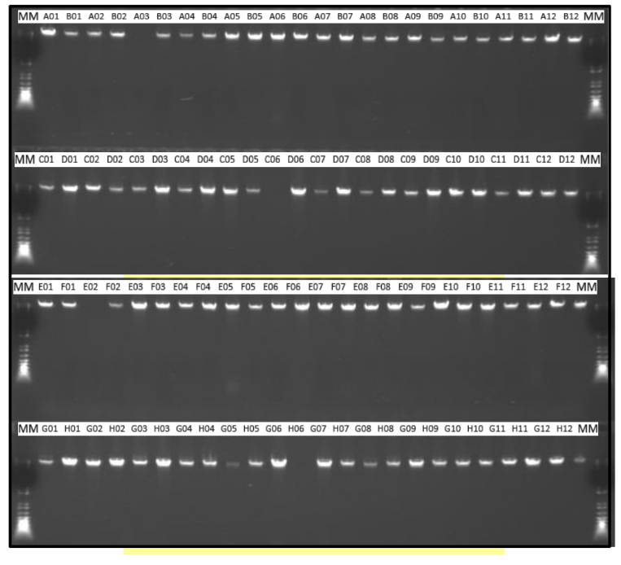
Figure S2: DNA agarose electrophoresis.
Agarose gel image to verify DNA integrity of cord blood DNA samples prior to rDNAcn and DNA methylation analysis.

Figure S3: Quantile-quantile plots of p-values obtained in the EPIC discovery EWAS.
Panel A shows the original p-values from the EWAS. Panel B shows the bacon-corrected p-values.

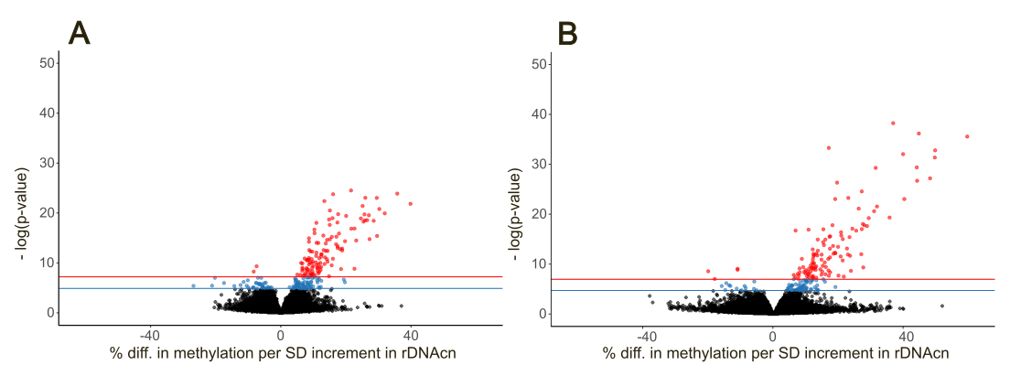

Figure S4: Volcano plots for the EWAS between cord blood rDNAcn and DNA methylation using the EPIC discovery (A) and the 450K replication (B) dataset
The volcano plots shows the % difference in methylation per SD increment in rDNAcn on the x-axis and the corresponding -log₁₀ transformed p-value on the y-axis. Standardized estimates and p-values obtained from robust regression models adjusted for newborn sex, gestational age, birth weight, maternal age, pre-pregnancy BMI, sample storage time, and estimated blood cell count as fixed effects using the EPIC discovery (A) and the 450K replication (B) dataset. The horizontal blue and red lines represent the FDR and Bonferroni levels of significance, respectively.

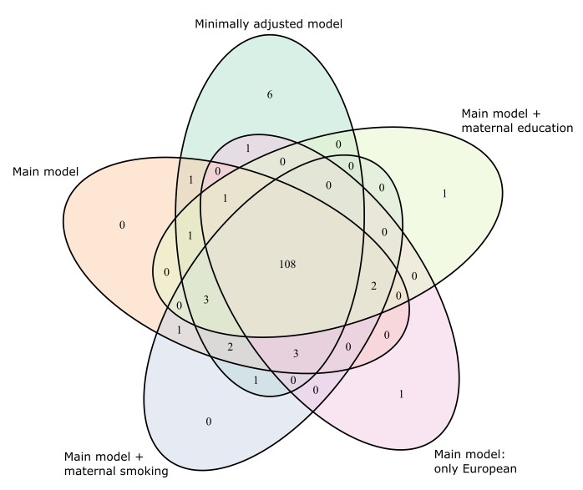

Figure S5: Venn diagram of overlapping EWAS results obtained by different sensitivity analyses using the EPIC discovery dataset.
The Venn diagram shows the overlap of the rDNAcn-associated Bonferroni significant CpGs obtained after several sets of adjustments. A first minimally adjusted model was adjusted for storage time and estimated blood cell counts. Second, our main model was additionally adjusted for newborn sex, gestational age, birth weight, maternal age, and pre-pregnancy BMI. Two other sensitivity models included additional adjustments for maternal smoking and maternal education, respectively. A final sensitivity analysis was run by restricting the main model to participants of European origin.

Figure S6: Ideogram of autosomes showing the position of cord blood rDNAcn-associated CpGs (from the EPIC discovery analysis) and NADs.
NADs are shown in green above the chromosome structure. Below the chromosome structure, the position of the cord blood rDNAcn-associated CpGs after Bonferroni correction is displayed. The positions of the NADs are taken from Bersaglieri et al. 2022. Abbreviations: rDNAcn: ribosomal DNA copy number; NAD: nucleolar-associated domains.

Figure S7: Ideogram of autosomes showing the position of cord blood rDNAcn-associated DMRs (from the EPIC discovery analysis) and NADs.
NADs are shown in green above the chromosome structure. Below the chromosome structure in orange, the position of the cord blood rDNAcn-associated DMR after false discovery rate correction is displayed. The positions of the NADs are taken from Bersaglieri et al. 2022. Abbreviations: rDNAcn: ribosomal DNA copy number; DMR: differentially methylated region; NAD: nucleolar-associated domains.

References
Bersaglieri, C., Santoro, R., Perenthaler, E., Arieti, F., Carotenuto, W., Termanini, A., … Gabriele, A. (2022). Genome-wide maps of nucleolus interactions reveal distinct layers of repressive chromatin domains. Nature Communications, 13(1). https://doi.org/10.1038/s41467-022-29146-2
Cox, B., Martens, E., Nemery, B., Vangronsveld, J., & Nawrot, T. S. (2013). Impact of a stepwise introduction of smoke-free legislation on the rate of preterm births: Analysis of routinely collected birth data. BMJ, 346(7897), 1–8. https://doi.org/10.1136/bmj.f441
Winckelmans, E., Cox, B., Martens, E., Fierens, F., Nemery, B., & Nawrot, T. S. (2015). Fetal growth and maternal exposure to particulate air pollution – More marked effects at lower exposure and modification by gestational duration. Environmental Research, 140, 611–618. https://doi.org/10.1016/j.envres.2015.05.015

