**Ministerul Educaţiei și Cercetării al Republicii Moldova Universitatea Tehnică a Moldovei**

**Facultatea Calculatoare, Informatică și Microelectronică**

Laboratory work 4:

Dynamic programming

Elaborated:

st. gr. FAF-221 Berco Andrei

Verified:

asist. univ. Fiștic Cristofor

prof. univ. Andrievschi-Bagrin Veronica

Chişinău - 2024

**Objective:**

Study and analyze different graph traversing algorithms.

**Tasks:**

1. To study the dynamic programming method of designing algorithms.
2. To implement in a programming language algorithms Dijkstra and Floyd–Warshall using dynamic programming.
3. Do empirical analysis of these algorithms for a sparse graph and for a dense graph.
4. Increase the number of nodes in graphs and analyze how this influences the algorithms. Make a graphical presentation of the data obtained

Theoretical Notes:

Empirical analysis provides an alternative approach to understanding the efficiency of algorithms when mathematical complexity analysis is impractical or insufficient. This method proves beneficial in various scenarios:

1. Initial Insights: It offers preliminary insights into an algorithm's complexity class, aiding in the understanding of its efficiency characteristics.
2. Comparative Analysis: It facilitates the comparison of multiple algorithms tackling the same problem, allowing for informed decisions regarding efficiency.
3. Implementation Comparison: Empirical analysis enables the comparison of different implementations of the same algorithm, providing insights into which may perform better in practice.
4. Hardware-specific Evaluation: It helps in assessing an algorithm's efficiency on a particular computing platform, taking into account hardware constraints and capabilities.

The empirical analysis of an algorithm typically involves the following steps:

Establishing Analysis Goals: Clearly define the objectives and scope of the analysis.

1. Choosing Efficiency Metrics: Select appropriate metrics, such as the number of operations executed or the execution time, based on the analysis goals.
2. Defining Input Data Properties: Determine the characteristics of the input data relevant to the analysis, including data size or specific attributes.
3. Implementation: Develop the algorithm in a programming language, ensuring it accurately reflects the intended logic.
4. Generating Input Data Sets: Create multiple sets of input data to cover a range of scenarios and edge cases.
5. Execution and Data Collection: Execute the program for each input data set, recording relevant performance metrics.
6. Data Analysis: Analyze the collected data, either by computing synthetic quantities like mean and standard deviation or by plotting graphs to visualize the relationship between problem size and efficiency metrics.
7. The choice of efficiency measure depends on the analysis's objectives. For instance, if assessing complexity class or verifying theoretical estimates, counting the number of operations may be suitable. Conversely, if evaluating algorithm implementation behavior, measuring execution time becomes more relevant.

8. Post-execution, recorded results undergo analysis. This involves computing statistical measures or plotting graphs to visualize the algorithm's performance characteristics in terms of problem size and efficiency metrics. Such analyses aid in making informed decisions regarding algorithm selection and optimization strategies.

Introduction:

Dijkstra's Algorithm:

Dijkstra's algorithm, named after Dutch computer scientist Edsger W. Dijkstra, is a widely used algorithm for finding the shortest paths between nodes in a graph, particularly for graphs with non-negative edge weights. It is commonly employed in various applications such as network routing protocols and GPS navigation systems.

The algorithm works by iteratively selecting the node with the smallest tentative distance from a set of unvisited nodes and updating the distances to its neighbors accordingly. It maintains a priority queue or a min heap to efficiently select the next node to visit.

Dijkstra's algorithm guarantees the shortest path from a single source node to all other nodes in the graph. However, it does not handle negative edge weights and requires non-negative weights for its correctness.

Time Complexity: O(V^2) with adjacency matrix representation and O((V + E)logV) with adjacency list representation, where V is the number of vertices and E is the number of edges in the graph.

Space Complexity: O(V) for storing distances and predecessors.

Floyd-Warshall Algorithm:

The Floyd-Warshall algorithm is a dynamic programming-based algorithm used to find the shortest paths between all pairs of vertices in a weighted graph, including graphs with negative edge weights (but with no negative cycles). It was developed independently by Bernard Roy in 1959 and later by Stephen Warshall in 1962.

The algorithm works by iteratively considering all pairs of vertices as intermediate vertices and updating the shortest path distances between them. It maintains a two-dimensional array to store the shortest distances between all pairs of vertices.

Floyd-Warshall algorithm provides a convenient way to find the shortest paths between all pairs of vertices in a graph, making it suitable for applications such as network topology analysis and traffic routing.

Time Complexity: O(V^3), where V is the number of vertices in the graph.

Space Complexity: O(V^2) for storing the distance matrix.

## **Comparison Metric:**

The comparison metric for this laboratory work will be considered the time of execution of each algorithm (T(n))

## **Input Format:**

As input, each algorithm will receive 8 series of numbers of nodes 4, 8, 16, 32, 64, 128, 256, ,512.

Next, using this numbers of nodes, it will be generated randomly graphs with that amount of nodes.

**Implementation**

All algorithms will be implemented in their naïve form in python an analyzed empirically based on the time required for their completion. While the general trend of the results may be similar to other experimental observations, the particular efficiency in rapport with input will vary depending on memory of the device used.

Dijkstra Algorithm:

def dijkstra(graph, start):

distances = {node: float('inf') for node in graph}

distances[start] = 0

visited = set()

while len(visited) < len(graph):

current_node = min((node for node in graph if node not in visited), key=lambda x: distances[x])

visited.add(current_node)

for neighbor, weight in graph[current_node].items():

new_distance = distances[current_node] + weight

if new_distance < distances[neighbor]:

distances[neighbor] = new_distance

return distances

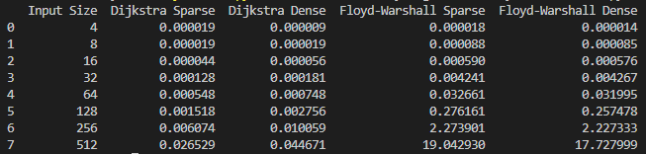**Figure 1. Time table for algorithms**

As observed in the table, Dijkstra algorithm is faster than Floyd-Warshall in all cases. For a small number of nodes, either the graph is sparse of dense, the algorithms are executed almost in the same time. But as the number of nodes increase, the time also increase considerably for Floyd-Warshall.

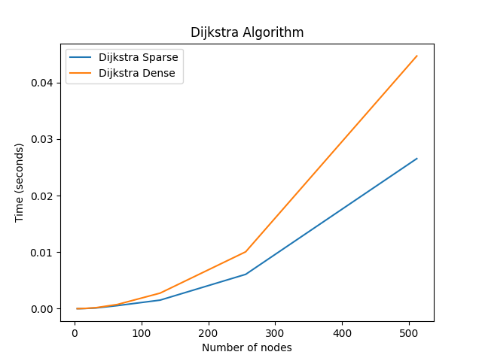**Figure 2. Graph for Dijkstra algorithm**

Floyd-Warshall:

def floyd_warshall(graph):

dist = {i: {j: float('inf') for j in graph} for i in graph}

for i in graph:

dist[i][i] = 0

for j, w in graph[i].items():

dist[i][j] = w

for k in graph:

for i in graph:

for j in graph:

if dist[i][j] > dist[i][k] + dist[k][j]:

dist[i][j] = dist[i][k] + dist[k][j]

return dist

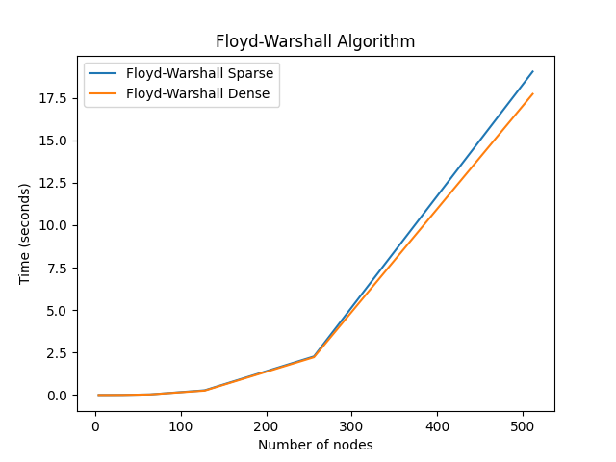

**Conclusion**

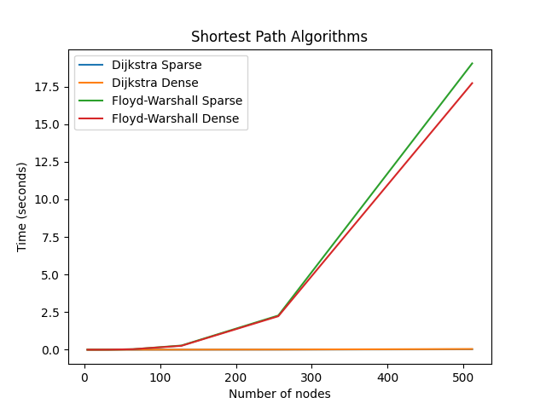This examination illuminates the characteristics and performance of Dijkstra's and Floyd-Warshall algorithms in finding shortest paths in graphs. Both algorithms offer efficient solutions for determining the shortest path between pairs of vertices, yet they operate on different principles and exhibit distinct computational complexities under various conditions.

Dijkstra's algorithm, with its greedy approach, explores paths based on the accumulated shortest distances from a source node to all other nodes. Its time complexity depends on the implementation, but generally ranges from O(V^2) to O((V + E)logV), making it suitable for sparse and dense graphs alike. However, it requires non-negative edge weights for correctness and may not handle negative cycles.

On the other hand, Floyd-Warshall algorithm employs dynamic programming to compute shortest paths between all pairs of vertices, ensuring completeness and correctness even with graphs containing negative edge weights, as long as there are no negative cycles present. Despite its cubic time complexity of O(V^3), Floyd-Warshall's efficiency remains acceptable for moderately sized graphs.

In conclusion, the choice between Dijkstra's and Floyd-Warshall algorithms depends on the specific characteristics of the graph and the requirements of the problem at hand. Dijkstra's algorithm excels in scenarios where edge weights are non-negative and only require the shortest path from one source to all other vertices. In contrast, Floyd-Warshall algorithm offers a comprehensive solution for finding shortest paths between all pairs of vertices, making it suitable for more general cases but at the cost of higher computational complexity. Understanding the strengths and limitations of each algorithm enables informed decision-making when solving graph-related problems.