

Ministry of Education and Research of the Republic of Moldova

Technical University of Moldova

Department of Software and Automation Engineering

**REPORT**

Laboratory work No. 4

**Discipline**: Cryptography and Security

Elaborated: Berco Andrei, FAF - 221

Checked: asist. univ., Nirca Dumitru

Chișinău 2024

## Topic: Cypher Blocks. DES Algorithm

## Tasks:

To develop a program in one of the preferred programming languages for implementing an element of the DES algorithm. The task will be chosen based on the student's ordinal number nn in the group list, according to the formula: nr_task=nmod  11nr\_task = n \mod 11. For each task, the tables used and all intermediate steps must be displayed on the screen. The input data should either be user-provided or generated randomly.

Task 2.3: In the DES algorithm, K+ is given. Determine the round key Ki for a given i.

## Theoretical notes:

### Data Encryption Standard (DES) - Overview

1. **Type**: Symmetric-key block cipher.
2. **Block Size**: 64-bit blocks.
3. **Key Size**: 56 bits (plus 8 parity bits).
4. **Structure**: Based on the Feistel network with 16 rounds.

### DES Algorithm Steps:

1. **Initial Permutation (IP)**: Rearranges the input bits.
2. **16 Rounds**:
   * Expansion (E): Expands 32 bits to 48 bits.
   * Key Mixing: XOR with the 48-bit round key (KiK_iKi​).
   * Substitution (S-Box): Reduces 48 bits to 32 bits.
   * Permutation (P): Rearranges bits.
3. **Final Permutation (FP)**: Inverse of the initial permutation.

### Key Generation:

* 56-bit key (K+K^+K+) generates 16 round keys (KiK_iKi​) via bit shifts and permutations.

### Security:

* **Strength**: Simple design with strong diffusion and confusion principles.
* **Weakness**: 56-bit keys are vulnerable to brute-force attacks; replaced by AES and 3DES in modern use.

**Implementation:**

# Permutation tables for DES

PC1 = [

    57, 49, 41, 33, 25, 17, 9,

    1, 58, 50, 42, 34, 26, 18,

    10, 2, 59, 51, 43, 35, 27,

    19, 11, 3, 60, 52, 44, 36,

    63, 55, 47, 39, 31, 23, 15,

    7, 62, 54, 46, 38, 30, 22,

    14, 6, 61, 53, 45, 37, 29,

    21, 13, 5, 28, 20, 12, 4

]

PC2 = [

    14, 17, 11, 24, 1, 5,

    3, 28, 15, 6, 21, 10,

    23, 19, 12, 4, 26, 8,

    16, 7, 27, 20, 13, 2,

    41, 52, 31, 37, 47, 55,

    30, 40, 51, 45, 33, 48,

    44, 49, 39, 56, 34, 53,

    46, 42, 50, 36, 29, 32

]

#### **1. Permutation Tables (**PC1 **and** PC2**):**

* **PC1**: Used to permute the 64-bit input key (K+ into a 56-bit key by removing parity bits.
* **PC2**: Reduces the combined 56-bit key (after shifts) to 48 bits for round keys (Ki).

# Shift schedule

SHIFT_SCHEDULE = [1, 1, 2, 2, 2, 2, 2, 2, 1, 2, 2, 2, 2, 2, 2, 1]

#### **2. Shift Schedule (**SHIFT_SCHEDULE**):**

* Defines the number of left shifts to be applied to each half of the key (C and D) for each of the 16 DES rounds.

def left_shift(bits, shift):

    """

    Perform a left circular shift on the given bits.

    """

    return bits[shift:] + bits[:shift]

**left_shift(bits, shift)**:

* Performs a circular left shift on a binary string by a given number of positions.

def apply_permutation(bits, table):

    return ''.join(bits[i - 1] for i in table)

**apply_permutation(bits, table)**:

* Maps the input bits to new positions based on a permutation table (e.g., PC1 or PC2).

def generate_round_key(k_plus, round_index):

    # Step 1: Apply PC1 to the 64-bit key to reduce it to 56 bits

    permuted_key = apply_permutation(k_plus, PC1)

    print(f"Key after PC1 permutation (56 bits): {permuted_key}\n")

    # Step 2: Split into two halves (C and D)

    c, d = permuted_key[:28], permuted_key[28:]

    print(f"Initial C0: {c}")

    print(f"Initial D0: {d}\n")

    # Step 3: Perform left shifts as per the shift schedule

    for i in range(round_index):

        c = left_shift(c, SHIFT_SCHEDULE[i])

        d = left_shift(d, SHIFT_SCHEDULE[i])

        print(f"After round {i + 1} shift:")

        print(f"C{i + 1}: {c}")

        print(f"D{i + 1}: {d}\n")

    # Step 4: Combine C and D after the final shift

    combined_key = c + d

    print(f"Combined key after final shift (56 bits): {combined_key}\n")

    # Step 5: Apply PC2 to derive the 48-bit round key

    round_key = apply_permutation(combined_key, PC2)

    print(f"Round Key K{round_index} after PC2 permutation (48 bits): {round_key}\n")

    return round_key

**generate_round_key(k_plus, round_index)**:

* Implements the DES key schedule for generating round keys:
  1. Applies PC1 to derive a 56-bit key.
  2. Splits the key into two 28-bit halves (C and D).
  3. Applies left shifts as per the shift schedule for the specified round.
  4. Combines shifted halves and applies PC2 to derive the 48-bit round key.

**Results:**

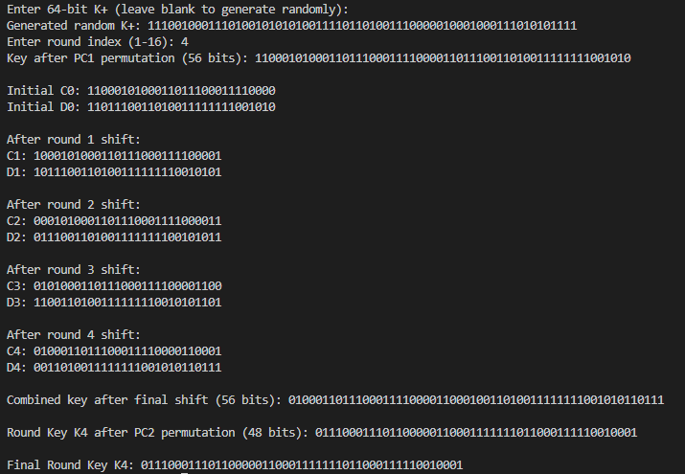

**Conclusion**

In this laboratory work, we explored the key generation process of the DES (Data Encryption Standard) algorithm, focusing on the derivation of round keys. We implemented critical steps, including the use of permutation tables (PC1 and PC2), bit shifts, and the combination of key halves. Through this, we gained hands-on experience with key concepts such as:

1. **Permutations**: The significance of rearranging bits to enhance security and randomness.
2. **Circular Shifting**: The role of left shifts in introducing variation between rounds.
3. **Round Key Generation**: The importance of deriving unique keys for each DES round to ensure cryptographic strength.

The implementation allowed us to visualize intermediate steps and understand how DES transforms the initial key into round-specific keys. This practical understanding reinforces the importance of structured transformations and permutations in cryptographic algorithms. Overall, this lab demonstrated the foundational principles behind symmetric encryption and provided valuable insights into the workings of the DES algorithm.