Packet Tracer - Logical and Physical Mode Exploration 1.0.5

What are the subcategories for Network Devices?

* Routers
* Switches
* Hubs
* Wireless Devices
* Security
* WAN Emulation

What devices use a wired connection to connect to switch ALS2?

* Switch ALS1
* Access_Point
* Web Server

Which device is connected to Access_Point?

* Laptop_1

Where is the device connected to Access_Point physically located?

* On the table

## Packet Tracer - Network Representation 1.5.5

List the intermediary device categories:

* Switches
* Hubs
* Routers
* Wireless devices

Without entering into the internet cloud or intranet cloud, how many icons in the topology represent endpoint devices (only one connection leading to them)?

* 15

Without counting the two clouds, how many icons in the topology represent intermediary devices (multiple connections leading to them)?

* 13

How many end devices are **not** desktop computers?

* 8

How many different types of media connections are used in this network topology?

* 4

In Packet Tracer, only the Server-PT device can act as a server. Desktop or Laptop PCs cannot act as a server. Based on your studies so far, explain the client-server model.

* The client-server model is a distributed application structure that divides tasks or workloads between the providers of a resource or service, called servers, and service requesters, called clients.

 List at least two functions of intermediary devices

* Intermediary devices such as routers and switches are responsible for forwarding data packets between different network segments.
* Intermediary devices also perform traffic management and control functions to optimize network performance and ensure quality of service

List at least two criteria for choosing a network media type

* What is the maximum distance that the media can successfully carry a signal?
* What is the environment in which the media will be installed?
* What is the amount of data and at what speed must it be transmitted?
* What is the cost of the media and installation?

Explain the difference between a LAN and a WAN. Give examples of each.

* A LAN is a network infrastructure that provides access to users and end devices in a small geographical area. A LAN is typically used in a department within an enterprise, a home, or a small business network.
* A WAN is a network infrastructure that provides access to other networks over a wide geographical area, which is typically owned and managed by a larger corporation or a telecommunications service provider.

In the Packet Tracer network, how many WANs do you see?

* 2

How many LANs do you see?

* 3

The internet in this Packet Tracer network is overly simplified and does not represent the structure and form of the real internet. Briefly describe the internet.

* The internet is a worldwide collection of interconnected networks (internetworks, or internet for short). The internet is not owned by any individual or group. Ensuring effective communication across this diverse infrastructure requires the application of consistent and commonly recognized technologies and standards as well as the cooperation of many network administration agencies

What are some of the common ways a home user connects to the internet?

* Cable
* DSL (Digital Subscriber Line)
* Cellular
* Satellite
* Dial-Up Telephone

 What are some common methods that businesses use to connect to the internet in your area?

* Dedicated Leased Lines
* Metro Ethernet
* Business DSL
* Satellite

 Add an end device to the topology and connect it to one of the LANs with a media connection. What else does this device need to send data to other end users? Can you provide the information? Is there a way to verify that you correctly connected the device?

* We will need to configure: IP Address, Subnet Mask, Default Gateway, DNS Server
* We could check the ping, IP Configuration, Network Activity

Add a new intermediary device to one of the networks and connect it to one of the LANs or WANs with a media connection. What else does this device need to serve as an intermediary to other devices in the network?

* Interface configuration
* VLAN Configuration

Open a new instance of Packet Tracer. Create a new network with at least two LANs connected by a WAN. Connect all the devices. Investigate the original Packet Tracer activity to see what else you might need to do to make your new network functional. Record your thoughts and save your Packet Tracer file. You may want to revisit your network later after you have mastered a few more skills.

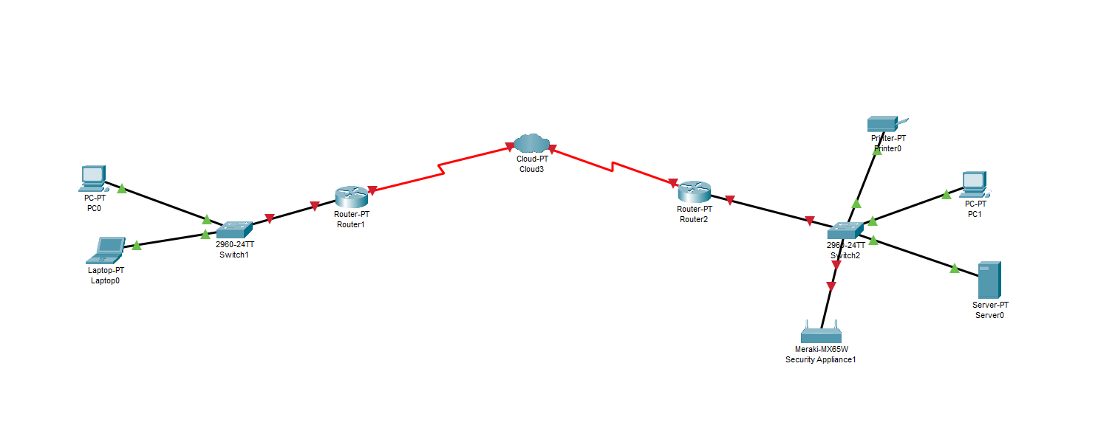

## Packet Tracer - Configure Initial Switch Settings 2.5.5

How many Fast Ethernet interfaces does the switch have?

* 24

How many Gigabit Ethernet interfaces does the switch have?

* 2

What is the range of values shown for the vty lines?

* 0 – 15

Which command will display the current contents of non-volatile random-access memory (NVRAM)?

* show startup-config

Why does the switch respond with “startup-config is not present?”

* there is no start-up conf present in NVRAM

Why is the **login** command required?

* Cause it enables authentication on the terminal line, requiring users to enter valid credentials

What is displayed for the enable secret password?

* $1$mERr$ILwq/b7kc.7X/ejA4Aosn0

Why is the enable secret password displayed differently from what we configured?

* Because it is encrypted

When will this banner be displayed?

* When login or upon accessing privileged mode

Why should every switch have a MOTD banner?

* Security awareness
* legal compliance