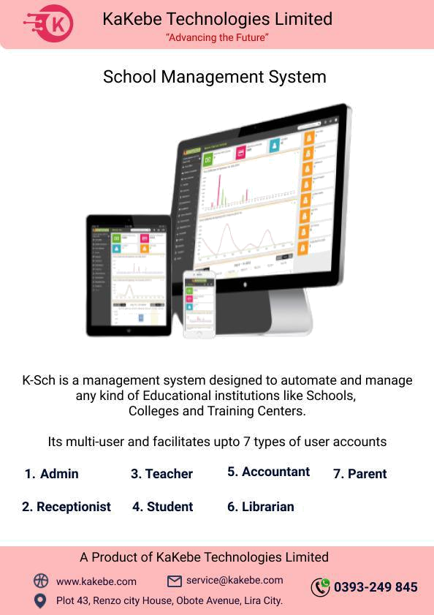

Abstract

- Managing students and other resources are crucial for any school. Smart School helps you to manage everything in centralize way -

- Take student admission with powerful student admission form add 40+ records for student including previous school details. Add student siblings, RTE, IDs and multiple documents to maintain complete record in student profile.

- Search student with different criteria and keywords.
- Student profile consist 360* student record with admission, personal, contact, fees, exam and document details.

- Promote student in next academic session based on pass/fail and continue/leaving school.

- Categories students in a class-section based on different criteria like caste, their skill ability etc.

- Most advanced fees collection mechanism to adopt any type of fees structure including fees type, fees groups, fees masters, free hand fees, due date, fine, discount, fees and discount allotment on more than 5 different criteria. State of the art fees collection page. Various fees reports.

- Manage school other income and expense head wise with receipt upload.
- Manage student attendance smartly in few clicks. Get attendance report monthly class-section wise.

- Complete examination management from exam create to exam schedule to marks entry to progress report with grades.

- Manage classes, section subjects, teacher, assign subject and create class timetable.

- Manage downloadable content for students, teacher like syllabus, assignments, study material etc.

- Complete library management system with books add, members add, books issue/return.

- Manage school vehicle/bus/van, routes, driver details.
- Manage school hostel, hostel rooms with room types.
- Send messages to students, parent and teachers through notice board.
- Get various reports based on students, fees statement, transaction, balance fees, attendance, exam.

INTRODUCTION

School Management System:
A school management system is a large database system which can be used for managing school’s daily work. It is configurable and can be configured to meet most individual school’s needs. It is a multi-user system. Generally Speaking, it is platform available for running on a Local Area Network (LAN).It is used for handling all teachers and students details, also has information about student and teacher details, personal details and other details. Here all the work is computerized.

Necessity:

School management application helps to overcome boring paper work in school. This Application is very easy to use. It can work accurately and very smoothly in different scenario. It reduces effort work load and increase efficiency in work. In aspects of time value it is worthy. In this Application teacher can manage student’s grade sheet, update their marks, managing online leave application, students and teacher’s registration. Administrative Staff can add or remove teacher and student from database via this application. They also can register themselves.

PROJECT PROPOSAL

Mission
Online web based application is very popular and well known to everyone.
nowadays everybody wants to get it and work with it.
School management application runs every school in everywhere. It was originally built for teachers, students, staffs and administrations.

When a teacher works in manually then he/she faces some problems. Sometimes they lose their data or randomize their data.

With the help of an online school management system he/she works fluently and frequently.

Online web based application is easy application provides school teachers and students to use this application for several purposes. First of all every teachers and students need to register in this application and then go through their work.

Goal
The goal of this online application for school management.
Using this application, teachers can check students grade sheet, update their marks, leave application, check student’s upgrades, student’s and teacher’s registration.

When any teacher knows that he/she is not good in their studies then the teacher can connect his/her parent and tell them about their children’s studies.

Scope
This school management system application is for school teachers, principal,students, admin which is very easy to use for their work purpose. The application works with most popular browser i.e. Mozilla Firefox., Google Chrome, Opera, Edge, etc.
Target Audience:
This system is basically on school management.
Administrative staff, teacher & student of a school can use this application via web protocol.

Students can register themselves, check their result and update their profile. They also can view their class routine and related resources from this Web application.

Teachers can register themselves on this site; they can update & publish students result. They can update their profile.

Teacher can apply for their leave by using online leave application. Administrative Staff can add or remove teacher and student from database via this application.

They also can register themselves.
2,000+ users can use this.

Benefits to Customer:
It reduces effort to maintain data in effective manner.
Teachers can easily see the status and progress of the students.
Students can see, get information when they need by simply accessing the site. Data management in the system is much easier in this way as because there is no way to loss/theft of data.

Environment:
This system is a web-based that requires a server that will run on a machine with 24 * 7 monitoring.

Users can access this system anywhere. This system can run on any machine. They do not need any high configuration machine.

They need Pentium processor, 256 MB RAM, 16 bit operating system, Internet Explorer, Mozilla Firefox and Google Chrome.

Stakeholders:
Administrative staff, teachers & students of a school can use this application via web protocol.

Performance and Capacity Needs:
2,000+ users can use the application.
Use common processor.
Use available Operating System.
Working with most common browser.
Design:
GUI: Graphical User Interface.
Here are given page-mock-ups of application (Screenshots) where user can interact with the application in their respective departments.

Admin Dashboard
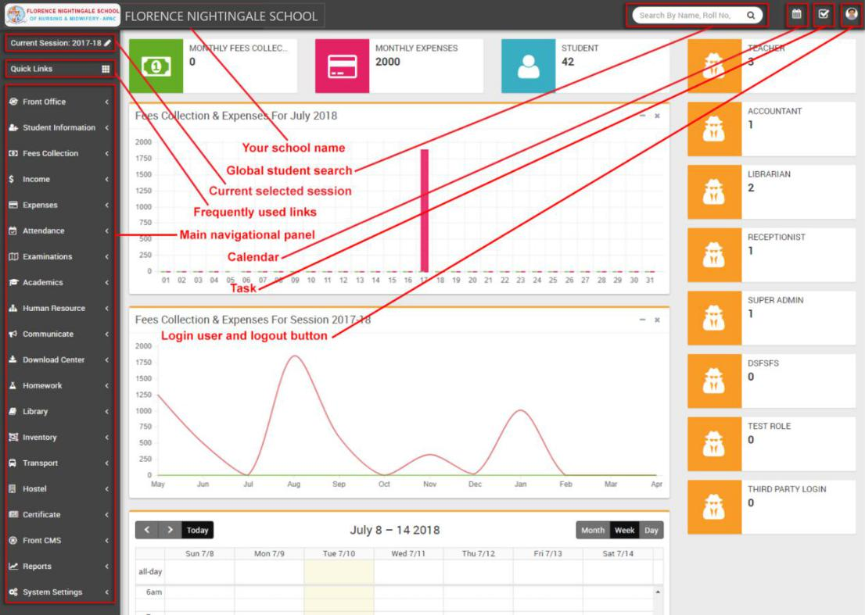

Student Information
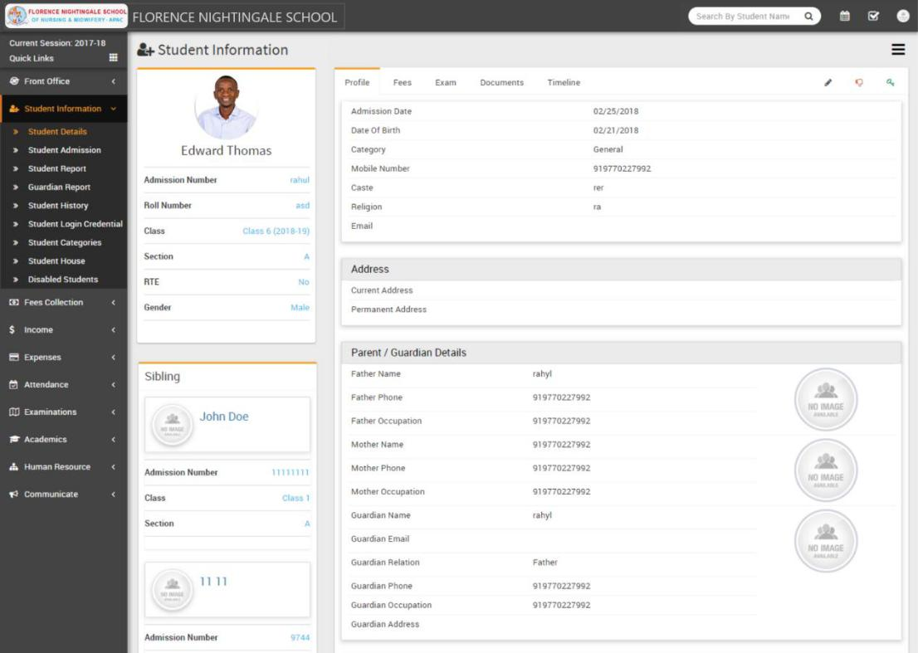
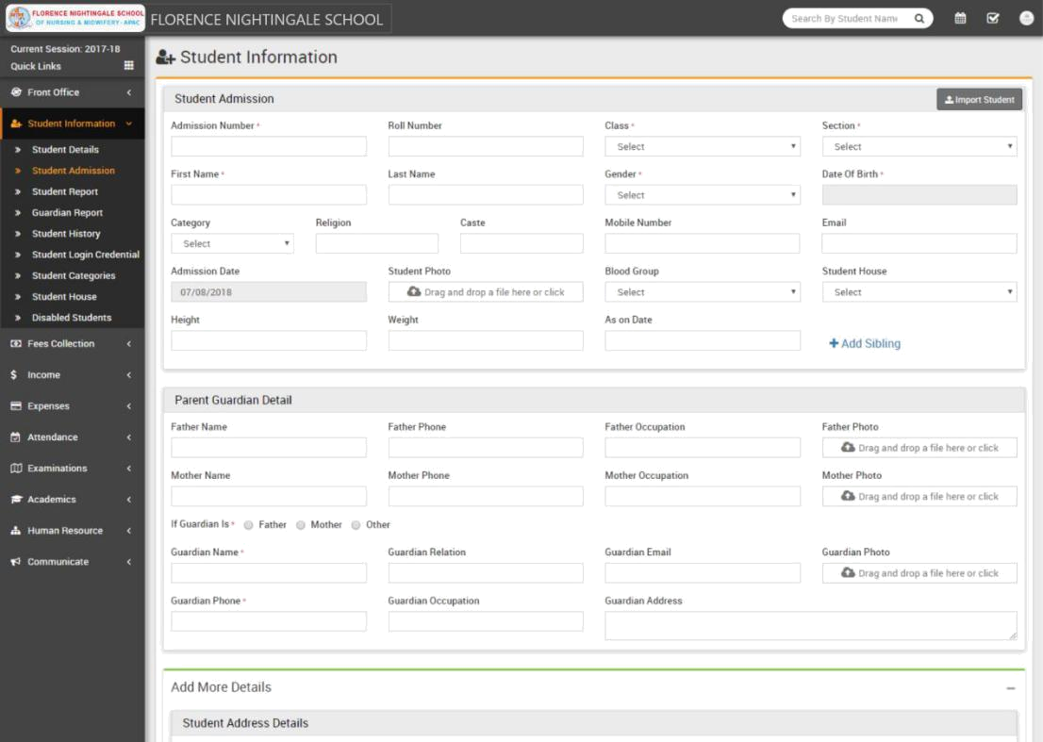

Human Resource.
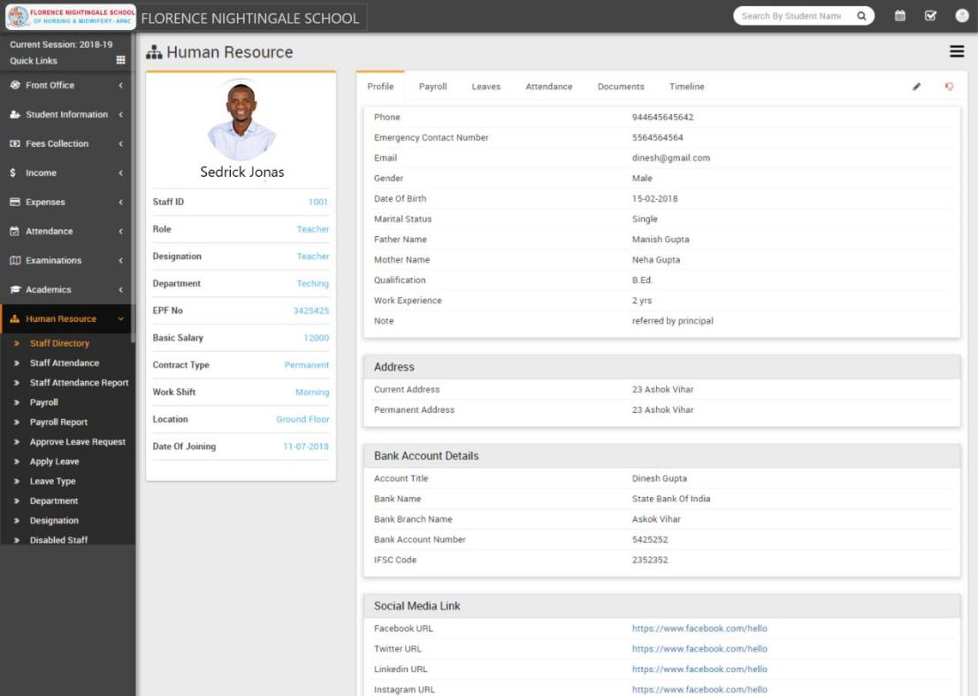

Fees Collection.
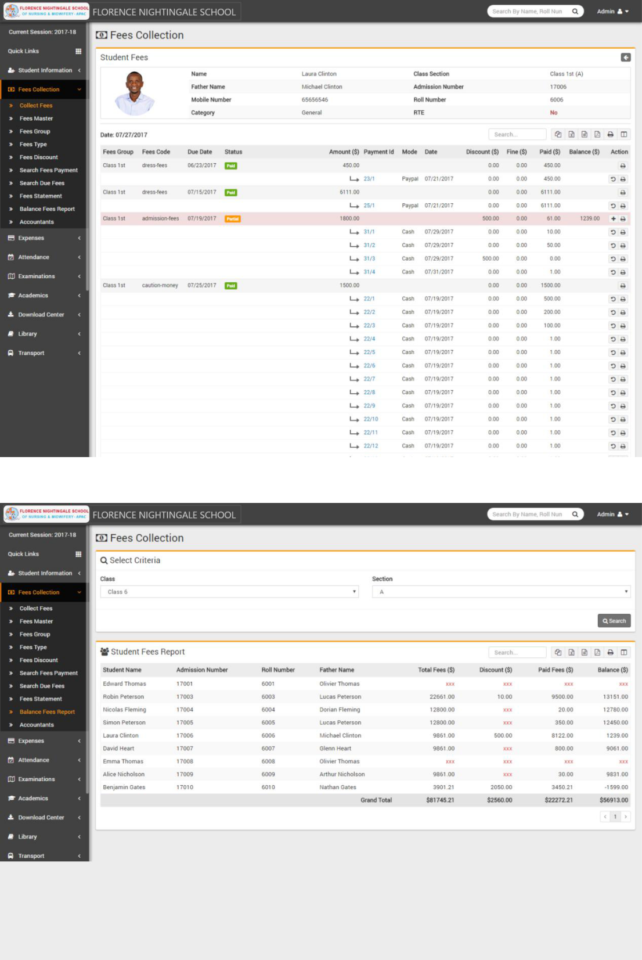

Academics.
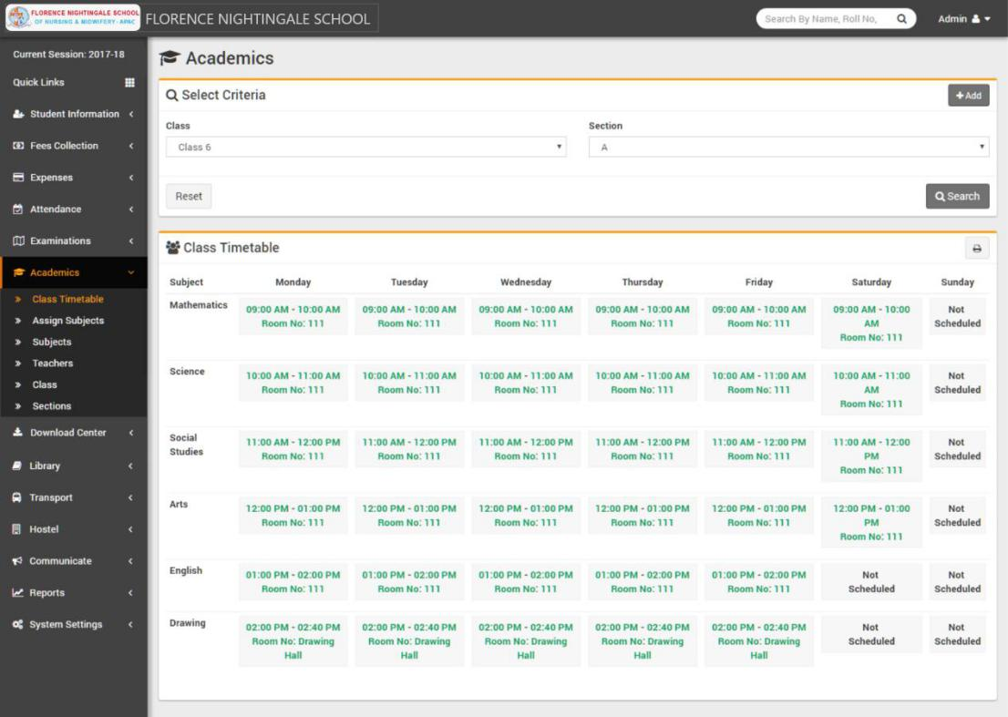

Attendance.
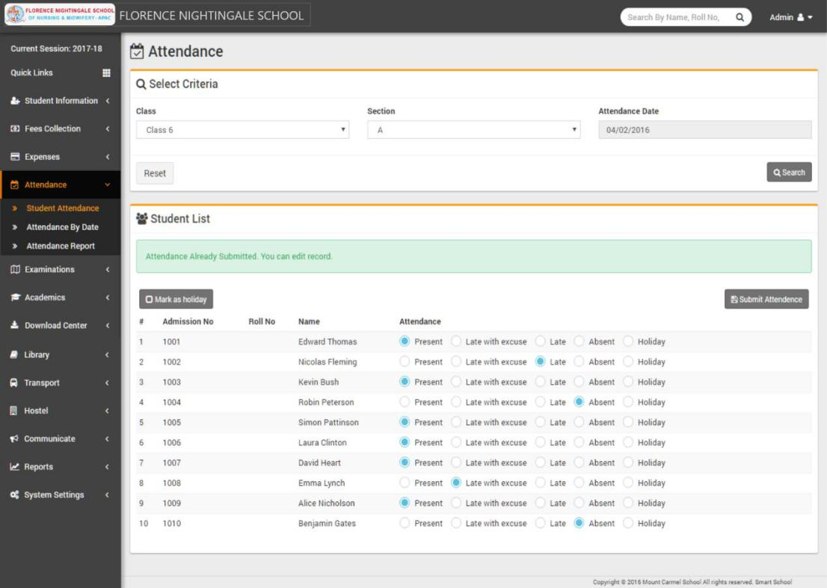

Download Center.
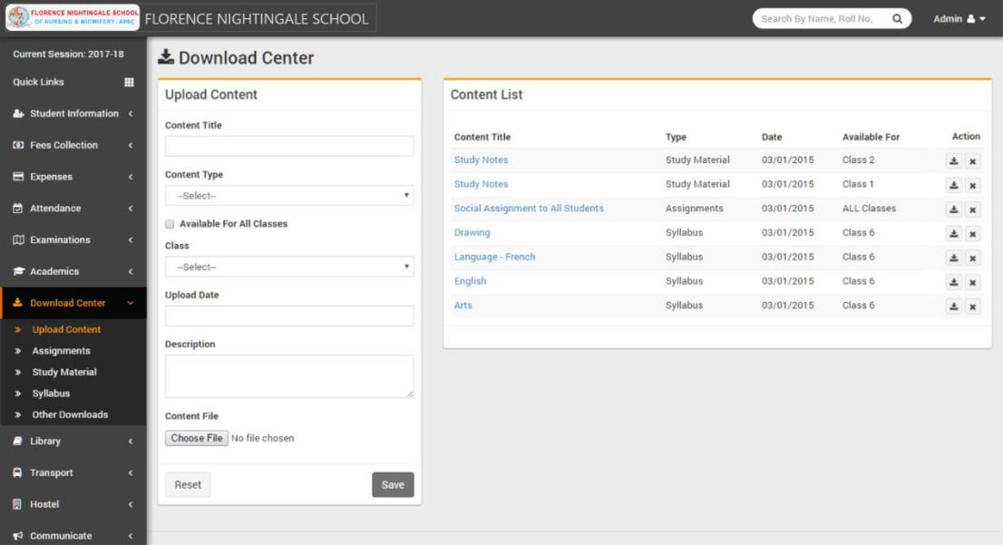

Reports.
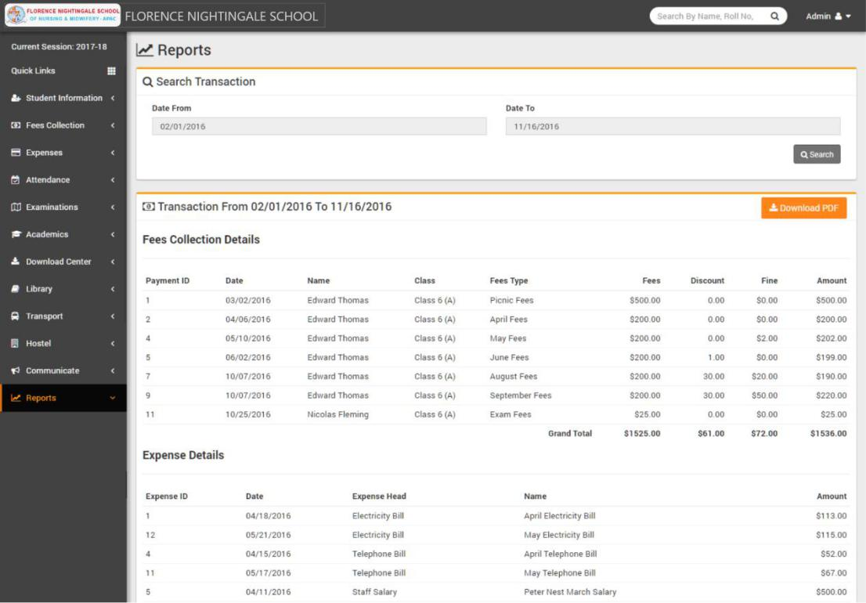

System Settings.
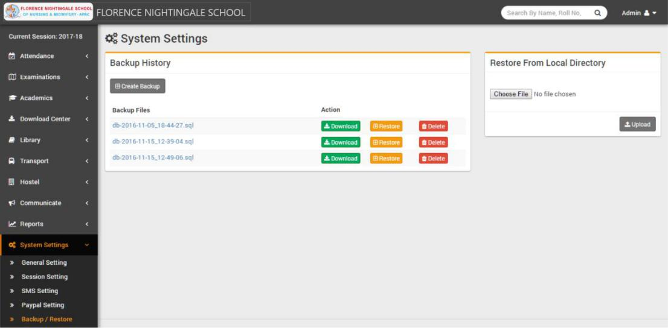

Top Features
