

**Revision and Signoff Sheet**

**Change Record**

| **Author** | **Version** | **Change reference** | **Date** |
| --- | --- | --- | --- |
| Thinh Nguyen Phuc | 0.1.0 | Initial draft | 25/3/2025 |
|  |  |  |  |

**Table of Contents**

**1. Introduction** **5**

**1.1. Purpose** **5**

**1.2. Scope** **5**

**1.3. Intended Audiences and Document Organization** **5**

**1.4. References** **5**

**2. Functional Requirements** **6**

**2.1. Use Case Description** 44

**2.2. List Description** **44**

**2.3. View Description** **44**

**3. Non-functional Requirements** **44**

**4. Other Requirements** **46**

Archive Function 46

**5. System requirements** **46**

Custom Pages 46

Scheduled Agents 46

Technical Concern 46

**6. Appendixes** **46**

Glossary 46

Messages 47

Issues List 48

# Introduction

# Purpose

The purpose of this Software Requirements Specification and Design Document is to clearly define the functional and non-functional requirements of the sell airline tickets mobile application. It serves as a comprehensive reference for all stakeholders involved in the development, including developers, designers, testers, and project managers.

# Scope

The scope of this SRS documentation encompasses:

* Detailed descriptions of the functional requirements of the application, including user authentication, search flight/airline information, promotional services , booking, and payment.
* Specification of non-functional requirements such as performance, security, and usability criteria.
* Assumptions and constraints that may impact the development and deployment of the application.
* Outlining of any external interfaces or dependencies necessary for the proper functioning of application.
* Identification of any features or functionalities that are explicitly excluded from the scope of this documentation.

# Intended Audiences and Document Organization

The primary audience for this documentation includes:

* Development team members responsible for implementing the software.
* Quality assurance personnel tasked with testing the application.
* Project managers overseeing the development process.
* Stakeholders and clients interested in understanding the requirements and functionalities of application.

# References

| **#** | **Title** | **File Name / Link** |
| --- | --- | --- |
| 1 | Instagram | <https://instagram.com> |
| 2 | Pinterest | <https://pinterest.com> |
| 3 | Unsplash | <https://unsplash.com> |

# Functional Requirements

# Use Case Diagram

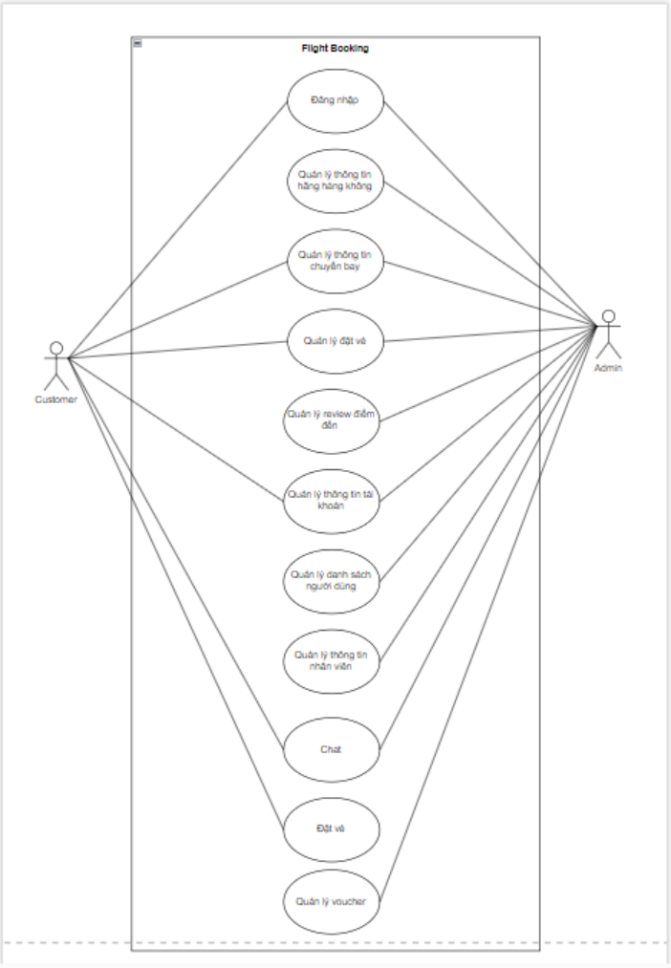

# Use Case Description

### UC1: Sign up

| **Name** | **Sign up** |
| --- | --- |
| **Description** | This use case allows users to sign up for their own account in StyLLe application . They can choose between two options to sign up, sign up with email and password or with Google |
| **Actor** | User |
| **Trigger** | * A user want to sign up for a new account |
| **Pre-condition** | * The staff has accessed the StyLLe interface. |
| **Post-condition** | * POST-1. The user can log in with their newly created account. |

#### 

#### Sequence Diagram

### 

#### Business Rules

| **Activity** | **BR Code** | **Description** |
| --- | --- | --- |
| ***(1)*** | ***BR1*** | **Loading Screen Rules:**   * The system loads the “Sign up” screen. |
| ***(2)*** | ***BR2*** | * The system signs up a new account for user with “signUp” method.   **[signUp] method**   * There are 2 options to sign up, "emailPassword" or "Google"   + If [signupOption] = "emailPassword", the user has to enter his [email] and [password] as account credentials.     - If [email] and [password] is "valid", then show a success message for the user.     - If [email] and [password] is "inValid", then show error message for user and require re-enter his credential   + If [signupOption]= "Google", then their google accounts be checked by GoogleAuthService     - If the checked account is "valid" then show a success message for the user.     - If the checked account is "inValid" then show an error message for the user. * On [Error], throw [GenericException] |

### UC2: Sign in

| **Name** | **Sign in** |
| --- | --- |
| **Description** | When the users want to access the StyLLe application or do some actions like viewing photos, uploading photos… they have to sign in to the application. |
| **Actor** | User |
| **Trigger** | * The user indicates that he wants to access the application. |
| **Pre-condition** | * PRE-1. User already had his own account. |
| **Post-condition** | * POST-1. User is logged in to the application and can do actions in the application. |

#### Sequence Diagram

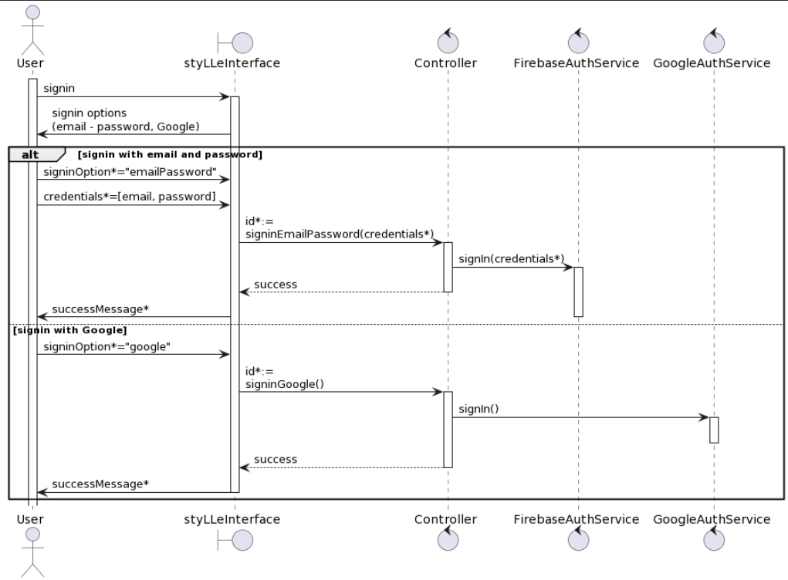

#### Business Rules

| **Activity** | **BR Code** | **Description** |
| --- | --- | --- |
| ***(1)*** | ***BR3*** | **Loading Screen Rules:**   * The system loads the “Sign in” screen. |
| ***(2)*** | ***BR4*** | * The system signs the user in with “signIn” method   **[signIn] method**   * There are 2 options to sign in, "emailPassword" or "Google"   + If [signupOption] = "emailPassword", the user has to enter his [email] and [password], then the system will check his account information in database     - If [email] and [password] is "exist", then show a success message for the user, leading the user to the Home screen of the app.     - If [email] and [password] is "notExist", then show an error message for the user and require re-enter his credential.   + If [signupOption]= "Google", then their google accounts be checked by GoogleAuthService     - If the checked account "exist" then shows a success message for the user, leading the user to the Home screen of the app.     - If the checked account is "notExist" then show an error message for the user. * On [Error], throw [GenericException] |

### UC3: Change password

| **Name** | **Modify Image** |
| --- | --- |
| **Description** | The user can change their old password to a new password for more convenience or insecure security. |
| **Actor** | User, Admin |
| **Trigger** | * A user indicates that he needs to change his account password. |
| **Pre-condition** | * The user has accessed the StyLLe application. |
| **Post-condition** | * The user changed his account password successfully. |

#### Sequence Diagram

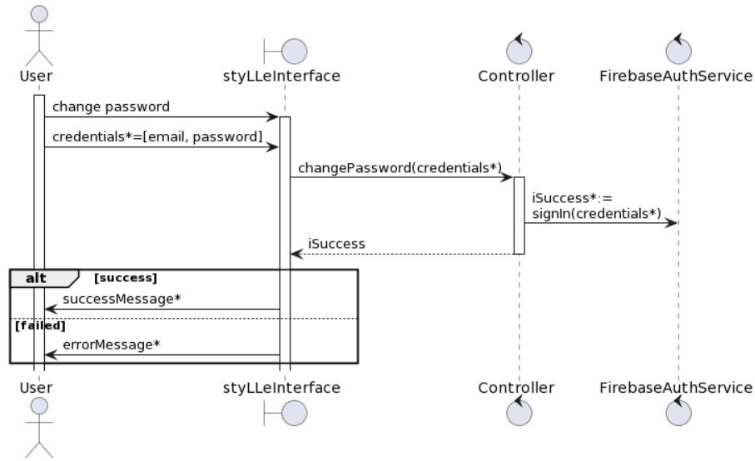

### 

#### Business Rules

| **Activity** | **BR Code** | **Description** |
| --- | --- | --- |
| ***(1)*** | ***BR5*** | **Loading Screen Rules:**   * The system loads the “Change Password” screen. |
| ***(3)*** | ***BR6*** | * The user has to enter his new password, then the system will change the account password with the “changePassword” method.   **[changePassword] method**   * This method takes a “newPassword” as arguments   + If “newPassword” is "valid" then edit the user password with “newPassword”, leading the user to the Sign in page of the app.   + If the new information is "inValid" then throw [NotValidDataException]. * On [Error], throw [GenericException] |

# Non-functional Requirements

|  | Actor  Function | Admin | User |
| --- | --- | --- | --- |
| **1** | **SignUp** |  | X |
| **2** | **SignIn** | X | X |
| **3** | **Change Password** | X | X |
|  | **Images** |  |  |
| **4** | View | X | X |
| **5** | Upload |  | X(*) |
| **6** | Edit |  | X(*) |
| **7** | Delete | X | X(*) |
| **8** | Download/Share |  | X |
| **9** | Like |  | X |
|  | **Tag** |  |  |
| **10** | Use |  | X |
| **11** | Create | X |  |
| **12** | Edit | X |  |
| **13** | Delete | X |  |
| **14** | **Delete Account** | X | X(*) |

X: User has full permission to do the action.

X (*): User has permission to do the action on his own items.

Performance Requirements

**Number of user**

* Number of concurrent user: 100

**Data volume**

* Data growth rate: 20%

**Level of availability**

* 24/7

**Usage frequency**

* Daily

**Location**

* International

**Read-only Duration**

* N/A

**Read-only Timeframe**

* N/A

**Maintenance Window**

* Monthly

**Other plans and activities**

* N/A

# Other Requirements

## Archive Function

Enable Archival Function for following list:

| **List** | **Actor** | **Condition** |
| --- | --- | --- |
| Images | User | Actor is able to archive items in the “Images” list by the created date. |

# System requirements

## Custom Pages

There is no custom page implemented in this application.

## Scheduled Agents

There is no scheduled agent implemented in this application.

## Technical Concern

* Growth Rate is low => less risk in performance
* Huge amount of data => saving/loading issue
* Too much content is in a single page
* Integrate to another systems

# Appendixes

## Glossary

The list below contains all the necessary terms to interpret the document, including acronyms and abbreviations.

| **Term** | **Description** |
| --- | --- |
| *BR* | **B**usiness **R**ule |
| *CBR* | **C**ommon **B**usiness **R**ule |
| *DB* | **D**ata**b**ase |
| *MSG* | **M**es**s**a**g**e |
| *UC* | **U**se **C**ase |
| *N/A* | **N**ot **A**vailable or **N**ot **A**pplicable, used to indicate when information in a certain section could not be provided because it does not apply to this application. |
| *UI* | **U**ser **I**nterface |
| *SRS* | **S**oftware **R**equirements **S**pecification |
| *TBD* | **T**o **b**e **d**etermined or **t**o **b**e **d**efined |

## Issues List

N/A