Open-World City Game (Name W.I.P.)

**Main inspirations:**

Deus Ex 1

Half Life 2

Garry’s mod maps

**Setting:**

The game will be set at night in a gloomy city. The city contains multiple factions, and you can interact with faction members and build and lose reputation by working for them. You do this to work towards a goal.

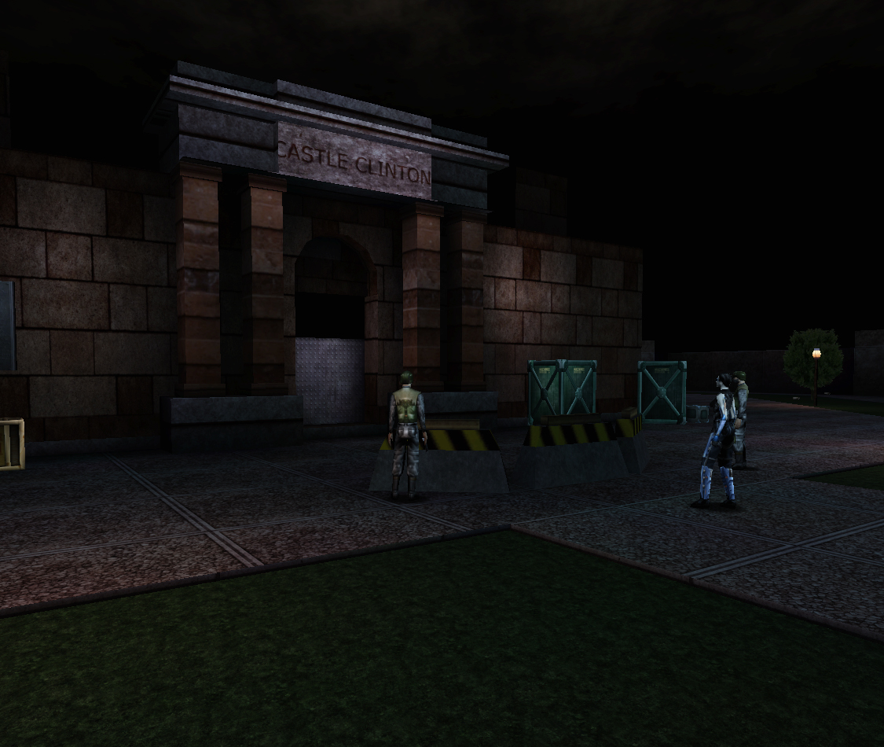**Art:**  
3d models with images projected on them to mimic the art style of half-life and deus ex.

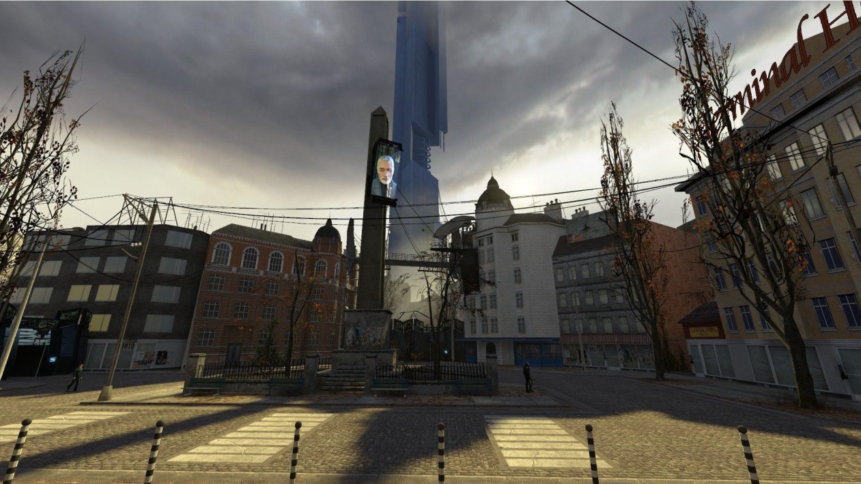

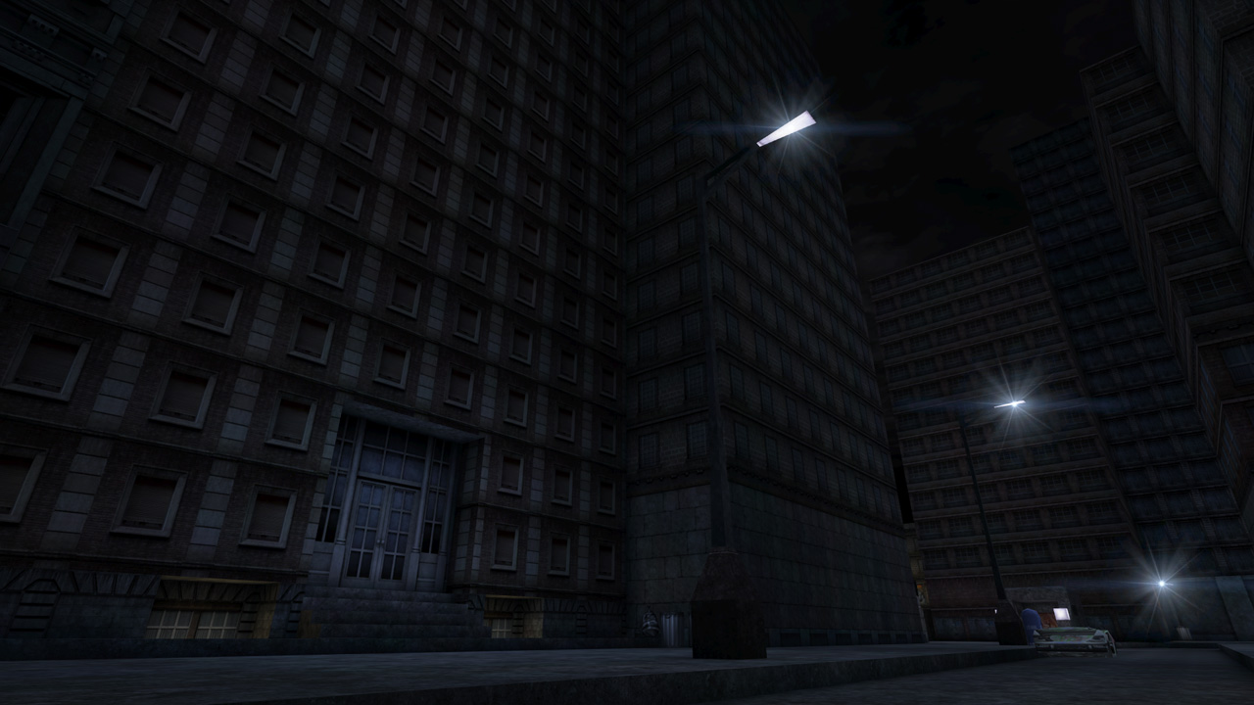

**Notes on art:**

Simple low-poly geometry with real life images slapped on as textures.

Lighting will do 90% of the work to make game look good.

Night time setting means streetlights and moonlight are main sources of lighting.

**Setting:**

The Setting will be in an American city with a totalitarian government which has lost control of its own city, just like a failed state (e.g. Haiti, Syria etc.)

Military vehicles will dot the streets. Gangs and Rebel factions will have their own districts which are controlled.

The player will be surrounded by buildings in every direction, giving a claustrophobic feel.

**Potential Factions:**

**The Government:**  
Totalitarian regime which strictly tries to bring order and discipline to the city, but is failing miserably. Roads are dotted with checkpoints. They use APCs similar in design to the VAB APCs from half life 2.

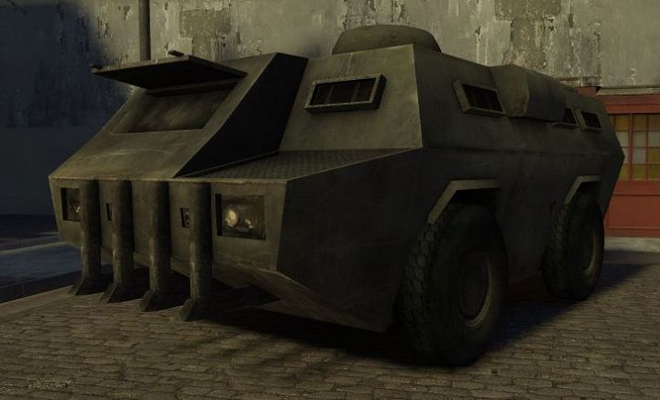

**The Revolutionaries:**

Anti-government faction which follows Marxist ideas of revolution. It regularly tries to fight the government and works behind the scenes. It funds gangs and other illegal groups to try and weaken the government. It has one leader who is hidden and strongly guarded by an elite group of soldiers.

**Yokoma Group:**

South Korean mega-corporation run by a single family. The leader is referred to as the Emperor. They receive tax-breaks and get to own a private military in exchange for supplying the government with weaponry and vehicles. Extremely anti-competitive, most small businesses are bought up by them if possible; else they destroy them by force. Currently the only corporation in the city.

**Los Muerte:**

The deadliest gang in the city, funded by the revolutionaries. They are cruel and hostile to anyone who hasn’t bent a knee to them. They are regularly contracted to kill people, which they do openly by sending a horde of gangsters.

**“The Cool Gang” [sic]:**

Run by the rebellious son of the Emperor, who chose a life of crime over school. Him and his fellow teenage friends run the gang, splurging his father’s money on hiring people to work for him. He pays extremely generously to people who are willing to work for him, and has the goal of overtaking the city.

(Not every faction is joinable to keep scope in control)

**The Goal of the Game:**

The Player’s initial goal is to leave the City by earning enough money to purchase a ticket. Upon having enough money, if they try to leave without completing at least one questline, they will be stopped by a government official, preventing them from leaving over some sort of document problem. They can either overthrow the local government by completing a questline, or doing a short quest which lets the player leave early, such as forging documents.

**Questlines: W.I.P.**

**Key game mechanics:**

First Person camera view.

First person shooting.

Simple inventory system to allow switching weapons.

Journal containing quest logs.

NPCs

Dialogue system which allows making choices

Potential Cutscenes

**Weapons:**

AR-15, Glock, Sniper Rifle, Shotgun, Rocket Launcher, C-4

**Estimated Time To Complete:**

**Few months**