ITURBO

Authors: Karmele Elorza, Joseba Arginzoniz, Diyar Ali
Date: 19/05/2022

INDEX
1 IMAGES INDEX 3
2 PROJECT CONTEXT 4
3 APPLICATION ANALYSIS 4
4 APPLICATION DESIGN 5
4.1 USE CASE DIAGRAM 5
4.2 CLASS DIAGRAM 9
4.3 DATABASE DESIGN 11
5 TASK PLANNING AND REGISTER 12
6 SOFTWARE APPLICATION IMPLEMENTATION/INSTALLATION 12
7 USERS GUIDE 12
8 THOUGHTS 16
9 BIBLIOGRAPHY 16

IMAGES INDEX
img 1: PythonApp general view 5
img 2: PythonApp employees management 5
img 3: PythonApp customers management 6
img 4: PythonApp booking management 6
img 5: PythonApp booking for users management 6
img 6: PythonApp cabins management 7
img 7: PythonApp facturation by month report 7
img 8: PythonApp the best customer report 7
img 9: Web page general view 8
img 10: Desktop APP general view 8
Img 11: appMain, controller and login packages 9
Img 12: model and view packages 9
Img 13: objects package 10
Img 14: reports package 10
Img 15: reports.Class package 11
img 16: Database diagram 11
Img 17: Home page of the webpage 13
Img 18: Users role example 13
Img 19: Login as administrator. Example of changing 14
Img 20: Report page of the java application 14
Img 21: Example of a graphical report 15
Img 22: Main menu on Python app 16
Img 23: Menu of customers 16

PROJECT CONTEXT
A company has contact us for upgrading their actual management system of the garage and for creating a new database of their new service of the DIY Garage. For this purpose, we will be creating a responsive web page, an application for the staff, a server to host our data and another application written in python.

APPLICATION ANALYSIS
This Project consists in developing a management and graphical system for a DIY garage. For this purpose, we will need to use the next elements:
  - Database system: We will need a database system for providing a management between the DIY Garage and its components as customers, the cabins, the tools, the employees, customer´s cars and so on. To achieve this goal, we will need to use an Apache server that will store the database.
  - Information systems: The information system will be used for build the server where will be host the web page and the database. This host will be based on Linux operating system. So in order to do this, we will need to install a XAMP service.
  - Web page: We will need to create a web page where the customers can book the different services and see the facilities, tools, contact us… However, not only the customer part, we will have a first look of the web page that will be a general look of the DIY Garage. We will have a login system for our customers or for the staff of the garage and depending on the type of record they will be able to change things or only read them. On our general look, we will put a menu with a login system, about us information, information to contact us, our services, some offers and a blog of the garage. All the web page will be a responsive web page for all the devices using tools as CSS Bootstrap, JavaScript, JQuery, PHP and so on.
  - Desktop application: We will create a desktop application for the garage staff to be able to manage different reports of the information store on the database. The staff will be able to display some information as today´s occupation of the cabins, their facturation by day or month or see some statistic of the most used services. Apart for displaying, they will be able to save it on a text file.
  - CRUD dashboard application: We will develop an application written in python that will be able to manage the customers, employees and the bookings of the customers. As on the web page, there will be a first login system because in base of the user selected, will be different permissions. With the manager login as admin, will be five options: customer, employees and booking management system, see the facturation by month/day and see the best customer (the more spent, the better customer). In addition, with the user login (staff) will be able only to make a booking and to change and delete that booking. The log out option there will be always visible and the information stored will be available for saving on a file.
  - Prevention of occupational hazards: We will have to take in count all the possible risks that will be on the garage and investigate to minimize or delete them.
  - English: The entire project will be on English. We will make an email asking for a service of the company from a customer and the answer to that email. We will do another email sending the facturation of the service asked with the entire invoice and the answer to it as well from the customer.

APPLICATION DESIGN

USE CASE DIAGRAM
Python APP: This part will show the different use-cases of the Python APP that we will be using.
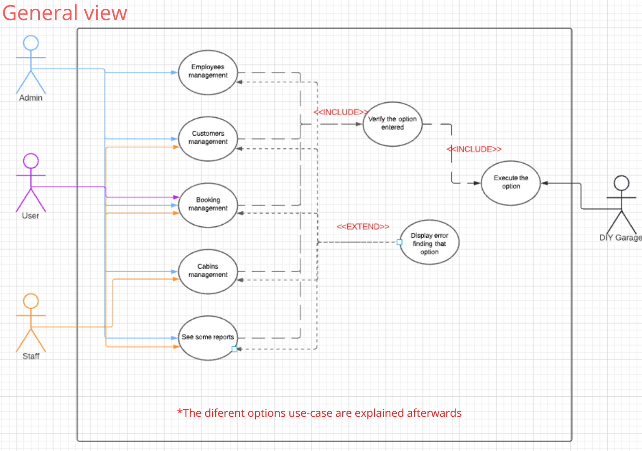
img 1: PythonApp general view
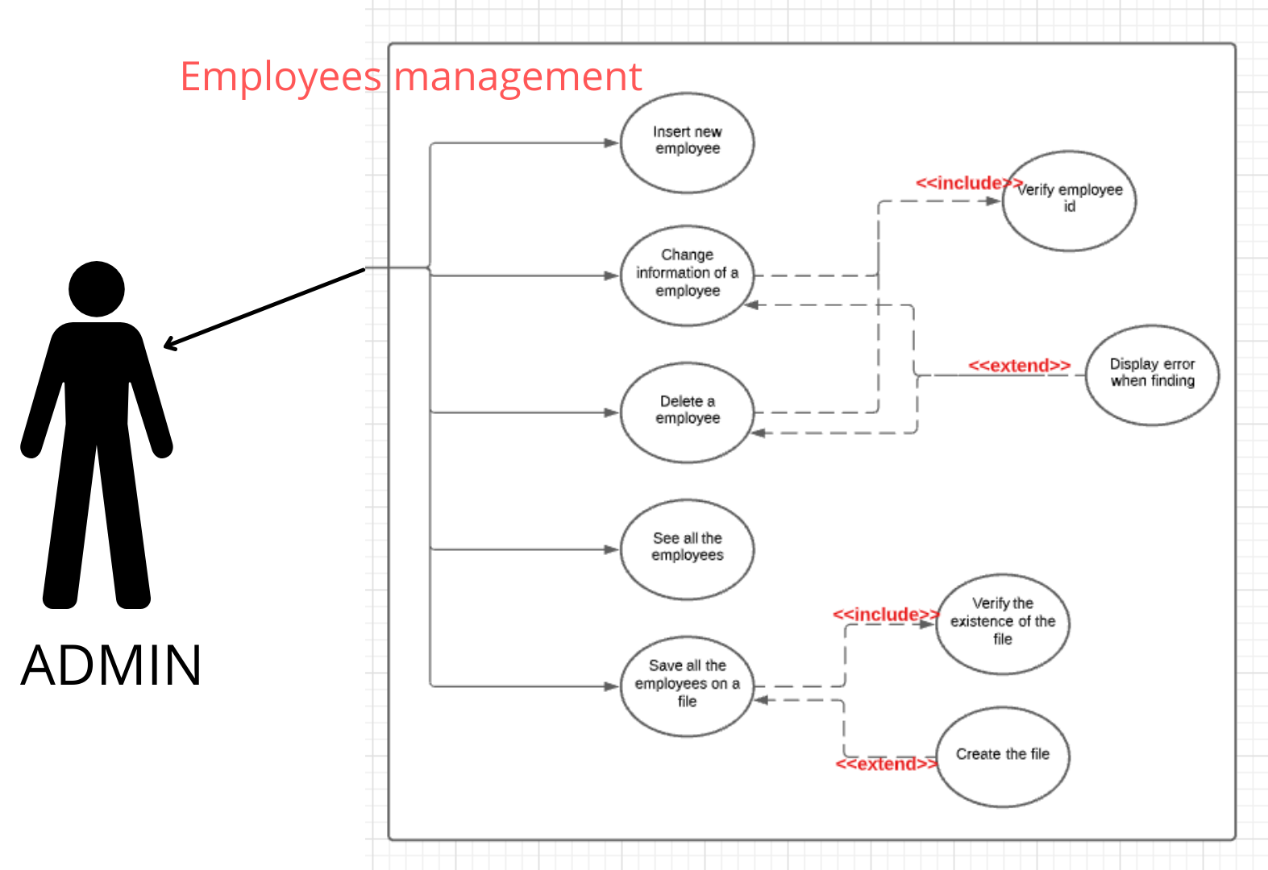
img 2: PythonApp employees management
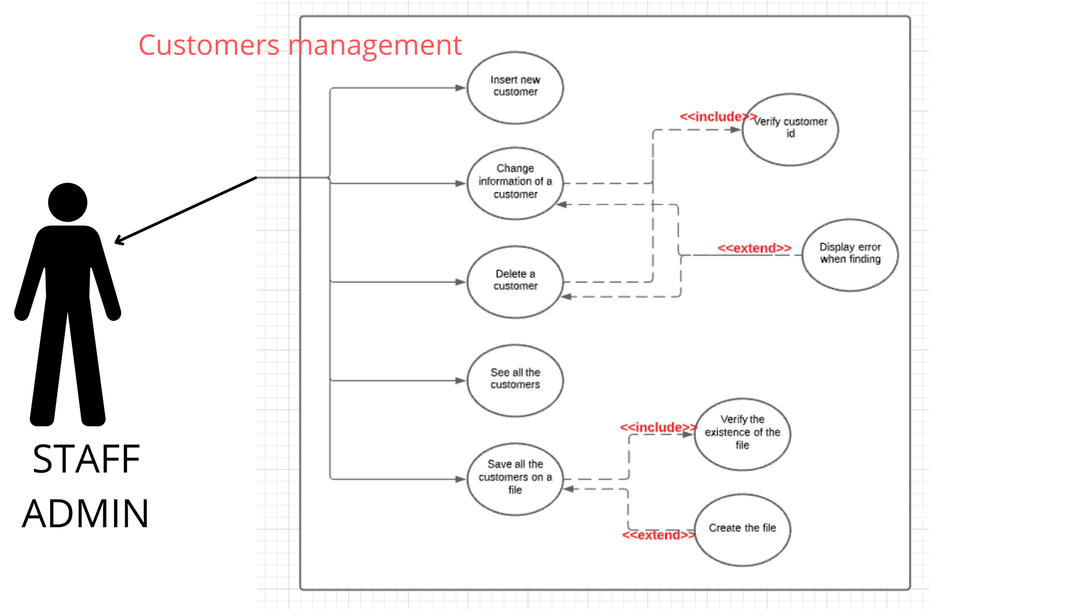
img 3: PythonApp customers management
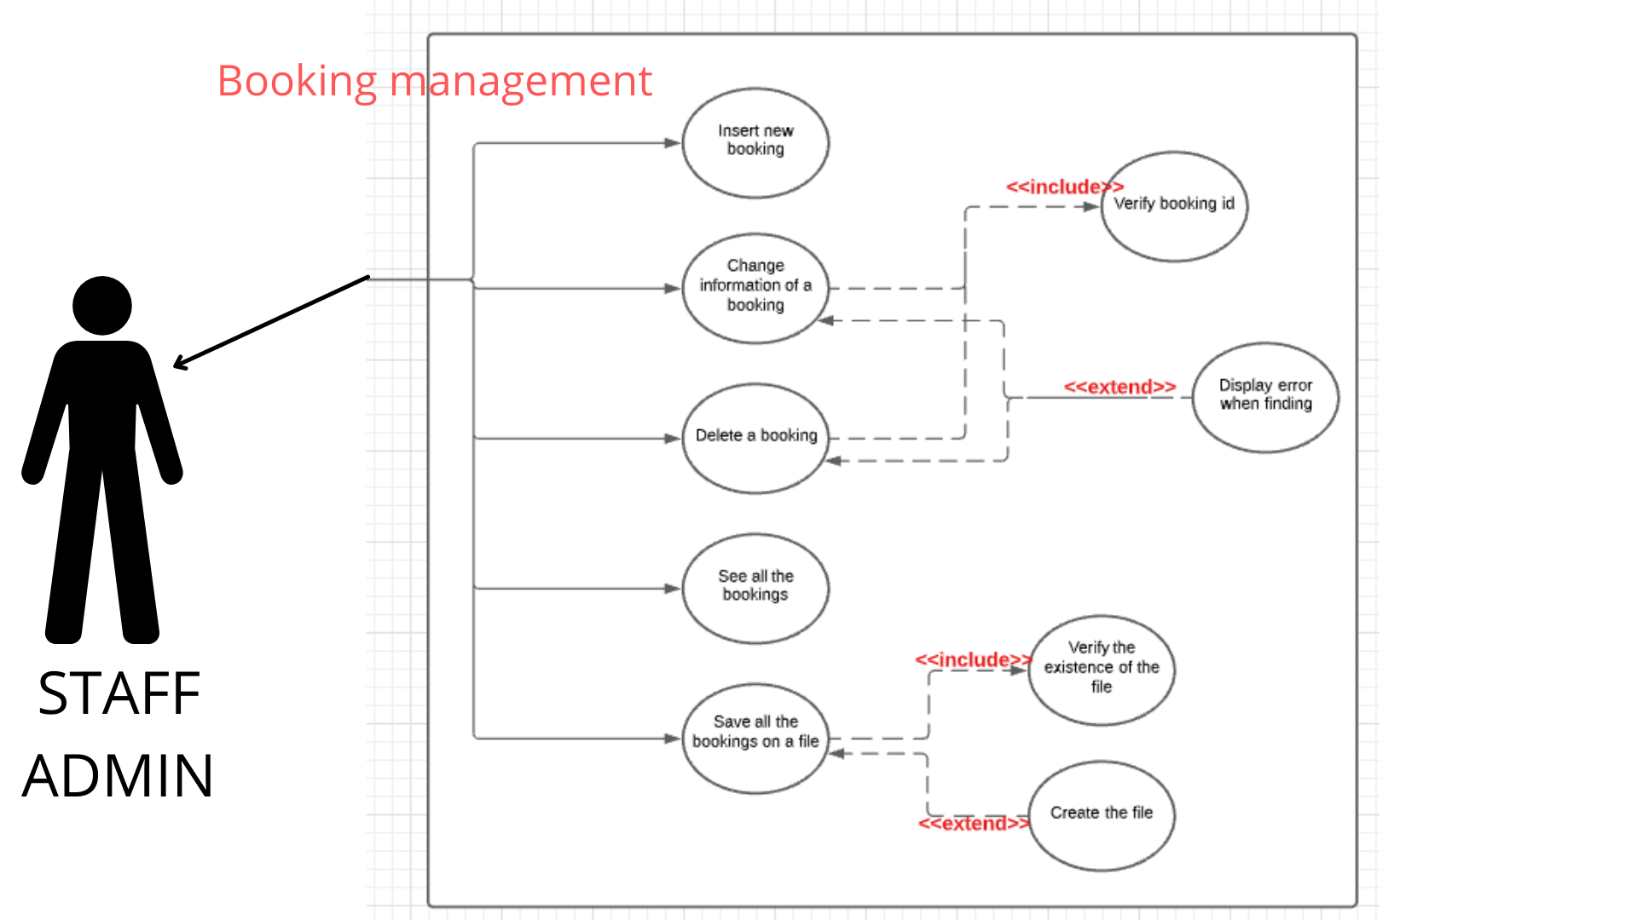
img 4: PythonApp booking management
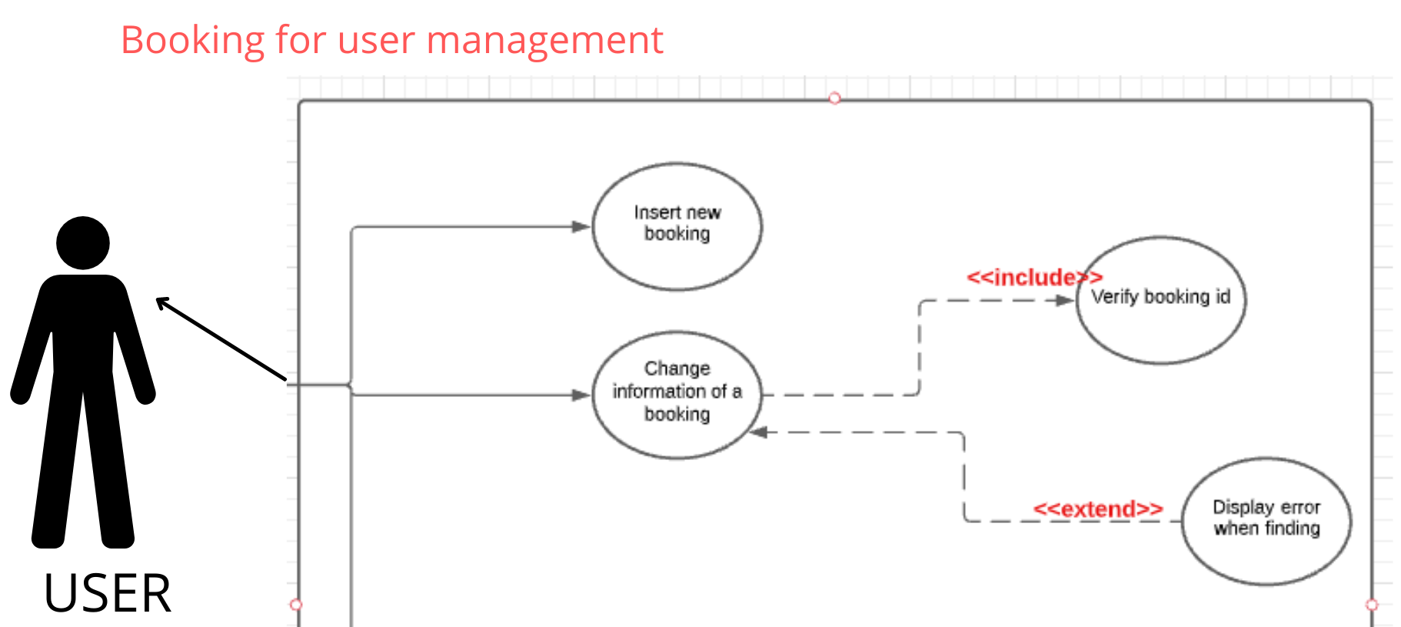
img 5: PythonApp booking for users management

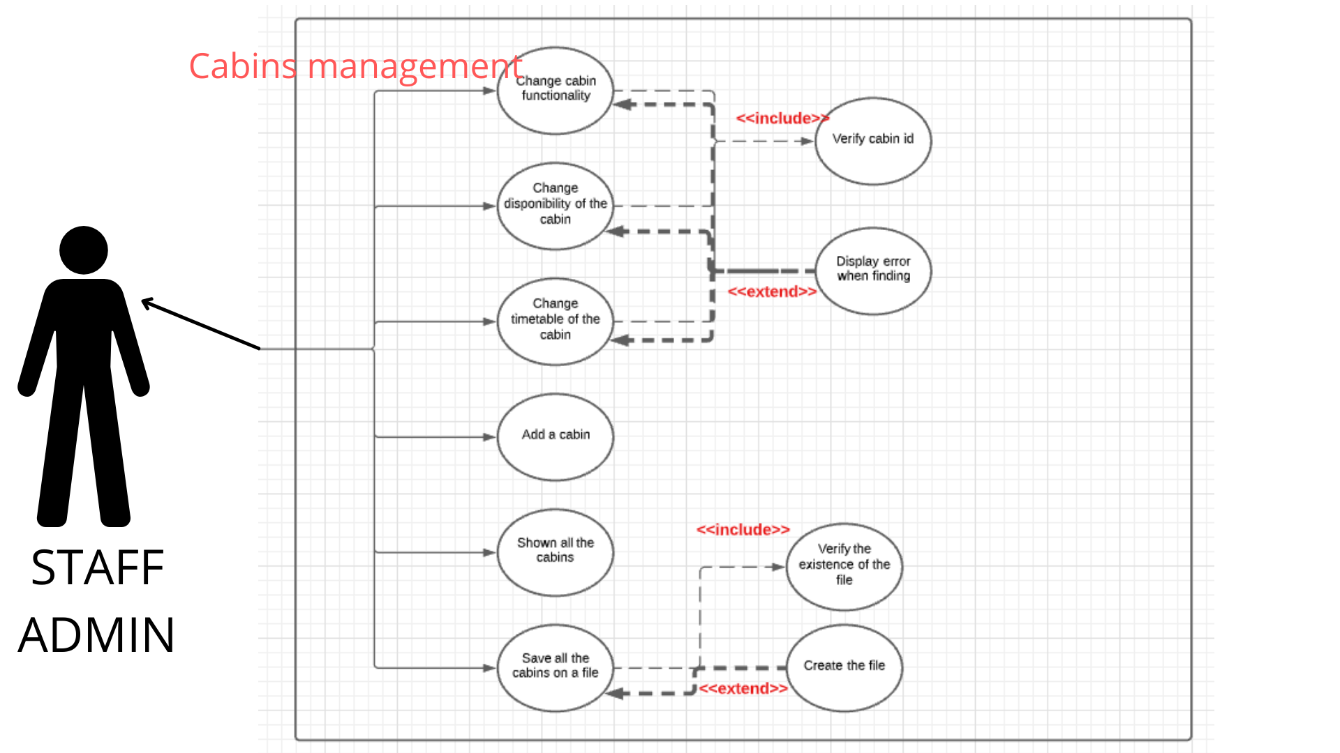
img 6: PythonApp cabins management
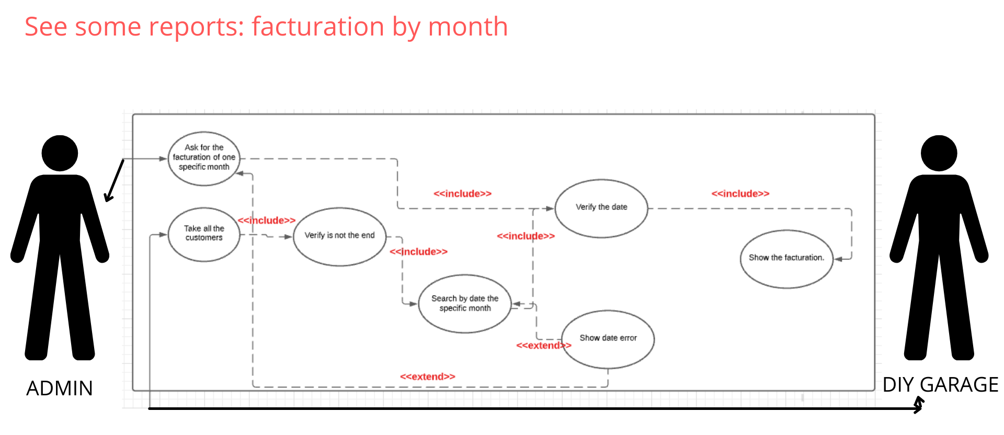
img 7: PythonApp facturation by month report
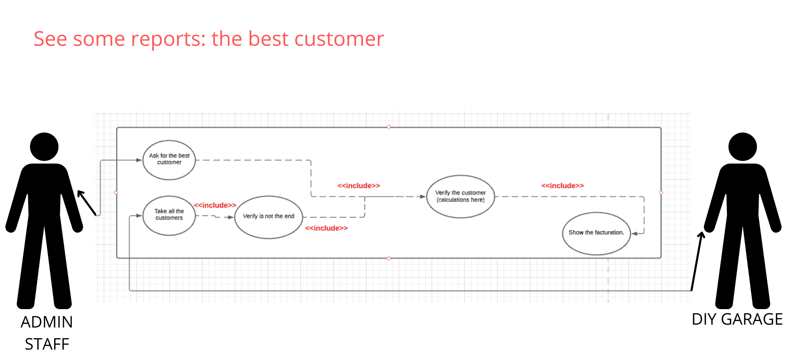
img 8: PythonApp the best customer report

Web page: This part will show the general view use-cases of the web page that we will be using.
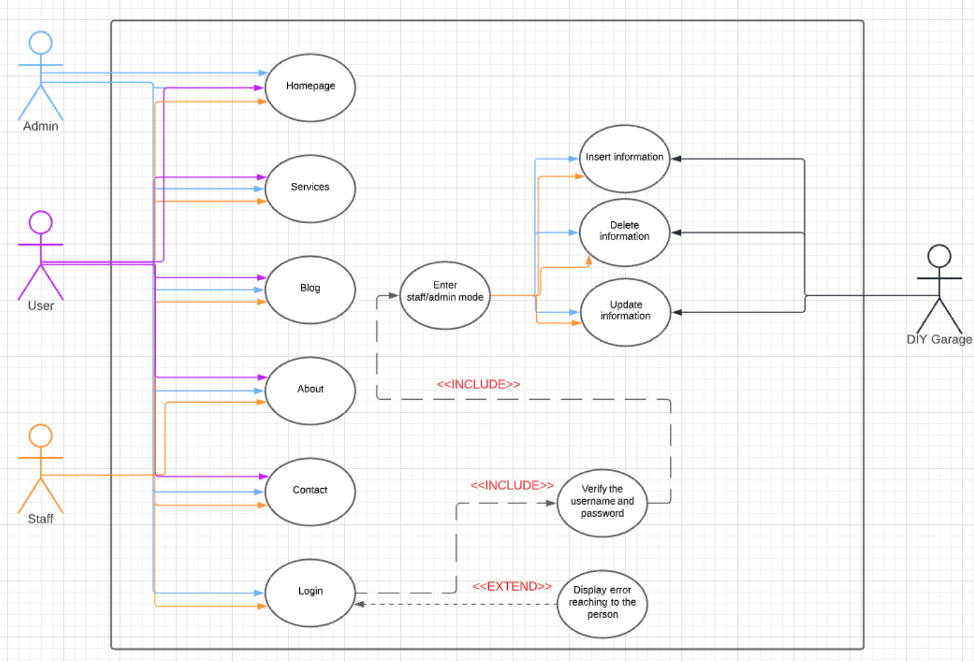
img 9: Web page general view

Desktop APP: This part will show the general view use-cases of the Desktop APP that we will be using.
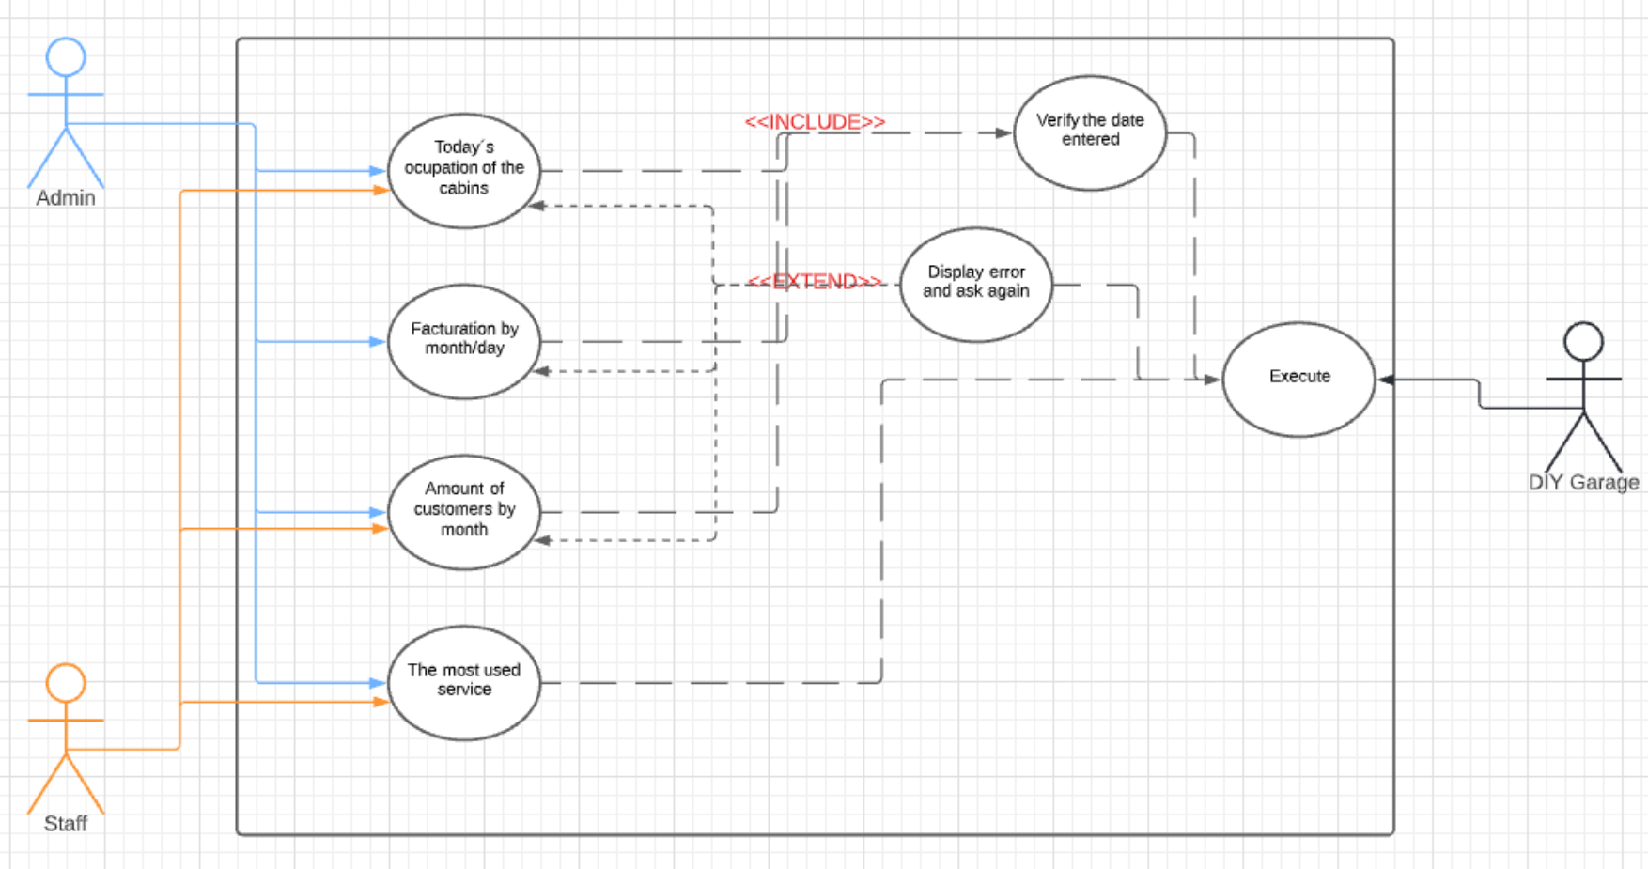
img 10: Desktop APP general view

CLASS DIAGRAM
On this part, we will be showing on the next images our class diagram of the desktop app that will be programed in Java:
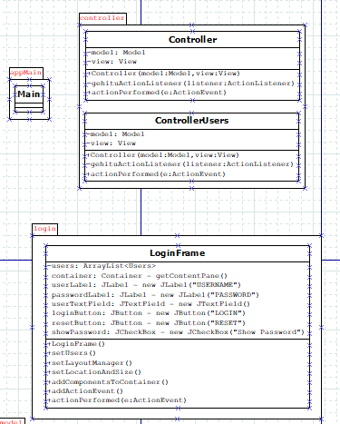
Img 11: appMain, controller and login packages
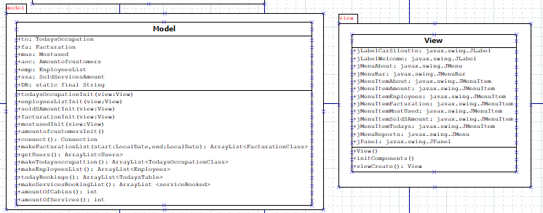
Img 12: model and view packages
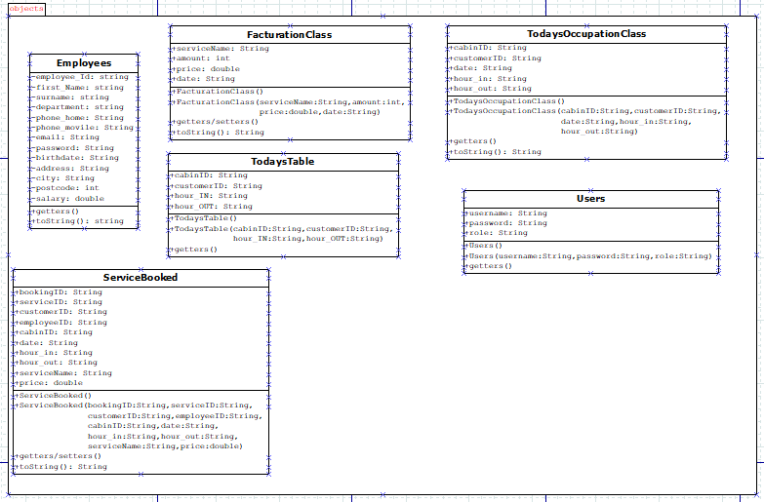
Img 13: objects package

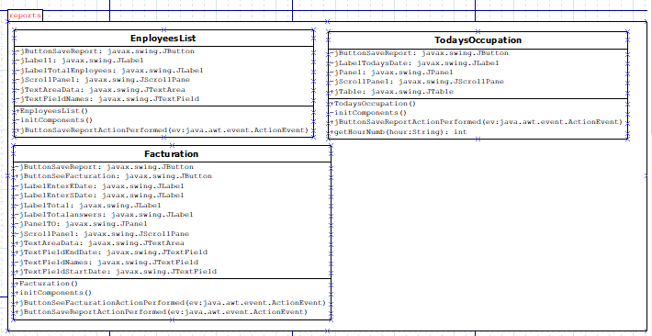
Img 14: reports package

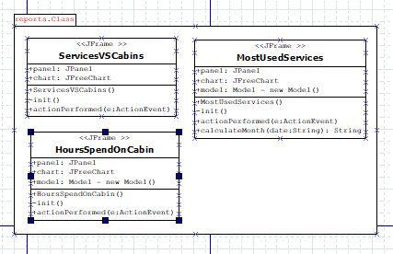
Img 15: reports.Class package

DATABASE DESIGN
On the next part, we will be showing on the next image our database diagram:
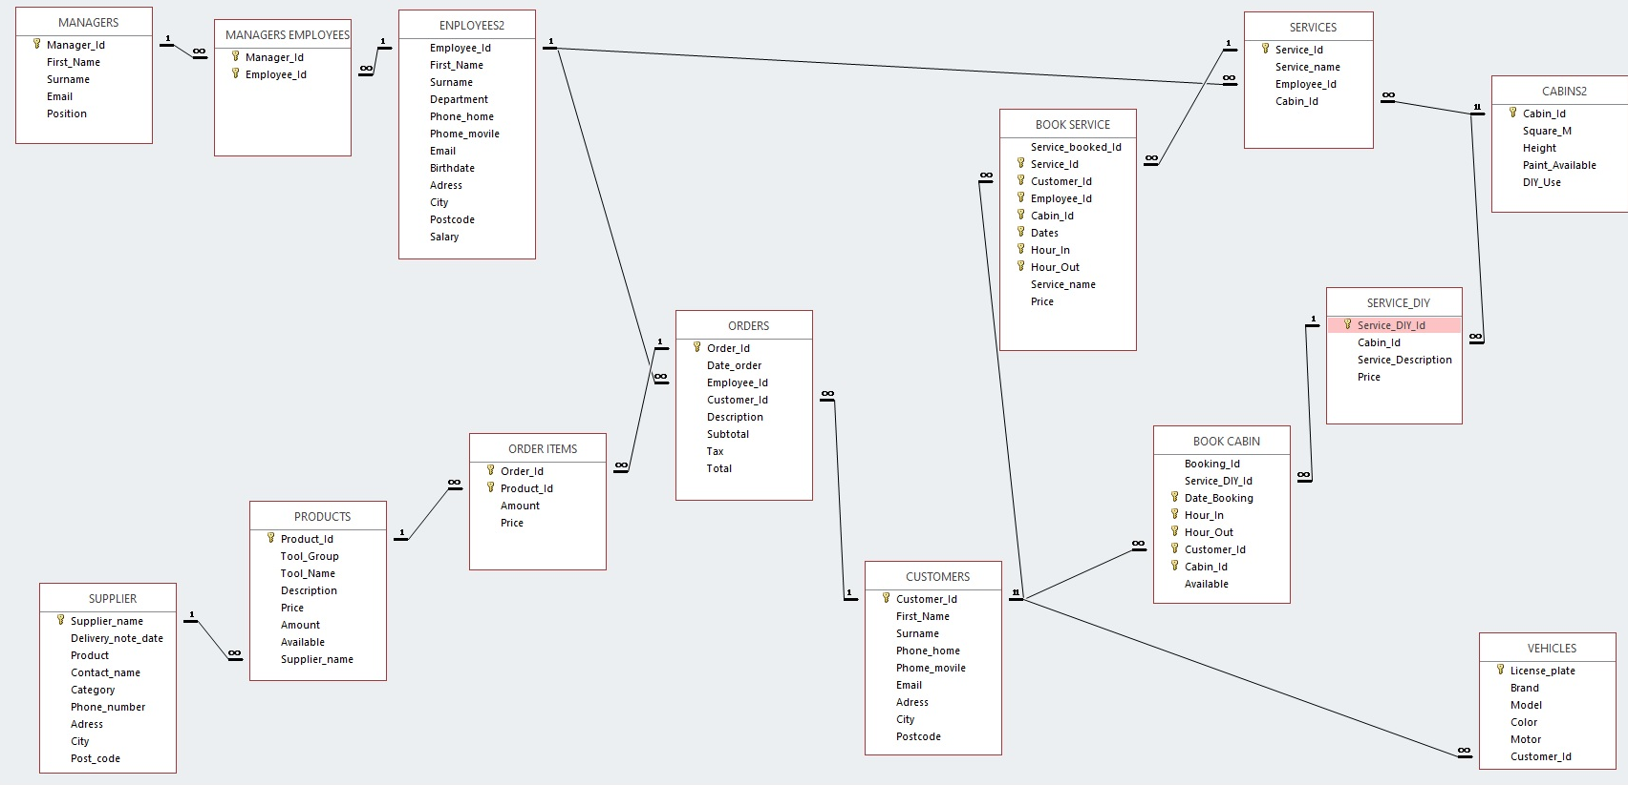
img 16: Database diagram

TASK PLANNING AND REGISTER
TASK1: (Analysis and Design): Goal and methodology: This task will be the starting of our project. On this part, we will analyse our project and making notes of the goals and the design we want to achieve. This task will be a important task for the future as it will be a base for the rest of the tasks.

 | Duration (hours) | Beginning date | Finishing date | Responsible
Task 1: Analysis and Design | 72,05 | 21/03 | 1/04 | All members
Task 2: Making process | 135 | 2/04 | 15/05 | All members
Create java desktop application | 55 | 2/04 | 15/05 | Karmele
Create webpage | 55 | 2/04 | 15/05 | Joseba, Diyar
Create pyhon application | 10 | 2/04 | 15/05 | Karmele
Set up the server | 15 | 2/04 | 15/05 | Joseba
Task 3: Documentation and improving | 40 | 16/05 | 19/05 | All members
Improving java desktop application | 5 | 16/05 | 19/05 | Karmele
Improving webpage | 15 | 16/05 | 19/05 | Joseba, Diyar
Improving pyhon application | 15 | 16/05 | 19/05 | Karmele
Create the documentation | 4 | 18/05 | 19/05 | Karmele
Improve the server | 1 | 17/05 | 18/05 | Joseba
TOTAL | 247,05 HOURS

SOFTWARE APPLICATION IMPLEMENTATION/INSTALLATION
In order to see our project you will need to be on the local network and install a program with one program extra if you want to see the code. The first will be to install java because to execute the desktop application will be needed. The other program will be Visual studio code to be able to see the code.

USERS GUIDE
In order to doing a better understanding of the users guide, the project will be split on different parts.
We are going to start from the webpage that can be seen on the next direction 192.168.72.194/php/ iturbo_garage.php. We are looking forward to change the direction and put our garages name https://iturbogarage.com for not only entering from the local network but we are still working on that.
This will be the very first page:
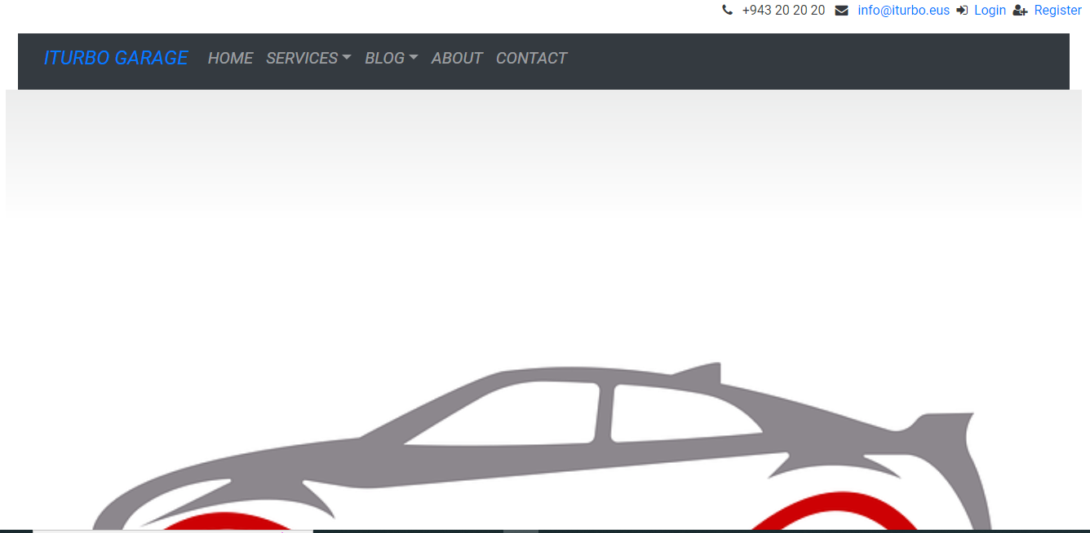
Img 17: Home page of the webpage
As you can see, from the webpage you will be able to see the services we offer, the products that we sell, to contact us and more things. Also, you will be able to register to make a booking of a cabin or to make a purchase. The things that you can do on the webpage will be based on the login role, if you are a customer you can not change or delete something but if you are the administrator you can as you can see on the next image.

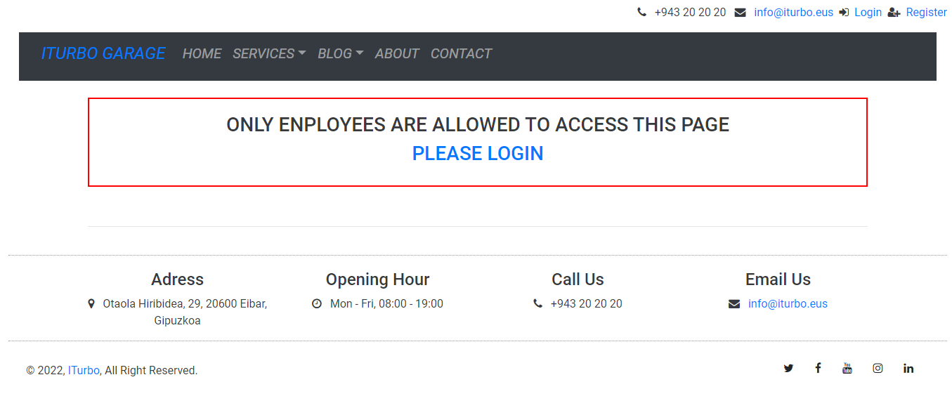
Img 18: Users role example
The data that the webpage manages its stored on a database called iturbo. On this database you can see different data as all the customers, all the employees and so on but also, you can change the database from the webpage login as an administrator.
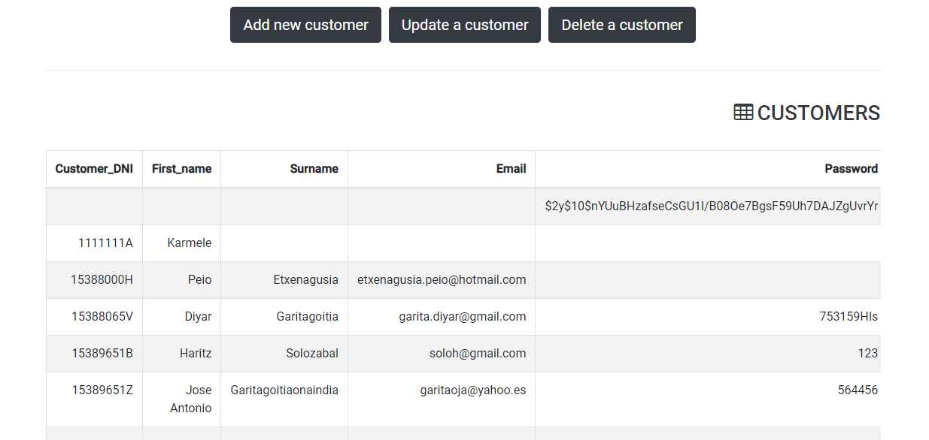
Img 19: Login as administrator. Example of changing
On the other hand, we have two applications for the staff: one is written in python which can see through the terminal and the other is developed in java that can see graphically.
First, we have the java desktop application that will be for the staff to see different reports based on the database. First, you will see a login form to enter the app because the administrator and a staff member will not be able to see the same things. The administrator will have all the access but the staff members only to some of them. There are different reports: the first 3 are text report and other 3 are graphic reports as we can see on the top left of the next image.
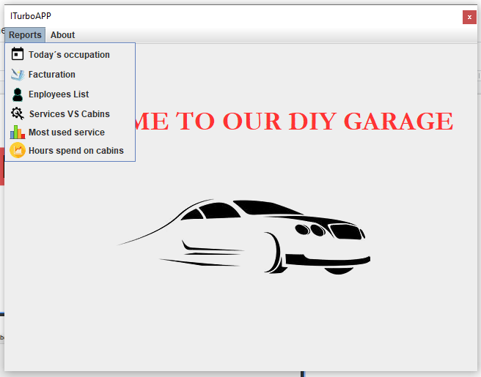
Img 20: Report page of the java application

    - Today´s occupation report is about the bookings of the cabins that exists for that day.
    - Facturation report is about all the services that customers consumed between the gap entered.
    - Employees list report is to display all the employees that work or worked for the company.
    - Services vs cabins is a graphical report that displays the percentage of the bookings between cabins and services.
    - Most used services is a graphical report that displays the different services and the amount of booking them each month.
    - Hours spend on cabins is a graphical report that displays the total of hours spend on each cabin by customers as you can see on the next image.

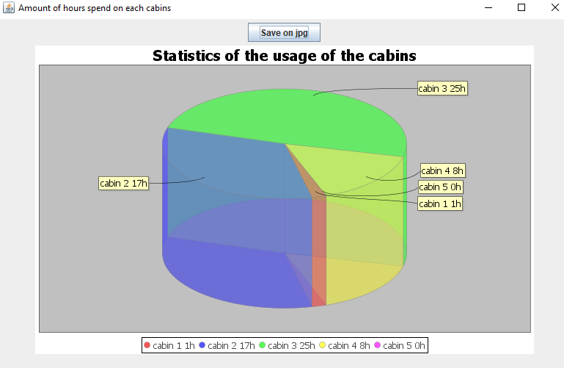
Img 21: Example of a graphical report

Secondly the other application programmed in python works on the terminal. Firstly, it has a main menu where you can choose between some options as employee, customers, products and soon management system as you can see on the next image.
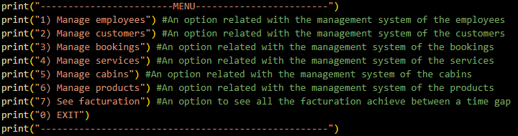
Img 22: Main menu on Python app
Inside each option, we will have another menu where you can update, create, see, or delete an object chosen for example on the next image you can see the menu of the customers.
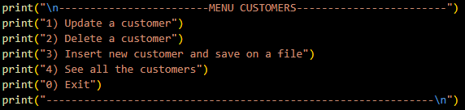
Img 23: Menu of customers
We have an option called “See facturation” that will display another menu with the next option: 1) See all the facturation, 2) See all the facturation of the bookings and 3) See all the facturation of the products. This option is thought to see the facturation (all or of each booking) but we are still working on it so it doesn´t work properly. Our future goal will be to make work the facturation part.
To go back throught the menus, we will use the 0 key and if you press the 0 key on the main menu, the program will say a message when you leave. We have to say that our python application is not related to the database and either to the webpage or the java desktop application.

THOUGHTS
To sum up, we can say that we develop two working applications on different languages, a webpage, a database, and a server on this project. Even thought we have more ideas to do on this project on the future like develop a more graphic application on python that works out of the terminal also, add some more functionality, make a login process and so on. On the webpage we are looking to improve the design and the functionality of it.

BIBLIOGRAPHY
Translator = https://www.wordreference.com/
Server = https://todoxampp.com/descargar-e-instalar-xampp-para-linux-ubuntu/
https://www.mundodeportivo.com/urbantecno/linux/como-cambiar-el-dns-en-linux-para-navegar-mas-rapidamente
https://www.w3schools.com/sql/sql_injection.asp
Java desktop application = https://community.jaspersoft.com/project/jasperreports-library
https://www.jfree.org/jfreechart/
https://curiotecnology.blogspot.com/2013/01/grafica-de-barras-con-jfreechart-java.html
https://programacion.net/articulo/graficas_en_java_con_jfreechart_238
Python application = https://realpython.com/python3-object-oriented-programming/
Webpage = https://www.w3schools.com/php/
https://carcustomgarage.com/
https://www.w3schools.com/js/default.asp
Database = http://sistemamanejadordebasededatossmbd.blogspot.com/2011/02/construir-una-base-de-datos-taller.html
http://luiscarloslc.blogspot.com/2011/02/ejercicio-taller-mecanico.html

