Froggy Arcade
Game Development Guide
How the game is built, how its parts fit together, and how to change it safely
How to use this guide. Every section starts on a new page and stands on its own, so the guide can be split into separate documents along its section headings. The index on the next page lists every section; in Word, right-click it and choose Update Field after editing to refresh the page numbers.
Repository: github.com/KaTim128/froggy-arcade. Stack: TypeScript, Phaser 3, Three.js, Vite. Saves: the player's browser (localStorage). Shared settings: one small serverless API on Vercel.

Index
1. The Games, One by One 3
1.1 Cabinet games
1.2 Bigger games inside the arcade
1.3 Story and horror
2. Code Structure 5
2.1 Rules the code enforces
3. Tools 7
3.1 Dev URL parameters
4. Systems 8
Saves, economy, session resume, input, audio, badges, Creature Clash, police
5. Assets 9
6. Data Flow 10
6.1 A cabinet game, start to finish
6.2 Settings, from the admin to every player
7. Admin and Configuration 11
What can be changed, the workflow, publishing to every device, security limits
8. How to Extend the Game 12
Cabinet games, creatures and specials, admin settings, scenes
9. Testing and Debugging 13
9.1 Debugging tips
10. Workflow 14
11. Glossary 15

1. The Games, One by One
The building has three playable areas: the street outside (shops, alleys, hotel, condo), the arcade itself (four rooms of cabinets, crane machines, the prize counter and the change machine), and the horror layer underneath (the dark arcade, the basement, the 3D chase and hide rooms, and the police escape). Every cabinet game is a minigame module in src/minigames/ registered in src/minigames/registry.ts, with its price and position in src/game/content.ts (CABINETS).

1.1 Cabinet games
Id | Title | Room | Cost | What it is
tictactoe | MINI DUELS | front | 1 | Tic-tac-toe or rock paper scissors against Froggy.
hoops | CHUBBY CHOMP | front | 5 | 5 points in 75 seconds; streaks pay double.
whack | WHACK-A-FROG | front | 5 | 30 seconds, whack all you can.
bowling | BOWLING | front | 5 | 3 rounds against Froggy; beat his total.
battleship | FROG POND HUNT | front | 10 | Find their frogs before they find yours.
grudge | GRUDGE | annex | 10 | Best-of-3 animal boxing; tortoise, zebra, lion, rhino and more.
donkeykong | BARREL CLIMB | annex | 10 | Climb to the top past barrels.
airhockey | AIR HOCKEY | annex | 10 | First to 5.
fallingblocks | THE FLOOD | annex | 10 | Climb out before the water gets you.
danceoff | DANCE OFF | annex | 10 | Beat the dancer three times (20/35/50).
frogcross | FROG CROSS | annex | 10 | Cross 5 times for 20 tokens.
carchase | CAR CHASE | annex | 10 | Dodge, grab cash, bomb the law.
frogvslizard | FENCE WARS | annex | 7 | One round of throws over the fence; mind the wind.
bogball | BOG BALL | lounge | 5 | Slingshot football, ten shots each.
padbattles | PAD BATTLES | lounge | 5 | Last frog standing on the lily pads.
croaked | CROAKED | lounge | 5 | Catch it, or eat everything and live.
slots | FROGGY SLOTS | casino | 3 | Five-reel slot machine with a hidden pay table.
blackjack | FROGGY 21 | casino | bet | Blackjack against Froggy; bet what you like.
roulette | CHAMBER | casino | 15 | Six chambers, one live round, five a pull.
wheel | WHEEL OF FORTUNE | casino | 40 | One prize per spin, a daily respin and two bonus spins.
frograce | FROG RACE | casino | 10 | Pick a frog, watch the race.
frogstermash | FROGSTER MASH | casino | 25 | Monster brawler with animal archetypes (zebra kicker and others).

Costs are defaults: the admin settings screen can change any cabinet's cost and win payout (see section 7).

1.2 Bigger games inside the arcade
- Creature Clash (scenes2d/CreatureHub.ts, scenes2d/CreatureArena.ts, game/creature*.ts, game/specials.ts): recruit creatures from packs, level them up, and fight on a story trail of worlds with bosses. 110 creatures, each with a plain attack and two specials, plus element effects, walls and barriers. Owned creatures are capped at 8.
- Crane machines (scenes2d/CraneGame.ts, game/cranePile.ts): a physical claw with a timed drop; the claw-to-prize hold geometry decides what is carried.
- Prize counter and change machine (PrizeCounter.ts, PrizeExchange.ts, ChangeMachine.ts): tokens buy prizes off a shelf that restocks in waves; prizes sell outside for cash; cash buys tokens back.

1.3 Story and horror
- Street scenes: ExteriorDay, ExteriorNight, StreetWest, StreetEast, SideAlley, BackAlley, plus shops (shops/BarberShop, ClothesStore, FurnitureStore) and the Condo.
- Hotel and police arc: Hotel, HotelLobby3D, HotelHall3D, Stairwell, PoliceEscape3D, RooftopEscape, endings JailEnding / ArrestEnding.
- Horror: ArcadeDark, BasementSequence, Chase3D, HideRoom3D, NightRoad3D, with Froggy's scares in src/froggy/.

2. Code Structure
All source is TypeScript under src/. The folders split by responsibility, not by game:
Folder | What lives there
src/core/ | Services every scene shares: state.ts (GameState, profiles, saving), ledger.ts (the only token writer), audio.ts, input.ts/keymap.ts (rebindable keys), ui.ts (buttons, text), sceneManager.ts, session.ts/resume.ts (reload resume), gameConfig.ts (admin settings), adminAuth.ts, debug.ts (dev bridge), singleInstance.ts (one tab at a time).
src/scenes2d/ | Every Phaser scene: rooms, shops, modals (Settings, Profile, Inventory, Badges), the MinigameScene shell, Creature Clash hub and arena, the admin screen.
src/minigames/ | One file per cabinet game implementing MinigameModule (types.ts), plus registry.ts.
src/game/ | Game data and rules with no rendering: content.ts (cabinets, prizes), creatures, specials, levels, badges, life/day-night, patrols, inventory.
src/art/ | Procedural painters: cabinets, rooms, props, creature bodies (SDF renderer in sdf.ts), icons.
src/render/ | 320×180 pixel scaler, palette, pixel fonts, froggyLayer.ts (Froggy's unfiltered overlay), threeStage.ts (the one WebGL renderer).
src/three/ | Three.js levels and models: chase grid and nav, hotel lobby, police building and officers, hide rooms.
src/froggy/ | Froggy himself: vector art, dialogue, script, jumpscares.
src/ui/ | HUD, touch controls, tutorial cards and demos, talk panel.
api/ | config.js: the Vercel serverless function that stores published admin settings.
tools/ | Browser test scripts (*.mjs) driven by puppeteer-core; tools/shots/ holds reference screenshots.
docs/ | PRD, QFD, requirements log, police rules, and this guide.

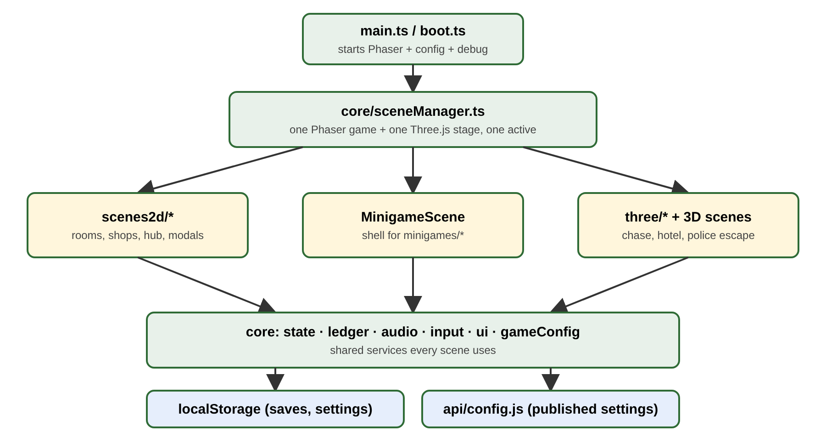
Figure 1. How the layers fit together.

2.1 Rules the code enforces
- Only the ledger writes tokens. Everything that charges or pays goes through ledger.credit / ledger.debit (via the MinigameApi in games).
- Route guards decide which scene is reachable (core/routes.ts), not individual scenes.
- Froggy is the only non-pixel element, drawn on his own overlay above the 320×180 buffer.
- Silent scenes instantiate no audio at all; tests assert a source count of zero.

3. Tools
Tool | Used for
Node.js + npm | Install (npm install), run scripts.
Vite 5 | Dev server (npm run dev, port 5173) and production build (npm run build). Generates the offline service worker; it skips /api/.
TypeScript 5 | npx tsc --noEmit typechecks the whole project; run before every commit.
Phaser 3 | 2D engine for every scene and minigame.
Three.js 0.170 | 3D scenes through the single shared ThreeStage renderer.
Howler | Audio playback; core/audio.ts wraps it with buses and synthesised sfx.
puppeteer-core / Playwright | Drive the real game in headless Chromium for tests and screenshots.
Vercel | Hosts the game and api/config.js; Upstash Redis (KV) stores the shared settings.
GitHub Pages + Actions | .github/workflows/deploy.yml publishes the static build on push to master.

3.1 Dev URL parameters
In a dev build, core/debug.ts reads URL parameters so a test can jump anywhere:
Parameter | Effect
intro=1 | Skip the intro cutscene.
tokens=N, cash=N | Start with this many tokens / cash.
scene=Name | Open a scene directly (e.g. scene=ArcadeCasino).
game=id | Open a cabinet's minigame directly (e.g. game=wheel).
hour=, time=, arc=, items=, key=, rented=, charity=, route=, hideRoom=, gone= | Set the clock, story arc, inventory and other story flags.

window.__froggy is the dev bridge: state(), activeScenes(), game(), useProfile(), adminLogin(), config, badges and more. Most minigames also expose their own bridge (for example window.__wheel).

4. Systems

4.1 Saves and profiles
core/state.ts holds GameState (tokens, cash, prizes, badges, creatures, life, story flags) for up to 3 profile slots (MAX_SLOTS). applyRun sanitises every field when a save loads, so a broken or edited save cannot crash the game. Settings (volume, keys, graphics) live outside the run and survive a new game.

4.2 Economy
- Tokens are charged once when PLAY is pressed; walking up to a machine and reading the card is free.
- A draw refunds the entry once; a win pays the cabinet's reward or the game's own payout.
- Table games (blackjack, wheel) charge per go inside the game with api.raise(n) and pay each result with api.payout(n).
- Prizes sell outside for half their token price in cash; the change machine converts cash back at half again.

4.3 Session resume
Every second of play the shell stores the module's snapshot(). After a reload the game reopens the same go, paused, and calls restore(). A snapshot may carry refund: n to hand back a stake that cannot be replayed. The wheel does not do this: its results are written down before the wheel turns and are paid on the next visit.

4.4 Input, touch and keys
Keys are rebindable in Settings (core/keymap.ts). On touch screens, ui/touchControls.ts draws a stick and the buttons each cabinet declares in its touch layout, under the picture.

4.5 Audio and music
Scenes declare their music (core/tracks.ts); minigames name theirs with music. Sound effects are synthesised by name (audio.sfx('chime')).

4.6 Badges and goals
game/badges.ts defines every badge and its progress counters; the Goals screen lists them with CLAIM buttons.

4.7 Creature Clash
- Data: creatures.ts (stats, attacks), specials.ts (special abilities), creatureTraits.ts (strengths and weaknesses), creatureLevel.ts (XP), creatureStory.ts (trail and payouts).
- Arena: CreatureArena.ts runs movement, line of sight, walls, status timers, special handlers and AI.

4.8 Police and stealth
Patrols (game/patrol.ts, indoorPatrol.ts, policeVisits.ts) and the 3D police AI (three/navGrid.ts, policeOfficer.ts) follow the rules in docs/POLICE_RULES.md.

5. Assets
Almost nothing is a bitmap file. Art is painted in code at load time, so it scales and recolours freely:
- Pixel art is drawn with Phaser Graphics into the 320×180 buffer using render/palette.ts colours.
- Creature bodies use a signed-distance-field renderer (art/sdf.ts, creatureBodies.ts, creatureArt.ts) with a material table.
- 3D textures are generated on canvases (three/arcadeTextures.ts, labTextures.ts) and capped in size on phones.
- Fonts are pixel bitmap fonts in render/pixelFont.ts and smallFont.ts.
- The few real files: src/assets/apparition-corridor.webp, files in public/ and assets/, and reference images in docs/refs/.
When adding art, keep to the palette, draw at the 320×180 scale, and keep text inside its box: the text tests check every label fits.

6. Data Flow

6.1 A cabinet game, start to finish
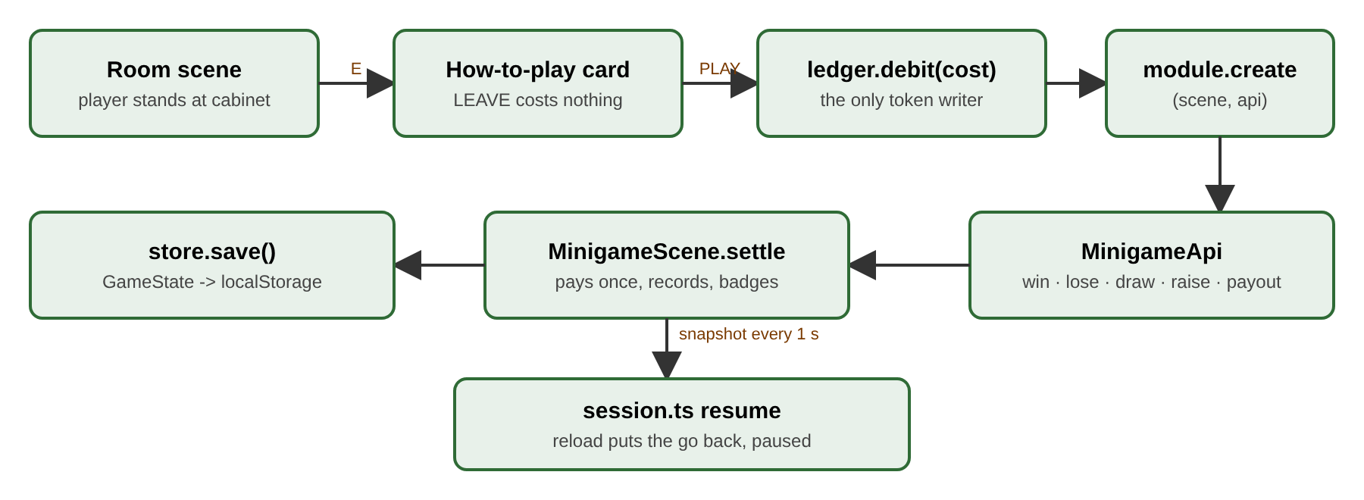
Figure 2. One go at a cabinet: from the room to the save.
- The player stands at a cabinet and presses E; the how-to-play card opens. LEAVE costs nothing.
- PLAY debits the cost through the ledger and calls the module's create(scene, api).
- The game reports through the MinigameApi: win, lose, draw, raise, payout, record, badge.
- MinigameScene settles exactly once, records high scores and badges, and saves.
- While the go runs, a snapshot is saved every second so a reload can resume it.

6.2 Settings, from the admin to every player
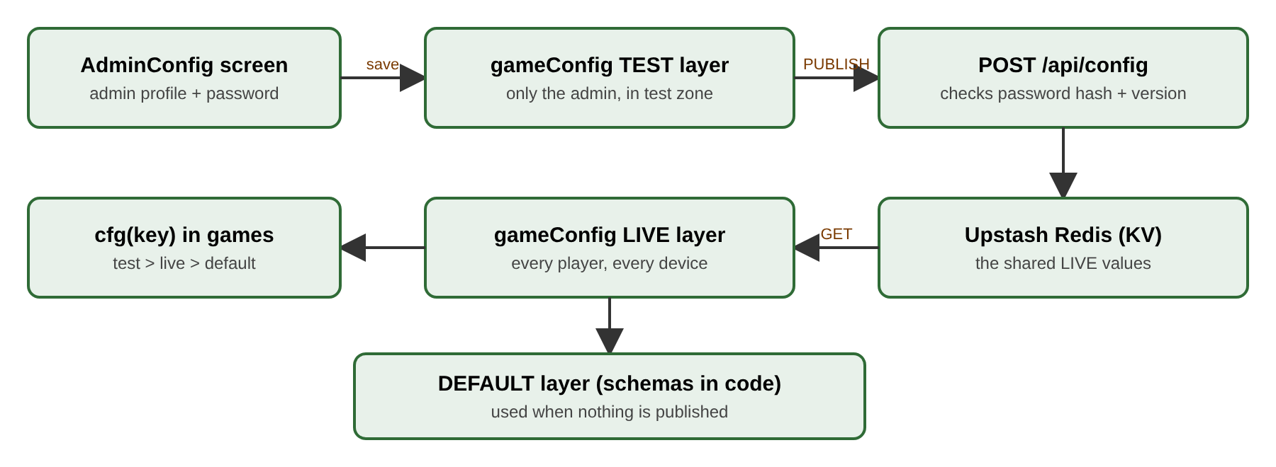
Figure 3. How a published setting reaches every device.
cfg(key) reads the TEST value (only for the admin inside the test zone), otherwise the LIVE value published to the server, otherwise the DEFAULT from the schema in code.

7. Admin and Configuration
The admin settings screen (scenes2d/AdminConfig.ts, opened from Settings) changes game values without a code change. It is only offered to the admin profile after its password is entered. The admin profile name and password are not stored in the code: only salted SHA-256 hashes are (core/adminAuth.ts), and the server checks its own hash (ADMIN_PASSWORD_HASH).

7.1 What can be changed
- Every cabinet: token cost and win payout.
- Crane: clock and costs. Grudge: round time, HP, power and speed percentages. Creature Clash: XP and story pay percentages, opponent damage and speed.
- Test-zone-only picks (never published): force a creature in packs, a specific foe or boss, a Grudge opponent.

7.2 The workflow
- Save values into the test layer; with test zone on, only the admin plays them.
- Reset throws test values away. Publish sends them to the server as the new live version.
- A publish over a newer live version is refused, so two admins cannot overwrite each other.
- Restore defaults for one game clears its published values and leaves other games alone.

7.3 Making publish reach every device
Publishing to all players needs the Vercel deployment to have Upstash Redis (KV) storage connected so that KV_REST_API_URL and KV_REST_API_TOKEN exist, then a redeploy. Without it, a publish only reaches the device it was made on. The GitHub Pages build must be built with VITE_CONFIG_API set to the Vercel URL so it reads the same settings.

7.4 Security limits
Saves and tokens live on each player's device. Nothing in the browser can stop a determined player from editing their own storage; the game's own defences (no double pays, results saved before animations, one tab at a time) stop the game from ever paying twice. A server-held economy would be needed to go further.

8. How to Extend the Game

8.1 Add a cabinet game
- Add the id to the GameId union in core/state.ts.
- Create src/minigames/<id>.ts exporting a MinigameModule: id, title, rules, tutorial, touch, create, and optionally update, destroy, snapshot, restore, atRisk, practice.
- Register it in src/minigames/registry.ts.
- Add a CABINETS entry in src/game/content.ts (room, position, cost, reward, colour, motif). The admin screen picks up its cost and payout automatically.
- Add a tutorial demo in ui/tutorialDemos.ts if the card names one, and a music track if wanted.
- Add a check to tools/games.mjs and run the test suite.
export const myGame: MinigameModule = {
id: 'mygame', title: 'MY GAME', rules: 'one line',
tutorial: { objective: ['...'], controls: [['SPACE', 'GO']] },
touch: { buttons: [{ label: 'GO', key: 'SPACE', primary: true }] },
create(scene, api) { /* build; call api.win() / api.lose() */ },
};

8.2 Add a creature or a special
- Add the creature to game/creatures.ts (stats, element, plain attack, two specials) and its body to the art tables.
- Add a special to game/specials.ts and, if it needs new behaviour, a handler in CreatureArena.ts cast(). Move names must fit 11 characters.
- Run the balance sim and tools/clash.mjs.

8.3 Add a setting the admin can change
- Add a param to the right group in schemas() in core/gameConfig.ts (key, label, kind, default, min, max).
- Read it in the game with cfgNum(key), cfgPct(key) or cfgStr(key); never cache it across a go.

8.4 Add a scene
- Create the Phaser scene in src/scenes2d/ and register it in core/sceneManager.ts; add a route guard if it should be locked.

9. Testing and Debugging
Tests drive the real game in headless Chromium. Start the dev server first (npx vite --port 5173 --base /), then run a script.
Script | Checks
tools/smoke.mjs | Boots every scene without errors.
tools/games.mjs | Every cabinet: card, charge once, pay once, odds tables.
tools/frame.mjs | The shared cabinet frame and HUD (14 checks).
tools/wheel.mjs | Wheel house edge, bonus odds, respin, reload safety (24 checks).
tools/admin.mjs | Admin permissions, test zone, publish, conflicts (28 checks). Needs FROGGY_ADMIN_NAME and FROGGY_ADMIN_PASS set in the environment.
tools/profiles.mjs | Profile slots and the admin profile (same environment variables).
tools/clash.mjs, story.mjs | Creature Clash battles and the story trail.
tools/police*.mjs, stealth.mjs, stairwell.mjs | Police AI, stealth and the hotel arc.
tools/text.mjs, textfit.mjs | Every label fits its box.
tools/mobile.mjs, mobilecrawl.mjs | Touch layouts and phone play.

9.1 Debugging tips
- Use the URL parameters (section 3.1) to jump straight to the scene or game.
- Use window.__froggy and the game's own bridge in the browser console to read state.
- A hidden tab does not tick: tests call page.bringToFront() before timing anything.
- Take screenshots with Playwright at 960×540 to check layout.

10. Workflow
- Pull the latest branch; npm install if dependencies changed.
- Make the change; keep it to what the task needs.
- npx tsc --noEmit, then the relevant tools/*.mjs tests, plus tools/frame.mjs.
- Look at a screenshot of anything visual.
- Update IMPLEMENTATION_PROGRESS.md with a row for the change.
- Discard scratch screenshots (git checkout -- tools/shots), commit with a clear message, push the feature branch.
- Open a pull request into master; merging deploys (GitHub Pages workflow, and Vercel if connected).
Never commit secrets, the admin name or the admin password. Temporary scripts go in tools/*_tmp.mjs, which git ignores.

11. Glossary
Term | Meaning
Cabinet | An arcade machine in a room; opens a minigame.
Minigame module | The object a cabinet game exports (MinigameModule).
MinigameApi | What a game may call: win, lose, draw, raise, payout, record, badge.
Shell | MinigameScene: the frame around every minigame (card, HUD, pause, settle).
Ledger | The only code that changes the token balance.
Stake | Tokens riding on the current go: the entry cost plus raises.
Snapshot / restore | Saving a go mid-play and putting it back after a reload.
Profile / slot | One of three saved runs on a device.
Admin profile | The profile that, with its password, can open the settings screen.
Test zone | Admin-only mode that plays unpublished test values.
Live / publish | Settings sent to the server for every player.
Route guard | The rule deciding whether a scene can be entered.
Froggy layer | The unfiltered overlay Froggy is drawn on.
ThreeStage | The single shared WebGL renderer for 3D scenes.
Special | A Creature Clash ability beyond the plain attack.
Element | A creature's type, which adds an effect to its hits.
House edge | How much of each spin or bet the game keeps on average.

