ASU RRAM Verilog-A Compact Model

- Introduction
The Verilog-A compact model is developed for metal-oxide based RRAM devices with bipolar switching characteristics. It is improved based on the earlier work originally developed at Stanford [1]. The parameters of the model are re-fitted to the experimental data of IMEC HfO_{x}-based RRAM devices [2-3]. In the model, the switching mechanism relies on the dynamics of 1D conductive filament growth/dissolution in the oxide layer. For simplicity, there is no definition on the lateral size of the filament. The primary internal variable used in this model is the gap distance (g), which is defined as the distance between the top electrode and the tip of the conductive filament. The gap (g) can determine the RRAM resistance through electron tunneling conduction mechanism. By applying a positive/negative voltage on the RRAM device, the gap will decrease/increase due to the generation/recombination of oxygen vacancies at the tip of conductive filament. Temperature dynamics is also included in this model to emulate the Joule heating effect on the device. This Verilog-A model is compatible with common SPICE simulators, although HSPICE H-2013.03-SP2 is the recommended software. To demonstrate the model, an HSPICE netlist for 1T1R configuration is provided as an example.
Copyright of the model is maintained by the developers, and the model is distributed under the terms of the Creative Commons Attribution-NonCommercial 4.0 International Public License http://creativecommons.org/licenses/by-nc/4.0/legalcode. If you use this model in your work, you are requested to cite [1] in the reference.

Developers and contact information:
Pai-Yu Chen, Shimeng Yu, Arizona State University
For technical questions, address to Pai-Yu Chen, pchen72@asu.edu
For logistic questions, address to Prof. Shimeng Yu, shimengy@asu.edu

Caution:
This RRAM model is a dynamical model that can only be run in transient mode in SPICE, DC mode is not available. If you want to simulate quasi-DC sweep, you should create a staircase voltage pulse trains.

- Model equations
  - I-V relation (electron tunneling)
$$\text{I=}{\text{I}}_{\text{0}}\text{exp}\left(\text{-}\frac{\text{g}}{{\text{g}}_{\text{0}}}\right)\text{sinh}\left(\frac{\text{V}}{{\text{V}}_{\text{0}}}\right)$$ | (1)
  - Local field enhancement factor
$$\text{γ=}{\text{γ}}_{\text{0}}\text{-β}{\left(\frac{\text{g}}{{\text{g}}_{\text{1}}}\right)}^{\text{3}}$$ | (2)
  - Gap dynamics (ion migration)
$$\frac{\text{dg}}{\text{dt}}\text{=-}{\text{v}}_{\text{0}}\left[\text{exp}\left(\text{-}\frac{{\text{qE}}_{\text{ag}}}{\text{kT}}\right)\text{exp}\left(\frac{\text{γ}{\text{a}}_{\text{0}}}{\text{L}}\frac{\text{qV}}{\text{kT}}\right)\text{-}\text{exp}\left(\text{-}\frac{{\text{qE}}_{\text{ar}}}{\text{kT}}\right)\text{exp}\left(\text{-}\frac{\text{γ}{\text{a}}_{\text{0}}}{\text{L}}\frac{\text{qV}}{\text{kT}}\right)\right]$$ | (3)
$$\text{g(t+dt)=g(t)+dg}$$ | (4)
  - Temperature dynamics
$$\frac{\text{dT}}{\text{dt}}\text{+}\frac{\text{T-}{\text{T}}_{\text{0}}}{{\text{τ}}_{\text{th}}}\text{=}\frac{\left|\text{V×I}\right|}{{\text{C}}_{\text{th}}}$$ | (5)
$$\text{T(t+dt)=T(t)+dT}$$ | (6)
- Symbols and parameters
  - Universal constants
Symbol | Name in code | Unit | Value | Description
$$\text{k}$$ | kb | J/K | 1.38e-23 | Boltzmann constant
$$\text{q}$$ | q | C | 1.6e-19 | Elementary unit charge
  - Model parameters
Symbol | Name in code | Unit | Default | Rangeª | Description
$${\text{a}}_{\text{0}}$$ | a0 | m | 0.25e-9^{b} | (0:inf) | Atomic hopping distance
$${\text{E}}_{\text{ag}}$$ | Eag | eV | 1.501^{b} | (0:inf) | Activation energy for vacancy generation
$${\text{E}}_{\text{ar}}$$ | Ear | eV | 1.5^{b} | (0:inf) | Activation energy for vacancy recombination
L | L | m | 5e-9 | (0:inf) | Oxide thickness
$${\text{g}}_{\text{min}}$$ | gap_min | m | 0.1e-9 | (0:L) | Minimum gap distance
$${\text{g}}_{\text{m}\text{ax}}$$ | gap_max | m | 1.7e-9 | (${\text{g}}_{\text{m}\text{in}}$:L) | Maximum gap distance
$${\text{g}}_{\text{ini}}$$ | gap_ini | m | 0.1e-9 | [${\text{g}}_{\text{min}}$:${\text{g}}_{\text{m}\text{ax}}$] | Initial gap distance
$${\text{I}}_{\text{0}}$$ | I0 | A | 6.14e-5 | (0:inf) | I-V fitting parameter
$${\text{g}}_{\text{0}}$$ | g0 | m | 2.75e-10 | (0:inf) | I-V fitting parameter
$${\text{V}}_{\text{0}}$$ | V0 | V | 0.43 | (0:inf) | I-V fitting parameter
$${\text{v}}_{\text{0}}$$ | Vel0 | m/s | 150 | (0:inf) | Gap dynamics fitting parameter
$${\text{γ}}_{\text{0}}$$ | gamma0 | -- | 16.5 | (0:inf) | Gap dynamics fitting parameter
$${\text{g}}_{\text{1}}$$ | g1 | m | 1e-9 | (0:inf) | Gap dynamics fitting parameter
$$\text{β}$$ | beta | -- | 1.25 | (0:$\frac{{\text{γ}}_{\text{0}}}{{\left(\frac{{\text{g}}_{\text{max}}}{{\text{g}}_{\text{1}}}\right)}^{\text{3}}}$) | Gap dynamics fitting parameter
$${\text{T}}_{\text{0}}$$ | T0 | K | 298 | (0:inf) | Ambient temperature
$${\text{C}}_{\text{th}}$$ | Cth | J/K | 3.18e-16 | (0:inf) | Effective thermal capacitance
$${\text{τ}}_{\text{th}}$$ | Tau_th | s | 2.3e-10 | (0:inf) | Effective thermal time constant
ª The range is specified to make parameters physically reasonable, or to prevent difficulties in the numerical evaluation, such as division by zero.
^{b} The values may vary with different material systems of the RRAM device. You may tune these parameters to fit your specific RRAM characteristics.
  - Model variables
Symbol | Name in code | Unit | Description
$$\text{V}$$ | V | V | Voltage across the cell
$$\text{I}$$ | I | A | Current flowing through the cell
g | gap | m | Gap distance from the filament tip to the top electrode
dg/dt | gap_ddt | m/s | Gap velocity (growth/dissolution)
γ | gamma | -- | Local field enhancement factor
T | temperature | K | Temperature of the conductive filament
- Gap-R relation
Based on Eq. (1) with the default parameters, the gap-resistance relation is provided below, when the resistance is read at 0.1V. The RRAM can switch within this range depending on the programming condition:
R (Ω) | 10k | 20k | 30k | 50k | 100k | 200k | 300k | 500k | 1M | 2M | 3M
Gap (nm) | 0.1 | 0.144 | 0.403 | 0.543 | 0.734 | 0.925 | 1.036 | 1.177 | 1.367 | 1.558 | 1.669

- Model demonstration for 1T1R configuration (SET→RESET in pulse programming mode)
1-transistor-1-resistor (1T1R) memory cell is shown below. The transistor is implemented using PTM model [4] at 65nm technology (model released at February 22, 2006). When the cell is set from high resistance to low resistance state, WL is turned on, and the SET pulse is sent to BL while SL is ground. When the cell is reset from low resistance state to high resistance state, WL is turned on, and the RESET pulse is sent to SL while BL is ground. In this demonstration, both SET and RESET pulse widths are fixed at 10ns. The WL, BL and SL pulse voltages are chosen to achieve the SET resistance switching from ~1MΩ to ~50kΩ, followed by the RESET resistance switching back to ~1MΩ again.
Schematic of 1T1R configuration:

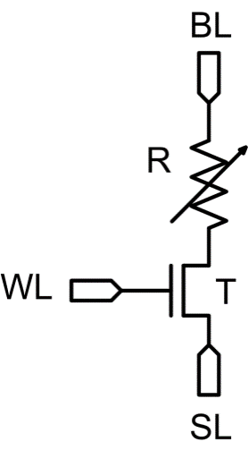
The SPICE netlist:

Simulation results by HSPICE 2013:

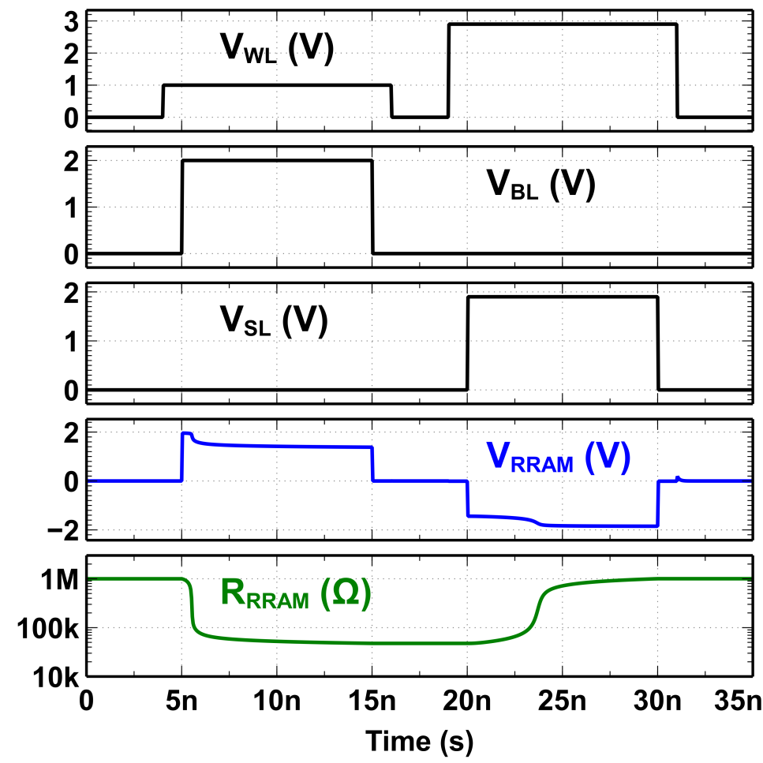

References:

[1] P.-Y. Chen, S. Yu, “Compact modeling of RRAM devices and its applications in 1T1R and 1S1R array design,” IEEE Transactions on Electron Devices, vol. 62, no. 12, pp. 4022-4028, 2015.
[2] Y. Y. Chen, B. Govoreanu, L. Goux, R. Degraeve, A. Fantini, G. S. Kar, D. J. Wouters, G. Groeseneken, J. A. Kittl, M. Jurczak, and L. Altimime, “Balancing SET/RESET pulse for endurance in 1T1R bipolar RRAM,” IEEE Transactions on Electron Devices, vol. 59, pp. 3243-3249, 2012.
[3] Y. Y. Chen, M. Komura, R. Degraeve, B. Govoreanu, L. Goux, A. Fantini, N. Raghavan, S. Clima, L. Zhang, A. Belmonte, A. Redolfi, G. S. Kar, G. Groeseneken, J. A. Kittl and M. Jurczak, “Improvement of data retention in HfO₂/Hf 1T1R RRAM cell under low operating current,” IEEE International Electron Devices Meeting (IEDM), pp. 252-255, 2013.
[4] Predictive Technology Model (PTM), http://ptm.asu.edu/

