

Hybrid Epidemic Forecasting
Part A Implementation
February 2026
─
Abdirahman Mohamed
1TE864 Degree Project in Engineering Physics
Uppsala University

1. Introduction

1.1 Background
In epidemic forecasting, mechanistic compartment models (such as SIR/SIRS) often struggle to accurately predict the effective reproduction number (R_{t}). Because R_{t} is a hidden parameter that changes over time, we have to estimate it from noisy case counts. Relying on just data-driven methods (such as time-series models) or just mechanistic models usually leads to poor predictions. In this project, we investigate a hybrid forecasting framework. We combine mechanistic models with statistical time-series inference (such as AR/ARX) to better capture how R_{t} changes over time.

1.2 Objective
The objective of this initial phase is to establish a controlled synthetic baseline for evaluating the forecasting framework. Instead of using empirical data, analytically constructed R_{t} trajectories are defined and treated as known transmission signals.
Because the true evolution of these trajectories is fully specified, forecast performance can be assessed directly against the underlying transmission process.
By working under these controlled conditions, this phase isolates the statistical forecasting component from uncertainties related to data estimation or observational noise. The purpose is therefore to determine the theoretical performance limits of the framework before introducing additional sources of complexity in later stages of the project.

2. Methods

2.1 Synthetic Transmission Scenarios
To evaluate the forecasting framework under controlled conditions, four synthetic R_{t} scenarios were defined using analytic functions. Each trajectory spans a 365-day timeline and represents a distinct transmission pattern while remaining within realistic bounds, approximately 0.5 and 2.0. These predefined R_{t} curves serve as the ground-truth transmission signals throughout this phase of the study.
The following transmission patterns were constructed:
- Seasonal Forcing: A sinusoidal R_{t} profile that produces periodic epidemic waves over time.
- Policy Intervention: A sigmoid-based transition representing a gradual change in R_{t}, analogous to the implementation of public health measures such as lockdowns or mobility restrictions.
- Damping Resurgence: A multi-wave Gaussian construction in which each successive peak decreases in magnitude, representing a gradually weakening outbreak.
- Amplifying Resurgence: A multi-wave Gaussian construction in which each successive peak increases in magnitude, representing a progressively intensifying outbreak.
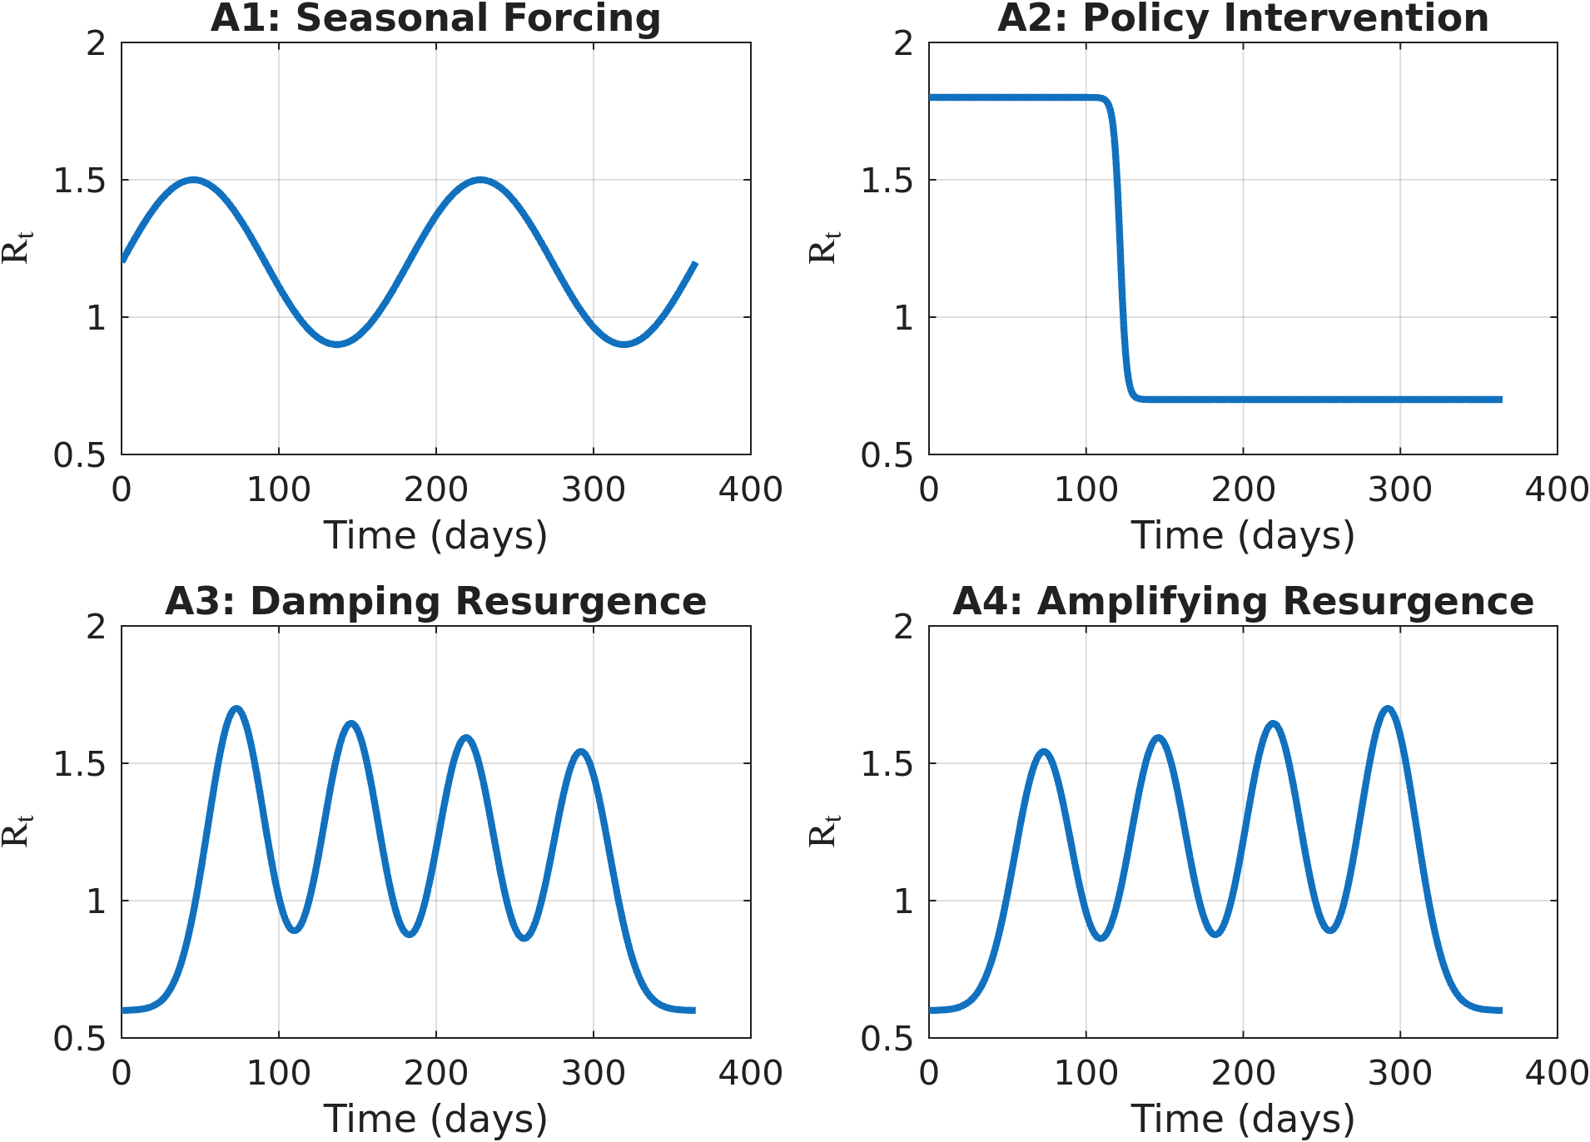
Figure 1: Synthetic R_{t} trajectories representing the four transmission scenarios. The curves illustrate the predefined ground-truth transmission signals used for forecasting evaluation.
In addition to the transmission trajectories, mechanistic state variables were generated using the deterministic solver of the SIRS model within the URDME framework.
Given the predefined R_{t} signal, the solver produces consistent Susceptible and Infected state trajectories. These states are later used as exogenous inputs in the ARX configuration. The deterministic solver ensures that the state trajectories remain free from stochastic variability, allowing this phase to isolate the forecasting component under idealized conditions.

2.2 Statistical Forecasting Models
To forecast the synthetic R_{t} trajectory defined in Section 2.1, statistical time-series models were applied to its historical values. These models aim to capture the temporal dependence in the R_{t} series and generate short-term forecasts.
The primary models evaluated in this phase are:
- AR: A pure autoregressive model that serves as the statistical baseline. It uses only past values of the synthetic R_{t} trajectory to generate forecasts of future R_{t} values.
- ARX: An autoregressive model with exogenous inputs. In addition to historical R_{t} values, mechanistic state variables are incorporated as external covariates. These state trajectories are obtained using the deterministic solver of the SIRS model within the URDME framework, ensuring consistency with the predefined transmission process. The inclusion of these covariates allows evaluation of whether mechanistic state information improves forecasts of future R_{t}.
Three covariate configurations were considered: using the Susceptible compartment alone, the Infected compartment alone, and both compartments jointly.
The implementation also supports ARIMA and ARIMAX formulations. In this phase, however, differencing and moving-average components were not explored, restricting the analysis to AR and ARX structures. Two state-space identification methods (N4SID and SSEST) are available within the codebase but are not examined in this phase of the study.

2.3 Expanding-Window Validation
Forecast performance was evaluated using an expanding-window validation strategy that reflects sequential data availability. The procedure begins with an initial training window of 49 days of historical synthetic R_{t} values. Based on this window, model parameters are estimated and a 14-day forecast of R_{t} is generated.
After each forecast is recorded, the window endpoint is advanced by 7 days. The models are retrained using the expanded set of historical R_{t} observations, and a new 14-day forecast is produced. This process continues across the 365-day synthetic timeline until the remaining data length equals the forecast horizon, ensuring that each prediction is evaluated against the corresponding ground-truth values.
Model selection was performed independently at each window endpoint using an exhaustive grid search. The optimal configuration was chosen according to the corrected Akaike Information Criterion (AICc). In this phase, the search was restricted to autoregressive structures ($d=0, q=0$), so that only AR and ARX models were considered.
If a candidate model failed during estimation or produced invalid parameter configurations, a persistence forecast, defined as a constant continuation of the last observed R_{t} value, was used as a fallback. In such cases, an infinite AICc penalty was assigned to prevent selection of the invalid model.

2.4 Forecast Evaluation and Numerical Safeguards
Forecast accuracy was quantified using the Root Mean Square Error (RMSE), computed over the 14-day forecast horizon:
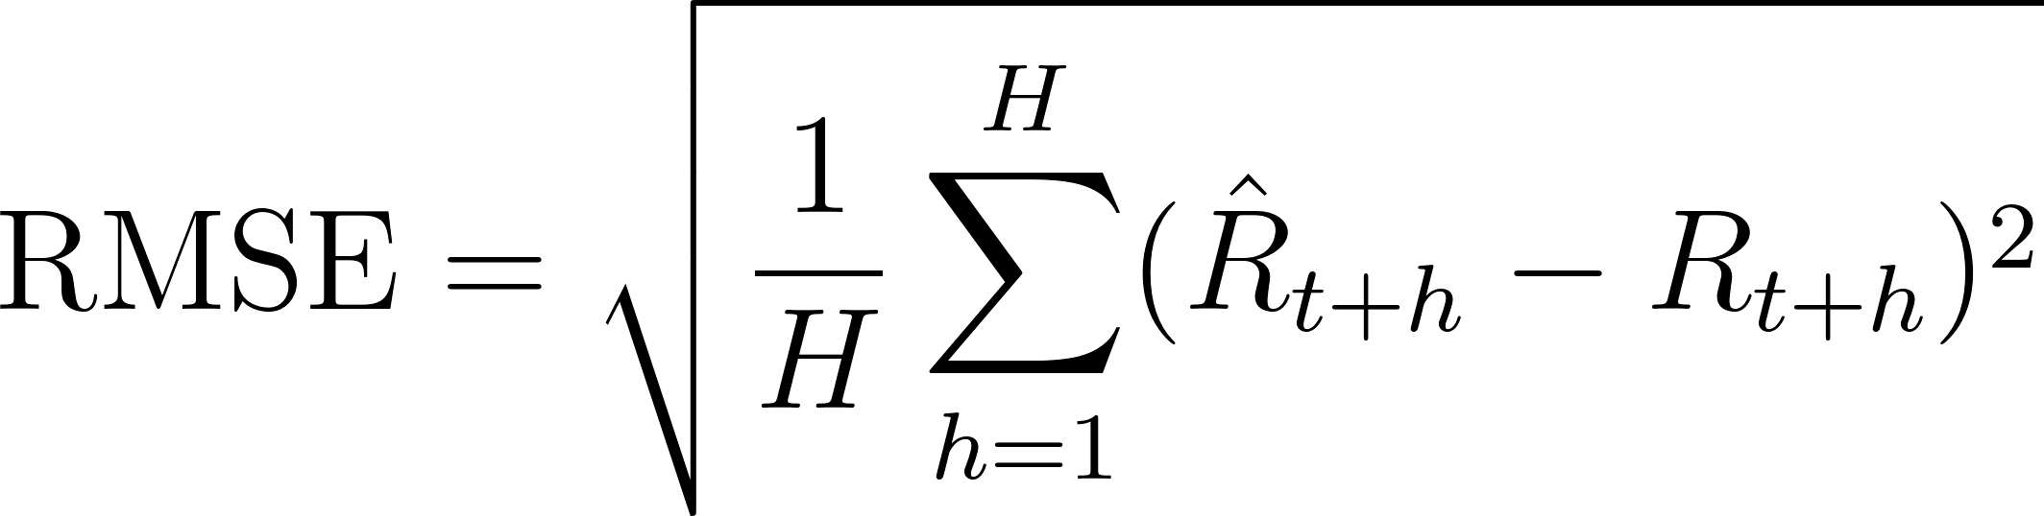
where $H=14$, ${\hat{R}}_{t+h}$ denotes the forecasted value at horizon step h, and $R_{t+h}$ denotes the corresponding synthetic ground-truth value.
RMSE was calculated independently for each expanding-window iteration. Performance comparisons were then made across windows and scenarios to assess relative model behavior.
To ensure numerical stability during parameter estimation, the historical R_{t} training data was log-transformed prior to model fitting. Forecasts were subsequently exponentiated and constrained to remain within predefined bounds to prevent non-physical values.

3. Results

3.1 Qualitative Forecast Dynamics
Forecast performance varies systematically with the structural characteristics of the underlying transmission pattern. In scenarios characterized by smooth and continuously evolving dynamics, both AR and ARX configurations are able to track the synthetic R_{t} trajectory with relatively stable forecasts across the expanding windows.
In Scenario A4 (Amplifying Resurgence), which exhibits gradual multi-wave dynamics, the forecasts follow the oscillatory structure with good alignment over successive windows. The models adapt to changes in amplitude and timing without exhibiting major instability. Differences between AR and ARX configurations remain modest under these smooth conditions.

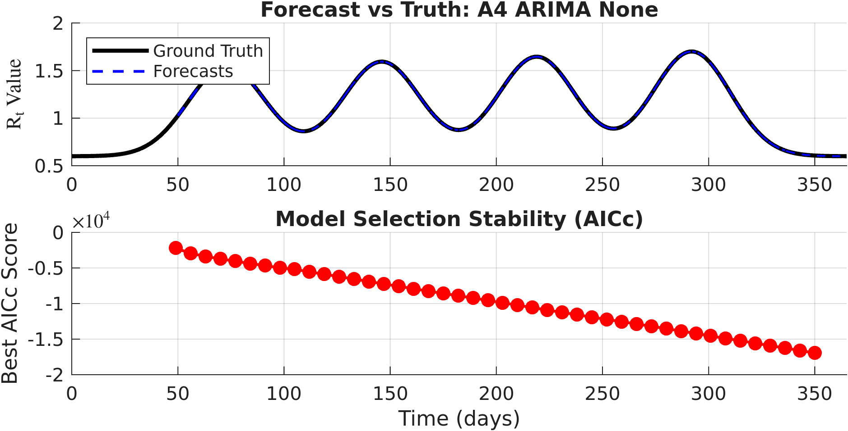
Figure 2: Expanding-window forecasts for Scenario A4 (Amplifying Resurgence). The top panel compares the synthetic ground-truth R_{t} trajectory with all 14-day forecasts issued at successive window endpoints. The bottom panel illustrates the evolution of the best AICc value selected at each window endpoint.

In contrast, Scenario A2 (Policy Intervention), which includes an abrupt change in R_{t}​, is more difficult to forecast. Forecasts produced before the structural change cannot anticipate the new transmission level because the models are trained only on the earlier transmission level. As a result, predictions remain close to that previous level, creating a systematic lag. The forecasts adjust only after enough post-transition observations are included in the expanding training window.
In later windows, some ARX configurations show increased variability. This appears as large deviations in the forecast overlays. These effects occur during periods where the relationship between R_{t}​ and the included mechanistic covariates changes suddenly. Under such structural shifts, parameter estimates may vary more across windows, which can lead to larger forecast fluctuations compared to the AR baseline.

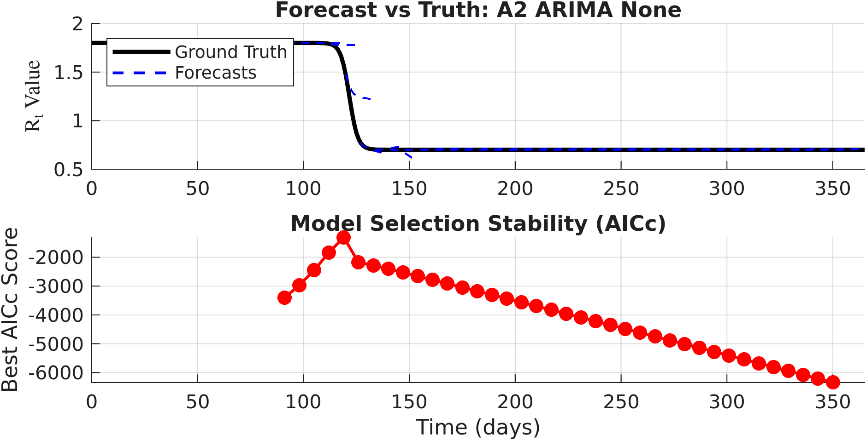 | 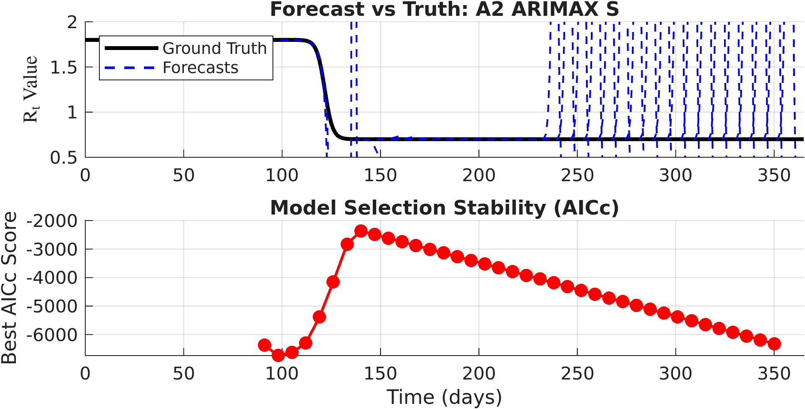
Figure 3: Expanding-window forecasts for Scenario A2 (Policy Intervention).
(a) AR baseline model.
(b) ARX model including the Susceptible compartment S($t$) as an exogenous input.

In each panel, the upper subplot shows the synthetic ground-truth $R_{t}$ trajectory together with the 14-day forecasts issued at successive window endpoints. The lower subplot displays the evolution of the best AICc value selected at each window.
Overall, qualitative inspection indicates that model performance is strongly dependent on the smoothness of the underlying transmission dynamics. Gradual changes are handled effectively, whereas abrupt changes introduce forecasting difficulty and increased variability.

3.2 Quantitative Performance Evaluation
Forecast accuracy was assessed using the RMSE computed over the 14-day forecast horizon at each window endpoint. The resulting error distributions reveal clear differences across scenarios and model configurations.
For the smooth seasonal and multi-wave scenarios (Scenario A1, Scenario A3, and Scenario A4), RMSE values remain consistently low across both AR and ARX families. Error distributions are tightly concentrated, reflecting stable predictive behavior under continuous dynamics.
In contrast, Scenario A2 contributes disproportionately to the overall error dispersion. The abrupt transition contributes large forecast deviations in windows surrounding the structural break, leading to higher variance and the largest RMSE outliers.

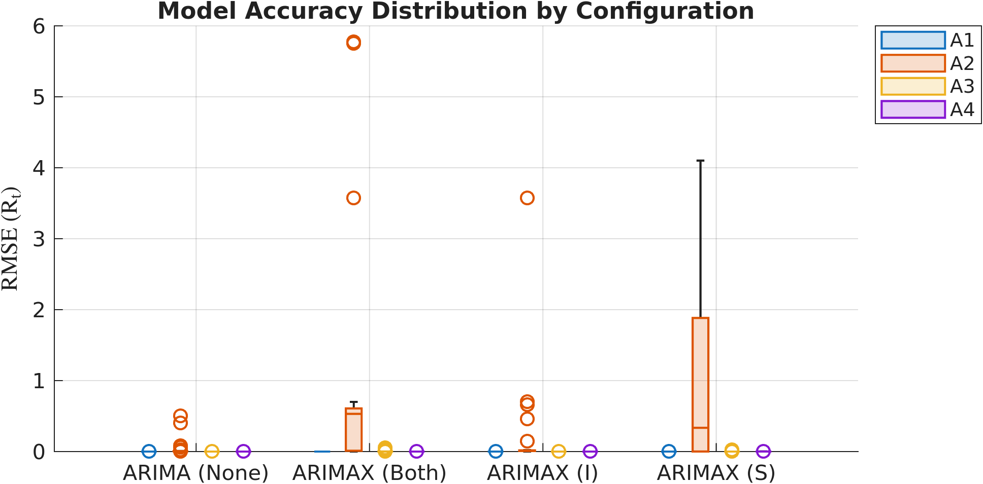
Figure 4: RMSE distributions for all evaluated model configurations across the four synthetic scenarios. Smooth transmission scenarios yield concentrated low-error distributions, whereas Scenario A2 produces the largest dispersion and outliers, particularly for selected ARX configurations.
Across scenarios, the baseline AR models exhibit stable and predictable error behavior. While the ARX models can perform comparably under smooth conditions, they demonstrate increased sensitivity when the underlying transmission level changes abruptly, resulting in greater dispersion in their RMSE distributions.
Taken together, the quantitative results align with the qualitative observations: smooth transmission dynamics are forecasted with high accuracy, whereas abrupt structural changes remain the dominant source of forecasting error in this controlled synthetic setting.

4. Discussion
This phase serves as a controlled synthetic baseline for evaluating the forecasting framework. Since the effective reproduction number R_{t} was defined analytically and is therefore known exactly, the forecast results reflect how the statistical models behave, rather than being influenced by errors in data estimation or reporting noise. The results should therefore be understood as performance under simplified and controlled conditions.
The results show that linear autoregressive models perform well when the transmission pattern changes gradually over time. Under smooth dynamics, the expanding-window approach allows the models to track the underlying R_{t} trajectory in a stable way. However, when R_{t} changes abruptly, systematic forecast lag appears. This occurs because the expanding window continues to include earlier observations that reflect the previous transmission level. As a result, the models adjust only gradually after the change. This effect is clearly visible in Scenario A2, where forecasts generated before the intervention cannot anticipate the drop in transmission. Although the ARX models include mechanistic state variables as additional inputs, this does not automatically lead to improved performance when the transmission level changes suddenly.
These behaviors are also influenced by the hyperparameter choices used in the validation design. The 14-day forecast horizon, the 49-day minimum training window, and the 7-day update step together determine how quickly the models can adapt to changes. Longer training windows provide more stable parameter estimates but slow the response to sudden shifts, while shorter windows may increase variability. In addition, restricting the analysis to autoregressive structures ($d=0, q=0$) ensures consistency across scenarios but limits the range of temporal dynamics that can be captured. The selected grid-search ranges and the use of AICc for model selection therefore define a controlled reference setup rather than a fully optimized configuration.
Overall, this phase shows that autoregressive forecasting of R_{t}​ works reliably when transmission evolves smoothly, but becomes more difficult when abrupt changes occur. These results provide a clear starting point for later stages of the study, where additional sources of uncertainty and model complexity may further affect forecasting behavior.

