Experiment 7: Design of a Moving Average Filter Using Verilog
Objectives
- To design and simulate a 4-point moving average filter using RTL Verilog to reduce noise in input signals by averaging recent samples.
- To implement a four-stage 8-bit shift register (shift_reg[0:3]) that stores the four most recent input samples.
- To calculate the 10-bit cumulative sum (sum) of the four samples and perform division by 4 using a bitwise right shift operation (sum >> 2).
- To evaluate the filter performance using a Verilog testbench named tb_moving_average_with_noise, which generates a noisy sinusoidal input signal for simulation in Vivado Simulator (XSIM).
Software Requirements
- Xilinx Vivado Design Suite
- Vivado Simulator (XSIM)
- PC or laptop
Experimental Procedure
Step 1: Create the Vivado Project and RTL Module
Create a new RTL project in Xilinx Vivado and develop a Verilog module for the 4-point moving average filter. Define the necessary input, output, clock, and reset signals.
Step 2: Implement Shift Register and Accumulator Logic
Implement a four-stage 8-bit shift register to store the most recent input samples. Add the four samples using a 10-bit accumulator and calculate the average by shifting the sum right by two bits.
Step 3: Develop the Testbench with a Noisy Sine Wave Input
Create a Verilog testbench named tb_moving_average_with_noise to generate a sinusoidal input signal with added noise. Apply the samples sequentially to the filter and observe the corresponding filtered outputs.
Step 4: Perform Behavioral Simulation and Waveform Verification
Run the design in Vivado Simulator (XSIM) and examine the input and output waveforms. Compare the noisy input signal with the filtered output to evaluate noise reduction and verify the correct operation of the moving average filter.
Formulas
1. Moving Average Difference Equation:
y[n] = (1/4) * sum_{k=0}^{3} x[n-k] = (x[n] + x[n-1] + x[n-2] + x[n-3]) / 4
2. Bit-Shift Division Relationship:
data_out = sum >> 2 => floor(sum / 4)
3. Accumulator Bit-Width Sizing:
Max Sum = 4 * 255 = 1020 => ceil(log2(1020)) = 10 bits (prevents arithmetic overflow)
4. Noisy Input Synthesis Model:
x[n] = clamp( floor(127.0 * (1.0 + sin(2 * pi * n / 20))) + noise[n], 0, 255 ) where noise in [-10, +10]

Output

S.No | Output Parameter | Expected / Theoretical Value | Simulated / Measured Value | Status / Result
1 | Peak Accumulation Sum | 10-bit Integer (Max 1020) | 1020 | 0% Overflow
2 | Output Division Logic | Bit-wise Right Shift (>> 2) | sum >> 2 | Exact Match
3 | High-Frequency Noise Reduction | Attenuated Ripple | Smooth Sinusoidal Curve | Verified
4 | Output Signal Fidelity | Low-pass Filtered Wave | Verified in XSIM Waveform | Pass

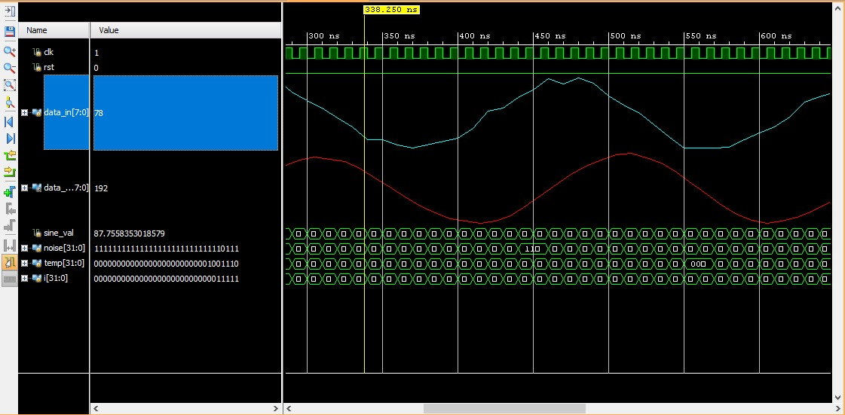
Figure: Moving average filter result
Result
The 4-point moving average filter was successfully designed using RTL Verilog and simulated in Xilinx Vivado. A sinusoidal input signal containing random additive noise was generated using the testbench and applied to the filter. The simulation waveforms demonstrated that the filter reduced random noise fluctuations while maintaining the overall shape of the original sinusoidal signal. The resulting smoothed waveform confirmed the proper functioning of the moving average filter as a low-pass finite impulse response (FIR) filter.

