Experiment 2: Design of an ECG Peak Detection Algorithm on Zynq SoC
Objectives
- To design a Verilog-based ECG peak detection model and perform functional verification using Vivado Simulator (XSIM).
- To implement and simulate a threshold-based local-maximum detection algorithm using consecutive ECG samples.
- To validate the peak detection algorithm using a Verilog testbench and predefined ECG sample data.
- To plot and analyze the ECG waveform and identify detected R-peaks using Python visualization tools.
Software Requirements
- Xilinx Vivado Design Suite with Vivado Simulator (XSIM)
- Python 3
- NumPy library
- Matplotlib library
Procedure
A. ECG Sample Preparation and Simulation Setup
- Prepare an input file named ECG.txt containing 2000 ECG samples represented as 8-bit or 16-bit integer values.
- Create a Vivado project for behavioral simulation without proceeding to physical hardware implementation.
- Establish the simulation architecture, including the ECG sample input, peak detection module, and corresponding detection output.
B. Verilog RTL Design and Local-Maximum Detection
- Develop a Verilog RTL model to detect ECG peaks using a three-sample window consisting of the previous, current, and next samples.
- Implement the peak detection condition in which the current sample must exceed the predefined threshold and be greater than both neighboring samples.
- Generate a peak detection output of 1'b1 when the condition is satisfied; otherwise, set the output to 1'b0.
- Adjust the threshold parameter to evaluate its effect on peak identification and detection accuracy.
C. Behavioral Simulation and Python-Based Visualization
- Create a Verilog testbench named tb_ecg_peak to read ECG samples from ECG.txt using the $fopen and $fscanf system tasks.
- Execute behavioral simulation using Vivado Simulator (XSIM) and observe the input ECG samples alongside their corresponding peak detection outputs.
- Test the algorithm with different ECG sample sequences and threshold values to verify its functionality.
- Export the simulated ECG samples and detected peak information into a CSV file for further analysis.
- Utilize Python, NumPy, and Matplotlib to plot the ECG waveform and highlight the detected R-peak locations.
- Analyze the simulation results by comparing the detected peaks with the original ECG waveform and examining how different threshold values affect peak detection performance.
Output
S.No | Output Parameter | Theoretical / Expected Value | Simulated / Measured Value | % Accuracy / Deviation
1 | Peak Flag Output Code | 8'h01 (Peak) / 8'h00 (No Peak) | 8'h01 (Peak) / 8'h00 (No Peak) | Verified
2 | Total Detected R-Peaks | 26 Peaks | 26 Peaks | 0% Error
3 | False Positive Peak Count | 0 | 0 | 0%
4 | Peak Detection Accuracy | 100% | 100% | 0% Deviation

- 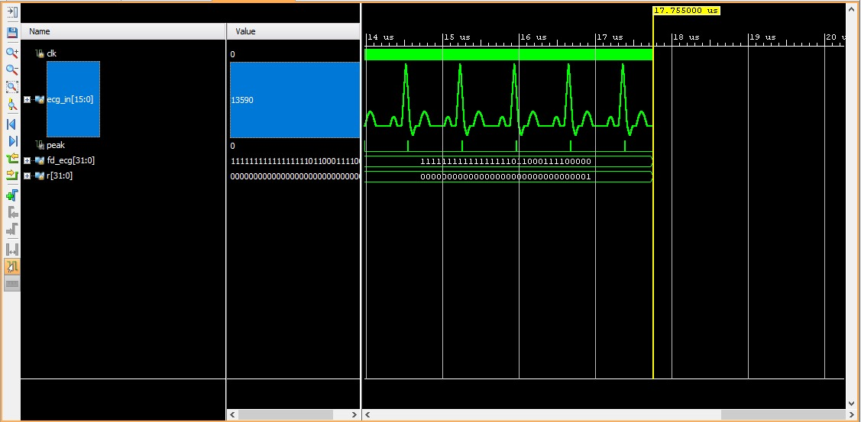
- Figure 1: Sample Peak Detection

Result
The threshold-based local-maximum ECG peak detection algorithm was successfully implemented using Verilog HDL and simulated in Xilinx Vivado. The simulation results obtained from Vivado Simulator (XSIM) demonstrated that the three-sample window (prev, curr, and next) effectively identifies ECG R-peaks among 2,000 samples based on the predefined threshold (THRESHOLD = 16'sd1000 / 16'd45000). The detected peaks were indicated by 8'h01 flags, confirming the functional operation of the algorithm.

