Experiment 5: Counter Design Using Vivado IP
Objectives
- To configure an 8-bit binary counter IP core in Xilinx Vivado with an increment step of 2.
- To design and configure a 16-bit binary counter IP core in down-counter mode with a decrement step of 1.
- To develop top-level modules and HDL wrappers that connect the system clock, reset, enable, and counter output signals.
- To perform behavioral simulation using Vivado Simulator (XSIM) to verify counter progression, down-counting operation, and rollover behavior.
Software Requirements
- Xilinx Vivado Design Suite
- Vivado IP Catalog
- Vivado Simulator (XSIM)
Procedure
A. Design of an 8-Bit Up-Counter Circuit (Increment by 2)
- Launch Xilinx Vivado and create a new project by selecting the appropriate FPGA device.
- Open the Vivado IP Catalog and add the Binary Counter IP core (c_counter_binary). Configure the output width to 8 bits and set the increment value to 2 by connecting a constant value of 2 to the increment input.
- Develop a top-level Verilog module that connects the clock (CLK), reset signal, and 8-bit counter output (Q or out1).
- Create a Verilog testbench named tb_clock_divider_by4 to generate a periodic clock signal, apply an initial reset, and monitor the counter output.
- Run the behavioral simulation using Vivado Simulator (XSIM) and inspect the output waveform to verify that the counter increments by 2 at each rising clock edge. The expected sequence is 0, 2, 4, 6, ..., 254, followed by rollover to 0.
B. Design of a 16-Bit Down-Counter Circuit (Decrement by 1)
- Launch Vivado and create a new RTL project by specifying the project name and selecting the appropriate target FPGA device.
- Open the IP Catalog, search for the Binary Counter IP core, configure its output width to 16 bits, select down-counter mode, and enable the required clock and reset options. Generate the IP core.
- Create an HDL wrapper for the generated IP and connect the clock, reset, enable, and 16-bit counter output signals.
- Develop a Verilog testbench to generate a periodic clock, apply an initial reset, assert the enable signal, and initialize the counter to a known value, such as FFFFH.
- Execute behavioral simulation using Vivado Simulator (XSIM) and examine the output waveform to verify that the counter decrements by 1 at each active clock edge.
- Formulas
- 1. Up-Counter Modulo & Rollover Calculation:
- Max Count = 2^WIDTH - 1 = 2^8 - 1 = 255
For Increment = 2: Maximum even state = 254. Next state: (254 + 2) mod 256 = 0 (Rollover).
- 2. Down-Counter Modulo & Underflow Calculation:
- Initial State = 2^16 - 1 = 65535 (FFFFH).
For Decrement = 1: Sequence follows FFFFH, FFFEH, FFFDH, ..., 0000H, FFFFH.
Output
S.No | Output Parameter | Target / Expected Behavior | Simulated / Measured Result | Status
1 | 8-Bit Up-Counter Step | Increment by +2 | Increment by +2 | Verified
2 | 16-Bit Down-Counter Step | Decrement by -1 | Decrement by -1 | Verified
3 | Up-Count Sequence & Rollover | 0, 2, 4, ..., 254 -> 0 | 0, 2, 4, ..., 254 -> 0 | Verified
4 | Down-Count Sequence | FFFFH, FFFEH, FFFDH, ... | FFFFH, FFFEH, FFFDH, ... | Verified
5 | Operation Stability | Stable Count Transitions | Validated in XSIM Waveform | Pass

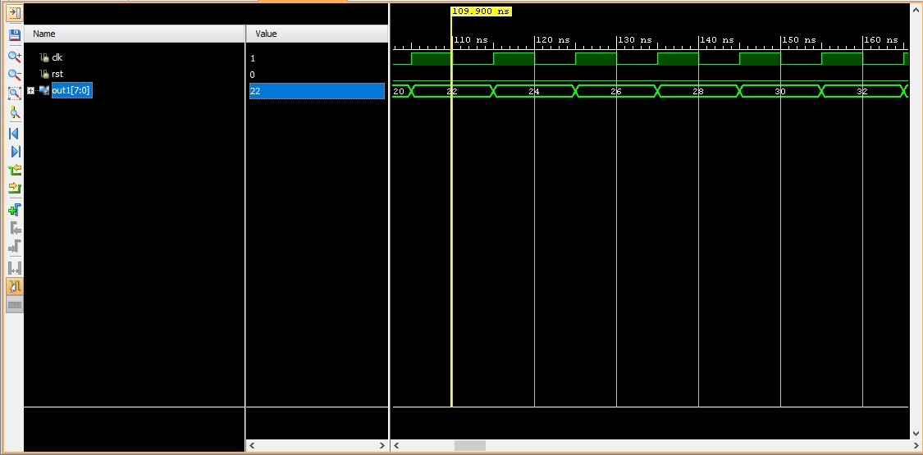
Figure: Example of upcounting by 2

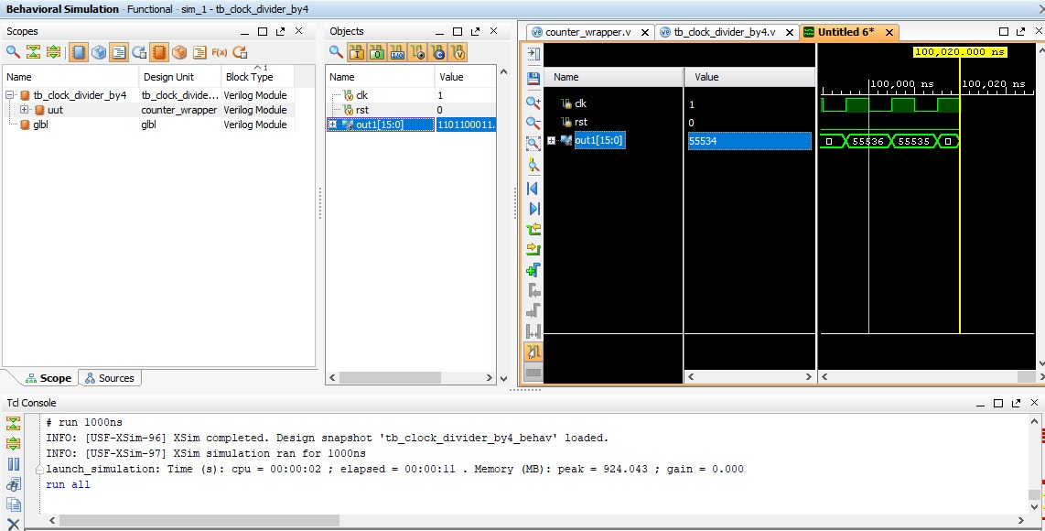
Figure: Example of downcounting by 1
Result
The 8-bit up-counter with an increment step of 2 and the 16-bit down-counter with a decrement step of 1 were successfully configured and simulated using the Binary Counter IP core in Xilinx Vivado. The simulation waveforms verified that the 8-bit up-counter advances by 2 at each rising clock edge, following the sequence 0, 2, 4, ..., 254, before rolling over to 0. Similarly, the 16-bit down-counter decreases by 1 on each active clock pulse, starting from FFFFH. The observed results confirmed the correct functioning of both counter designs.

