Experiment 6: Design of a UART Transmitter and Receiver Using RTL
Objectives
- To design and simulate UART transmitter (uart_tx) and receiver (uart_rx) modules using Verilog HDL in Xilinx Vivado.
- To calculate and configure baud-rate timing using the CLKS_PER_BIT parameter for a system clock of a specified frequency and a baud rate of 115200 bps.
- To integrate the transmitter and receiver into a loopback simulation model without requiring the Zynq Processing System (PS), AXI interconnect, or physical FPGA implementation.
- To verify the transmission and reception of predefined data patterns using a Verilog testbench and analyze serial communication timing through simulation waveforms.
Software Requirements
- Xilinx Vivado Design Suite
- Vivado Simulator (XSIM)
- Verilog HDL editor
Experimental Procedure
A. UART Transmitter RTL Design
Develop a Verilog module named uart_tx with clock, reset, transmit-enable, parallel data input, serial output, and transmission-status signals. Implement the UART frame format consisting of one start bit, eight data bits transmitted least-significant bit first (LSB first), and one stop bit. Use a clock counter to control the duration of each transmitted bit according to the configured baud rate.
B. UART Receiver RTL Design
Develop a Verilog module named uart_rx with clock, reset, serial data input, received-data output, and receive-valid signals. Implement start-bit detection, data-bit sampling, stop-bit verification, and received-data capture. Use appropriate clock counting and sampling logic to ensure reliable reception of the transmitted data.
C. Loopback Integration and Testbench Development
Create a top-level Verilog module that connects the UART transmitter's serial output (o_TX_Serial) to the UART receiver's serial input (i_RX_Serial). Develop a testbench to generate the clock and reset signals and transmit the following test patterns: 8'h00, 8'h11, 8'h22, 8'h33, 8'h44, 8'h55, 8'hAA, and 8'hFF. Wait for the receiver-valid signal and compare each received byte with its corresponding transmitted value to verify correct data transfer.
D. Behavioral Simulation and Waveform Analysis
- Execute the testbench using Vivado Simulator (XSIM).
- Observe the clock, reset, transmit-enable, transmitted data, serial output, serial input, received data, and receive-valid signals in the waveform viewer.
- Verify the correct generation of the start bit, eight data bits, and stop bit, along with the bit duration and successful reception of each test pattern.
E. Data Integrity and Timing Analysis
- Record the total number of transmitted bytes, correctly received bytes, and data mismatches.
- Calculate the data integrity percentage and effective communication throughput based on the simulation results.
- Evaluate the influence of the CLKS_PER_BIT parameter on UART bit timing and confirm that the transmitter and receiver use compatible baud-rate configurations.
Output

S.No | Output Parameter | Expected / Theoretical Value | Simulated / Measured Value | Status / BER
1 | Transmitted TX Byte Stream | 00, 11, 22, 33, 44, 55, AA, FF | 00, 11, 22, 33, 44, 55, AA, FF | Verified
2 | Received RX Byte Stream | 00, 11, 22, 33, 44, 55, AA, FF | 00, 11, 22, 33, 44, 55, AA, FF | 0% Bit Error
3 | Receiver Valid Pulse (o_RX_DV) | Active-High 1 Clock Pulse | Active-High 1 Clock Pulse | Verified
4 | Bit Error Rate (BER) | 0% | 0% Bit Mismatch | Pass

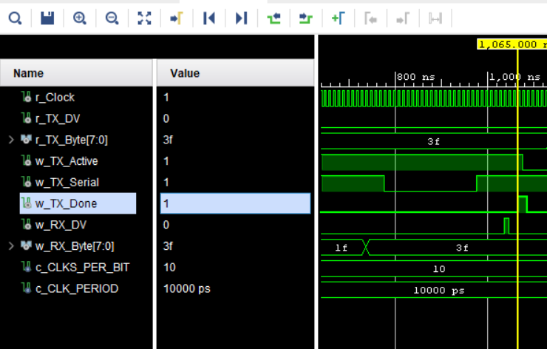
Figure 1: Verification of UART communication
Result
The UART transmitter (uart_tx) and receiver (uart_rx) modules were successfully designed using Verilog RTL and verified through behavioral simulation in Xilinx Vivado Simulator (XSIM). Both modules were integrated into a loopback configuration without requiring the Zynq Processing System, AXI interface, physical FPGA implementation, or external UART hardware. The testbench transmitted eight predefined data patterns (00, 11, 22, 33, 44, 55, AA, and FF) and compared the received bytes with the corresponding transmitted values. All eight patterns were received correctly, demonstrating 100% data integrity for the tested cases. The UART frame format, baud-rate timing, and receiver outputs were also verified through simulation waveforms.

