Experiment 1: Design of Clock Divider Circuits Using RTL
Objectives
- To design and verify a divide-by-2 clock divider using Verilog HDL that generates a 50 MHz output clock from a 100 MHz input clock.
- To design and verify a divide-by-4 clock divider using Verilog HDL that produces a 25 MHz output clock from a 100 MHz input clock.
- To implement toggle-based flip-flop logic for divide-by-2 operation and a 2-bit synchronous counter for divide-by-4 operation, using an active-high asynchronous reset.
- To perform behavioral simulation using Vivado Simulator (XSIM), measure the output clock periods, and validate the frequency division ratios.
Software Requirements
- Xilinx Vivado Design Suite
- Vivado Simulator (XSIM)
- PC or laptop
Procedure
A. Generation of a 50 MHz Clock from a 100 MHz Clock (Divide-by-2)
- Create a new RTL project in Xilinx Vivado and select the appropriate FPGA device.
- Create a Verilog module named clock_divider_by2 with the following ports: input clock (clk), reset (rst), and output clock (clk_out).
- Implement the RTL logic to toggle clk_out using clk_out <= ~clk_out on each rising edge of the input clock, with an asynchronous reset.
- Develop a testbench named tb_clock_divider_by2 to generate a 100 MHz input clock using always #5 clk = ~clk; and apply an initial reset.
- Run behavioral simulation using Vivado Simulator (XSIM) and examine the output waveform to verify the generation of a 50 MHz clock.
B. Generation of a 25 MHz Clock from a 100 MHz Clock (Divide-by-4)
- Create a new RTL project or add a Verilog module named clock_divider_by4 to the existing project.
- Define the module ports as input clock (clk), reset (rst), and output clock (clk_out). Declare an internal 2-bit register using reg [1:0] count.
- Implement the RTL logic to increment the counter on each rising edge of the input clock and toggle clk_out when the counter reaches 2'b01, using the specified reset behavior.
- Create a testbench named tb_clock_divider_by4 to generate a 100 MHz input clock and apply an initial reset.
- Execute behavioral simulation using Vivado Simulator (XSIM) and inspect the output waveform to verify the generation of a 25 MHz clock.
Output
S.No | Output Parameter | Theoretical / Expected Value | Simulated / Measured Value | % Deviation
1 | Input Clock Period (clk) | 10.0 ns | 10.0 ns | 0%
2 | Divide-by-2 Frequency (clk_out1) | 50.0 MHz | 50.0 MHz | 0%
3 | Divide-by-2 Clock Period | 20.0 ns | 20.0 ns | 0%
4 | Divide-by-4 Frequency (clk_out2) | 25.0 MHz | 25.0 MHz | 0%
5 | Divide-by-4 Clock Period | 40.0 ns | 40.0 ns | 0%
6 | Output Duty Cycle | 50% | 50% | 0%

Calculation
1. Clock Period Relationship: T = 1 / f
2. Frequency Division Formula: f_out = f_in / N
• Divide-by-2 Circuit: f_out1 = 100 MHz / 2 = 50 MHz ==> T_out1 = 20 ns
• Divide-by-4 Circuit: f_out2 = 100 MHz / 4 = 25 MHz ==> T_out2 = 40 ns
3. Percentage Frequency Deviation: Deviation (%) = | (f_simulated - f_theoretical) / f_theoretical | * 100
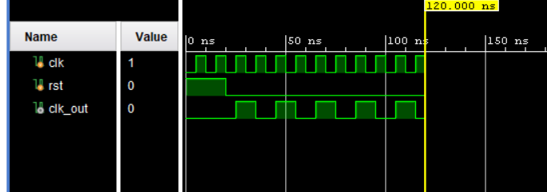
Figure 1: Clock division by 2
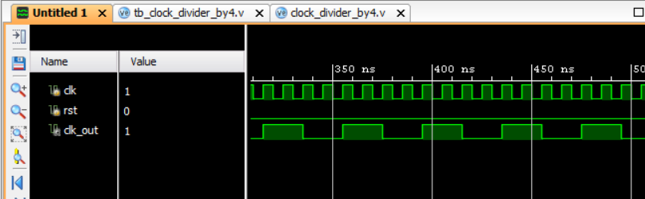

Figure 2: Clock division by 4
Result
The divide-by-2 and divide-by-4 clock divider circuits were successfully designed using RTL Verilog and simulated in Xilinx Vivado. The simulation results obtained from Vivado Simulator (XSIM) confirmed that the 100 MHz input clock was correctly divided to generate output frequencies of 50 MHz and 25 MHz, respectively. The corresponding output clock periods were verified as 20 ns and 40 ns, demonstrating the correct operation of both clock divider circuits and their specified frequency division ratios.

