Experiment 9: Design of a Convolutional Layer on Zynq SoC
Objectives
- To design and simulate a 3 × 3 convolutional layer using RTL Verilog for image processing and Convolutional Neural Network (CNN) accelerator applications.
- To define nine 8-bit signed input pixel registers (p0–p8) representing a 3 × 3 image window, nine 8-bit signed kernel coefficient registers (k0–k8), and a 16-bit signed bias input.
- To implement parallel multiply–accumulate (MAC) logic that computes nine products simultaneously, accumulates the results, and adds the bias to generate a 20-bit signed output (y).
- To develop a Verilog testbench named tb_conv2d_3x3, perform simulation using Vivado Simulator (XSIM) with multiple filter test cases, including all-ones, edge detection, and mixed signed values, and verify the results against theoretical calculations.
Software Requirements
- Xilinx Vivado Design Suite
- Vivado Simulator (XSIM)
- Verilog HDL
- Windows or Linux operating system
Procedure
Step 1: Project Creation
Launch Xilinx Vivado and create a new RTL project. Specify the project name and select the appropriate target FPGA device or board.
Step 2: Module Architecture and Port Declaration
Create a Verilog module named conv2d_3x3 to perform a 3 × 3 convolution operation. Declare nine 8-bit signed pixel input ports (p0 to p8) representing the image window, nine 8-bit signed kernel coefficient ports (k0 to k8), a 16-bit signed bias input (bias), and a 20-bit signed convolution output (y).
Step 3: Multiply–Accumulate (MAC) Logic Implementation
Implement parallel multiply–accumulate logic by calculating nine product terms, from m0 = p0 * k0 through m8 = p8 * k8. Sum all nine products to obtain the accumulated result and add the bias to generate the final output according to the equation:
[
y = \sum_{i=0}^{8}(p_i \times k_i) + bias
]
Step 4: Testbench Development
Create a Verilog testbench named tb_conv2d_3x3 and instantiate the conv2d_3x3 module. Develop the following test cases to evaluate the convolution operation:
- All-Ones Kernel: Set all input pixels to 10, all kernel coefficients to 1, and the bias to 5.
- Edge Detection Kernel: Set the center pixel (p4) to 20 and all other pixels to 5. Assign the center kernel coefficient (k4) a value of 8, all other coefficients a value of −1, and the bias to 0.
- Mixed Signed Values: Apply a combination of positive and negative pixel values and kernel coefficients, with the bias set to 2.
Step 5: Simulation and Result Verification
Launch Vivado Simulator (XSIM) and execute the behavioral simulation. Observe the output waveforms for each test case, record the corresponding y values, and compare the simulation results with manually calculated theoretical outputs to verify the accuracy of the convolutional layer.
Output
S.No | Test Scenario / Parameter | Expected Theoretical Output | Simulated Hardware Output | % Deviation / Status
1 | Test Case 1 (All-Ones Kernel) | y = (9 * 10 * 1) + 5 = 95 | y = 95 | 0% Error
2 | Test Case 2 (Edge Detection Kernel) | y = (20 * 8) + (8 * 5 * -1) + 0 = 120 | y = 120 | 0% Error
3 | Test Case 3 (Mixed Signed Inputs) | y = 33 + 2 = 35 | y = 35 | 0% Error
4 | Computational Accuracy | 100% MAC Precision | 100% MAC Precision | Verified

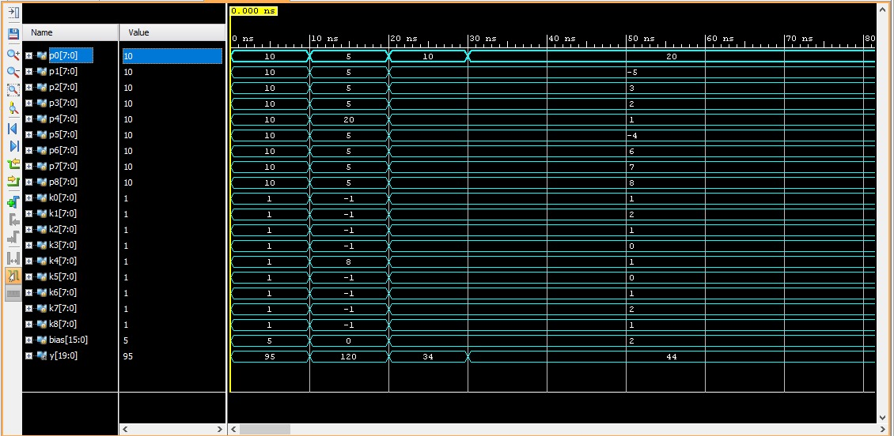
Figure 1: Output obtained for 3x3 convolution
Result
The 3 × 3 convolutional layer was successfully designed using Verilog HDL and simulated in Xilinx Vivado. The implemented architecture performed nine parallel 8-bit signed multiplications, accumulated the resulting products, and added the 16-bit bias to generate a 20-bit signed convolution output. The simulation results for all three test cases—All-Ones Kernel, Edge Detection Kernel, and Mixed Signed Values—were consistent with the theoretical calculations, confirming the functional correctness of the convolutional layer for image processing and CNN accelerator applications.

