Experiment 10: Design of a Fully Connected Neural Network Using RTL
Objectives
- To design and simulate a Fully Connected (FC) neural network layer with five input neurons (x0–x4), five weight inputs (w0–w4), and a single output neuron (y) using Verilog HDL.
- To implement parallel signed 8-bit × 8-bit fixed-point multipliers, a five-input adder-tree accumulator (sum), and a 16-bit signed bias addition stage.
- To develop a comprehensive Verilog testbench named tb_fully_connected_5in that applies positive, scaled, and signed two's-complement test vectors.
- To perform behavioral simulation using Vivado Simulator (XSIM), analyze the output waveforms, and verify computational accuracy against manually calculated multiply–accumulate (MAC) results.
Software Requirements
- Xilinx Vivado Design Suite
- Vivado Simulator (XSIM)
- Verilog HDL
- Windows or Linux operating system
Procedure
Step 1: Project Creation
Launch Xilinx Vivado and create a new RTL project. Specify the project name and select the appropriate target FPGA device or board.
Step 2: Module Architecture and Port Declaration
Create a Verilog module named fully_connected_5in to implement the fully connected neural network layer. Declare five 8-bit signed input ports (x0 to x4), five 8-bit signed weight ports (w0 to w4), a 16-bit signed bias input (bias), and an 18-bit signed output (y).
Step 3: Multiply–Accumulate (MAC) Logic Implementation
Implement five parallel signed 8-bit × 8-bit multipliers to calculate the products, from m0 = x0 * w0 through m4 = x4 * w4. Accumulate the five products using an adder tree to obtain the sum, then add the bias to generate the final output according to the equation:
[
y = \sum_{i=0}^{4}(x_i \times w_i) + bias
]
Ensure that the intermediate products and accumulator use appropriate signed arithmetic and bit widths to preserve the correctness of the computation.
Step 4: Testbench Development
Create a Verilog testbench named tb_fully_connected_5in and instantiate the fully_connected_5in module. Apply the following test cases to verify the functionality:
- All-Ones Weights: Apply input values with all weights set to 1 and a bias of 10.
- Scaled Weights: Apply weights scaled by a factor of 2 with the bias set to 0.
- Mixed Signed Values: Apply a combination of positive and negative input and weight values using two's-complement representation, with the bias set to 5.
Step 5: Simulation and Result Verification
Launch Vivado Simulator (XSIM) and execute the behavioral simulation. Observe the input values, weight coefficients, bias, intermediate MAC results, and final output in the simulation waveforms. Record the output values for each test case and compare them with manually calculated theoretical results to verify the accuracy of the fully connected neural network layer.

Formulas
1. Fully Connected Neuron MAC Formula: y = (sum_{i=0}^{4} x_i * w_i) + bias
2. Individual Test Case Arithmetic Verification:
• Test Case 1 (Positive inputs, all-ones weights): sum = (10x1) + (20x1) + (30x1) + (40x1) + (50x1) = 150; y = 150 + 10 = 160
• Test Case 2 (Scaled weights x2): sum = (5x2) + (10x2) + (15x2) + (20x2) + (25x2) = 150; y = 150 + 0 = 150
• Test Case 3 (Mixed signed negative inputs): sum = (-10x1) + (20x1) + (-5x1) + (15x1) + (10x1) = 30; y = 30 + 5 = 35
3. Bit-Width Precision & Guard Bit Analysis: 8-bit x 8-bit signed product yields 16-bit signed terms (m0..m4). Accumulating 5 16-bit terms requires ceil(log2(5)) = 3 guard bits, giving an 18-bit accumulator (sum). Adding a 16-bit bias yields an 18-bit output (y) preventing overflow.

Output
S.No | Test Scenario / Parameter | Expected Theoretical Output | Simulated Hardware Output | % Deviation / Status
1 | Test Case 1 (Positive Inputs) | y = 150 + 10 = 160 | y = 160 | 0% Error
2 | Test Case 2 (Scaled Weights x2) | y = 150 + 0 = 150 | y = 150 | 0% Error
3 | Test Case 3 (Mixed Negative Values) | y = 30 + 5 = 35 | y = 35 | 0% Error
4 | Accumulator Precision | 18-bit Signed Accumulator | No Arithmetic Overflow | Verified

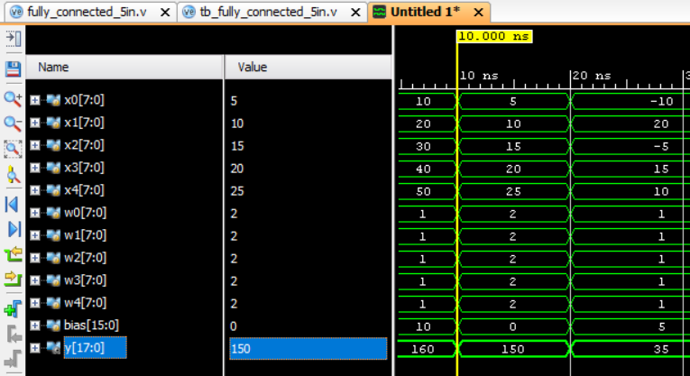
Figure 1: Output of fully connected network process
Result
The Fully Connected (FC) neural network layer with five input neurons was successfully designed using RTL Verilog and simulated in Xilinx Vivado. The implemented circuit performed five parallel signed 8-bit multiplications, accumulated the product terms, and added the 16-bit bias to generate the final 18-bit signed output. The simulation waveforms for all three test cases—Positive Values, Scaled Weights, and Mixed Signed Inputs—matched the theoretical multiply–accumulate (MAC) calculations. These results confirmed the functional correctness of the designed neural network layer for hardware-based AI acceleration.

