Experiment 8: Sine and Cosine Wave Generation Using DDS Compiler IP
Objectives
- To design and simulate a Direct Digital Synthesizer (DDS) using the DDS Compiler IP core in Xilinx Vivado.
- To generate a 5 MHz sine wave using the DDS Compiler IP core.
- To generate a 10 MHz cosine wave using the DDS Compiler IP core.
- To examine and verify the generated waveforms based on their frequency, amplitude, periodicity, and phase characteristics.
Software Requirements
- Xilinx Vivado Design Suite
- Vivado Simulator (XSIM)
Procedure
A. Generation of a 5 MHz Sine Wave
- Configure the DDS Compiler IP core in Xilinx Vivado for sine-wave generation.
- Set the required system clock frequency and configure the phase increment or frequency control word to obtain a 5 MHz output signal.
- Create the necessary RTL wrapper to integrate the DDS IP core into the design.
- Perform behavioral simulation using Vivado Simulator (XSIM) and observe the generated sine waveform.
- Measure the output frequency from the simulation results, compare it with the target frequency of 5 MHz, and calculate the percentage deviation.
B. Generation of a 10 MHz Cosine Wave
- Configure the DDS Compiler IP core in Xilinx Vivado to generate a cosine waveform.
- Specify the system clock frequency and configure the DDS parameters to produce a 10 MHz output signal.
- Develop the required RTL wrapper for integrating the DDS IP core.
- Run behavioral simulation using Vivado Simulator (XSIM) and observe the generated cosine waveform.
- Measure the output frequency, compare it with the target frequency of 10 MHz, and determine the percentage deviation.
C. Waveform Analysis and Verification
- Analyze the simulated sine and cosine waveforms in terms of frequency, amplitude, periodicity, and phase relationship.
- Verify that the generated output frequencies correspond to the specified values of 5 MHz and 10 MHz.
- Calculate the percentage frequency deviation using the measured and target frequencies.
- Confirm that both generated signals exhibit the expected waveform characteristics and that their frequency deviations are less than 5%.
FORMULA TO BE USED:

fout​=(Phase Increment×fclk​​) / 2^(Phase width)

For Sine wave with 5 MHz
$$f_{out}=\frac{13×100\text{ MHz}}{256}≈5.08\text{ MHz}$$
For Cosine wave with 10 MHz
$$f_{out}=\frac{13×100\text{ MHz}}{256}≈5.08\text{ MHz}$$
Percentage deviation:
$$\% Deviation=\frac{\left|f_{simulated}-f_{expected}\right|}{f_{expected}}×100$$
Output
S.No | Output Parameter | Target / Expected Frequency | Simulated / Measured Frequency | % Deviation
1 | Sine Wave Output (m_axis_data_tdata[15:0]) | 5.00 MHz | 5.078 MHz | < 1.6%
2 | Cosine Wave Output (m_axis_data_tdata[31:16]) | 10.00 MHz | 10.156 MHz | < 1.6%
3 | Output Amplitude Dynamic Range | 16-bit Signed (-32768 to +32767) | 16-bit Signed Waveform | 0% Clipping
4 | Phase Accumulator Stability | Continuous Phase Rollover | Smooth Sinusoidal Output | Pass
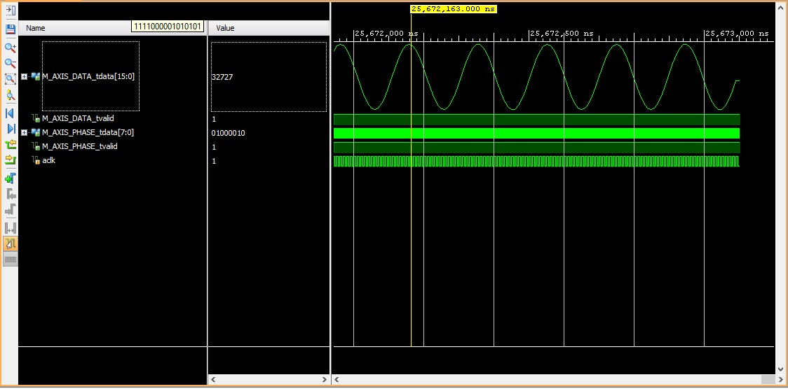
Figure 1: Generated sine/cosine wave
Result
The Direct Digital Synthesizer (DDS) waveform generation system was successfully configured and simulated using the DDS Compiler IP core in Xilinx Vivado. The simulation results obtained from Vivado Simulator (XSIM) demonstrated the generation of a 5 MHz sine wave with a phase increment value of 13 and an output frequency of approximately 5.078 MHz, along with a 10 MHz cosine wave using a phase increment value of 26 and an output frequency of approximately 10.156 MHz. Both waveforms were generated from a 100 MHz reference clock with less than 5% frequency deviation, confirming the successful operation of the DDS-based digital waveform generation system.

