**KAAN ÖZEL**

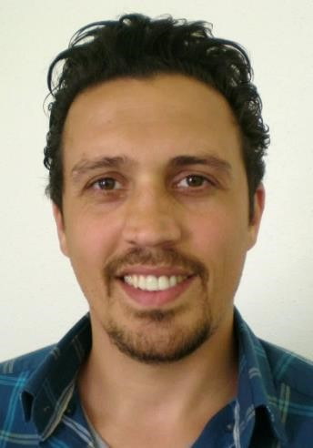professional  
photo

Participant at Powercoders

Guggenbühlstrasse 69, 8404 Winterthur

kaan.ozel@powercoders.org | 076 570 87 73

[GitHub](https://github.com/KaanOezel) | [Learning Blog](https://kaanozel.netlify.com) | Online portfolio | LinkedIn

Languages: English (B2), German (B2), Turkish ( mother tongue)

IT skills: ★☆☆☆☆ Python, JS ★★★★☆ Hardware, AutoCAD

★★☆☆☆ HTML, CSS

★★★☆☆ Photoshop

**WORK EXPERIENCE**

08.2018 – 02.2019 **Intern Childcare Assistance,** Betreuung Langwiesen, Winterthur

- Supporting children of all ages in their daily routines

- Help with the implementation of activities, small projects and excursions

- Take on household chores, prepare lunch and snack tables

- Holiday care, work in different teams and children's groups

04.2018 – 07.2018 Intensive German course

12.2016 - 03.2018 **Staff member,** Papiermanufaktur, Winterthur

- Craft activities in the production

- Instructing other staff members

- Hand papermaking and wrapping books

- Operating paper cutting machine and paper punch machine

05.2016 – 07.2016 **Staff member,** Caritas Markt, Winterthur

- Care of the store

- Presentation of assortment of goods

- Receiving and checking deliveries of goods

05.2012 – 09.2012 **Security Guard,** Atatürk Airport, Istanbul, Turkey

- Search and inspect baggage and cargo

- Screen passengers and airport staff prior to boarding

- Inspect vehicles and authenticate employee identification

- Submit written incident reports as necessary

- Question and privately search passengers who appear to be suspicious

- Work with trained canines to discover drugs and other illegal materials

- Support law enforcement

12.2010 – 03.2011 **Staff member,** Call Center, temporary, Istanbul, Turkey

- Answering incoming calls

- Management and resolve of customer complaints

- Identify and escalate issues to supervisors

- Follow up customer calls where necessary

05.2010 – 08.2010 **Patient Consultant,** Rumeli Hospital, temporary, Istanbul, Turkey

- Management of appointments and patient registrations

- Management of medical records

- Informing patients/visitors on procedures

03.2009 – 04.2010 **Supervisor,** Cyber Cafe, Istanbul, Turkey

- Maintenance and troubleshoot hardware, terminals, software and connectivity issues

- Help customers with the use of computers and applications

- Assist customers with downloads, printing, and encoding

- Monitor use of computers to ensure compliance with café policies and --

applicable laws and regulations

12.2006 – 05.2008 **Shift Supervisor,** AFM Cinema, Istanbul, Turkey

- Planning personal placement and duties during shift

- Training staff

- Handling complaints and customer enquiries

- Dealing with problems as and when they arise

08.2005 – 10.2006 **Mandatory Military Duty,**Turkey & Cyprus

12.2003 – 06.2005 **Draftsman,** Enermak Machine Construction Co.Ltd. Istanbul, Turkey

- Following specifications and calculations to create various technical

drawings

- Preparing both rough sketches and detailed work with CADD systems

- Prepare and review rough sketches and review them along with the team

- Identify potential operational issues and redesign products to improve

functionality

**EDUCATION**

03.2020 – 06.2020 Powercoders – Coding Academy for Refugees, Zurich, Switzerland

- Foundations in HTML, CSS, JavaScript; specialization tracks upcoming

weekly business & social skills trainings (time mgt., communication, etc.)

08.2011 – 01.2012 Security Guard Training, Istanbul, Turkey

- Armed security guard training

- Graduated with 89/100

09.2000 – 06.2003 High School, Istanbul, Turkey

- Social Sciences

- Graduated with 87/100