

**s**

**LEROTHOLI POLYTECHNIC**

**SCHOOL OF ENGINEERING**

**AND**

**TECHNOLOGY**

|  |  |
| --- | --- |
| **Student Number:** | **202301320CE** |

|  |  |
| --- | --- |
| **Surname & Other Names:** | **TLOKOTSI POTLOANE** |

|  |  |
| --- | --- |
| **Program:** | **B.ENG.TECH COMPUTER ENGINEERING** |

|  |  |
| --- | --- |
| **Subject Name:** | **Microcontroller Systems 1** |

|  |  |
| --- | --- |
| **Subject Code:** | **MCSY22107** |

|  |  |
| --- | --- |
| **Assignment Number:** | **6** |

|  |  |  |  |  |  |  |  |  |
| --- | --- | --- | --- | --- | --- | --- | --- | --- |
| **Due Date:** | **2** | **8** | **0** | **4** | **2** | **0** | **2** | **4** |

|  |  |
| --- | --- |
| **Lecturer:** | **Mr. T.P Raliete** |

**Declaration of own work**

I hereby declare that this assignment is my own work and that it has not been copied from any other person or document.

...T.Potloane.............................. ....28/04/24........................ signature date

**TRUTH TABLE**

|  |  |  |
| --- | --- | --- |
| Temperature | Fan (RA2) | Heater(RA3) |
| < 40 | Off | On |
| >= 40 | On | Off |

**FLOW CHART**

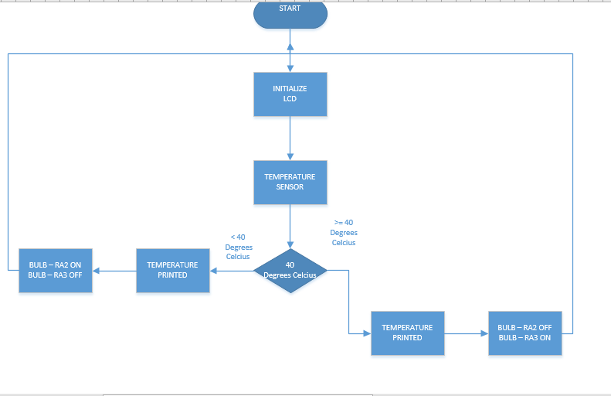

**THE CODE**

sbit LCD_RS at RB4_bit;

sbit LCD_EN at RB5_bit;

sbit LCD_D4 at RB0_bit;

sbit LCD_D5 at RB1_bit;

sbit LCD_D6 at RB2_bit;

sbit LCD_D7 at RB3_bit;

sbit LCD_RS_Direction at TRISB4_bit;

sbit LCD_EN_Direction at TRISB5_bit;

sbit LCD_D4_Direction at TRISB0_bit;

sbit LCD_D5_Direction at TRISB1_bit;

sbit LCD_D6_Direction at TRISB2_bit;

sbit LCD_D7_Direction at TRISB3_bit;

float temperature;

char temp[7];

void main() {

ANSEL = 0x01; // Configure AN0 pin as analog

ANSELH = 0x00; // Configure other AN pins as digital

TRISA = 0b00000001; // Configure PORTA as output (RA0 as input for LM35)

Lcd_Init(); // Initialize LCD

ADC_Init(); // Initialize ADC module

Lcd_Cmd(_LCD_CLEAR); // Clear display

Lcd_Cmd(_LCD_CURSOR_OFF); // Cursor off

LCD_OUT(1, 3, "Temperature");

LCD_OUT(2, 3, "Sensor");

delay_ms(2000);

Lcd_Cmd(_LCD_CLEAR);

Lcd_Cmd(_LCD_CURSOR_OFF);

while (1) {

// Read temperature from the sensor

temperature = ADC_Read(0); // Read ADC value from AN0 pin

temperature = temperature * (5.0 / 1023.0) * 100.0;

// Convert temperature to string for LCD display

floatToStr(temperature, temp);

// Display temperature on LCD

LCD_OUT(2, 1, temp);

LCD_OUT(2, 7, "C");

// Check if temperature exceeds 40 degrees Celsius

if (temperature > 40.0) {

// Turn on the fan

PORTA.RA2 = 1;

LCD_OUT(1, 1, "Fan: ON ");

} else {

// Turn off the fan

PORTA.RA2 = 0;

LCD_OUT(1, 1, "Fan: OFF");

}

// Check if temperature exceeds 40 degrees Celsius to turn on the heater

if (temperature > 40.0) {

// Turn off the heater

PORTA.RA3 = 0;

} else {

// Turn on the heater

PORTA.RA3 = 1;

}

delay_ms(500);

}

}

**THE CIRCUIT**

