

**s**

**LEROTHOLI POLYTECHNIC**

**SCHOOL OF ENGINEERING**

**AND**

**TECHNOLOGY**

|  |  |
| --- | --- |
| **Student Number:** | **202301320CE** |

|  |  |
| --- | --- |
| **Surname & Other Names:** | **TLOKOTSI POTLOANE** |

|  |  |
| --- | --- |
| **Program:** | **B.ENG.TECH COMPUTER ENGINEERING** |

|  |  |
| --- | --- |
| **Subject Name:** | **Microcontroller Systems 1** |

|  |  |
| --- | --- |
| **Subject Code:** | **MCSY22107** |

|  |  |
| --- | --- |
| **Assignment Number:** | **5** |

|  |  |  |  |  |  |  |  |  |
| --- | --- | --- | --- | --- | --- | --- | --- | --- |
| **Due Date:** | **2** | **2** | **0** | **4** | **2** | **0** | **2** | **4** |

|  |  |
| --- | --- |
| **Lecturer:** | **Mr. T.P Raliete** |

**Declaration of own work**

I hereby declare that this assignment is my own work and that it has not been copied from any other person or document.

...T.Potloane.............................. ....15/04/24........................ signature date

**TRUTH TABLE**

|  |  |  |
| --- | --- | --- |
| Password | Action | Bulb |
| Correct Password | Access Granted | On |
| inorrect Password | Access Denied | off |

**FLOW CHART**

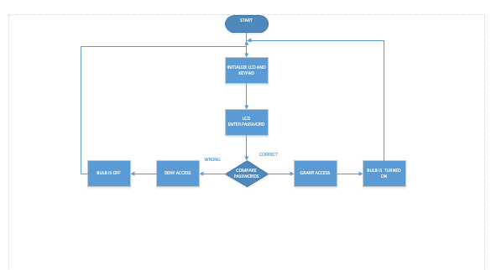

**THE CODE**

char keypadPort at PORTD;

// LCD module connections

sbit LCD_RS at RB4_bit;

sbit LCD_EN at RB5_bit;

sbit LCD_D4 at RB0_bit;

sbit LCD_D5 at RB1_bit;

sbit LCD_D6 at RB2_bit;

sbit LCD_D7 at RB3_bit;

sbit LCD_RS_Direction at TRISB4_bit;

sbit LCD_EN_Direction at TRISB5_bit;

sbit LCD_D4_Direction at TRISB0_bit;

sbit LCD_D5_Direction at TRISB1_bit;

sbit LCD_D6_Direction at TRISB2_bit;

sbit LCD_D7_Direction at TRISB3_bit;

char input[6]; // Stores user input

char password[5] = "1234"; // Predefined password

char keypad() {

unsigned short kp;

// Wait for key to be pressed and released

do {

kp = Keypad_Key_Click(); // Store key code in kp variable

} while (!kp);

// Prepare value for output, transform key to its ASCII value

switch (kp) {

case 1: kp = '1'; break; // 1

case 2: kp = '2'; break; // 2

case 3: kp = '3'; break; // 3

case 4: kp = 'A'; break; // A (/)

case 5: kp = '4'; break; // 4

case 6: kp = '5'; break; // 5

case 7: kp = '6'; break; // 6

case 8: kp = 'B'; break; // B (*)

case 9: kp = '7'; break; // 7

case 10: kp = '8'; break; // 8

case 11: kp = '9'; break; // 9

case 12: kp = 'C'; break; // C (-)

case 13: kp = '*'; break; // *

case 14: kp = '0'; break; // 0

case 15: kp = '#'; break; // # (=)

case 16: kp = 'D'; break; // D (+)

}

return kp;

}

void main() {

int i = 0;

Keypad_Init(); // Initialize Keypad

ANSEL = 0; // Configure AN pins as digital I/O

ANSELH = 0;

TRISE = 0XFF;

TRISA = 0X00;

PORTA = 0X00;

Lcd_Init(); // Initialize LCD

Lcd_Cmd(_LCD_CLEAR); // Clear display

Lcd_Cmd(_LCD_CURSOR_OFF); // Cursor off

delay_ms(500);

while (1) {

LCD_OUT(1, 1, "Enter Password:");

delay_ms(1000);

Lcd_Cmd(_LCD_CLEAR);

// Read user input from keypad

while (i < 4) {

input[i] = keypad();

lcd_chr_cp('*');

i++;

}

input[4] = '\0';

// Display the entered password on the LCD

//LCD_OUT(1, 1, input);

// Check if the entered password matches the predefined password

if (input[0] == password[0] && input[1] == password[1] && input[2] == password[2] && input[3] == password[3]) {

LCD_OUT(2, 1, "Access Granted");

PORTA.RA0 = 1;

delay_ms(10000);

PORTA.RA0 = 0;

} else {

LCD_OUT(2, 1, "Access Denied");

PORTA.RA0 = 0;

}

delay_ms(2000);

Lcd_Cmd(_LCD_CLEAR);

i = 0; // Reset the index for the next iterat

}

}

**SIMULATION CIRCUIT**

