**Watch Hub**

**E-Project**

**Group Members**

|  |  |
| --- | --- |
| Student1434937 | Muhammad Kaarim Hussain |
| Student1438944 | Muhammad Asim |
| Student1435101 | Ubaidullah |
| Student1436820 | Muhammad Arham Khan |
| Student1457819 | Sundus Khalid Khan |
| Student1439028 | Laiba Ali |

**Semester: HDSE 2**

**Faculty: Sir Owais Khan**

**Certificate of Completion**

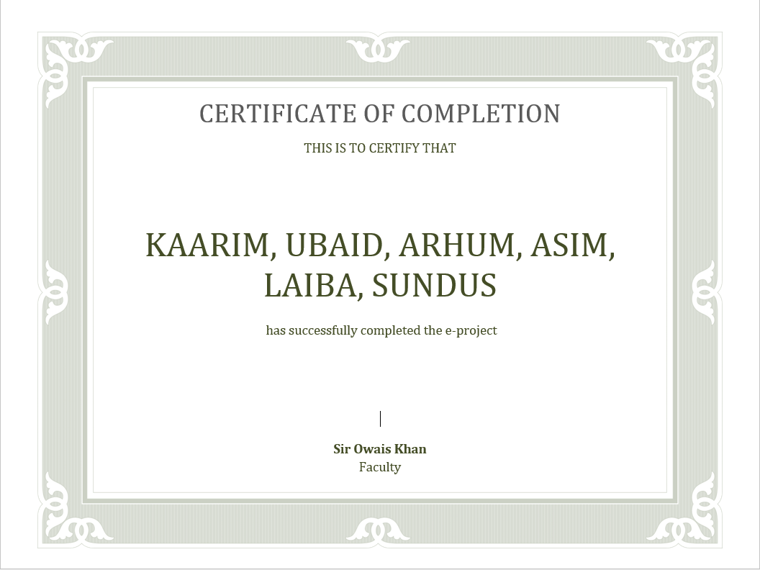

**Table of Content**

**Introduction:**

The thirst for learning, upgrading technical skills and applying the concepts in real life. environment at a fast pace is what the industry demands from IT professionals today. However busy work schedules, far-flung locations, unavailability of convenient time-slots pose as major barriers when it comes to applying the concepts into realism. and hence the need to look out for alternative means of implementation in the form of laddered approach.

The above truly pose as constraints especially for our students too! With their busy schedules, it is indeed difficult for our students to keep up with the genuine and constant need for integrated application which can be seen live especially so in the field of IT education where technology can change on the spur of a moment. Well, technology does come to our rescue at such times!!

Keeping the above in mind and in tune with our constant endeavor to use Technology in our training model, we at aptech have thought of revolutionizing the way our students learn and implement the concepts using tools themselves by providing a live and synchronous e-project learning environment!

**Objectives:**

The Objective of this program is to give a sample project to work on real life projects. These applications help you build a larger more robust application.

The objective is not to teach you the concepts but to provide you with a real life scenario and help you create applications using the tools.

You can revise them before you start with the project.

It is very essential that a student has a clear understanding of the subject. Kindly get back to e-projects team in case of any doubts regarding the application or its objectives.

**Functional Requirement**

**Background:**

The idea for the Watch Shopping Mobile App “**WatchHub**” stemmed from the growing demand for a convenient and user-friendly platform for purchasing premium watches. The client, a well-established watch retailer, recognized the need to enhance their digital presence and capitalize on the increasing trend of online shopping.

**Requirements**

**User Authentication:**

1. Users must be able to create accounts, log in, and log out.
2. Authentication should be secure and include password recovery options.

**Browse Watches:**

1. Users can browse a catalog of watches, categorized by brands, types, and price ranges.
2. Filtering options should be available, including sorting by price, brand, and popularity.
3. A search feature should allow users to find specific watches.

**Product Details:**

1. Detailed product pages for each watch, including images, descriptions, specifications, and prices.
2. Users can view high-quality images of the watches and zoom in for a closer look.
3. Availability and stock information should be displayed.

**Shopping Cart:**

1. Users can add watches to their cart.
2. Ability to modify the cart contents (add, remove, change quantities).
3. Cart should display the total price.

**User Profiles:**

1. Users can create and edit their profiles, including personal information, and shipping addresses.
2. Access to order history and order tracking.

**Wishlist:**

1. Users can add watches to a wishlist for future reference.
2. Wishlist items can be moved to the cart for purchase.

**Reviews and Ratings:**

1. Users can leave reviews and ratings for watches.
2. Sort and filter reviews based on helpfulness and date.

**Customer Support:**

1. Contact customer support through an in-app chat or a contact form.
2. View a frequently asked questions (FAQ) section.

**Search and Filters:**

1. Robust search functionality.
2. Filters for narrowing down search results, including brand, price, and product type.

**Admin Panel:**

1. A backend admin panel to manage product listings, user data, reviews, and orders.

**Feedback and Reviews:**

1. Users can provide feedback and report issues directly from the app.

**Non Functional Requirement**

**Responsiveness:** The app should respond to user interactions within 1-2 seconds, ensuring a smooth and lag-free experience.––

**Loading Time:** The app's initial loading time should be minimized to ensure users can access it quickly.

**User Interface:** The app's user interface should be intuitive, following best design practices for mobile apps to ensure ease of use.

**Accessible:** The application should have clear and legible fonts, user-interface elements, and navigation elements.

**User-friendly:** The application should be easy to navigate with clear menus and other elements and easy to understand.

**Operability:** The application should operate in a reliably efficient manner.

**Error Handling:** Implement robust error handling to provide clear error messages to users and gracefully handle unexpected situations.

**Scalability:** The application architecture and infrastructure should be designed to handle increasing user traffic, data storage, and feature expansions.

**Security:** The application should implement adequate security measures such as authentication. For example, only registered users can access certain features.

**User Documentation:** Provide user guides, FAQs, and tutorials to help users understand and navigate the application.

**Developer Documentation:** Maintain developer documentation to assist in further development and maintenance.

**Video:** Provide video displaying complete working of the application.

**Hardware and Software Requirement**

**Hardware**

* A minimum computer system that will help you access all the tools in the courses is a Pentium 166 or better
* 128 Megabytes of RAM or better
* Windows 2000 Server (or higher if possible)

**Software**

Use software as per your requirement

Windows OS/JAVA/Android SDK/Notepad/SQL/Dart/Flutter

**Project Plan**

|  |  |  |  |
| --- | --- | --- | --- |
| **1st Week** | **2nd Week** | **3rd Week** | **4th Week** |
| Planning & Management | Design & Development | Optimizations & Bug Fix | Build Project & Error Fixing |

|  |  |
| --- | --- |
| **Name** | **Task** |
| Ubaidullah | Login, Signup, Admin Panel, Watch Details, User Feedback, User Credentials Update, Checkout, Admin Order Management, FAQ’s & Information |
| Arham | Login, Signup, Admin Panel, Watch Details, User Feedback, User Credentials Update, Cart System, Admin Order Management, Dashboard Information, Database |
| Kaarim | UI Design, Admin Panel, Watch Details, Splash Screen, Profile Page, Checkout, Cart System, Admin Order Management, Validations |
| Asim | Collection, Admin Panel, Admin Collections, User Feedback, Profile Page, Cart System, Admin Order Management |
| Sundus | Watch CRUD, Admin Panel, Admin Feedback, Password Recovery, Cart System, Admin Order Management, Dashboard Information, Database |
| Laiba | Watch CRUD, Admin Panel, Admin Feedback, Password Recovery, Cart System, Admin Order Management, Dashboard Information, Database |

**Task Sheet**

**Project Review and Monitoring Report**

|  |  |
| --- | --- |
| User Authentication | **✔** |
| Browse Watches | **✔** |
| Product Details | **✔** |
| Shopping Cart | **✔** |
| User Profile | **✔** |
| Wishlist | **✔** |
| Reviews and Ratings | **✔** |
| Customer Support | **✔** |
| Search and Filters | **✔** |
| Admin Panel | **✔** |
| Feedback and Reviews | **✔** |
| Security | **✔** |
| Responsiveness | **✔** |
| Loading Time | **✔** |
| User Interface | **✔** |
| Accessible | **✔** |
| User friendly | **✔** |
| Error Handling | **✔** |
| User Documentation | **✔** |
| Developer Documentation | **✔** |