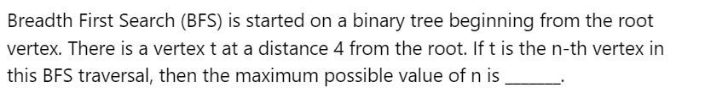

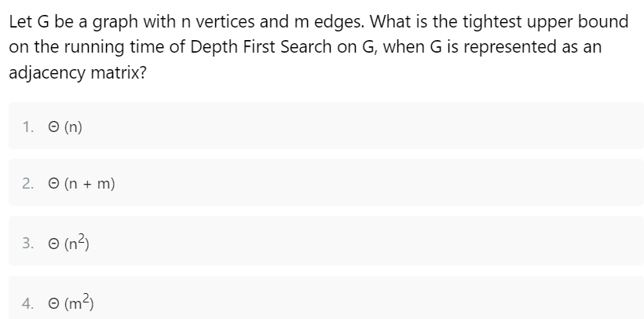

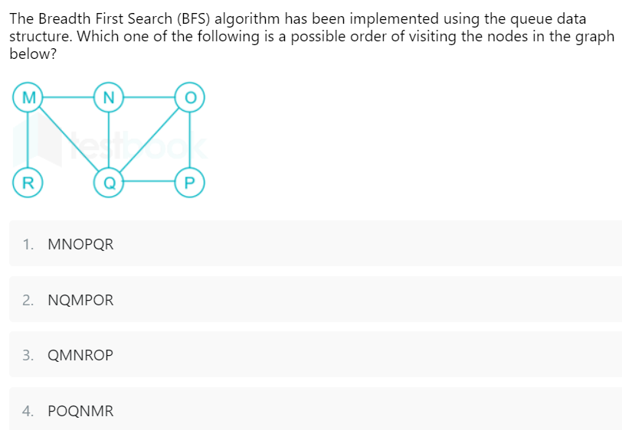

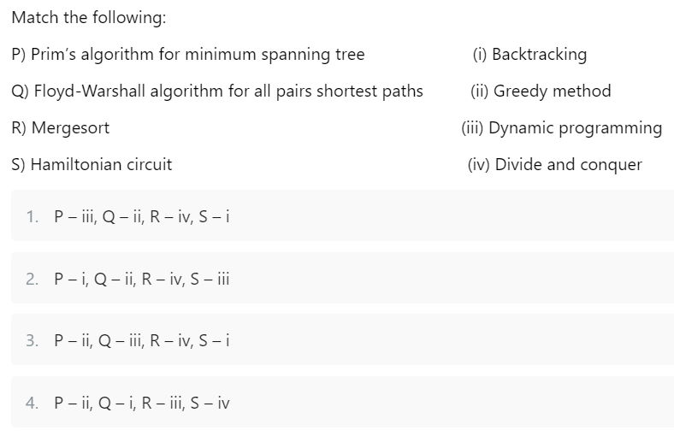

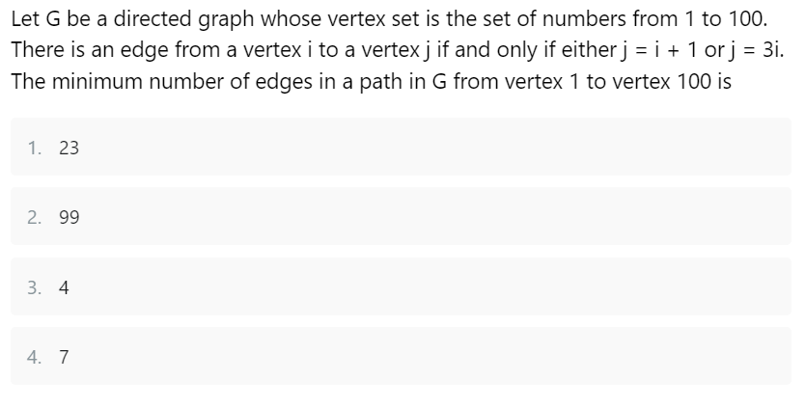

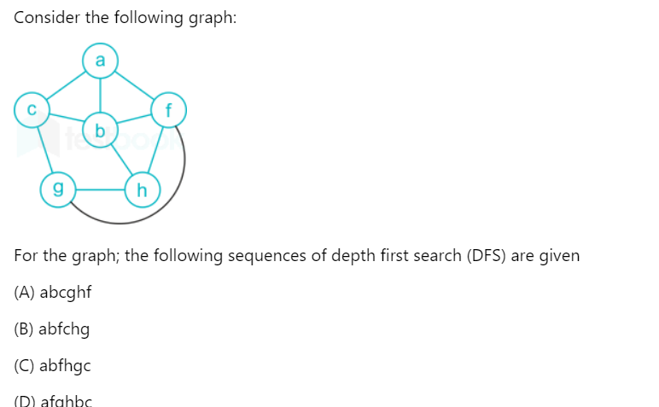

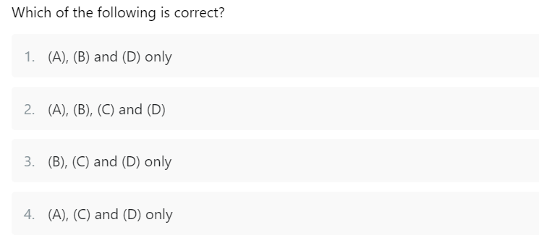

. Traversal of a graph is somewhat different from the tree because

**(A)** There can be a loop in a graph, so we must maintain a visited flag for every vertex

**(B)** DFS of a graph uses the stack, but the inorder traversal of a tree is recursive

**(C)** BFS of a graph uses a queue, but a time-efficient BFS of a tree is recursive.

**(D)** All of the above

Which of the algorithms given below can be used to most efficiently determine the presence of a cycle in a given graph?

**(A)** Breadth-First Search

**(B)** Depth First Search

**(C)** Prim's Minimum Spanning Tree Algorithm

**(D)** Kruskal's Minimum Spanning Tree Algorithm

What are the suitable [Data Structure](https://www.naukri.com/code360/library/data-structure)s for the following algorithms?

1) Breadth-First Search

2) Depth First Search

3) Prim's Minimum Spanning Tree

4) Kruskal's Minimum Spanning Tree

**(A)**

1) Stack

2) Queue

3) Priority Queue

4) Union Find

**(B)**

1) Queue

2) Stack

3) Priority Queue

4) Union Find

**(C)**

1) Stack

2) Queue

3) Union Find

4) Priority Queue

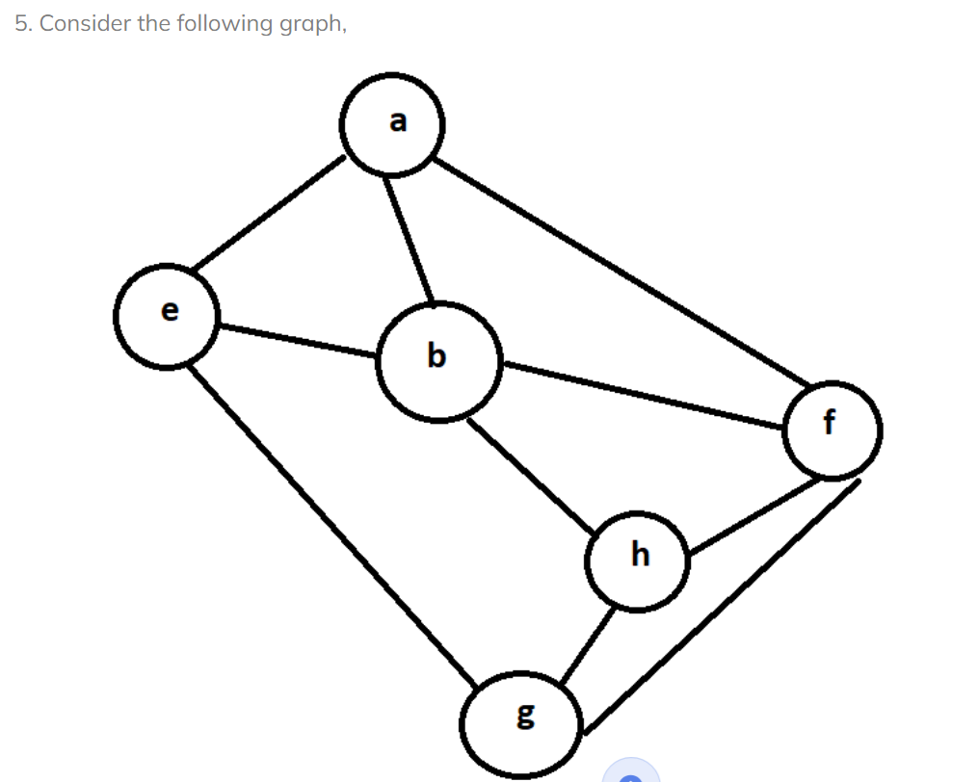

Among the following sequences:

(I) a b e g h f

(II) a b f e h g

(III) a b f h g e

(IV) a f g h b e

Which are the depth-first traversals of the above graph?

**(A)** I, II, and IV only

**(B)** I and IV only

**(C)** II, III, and IV only

**(D)** I, III, and IV only

