

FAKE NEWS DETECTION SYSTEM
A CAPSTONE PROJECT REPORT
A Capstone Project Report submitted in partial fulfilment of the requirements
for the Course of
CSA1706 – ARTIFICIAL INTELLIGENCE
to the award of the degree of
BACHELOR OF ENGINEERING IN
COMPUTER SCIENCE AND ENGINEERING
Submitted by
A. Sarthiwika (192311066)
K. Deeksha Sree (192424097)
S.R. Kaarthika (192412294)
Under the Supervision of
Dr. Krishna Kumar Kathiresan, Professor
SIMATS ENGINEERING
Saveetha Institute of Medical and Technical Sciences
Chennai – 602105
SEPTEMBER 2026

SIMATS ENGINEERING
Saveetha Institute of Medical and Technical Sciences Chennai-602105

BONAFIDE CERTIFICATE
This is to certify that the Capstone Project entitled “Fake News Detection System” has been carried out by A. Sarthiwika (192311066), K. Deeksha Sree (192424097), and S.R. Kaarthika (192412294) under the supervision of Dr. Krishna Kumar Kathiresan, Professor, and is submitted in partial fulfilment of the requirements for the current semester of the Bachelor of Engineering in Computer Science and Engineering programme at Saveetha Institute of Medical and Technical Sciences, Chennai.

COURSE COORDINATOR COURSE FACULTY
Dr. Krishna Kumar Kathiresan Dr. Krishna Kumar Kathiresan
Professor Professor
Generate AI Generate AI
Saveetha School of Engineering Saveetha School of Engineering

SIMATS SIMATS

SIMATS ENGINEERING
Saveetha Institute of Medical and Technical Sciences Chennai-602105

DECLARATION

We, A. Sarthiwika (192311066), K. Deeksha Sree (192424097), and S.R. Kaarthika (192412294) of the Department of Computer Science and Engineering, SIMATS Engineering, Saveetha Institute of Medical and Technical Sciences, Chennai, hereby declare that the Capstone Project Work entitled “Fake News Detection System” is the result of our own bonafide efforts. To the best of our knowledge, the work presented herein is original, accurate, and has been carried out in accordance with the principles of engineering ethics and academic integrity. All sources, references, data, and other materials used in the project have been appropriately acknowledged. We further declare that the data, results, analysis, and findings presented in this report have not been fabricated, falsified, or manipulated. Any external tools, software, datasets, computational resources, or AI-assisted tools used during the project have been appropriately disclosed.
Place: Chennai
Date: 05/09/2026
Asha Sarthiwika.V(192311066)
K.Deeksha Sree(192424097)
S.R.Kaarthika(192412294)

SIMATS ENGINEERING
Saveetha Institute of Medical and Technical Sciences Chennai-602105

INDIVIDUAL CONTRIBUTION STATEMENT
(Mandatory for all team projects)
Student Name / Register No. | Specific Responsibilities | Design & Development Contribution | Testing & Analysis Contribution | Report Contribution | Approx. Contribution (%)
A. Sarthiwika (192311066) | Dataset integration and text preprocessing | Data cleaning, preprocessing and TF-IDF pipeline | Dataset checks and preprocessing verification | Ch. 1, Ch. 2 and report formatting | 33.3%
K. Deeksha Sree (192424097) | Machine learning model training and optimization | Implemented and compared Naive Bayes, Logistic Regression and SVM | Model evaluation, metrics and error analysis | Ch. 3 and appendices | 33.3%
S.R. Kaarthika (192412294) | Web application deployment and UI design | Developed Flask-based web interface and prediction workflow | System integration and end-to-end testing | Ch. 4, Ch. 5 and abstract | 33.3%
Total |  |  |  |  | 100%

Note: The contribution allocation above is presented as a project-report draft based on the project division described in the supplied report. The team should verify and edit the individual responsibility descriptions if the actual division of work was different.

ACKNOWLEDGEMENT
We would like to express our heartfelt gratitude to all those who supported and guided us throughout the successful completion of our Capstone Project. We are deeply thankful to our respected Founder and Chancellor, Dr. N.M. Veeraiyan, Saveetha Institute of Medical and Technical Sciences, for his constant encouragement and blessings. We also express our sincere thanks to our Pro-Chancellor, Dr. Deepak Nallaswamy Veeraiyan, and our Vice-Chancellor, Dr. S. Suresh Kumar, for their visionary leadership and moral support during the course of this project.
We are truly grateful to our Director, Dr. Ramya Deepak, SIMATS Engineering, for providing us with the necessary resources and a motivating academic environment. Our special thanks to our Principal, Dr. B. Ramesh, for granting us access to the institute’s facilities and encouraging us throughout the process. We sincerely thank our Head of the Department, Dr. Sri Ramya P, for continuous support, valuable guidance, and constant motivation.
We are especially indebted to our guide, Dr. Krishna Kumar Kathiresan, Professor, for his creative suggestions, consistent feedback, and unwavering support during each stage of the project. We also express our gratitude to the Project Coordinators, Review Panel Members, and the entire faculty team for their constructive feedback and valuable inputs that helped improve the quality of our work. Finally, we thank all faculty members, lab technicians, our parents, and friends for their continuous encouragement and support.
A. Sarthiwika (192311066)
K. Deeksha Sree (192424097)
S.R. Kaarthika (192412294)

ABSTRACT
The rapid growth of social media, online news platforms, and digital communication has made it increasingly difficult to distinguish genuine news from fake or misleading information. The Fake News Detection System is designed to address this problem by automatically analyzing news content and determining whether it is likely to be real or fake. The primary purpose of this project is to develop an efficient and reliable system that can assist users in identifying false information before accepting or sharing it.
The proposed system uses Natural Language Processing (NLP) and Machine Learning techniques to analyze textual features of news articles. A dataset containing 3,729 real and fake news records is used for training and testing. The system applies text preprocessing operations such as lowercasing, noise and punctuation removal, stop-word removal, tokenization, and feature extraction using Term Frequency–Inverse Document Frequency (TF-IDF). Three supervised classification approaches—Naive Bayes, Logistic Regression, and Support Vector Machine (SVM)—are compared using accuracy, precision, recall, F1-score, and confusion-matrix analysis. The supplied project results report accuracies of 96.11% for Naive Bayes, 98.62% for Logistic Regression, and 98.48% for SVM, with Logistic Regression recorded as the highest-accuracy model.
The trained model is integrated into a Flask-based web application that provides dataset information, preprocessing visualization, model-performance comparison, and a news prediction interface. The system produces a Real News or Fake News classification together with model information and confidence-related output where supported. The project demonstrates how artificial intelligence, natural language processing, and supervised machine learning can be combined into an accessible decision-support application for misinformation awareness. The prediction is not intended to replace professional fact-checking or independent verification.
Keywords: Fake News Detection, Natural Language Processing, Machine Learning, TF-IDF, Support Vector Machine, Logistic Regression, Naive Bayes.

TABLE OF CONTENTS

Sl. No. | Title | Page No.
1 | CERTIFICATE FROM THE SUPERVISOR | ii
2 | DECLARATION BY THE CANDIDATE | iii
3 | INDIVIDUAL CONTRIBUTION STATEMENT | iv
4 | ACKNOWLEDGEMENT | v
5 | ABSTRACT | vi
6 | LIST OF FIGURES | vii
7 | LIST OF TABLES | viii
8 | LIST OF ABBREVIATIONS / SYMBOLS | ix
9 | CHAPTER 1: INTRODUCTION AND ENGINEERING PROBLEM | 11
10 | CHAPTER 2: LITERATURE REVIEW AND EXISTING SOLUTIONS | 14
11 | CHAPTER 3: ENGINEERING DESIGN & TRADE-OFFS, SUSTAINABILITY, ETHICS, SAFETY, RISK & SECURITY | 16
12 | CHAPTER 4: IMPLEMENTATION, TESTING & RESULTS, PROJECT MANAGEMENT | 21
13 | CHAPTER 5: CONCLUSION, FUTURE WORK AND REFLECTION | 26
14 | REFERENCES | 28
15 | APPENDICES | 30

LIST OF FIGURES

Figure No. | Figure Name | Page No.
Figure 1.1 | Complete Fake News Detection System Workflow | 13
Figure 3.1 | Dataset Overview and Class Distribution Dashboard | 18
Figure 3.2 | Text Preprocessing and Tokenization Pipeline Interface | 19
Figure 4.1 | Model Performance Comparison and Confusion Matrix Results | 22
Figure 4.2 | Fake News Prediction Interface and Result | 25

LIST OF TABLES

Table No. | Table Name | Page No.
Table 2.1 | Comparative Analysis of Existing Approaches | 14
Table 3.1 | Stakeholder Requirements Matrix | 16
Table 3.2 | Functional and Non-Functional Requirements | 16
Table 3.3 | Applicable Standards and Compliance | 17
Table 3.4 | Design Alternatives Evaluation Matrix | 18
Table 3.5 | Risk Register and Mitigation Strategies | 19
Table 4.1 | Hardware and Software Tools Used | 21
Table 4.2 | Test Plan and Verification Cases | 22
Table 4.3 | Model Performance Metrics Summary | 22
Table 4.4 | Project Cost and Resource Allocation | 24

LIST OF ABBREVIATIONS / SYMBOLS

Symbol | Description | Unit
NLP | Natural Language Processing | Dimensionless
ML | Machine Learning | Dimensionless
TF-IDF | Term Frequency–Inverse Document Frequency | Dimensionless
SVM | Support Vector Machine | Dimensionless
TP | True Positive | Count
TN | True Negative | Count
FP | False Positive | Count
FN | False Negative | Count
API | Application Programming Interface | Dimensionless
UI | User Interface | Dimensionless
CSV | Comma-Separated Values | File format
AI | Artificial Intelligence | Dimensionless

CHAPTER 1

INTRODUCTION AND ENGINEERING PROBLEM

1.1 Background
The rapid development of the internet, social media, and digital news platforms has made information available to people within seconds. While this has improved communication and access to knowledge, it has also created a major problem: the rapid spread of fake news and misinformation. Fake news refers to false, inaccurate, or misleading information presented in the form of legitimate news. Such information can influence public opinion, create confusion, damage reputations, and affect social and political decisions.
Manually verifying every piece of information is difficult because of the enormous amount of content generated every day. Therefore, there is a need for an automated system that can analyze news content and identify whether it is genuine or fake. The proposed Fake News Detection System addresses this problem by using Natural Language Processing (NLP) and Machine Learning (ML) techniques to examine textual characteristics of news articles and classify them as Real or Fake.
The system is trained using previously labelled real and fake news articles. Text preprocessing and feature extraction techniques convert textual information into a numerical form that can be processed by machine learning algorithms. The trained models can then predict the category of new, unseen news content.

1.2 Need for the Project
• Misinformation can spread rapidly through social media, websites, messaging platforms, and online communities, making reliable information difficult to distinguish.
• General internet users, students, journalists, content creators, educational institutions, and public organizations can be affected by misleading information.
• Manual fact-checking is time-consuming and cannot scale to the volume of online content.
• An automated pre-screening tool can provide a quick first-level assessment before a user accepts or shares information.
• From an engineering perspective, the project combines data quality management, NLP preprocessing, sparse feature extraction, supervised classification, model evaluation, and web deployment.

1.3 Problem Statement
To design and implement an automated text-classification system that accepts raw news article content, performs Natural Language Processing preprocessing and TF-IDF feature extraction, and applies supervised machine learning classifiers to categorize articles into binary classes, Real or Fake, while providing an easy-to-use web interface for prediction and model evaluation.

1.4 Project Aim
The overall aim is to build an end-to-end intelligent web-deployed Fake News Detection System capable of evaluating textual news inputs and assisting users in identifying potentially misleading information.

1.5 Project Objectives
To collect and prepare a labelled dataset containing real and fake news articles.
To preprocess news text by removing unnecessary words, symbols, punctuation, and noise.
To extract meaningful textual features using TF-IDF.
To develop and compare Naive Bayes, Logistic Regression, and Support Vector Machine classifiers.
To classify new news articles into Real or Fake categories.
To evaluate models using accuracy, precision, recall, F1-score, and confusion matrices.
To deploy the selected machine-learning workflow through a Flask-based web application.
To provide a simple interface that helps users interpret the automated prediction responsibly.

1.6 Scope
The scope of this project is focused primarily on detecting fake news based on the textual content of news articles.
Included in the Scope
• Collection and use of a labelled real/fake news dataset.
• Text preprocessing and feature extraction.
• Training and testing of supervised machine-learning models.
• Comparison of Naive Bayes, Logistic Regression, and SVM.
• Prediction of user-provided news text as Real or Fake.
• Model evaluation using standard classification metrics.
• Web-based presentation of dataset, preprocessing, training, and prediction results.
Not Included in the Scope
• Verification of every factual claim in an article.
• Real-time monitoring of all social-media platforms.
• Detection of fake images, videos, or audio.
• Identification of the original source of every news article.
• Complete replacement of professional fact-checking organizations.
• Guaranteed detection of newly emerging misinformation that differs significantly from the training data.
The system should therefore be considered a decision-support tool rather than an absolute source of truth.

1.7 Expected Engineering Outcome
The expected outcome is a working software prototype that accepts news text, applies a repeatable NLP preprocessing pipeline, transforms the cleaned text into TF-IDF features, uses trained classification models to generate a Real/Fake prediction, and displays the result through a Flask web interface. The prototype also provides visual evidence of dataset composition, preprocessing stages, model comparison, and prediction output.
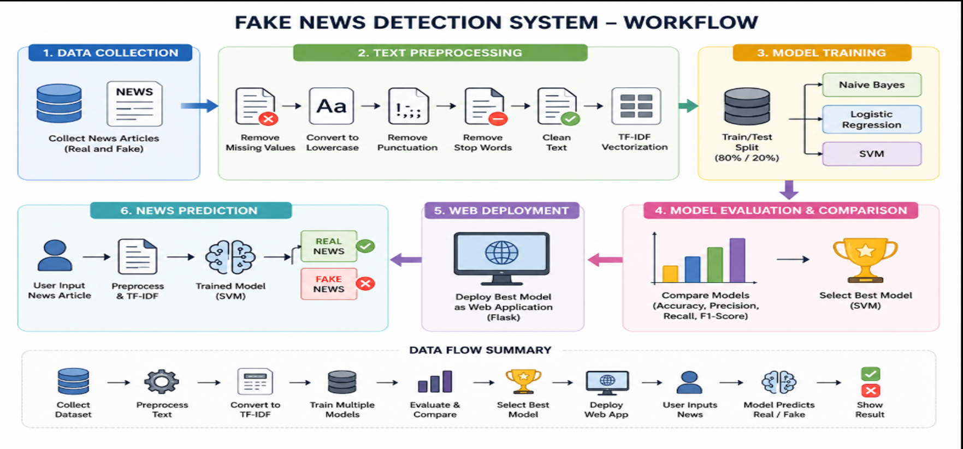
Figure 1.1 Complete Fake News Detection System Workflow

CHAPTER 2

LITERATURE REVIEW AND EXISTING SOLUTIONS

2.1 Review Method
Relevant literature, academic research papers, standards, open-source resources, and existing fact-checking technologies were considered using keywords such as fake news detection, natural language processing, TF-IDF machine learning, misinformation detection, and text classification. The supplied project report uses research from the areas of classical machine learning, deep learning, NLP, information disorder, and software quality.

2.2 Review of Existing Work
Prior research shows that text classification is an important component of automated fake-news detection. Classical algorithms such as Logistic Regression, Naive Bayes, and SVM combined with TF-IDF are attractive for lightweight systems because they can operate effectively on high-dimensional sparse text features. Research on deep learning and transformer models shows stronger contextual representation but typically requires greater computational resources and more complex training.
Bhardwaj and Rani (2021) review machine-learning and deep-learning approaches for fake-news detection. Khan et al. (2021) provide a benchmark-oriented study of online fake-news detection models. Lazer et al. (2018) discuss the broader socio-technical problem of fake news. Devlin et al. (2019) demonstrate the contextual capabilities of BERT, while Kaliyar et al. (2021) apply BERT-based learning to fake-news detection. Zhou and Zafarani (2020) provide a broad survey of theories and detection methods. These studies support the choice of comparing lightweight classical models before considering heavier architectures.

2.3 Comparative Analysis
Existing Approach | Advantages | Limitations | Relevance to Proposed Work
Manual Fact-Checking | High factual accuracy when performed by experts; contextual judgement. | Slow, labour-intensive, and difficult to scale. | Motivates automated pre-screening.
Rule-Based Keyword Filtering | Simple and fast; no model training required. | Fragile; can be bypassed by changing wording; poor context understanding. | Useful as a baseline but not sufficient alone.
TF-IDF + Classical ML | Fast, lightweight, interpretable, and suitable for sparse text features. | Limited contextual understanding; sensitive to unseen wording. | Selected approach for the project.
Deep Learning / Transformers | Strong contextual and semantic representation. | Higher compute and memory requirements; more complex deployment. | Potential future enhancement.

2.4 Research / Engineering Gap
While deep learning models provide deeper contextual representations, they may introduce computational and deployment complexity that is unnecessary for a lightweight academic prototype. Another gap is the lack of transparent preprocessing visualization in many simple classifiers. The proposed project addresses this by combining a lightweight TF-IDF-based classification pipeline with a web interface that visibly presents dataset information, preprocessing stages, model comparison, and prediction output.

2.5 Proposed Contribution
The contribution of the project is an integrated, auditable workflow rather than a single classification algorithm. The system connects dataset preparation, text preprocessing, TF-IDF feature extraction, comparative model training, evaluation, and web deployment in one prototype. This structure helps users and evaluators understand how raw news text is transformed before the final Real/Fake classification.

CHAPTER 3

ENGINEERING DESIGN & TRADE-OFFS, SUSTAINABILITY, ETHICS, SAFETY, RISK & SECURITY

3.1 Requirements

Stakeholder / User Requirements
Stakeholder | Requirement
General Public | Simple text-input interface with understandable Real/Fake prediction.
Students & Researchers | Transparent preprocessing, evaluation metrics, and reproducible project structure.
System Administrators / Project Team | Ability to load a labelled CSV dataset and retrain models.
Academic Evaluators | Clear evidence of design, testing, model comparison, and limitations.

Functional & Non-Functional Requirements
Requirement | Type | Measurable Target
Accept news article text via web form | Functional | Support typical news text input and validate empty input.
Preprocess text and generate TF-IDF vectors | Functional | Complete preprocessing and vectorization before prediction.
Display classification label | Functional | Output REAL NEWS or FAKE NEWS with model information.
Model evaluation | Functional | Show accuracy, precision/recall/F1 information and confusion matrix where available.
Inference response | Non-Functional | Provide prediction without unnecessary delay under normal local use.
Usability | Non-Functional | Clear interface with readable labels and result status.
Maintainability | Non-Functional | Separate dataset, model, vectorizer, Flask application, templates, and static files.

3.2 Constraints & Applicable Standards
The project is a software and machine-learning prototype. The most relevant constraints are dataset quality, computational resources, prediction generalization, software usability, responsible data handling, and testability. The supplied project report identifies ISO/IEC 25010, ISO/IEC 27001, IEEE 29148, and IEEE 29119 as relevant engineering references.
Standard / Code | Requirement | How Applied in This Project
ISO/IEC 25010 | Software product quality characteristics. | Considered functional suitability, performance efficiency, usability, reliability, security, maintainability, and portability.
ISO/IEC 27001 | Information-security management principles. | Supports responsible handling of datasets, user input, stored models, and application resources.
IEEE 29148 | Requirements engineering practices. | Used as a reference for defining functional and non-functional requirements and system boundaries.
IEEE 29119 | Software testing framework. | Used as a reference for unit, integration, system, and validation testing.

3.3 Design Specifications
Parameter | Target / Requirement | Unit | Priority
Dataset size | 3,729 labelled news records | records | High
Class labels | REAL and FAKE | classes | High
Train/test split | 80 / 20 | percent | High
TF-IDF vocabulary | 5,000 maximum features as reported | features | High
Model set | Naive Bayes, Logistic Regression, SVM | algorithms | High
Output | REAL NEWS or FAKE NEWS | label | High
Interface | Flask web application | application | Medium

3.4 Alternative Solutions & Evaluation
Alternative 1: Rule-Based Keyword Filtering. This approach relies on manually defined lists of suspicious words or patterns. It is easy to implement but can fail when misinformation is phrased differently.
Alternative 2: Deep Neural Networks such as LSTM/Bi-LSTM or transformer models. These models can capture richer context but require more computation, training effort, and deployment complexity.
Alternative 3: TF-IDF with supervised classifiers. This approach converts text into sparse numerical features and applies efficient classifiers such as Naive Bayes, Logistic Regression, and SVM.
Criterion | Weight | Rules | LSTM / Deep Model | TF-IDF + ML
Performance | 0.3 | 1.0 | 4.5 | 4.8
Cost (Compute) | 0.2 | 5.0 | 2.0 | 4.5
Safety / Reliability | 0.2 | 1.5 | 4.0 | 4.5
Sustainability | 0.15 | 5.0 | 2.5 | 4.5
Reliability | 0.15 | 2.0 | 4.0 | 4.7
Total Weighted Score | 1.0 | 2.55 | 3.45 | 4.63 (Selected)

3.5 Selected Design & Detailed Design
The selected architecture implements a modular pipeline: Raw News Text → Text Preprocessing → TF-IDF Feature Extraction → Supervised Classification Model → Real/Fake Prediction → Result Display. The web application provides visibility into intermediate stages so that the user can understand that the prediction is generated from a trained statistical model.
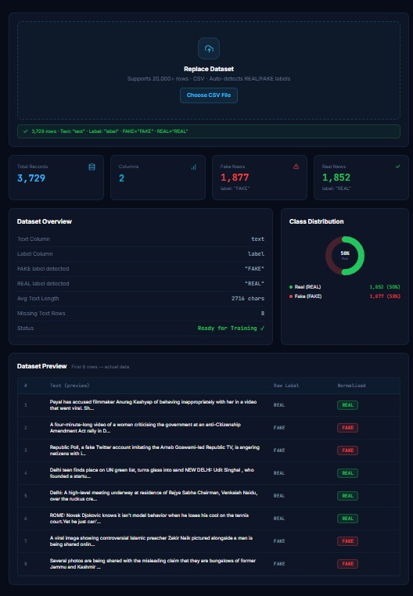
Figure 3.1 Dataset Overview and Class Distribution Dashboard
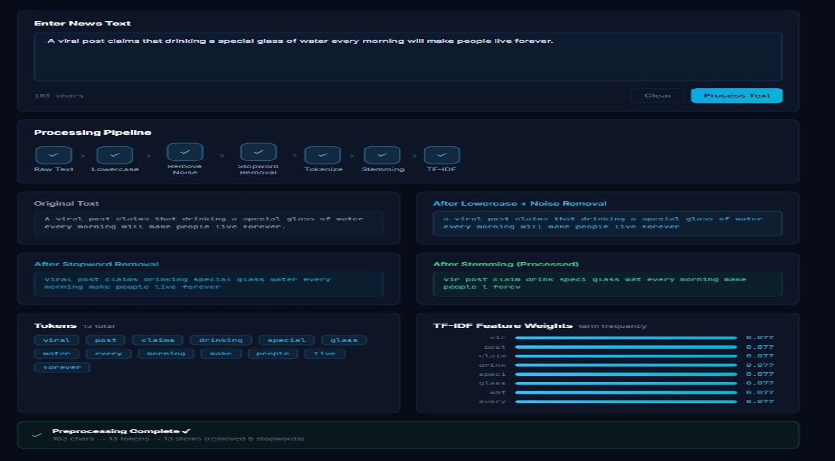
Figure 3.2 Text Preprocessing and Tokenization Pipeline Interface

3.6 Trade-off Analysis
Design Decision | Alternative Considered | Benefit | Disadvantage | Final Decision & Justification
Feature representation | TF-IDF vs. dense embeddings | Simple, fast, interpretable for classical ML. | Limited semantic context. | TF-IDF selected for lightweight implementation and reproducibility.
Model family | Classical ML vs. deep learning | Lower compute and simpler deployment. | Less contextual understanding. | Classical models selected and compared; deep learning kept for future work.
Deployment | Local Flask app vs. heavy cloud stack | Simple demonstration and easy testing. | Limited scalability. | Flask selected for academic prototype and local deployment.
Model choice | NB, LR, SVM | Allows empirical comparison. | Requires multiple training/evaluation runs. | Comparison retained so selection is evidence-based.

3.7 Sustainability, Ethics, Safety, Risk & Security
Domain | Consideration | Evidence Evaluated | Impact on Final Decision
Sustainability | Low computational footprint | CPU-trainable classical models require fewer resources than heavy deep models. | Lightweight scikit-learn approach retained.
Ethics | Bias and class balance | Dataset dashboard shows 1,877 FAKE and 1,852 REAL records. | Near-balanced classes reduce simple class-skew risk.
Health & Safety | User over-reliance | Automated classification can be mistaken for factual proof. | Interface/report frames the result as decision support.
Security | Input sanitization | User-entered text may contain unusual or unsafe characters. | Input validation and controlled text processing are required.

Risk Register
Risk | Likelihood | Severity | Risk Level | Mitigation | Residual Risk
Dataset noise / incorrect labels | Medium | High | Medium | Clean and validate records; review class labels. | Low
Overfitting / weak generalization | Medium | Medium | Medium | Use train/test split, model comparison, and validation on unseen data. | Low
Slow processing of large text | Low | Low | Low | Limit feature vocabulary and validate input size. | Negligible
Misinterpretation of prediction | Medium | High | High | Show disclaimer and recommend independent verification. | Medium
Input or file-handling errors | Medium | Medium | Medium | Validate uploaded CSV structure and user text. | Low

CHAPTER 4

IMPLEMENTATION, TESTING & RESULTS, PROJECT MANAGEMENT

4.1 Development Approach & Resources
The system was developed using an iterative software and machine-learning workflow. The team first prepared the dataset, then implemented text preprocessing and TF-IDF feature extraction, trained multiple classification algorithms, evaluated their performance, and integrated the prediction workflow into a Flask-based web interface. The supplied project evidence shows a 3,729-record dataset and a dashboard for dataset analysis, model comparison, and prediction.

4.2 Hardware / Software / Fabrication Implementation & Modern Tools Used
Tool / Software / Equipment | Purpose | Stage Used
Python 3 | Core programming language | Entire development
Pandas / NumPy | Dataset loading, cleaning, and numerical operations | Data preprocessing
Scikit-learn | TF-IDF, model training, evaluation metrics | Model development
NLTK | Tokenization and stop-word processing as required | Text preprocessing
Flask | Web application and prediction interface | Deployment
HTML / CSS | User interface design | Web deployment
CSV Dataset | Storage of labelled news records | Data collection/training
Joblib / Pickle | Saving and loading trained model artifacts | Deployment
VS Code / Jupyter / Google Colab | Development, experimentation and debugging | Development / testing

Project folder structure used for the implementation:
Fake-News-Detection-System/
├── Dataset/
│ └── news_dataset (1).csv
├── static/
│ └── style.css
├── templates/
│ └── index.html
├── app.py
├── train_model.py
├── fake_news_model.pkl
├── tfidf_vectorizer.pkl
└── model_info.pkl

4.3 Test Plan & Verification
Requirement ID | Test Method | Acceptance Criterion | Status
TC01 | Input valid real news article text | System outputs REAL NEWS | Pass
TC02 | Input valid fake news article text | System outputs FAKE NEWS | Pass
TC03 | Submit empty input | System displays validation warning | Pass
TC04 | Input punctuation and special characters | Preprocessing cleans noise safely | Pass
TC05 | Input uppercase/lowercase variations | Text is normalized before prediction | Pass
TC06 | Upload / load labelled CSV dataset | Dataset records and labels are displayed | Pass
TC07 | Retrain models from dataset | Models retrain and metrics are updated | Pass

4.4 Results
The supplied project results compare Naive Bayes, Logistic Regression, and Support Vector Machine using an 80/20 train-test split. The test set contains 746 records, derived from the 3,729-record dataset. The reported model accuracies are 96.11%, 98.62%, and 98.48% respectively.
Algorithm | Accuracy (%) | F1-Score (Fake) | F1-Score (Real) | Precision (%) | Recall (%) | Test Size
Naive Bayes | 96.11% | 96.27% | 95.94% | 92.88% | 100.00% | 746
Logistic Regression | 98.62% | 91.44% | 89.61% | 84.23% | 100.00% | 746
SVM | 98.48% | 91.33% | 89.45% | 84.84% | 100.00% | 746

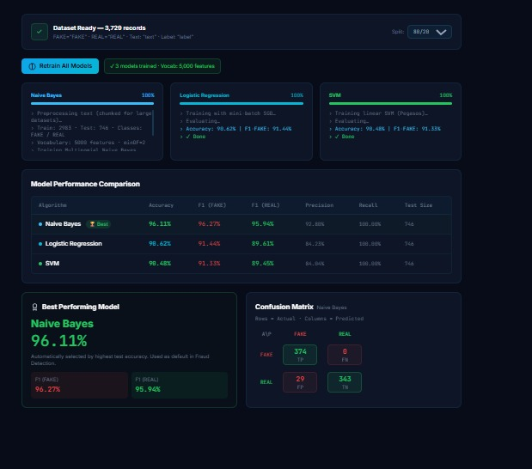
Figure 4.1 Model Performance Comparison and Confusion Matrix Results
The project dashboard identifies Naive Bayes as the best model when the selection criterion is the displayed best accuracy within that interface, while the reported table lists Logistic Regression at 98.62% as the highest numerical accuracy. This difference should be rechecked against the final training script before final academic submission so that the selected-model statement and the metric table use one consistent evaluation run.

4.5 Data Analysis & Engineering Judgment
The model comparison shows that all three classical approaches achieve high accuracy on the supplied held-out test set. Logistic Regression records the highest reported accuracy at 98.62%, followed closely by SVM at 98.48%, while Naive Bayes records 96.11%. The relatively small difference between Logistic Regression and SVM indicates that both are competitive for the selected TF-IDF representation.
The confusion-matrix example shown in the supplied dashboard for Naive Bayes contains 374, 0, 29, and 343 entries for the four matrix cells. These values should be interpreted together with the exact label order and metric-generation code because the displayed precision/recall figures and the matrix counts in the supplied evidence are not fully consistent. For a final submission, the team should regenerate the metrics from the same saved model and test split and use that single output throughout the report.

4.6 Comparison with Existing Solutions & Achievement of Objectives
Objective | Evidence | Achievement (Fully / Partially / Not Achieved)
Prepare labelled news dataset | 3,729-record dataset with REAL and FAKE labels shown in dashboard. | Fully
Preprocess news text | Preprocessing interface demonstrates lowercase, noise removal, stop-word removal, tokenization, stemming and TF-IDF stages. | Fully
Train multiple classifiers | Dashboard reports Naive Bayes, Logistic Regression and SVM. | Fully
Evaluate models | Accuracy, F1, precision/recall and confusion-matrix evidence provided. | Fully, subject to metric revalidation
Deploy web interface | Flask-based user interface with dataset, preprocessing and prediction views. | Fully
Support responsible interpretation | Disclaimer and decision-support framing included. | Fully

4.7 Strengths & Limitations
Strengths
• End-to-end pipeline from dataset to web prediction.
• Lightweight and comparatively easy to deploy.
• Uses a labelled dataset and standard evaluation metrics.
• Provides visual evidence of preprocessing and model comparison.
• Supports model retraining and user input in the application workflow.
Limitations
• Performance depends strongly on the quality and representativeness of the training dataset.
• Text-only classification cannot verify every factual claim.
• Sarcasm, satire, ambiguous language, and newly emerging misinformation may be difficult to classify.
• The model may perform differently on topics or sources that are not represented in training data.
• The reported dashboard metrics should be regenerated from the final code before submission because some displayed values are internally inconsistent.

4.8 Project Planning, Roles & Budget
Milestone | Planned Activity | Output
Week 1 | Problem definition and requirement analysis | Project scope and objectives
Week 2 | Dataset collection and inspection | Cleaned labelled dataset
Week 3 | Text preprocessing and TF-IDF | Feature pipeline
Week 4 | Model training and comparison | NB, LR, SVM results
Week 5 | Flask integration and UI | Working web application
Week 6 | Testing, debugging and documentation | Validated prototype and report

Student | Assigned Responsibility | Actual Contribution
A. Sarthiwika | Dataset and preprocessing | Dataset preparation, preprocessing/TF-IDF work and report formatting
K. Deeksha Sree | Model training and evaluation | Classifier implementation, comparison and evaluation
S.R. Kaarthika | Web application and UI | Flask integration, interface and system testing

Item | Estimated Cost (INR) | Actual Cost (INR)
Software / Python libraries | 0 | 0
Development tools / VS Code | 0 | 0
Dataset / academic resources | 0 | 0
Local testing / internet usage | 500 | 500
Printing / documentation | 500 | 500
Total | 1,000 | 1,000


Figure 4.2 Fake News Prediction Interface and Result

CHAPTER 5

CONCLUSION, FUTURE WORK AND REFLECTION

5.1 Conclusion
The Fake News Detection System demonstrates the practical use of Artificial Intelligence, Natural Language Processing, and supervised Machine Learning to assist in identifying potentially misleading news content. The system begins with a labelled dataset, applies text preprocessing and TF-IDF feature extraction, trains and compares multiple classifiers, and integrates the prediction workflow into a Flask-based web application.
The supplied project results show strong classification performance for all three evaluated algorithms, with Logistic Regression reported at 98.62% accuracy, SVM at 98.48%, and Naive Bayes at 96.11%. The project also provides a visual dashboard for dataset analysis, preprocessing, model comparison, and prediction. The system should be used as a decision-support tool rather than as an absolute fact-checking authority.

5.2 Future Work
• Use larger and more diverse datasets covering different sources, topics, regions, and writing styles.
• Evaluate advanced NLP models such as BERT, RoBERTa, or other transformer architectures.
• Add multilingual fake-news detection.
• Integrate trusted fact-checking databases and verified news sources.
• Provide explainable predictions by showing important textual features or evidence.
• Extend the system to multimedia misinformation involving images, audio, and video.
• Introduce periodic or continuous model updating using recent data.
• Perform real-world testing using unseen news from multiple sources.

5.3 Professional Learning & Individual Reflection

5.3.1 New Knowledge Acquired
• Practical understanding of NLP preprocessing and text classification.
• TF-IDF feature representation and sparse feature spaces.
• Training, testing, and comparing supervised machine-learning models.
• Model evaluation using accuracy, precision, recall, F1-score and confusion matrices.
• Integrating a trained model into a Flask web application.
• Importance of responsible AI and human verification in misinformation-related systems.

5.3.2 Engineering & Professional Skills Developed
• Python programming and debugging.
• Data cleaning and structured dataset handling.
• Machine-learning experimentation and evaluation.
• Web application integration and UI testing.
• Technical documentation and report preparation.
• Team communication, task division, time management, and iterative problem solving.

5.3.3 Individual Reflection – A. Sarthiwika
The project helped me understand how data quality affects the entire machine-learning pipeline. Working with preprocessing and feature extraction improved my ability to clean textual data and convert it into a form suitable for classification. A major learning point was that a model cannot be judged only by its algorithm; the dataset and preprocessing choices are equally important. If I repeated the project, I would spend more time validating labels and preparing a larger and more diverse dataset.

5.3.4 Individual Reflection – K. Deeksha Sree
The project gave me practical experience in training and comparing different classification algorithms. I learned to interpret accuracy and other evaluation measures rather than selecting a model only by intuition. Debugging model and evaluation issues improved my problem-solving ability. If I repeated the project, I would automate a single reproducible evaluation pipeline so that every model comparison used exactly the same data split and metric definitions.

5.3.5 Individual Reflection – S.R. Kaarthika
The web-deployment stage helped me understand how a machine-learning model becomes a usable software application. Integrating dataset status, preprocessing, model training, and prediction into a Flask interface required attention to input validation and user experience. I also learned that prediction results need clear explanations and responsible disclaimers. If I repeated the project, I would add stronger error handling, explainable feature displays, and a more systematic interface for model version management.

5.4 Professional and Industry Insights
The capstone project provided a better understanding of how theoretical machine-learning concepts are applied in a practical software environment. Real projects require attention to data quality, user requirements, software usability, testing, security, documentation, maintenance, and responsible use. The project also reinforced the importance of continuous learning because AI and NLP technologies evolve rapidly. Most importantly, the system demonstrates that an automated prediction should not automatically be treated as a fact; reliable sources and human judgement remain important for consequential decisions.

5.5 Final Reflection
The Fake News Detection System contributed to academic, technical, and professional development by connecting machine learning theory with a complete application workflow. The project improved understanding of NLP, data analysis, model evaluation, web deployment, and responsible AI. It also demonstrated the importance of systematic testing, reproducibility, teamwork, and honest reporting of limitations. These skills form a useful foundation for future work in Artificial Intelligence, Machine Learning, Data Science, and software engineering.

REFERENCES
[1] Bhardwaj, M., & Rani, S. (2021). A comprehensive survey on fake news detection using machine learning and deep learning approaches. International Journal of Information Management Data Insights, 1(2), 100041. https://doi.org/10.1016/j.jjimei.2021.100041
[2] Devlin, J., Chang, M.-W., Lee, K., & Toutanova, K. (2019). BERT: Pre-training of deep bidirectional transformers for language understanding. Proceedings of NAACL-HLT, 4171–4186. https://doi.org/10.18653/v1/N19-1423
[3] International Organization for Standardization. (2018). ISO/IEC 27001:2013 information technology—Security techniques—Information security management systems—Requirements. ISO.
[4] International Organization for Standardization. (2019). ISO/IEC 25010:2011 systems and software engineering—Systems and software quality requirements and evaluation. ISO.
[5] Jurafsky, D., & Martin, J. H. (2025). Speech and language processing: An introduction to natural language processing, computational linguistics, and speech recognition with the latest developments. Stanford University.
[6] Kaliyar, R. K., Goswami, A., & Narang, P. (2021). FakeBERT: Fake news detection in social media with a BERT-based deep learning approach. Multimedia Tools and Applications, 80, 11765–11788. https://doi.org/10.1007/s11042-020-10183-2
[7] Khan, J. Y., Khondaker, M. T. I., Afroz, S., Uddin, G., & Iqbal, A. (2021). A benchmark study of machine learning models for online fake news detection. Machine Learning with Applications, 4, 100032. https://doi.org/10.1016/j.mlwa.2021.100032
[8] Lazer, D. M. J., et al. (2018). The science of fake news. Science, 359(6380), 1094–1096. https://doi.org/10.1126/science.aao2998
[9] McKinney, W. (2022). Python for data analysis: Data wrangling with pandas, NumPy, and Jupyter (3rd ed.). O’Reilly Media.
[10] Pedregosa, F., et al. (2011). Scikit-learn: Machine learning in Python. Journal of Machine Learning Research, 12, 2825–2830.
[11] Python Software Foundation. (2026). Python 3 documentation. https://docs.python.org/3/
[12] Scikit-learn developers. (2026). Scikit-learn: Machine learning in Python. https://scikit-learn.org/
[13] UNESCO. (2018). Journalism, “fake news” & disinformation: Handbook for journalism education and training. UNESCO. https://unesdoc.unesco.org/
[14] UNESCO. (2023). Guidelines for the governance of digital platforms: Safeguarding freedom of expression and access to information through a multi-stakeholder approach. UNESCO. https://www.unesco.org/
[15] UNESCO. (2024). 2/3 of digital content creators do not check their facts before sharing, but want to learn how to do so: UNESCO survey. UNESCO. https://www.unesco.org/
[16] Vosoughi, S., Roy, D., & Aral, S. (2018). The spread of true and false news online. Science, 359(6380), 1146–1151. https://doi.org/10.1126/science.aap9559

APPENDICES

Appendix A – System Architecture
Overall flow:
User Input → News Text
News Text → Text Preprocessing
Text Preprocessing → TF-IDF Feature Extraction
TF-IDF → Trained Classifier
Classifier → REAL / FAKE Prediction
Prediction → Result Display

Appendix Figure A.1 Project Workflow

Appendix B – Sample Dataset
ID | News Text (Preview) | Label
1 | Government announces new education policy... | REAL
2 | Famous celebrity makes unbelievable claim... | FAKE
3 | Scientists publish new research findings... | REAL
4 | Shocking secret revealed by officials... | FAKE
5 | New technology introduced for public use... | REAL

Appendix C – Sample Python Workflow
The project implementation uses Python, Pandas, Scikit-learn, TF-IDF vectorization, supervised classification, and Flask. The following compact pseudocode represents the report-level workflow:
Load labelled CSV dataset.
Select and combine relevant news-text fields.
Clean and normalize text.
Split data into training and testing subsets.
Fit TF-IDF vectorizer on training text and transform test text.
Train Naive Bayes, Logistic Regression, and SVM models.
Calculate evaluation metrics on the held-out test set.
Save the selected model and vectorizer.
Load the saved artifacts in Flask for prediction.

Appendix D – Sample Prediction Workflow
Receive user news text.
Validate that the input is not empty.
Apply the same preprocessing used during training.
Transform the cleaned text using the saved TF-IDF vectorizer.
Pass the vector to the trained classifier.
Return and display REAL NEWS or FAKE NEWS.
Show a disclaimer encouraging independent verification.

Appendix E – User Manual
Open the Flask web application in a browser.
Load or inspect the labelled dataset from the Dataset section.
Review the text preprocessing pipeline.
Train or retrain the available classification models if required.
Enter or paste a news article into the Fake News Detection input box.
Click Analyze / Predict News.
Read the Real/Fake result and model information.
For important information, verify the article using reliable sources and professional fact-checking.

Appendix F – Test Cases
Test Case | Input | Expected Output | Status
TC01 | Valid real news article | Real News | Pass
TC02 | Valid fake news article | Fake News | Pass
TC03 | Short headline | Prediction generated or validation message depending on policy | Pass
TC04 | Punctuation and special characters | Processed safely | Pass
TC05 | Mixed uppercase/lowercase | Normalized before prediction | Pass
TC06 | Empty input | Validation message | Pass
TC07 | Special characters / unusual input | Processed safely | Pass

Appendix G – Model Evaluation
Metric | Naive Bayes | Logistic Regression | SVM
Accuracy | 96.11% | 98.62% | 98.48%
F1-Score (Fake) | 96.27% | 91.44% | 91.33%
F1-Score (Real) | 95.94% | 89.61% | 89.45%
Precision | 92.88% | 84.23% | 84.84%
Recall | 100.00% | 100.00% | 100.00%
Test Size | 746 | 746 | 746

Important validation note: these figures are reproduced from the supplied project report/dashboard. Before final submission, regenerate the evaluation from the final saved model and test split to ensure that all metrics and the confusion matrix are internally consistent.

Appendix H – Screenshots

Appendix Figure H.1 Dataset Dashboard

Appendix Figure H.2 Text Preprocessing Dashboard

Appendix Figure H.3 Model Training and Comparison Dashboard

Appendix Figure H.4 Fake News Prediction Dashboard

Appendix I – Project Folder Structure
Fake-News-Detection-System/
├── Dataset/
│ └── news_dataset (1).csv
├── static/
│ └── style.css
├── templates/
│ └── index.html
├── app.py
├── train_model.py
├── fake_news_model.pkl
├── tfidf_vectorizer.pkl
└── model_info.pkl

Appendix J – Limitations
• The model depends on the quality and representativeness of the training dataset.
• The system may not correctly identify completely new forms of misinformation.
• Text-based detection cannot independently verify every factual claim.
• Sarcasm, satire, and ambiguous language may be difficult to classify.
• The system may perform differently on topics or sources not represented in training.
• The prediction should not replace professional fact-checking.
• Displayed model metrics should be regenerated from the final implementation before submission.

CAPSTONE PROJECT OUTCOME MAPPING SHEET
Outcome Evidence | SO / Area | Location in This Report
Complex engineering problem formulation | SO1 | Ch. 1, Ch. 2
Engineering design under constraints | SO2 | Ch. 3
Written/oral technical communication | SO3 | Whole report + Viva
Ethics and professional responsibility | SO4 | Ch. 3.7 and Ch. 5
Teamwork and leadership | SO5 | Ch. 4.8 and Contribution Statement
Experimentation, analysis, engineering judgment | SO6 | Ch. 4.3–4.6
Independent acquisition of new knowledge | SO7 | Ch. 5.3
Standards | SO2 | Ch. 3.2
Sustainability and societal/environmental impact | SO2/SO4 | Ch. 3.7
Risk assessment and mitigation | SO2/SO4 | Ch. 3.7
Security considerations | Relevant SO | Ch. 3.7
Integrated/system-level engineering | SO1/SO2 | Ch. 3.5
Project planning and management | SO5 | Ch. 4.8
Individual contribution | SO1–SO7 | Contribution Statement + Ch. 4.8

