A. Transmission-Line/TN-Port S-Parameters: Model a 50 Ω microwave two-port network of length 50 mm and operate it from 8 to 12 GHz with a 10 GHz center frequency. Set both ports to 50 Ω and obtain S11, S12, S21 and S22. At 10 GHz calculate return loss RL = −20log10|S11|, insertion loss IL = −20log10|S21| and transmission efficiency η = |S21|²×100%. Compare the simulated values with the ideal 50 Ω matched reference.
OBJECTIVE:
1. To model coaxial, waveguide or microstrip transmission structures for microwave-frequency operation.

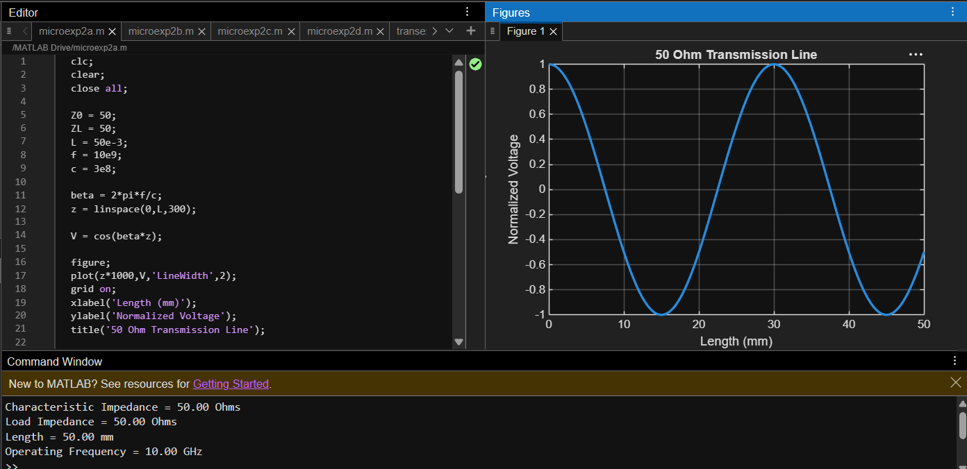

2. To determine characteristic impedance, propagation constant and transmission characteristics of the selected structure.

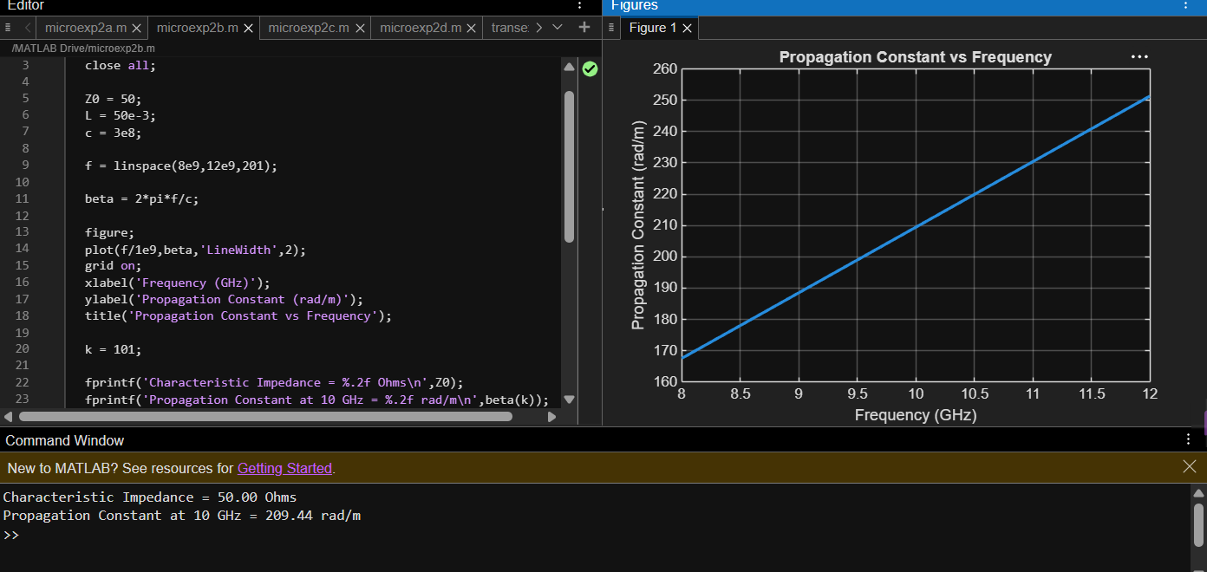
3. To obtain and analyze S11 , S21 , S12 and S22 over a specified frequency range. 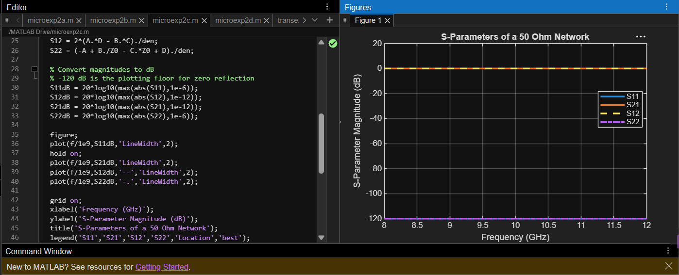

4. To evaluate return loss, insertion loss and transmission efficiency from the simulated S-parameter response.
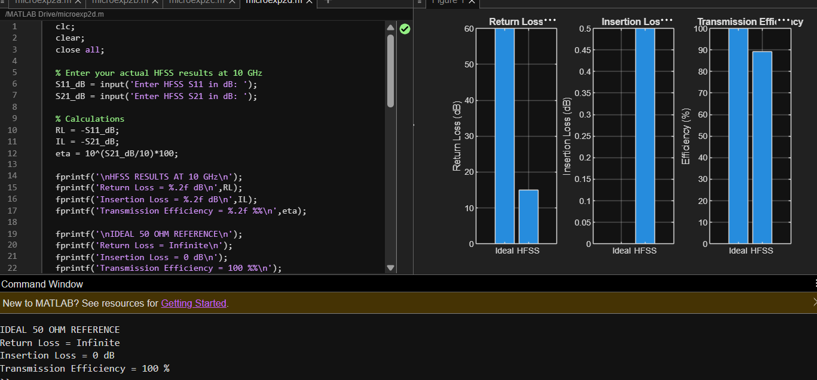

B. Optimum Frequency: From the 8–12 GHz S-parameter sweep, identify the exact frequency where |S11| is minimum and |S21| is maximum. Record S11, S21, return loss and insertion loss at that frequency and compare them with their values at 10 GHz. Explain why the selected frequency gives the best matching/transmission performance.
OBJECTIVES:
1. To model coaxial, waveguide or microstrip transmission structures for microwave-frequency operation.

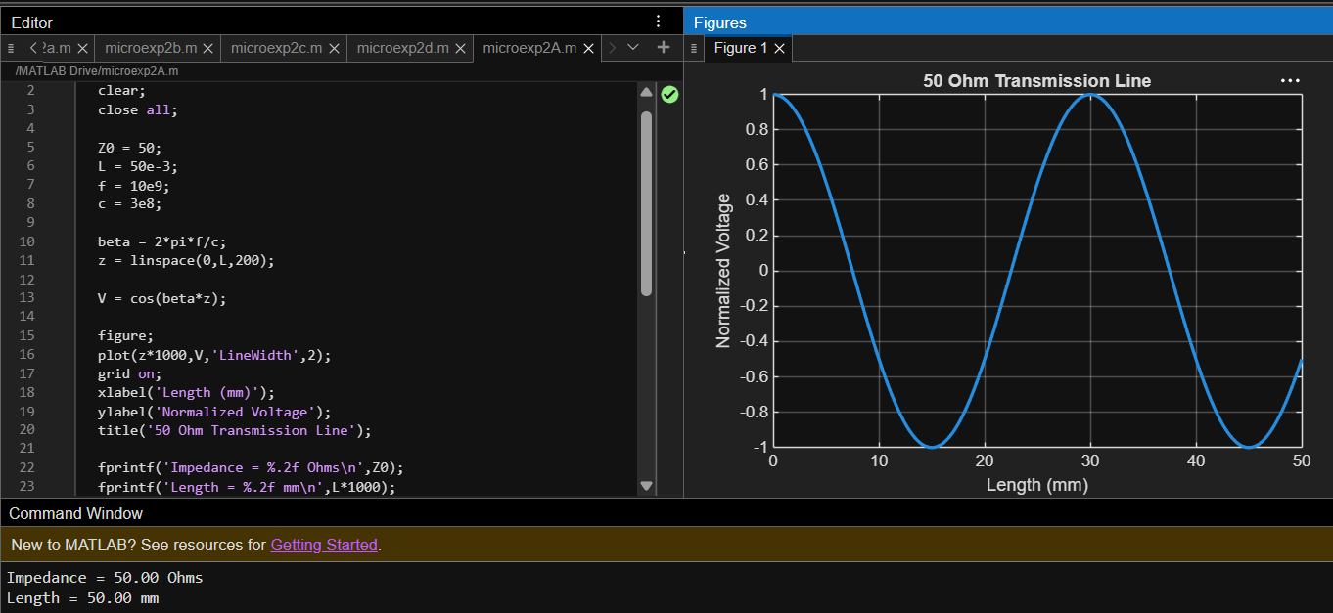

2. To determine characteristic impedance, propagation constant and transmission characteristics of the selected structure.

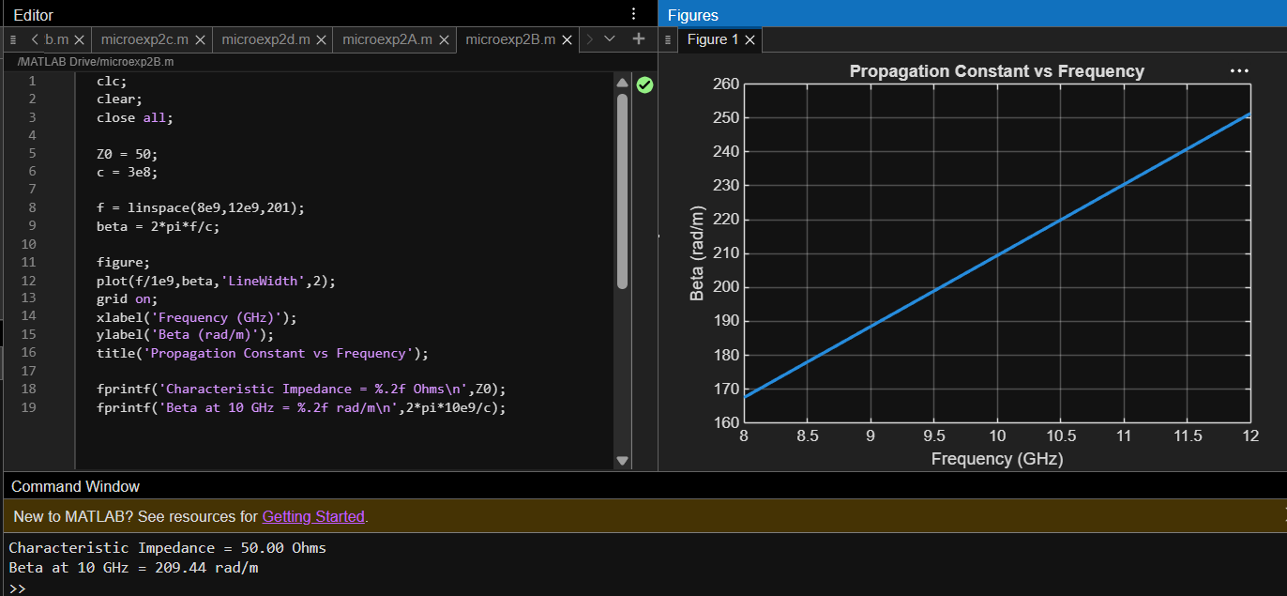

3. To obtain and analyze S11 , S21 , S12 and S22 over a specified frequency range.
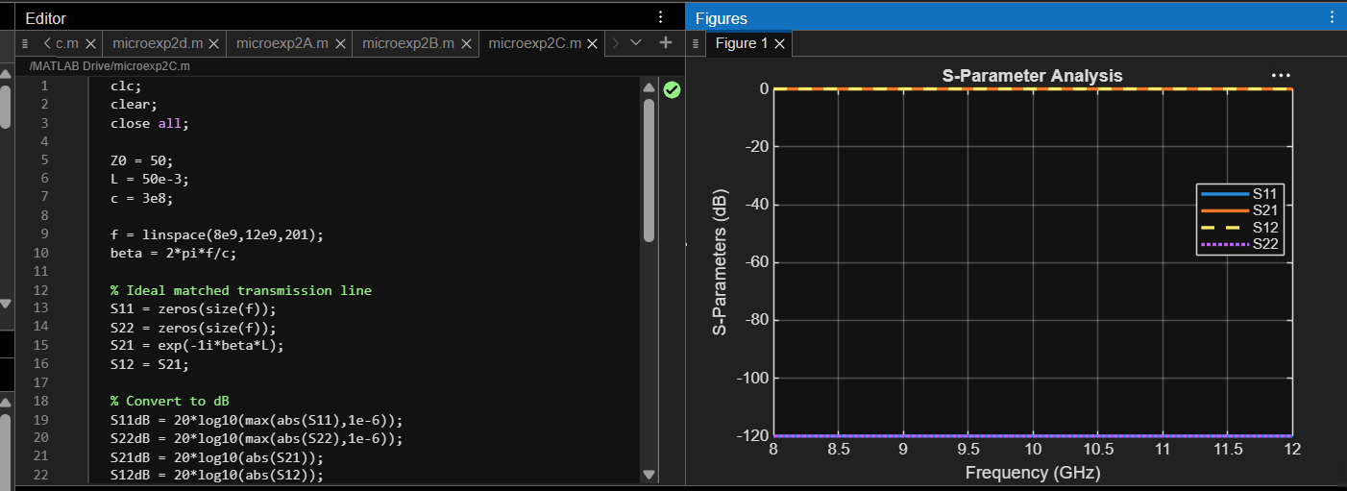

4. To evaluate return loss, insertion loss and transmission efficiency from the simulated S-parameter response.

