**Project Definition**:

Water Quality Analytics with Predictive Modelling

**Overview:**

The Water Quality Data Analytics project aims to develop a robust system for monitoring and analysing water quality in each region. This system will utilize a combination of sensor data, historical records, and predictive modelling techniques to provide accurate insights into water quality trends, potential risks, and actionable recommendations for maintaining or improving water quality.

**Objectives:**

1. **Data Collection and Integration:**

* Gather data from various sources including sensors, IoT devices, historical records, and external databases.

* Standardize and integrate data into a unified format for analysis.

2. **Exploratory Data Analysis (EDA):**

* Conduct a comprehensive EDA to understand the characteristics, distribution, and correlations within the dataset.

* Identify anomalies or outliers that may indicate unusual water quality events.

3. **Predictive Modelling:**

* Develop predictive models using machine learning algorithms to forecast water quality parameters (e.g., pH, turbidity, dissolved oxygen levels) based on historical data.

* Evaluate and select the most suitable models based on performance metrics like RMSE, MAE, etc.

4. **Real-time Monitoring:**

* Implement a real-time monitoring system to continuously collect and process incoming data from sensors.

* Integrate the predictive models to generate real-time forecasts and alerts for potential water quality issues.

5. **Visualization and Reporting:**

* Create interactive dashboards for visualizing water quality trends, predictions, and anomalies.

* Generate automated reports for stakeholders, summarizing key insights and recommendations.

6. **Anomaly Detection and Alerting:**

* Develop algorithms for detecting abnormal water quality readings that may signify a contamination event or a sudden change in environmental conditions.

* Implement an alerting system to notify relevant authorities or stakeholders in real-time.

**Design Thinking:**

**User Personas:**

1. **Environmental Scientists and Researchers**:

Require detailed data for academic and research purposes.

1. **Water Treatment Plants and Utilities**:

Need real-time monitoring and early alerts to ensure safe drinking water supply.

1. **Government Regulatory Agencies:**

Require periodic reports and compliance monitoring for legal and regulatory purposes.

1. **Environmental NGOs and Advocacy Groups:**

Utilize data for awareness campaigns and to advocate for policy changes.

**User Stories:**

1. As an environmental scientist, I want to access historical water quality data for research purposes.

2. As a water treatment plant manager, I want to receive real-time alerts for any anomalies in water quality parameters.

3. As a government regulator, I want to receive automated reports on compliance with water quality standards.

4. As an environmental NGO, I want access to aggregated data to support my advocacy efforts.

**Technology Stack:**

**Data Collection and Integration:**

Python, SQL, API Integrations (for external data sources)

**Predictive Modelling**:

Scikit-learn, TensorFlow, XG Boost, Random Forest, etc.

**Real-time Monitoring**:

Apache Kafka, RabbitMQ, or similar message brokers

**Visualization:**

Tableau, Power BI, or custom web-based visualization using D3.js or similar libraries.

**Alerting System**:

Email, SMS, Slack notifications, or custom API integrations

One innovative idea for a water quality analysis project using Python is to create a real-time water quality monitoring system with data visualization and anomaly detection. Here's a high-level outline of how you can implement this idea:

**Project Overview:**

**Real-Time Water Quality Monitoring System**

**1. Data Collection:**

Set up water quality sensors or acquire water quality data from publicly available sources, IoT devices, or sensors.

Use Python libraries like pySerial or requests to fetch data from sensors or APIs.

**2. Data Preprocessing:**

Clean and preprocess the incoming data, which may include filtering out noise, handling missing values, and converting data types.

Store the data in a database or a CSV file for historical analysis.

**3. Real-Time Data Visualization:**

Use Python libraries like matplotlib, Seaborn, or interactive libraries like Plotly to create real-time visualizations of water quality parameters.

Plot time-series graphs showing variations in parameters like pH, turbidity, temperature, and dissolved oxygen.

**4. Anomaly Detection:**

Implement anomaly detection algorithms to identify unusual patterns or outliers in the water quality data. You can use techniques like Z-score, Isolation Forest, or machine learning models.

Alert system: Set up alerts or notifications (e.g., email, SMS) when anomalies are detected, indicating potential water quality issues.

**5. Historical Analysis:**

Develop tools to perform historical analysis of water quality data. This could include generating summary statistics, trend analysis, and correlation analysis to identify long-term patterns and relationships.

Create visualizations to illustrate historical trends and changes.

**6. User Interface :**

Create a web-based dashboard or a desktop application using frameworks like Flask, Django, or PyQt to provide users with a user-friendly interface for viewing real-time and historical water quality data.

**7. Data Reporting:**

Generate automated reports summarizing water quality trends, anomalies, and other insights. You can use Python libraries like Pandas and ReportLab for this purpose.

**8. Data Storage:**

Choose an appropriate database system (e.g., SQLite, PostgreSQL, MongoDB) to store both real-time and historical data for easy retrieval and analysis.

**9. Data Sharing:**

Implement mechanisms to share water quality data with relevant stakeholders or authorities through APIs, FTP, or other data-sharing protocols.

**10. Integration with External Data Sources :**

Integrate external data sources such as weather data, geographical information, or water source information to provide additional context for water quality analysis.

**DATA VISUALISATION**

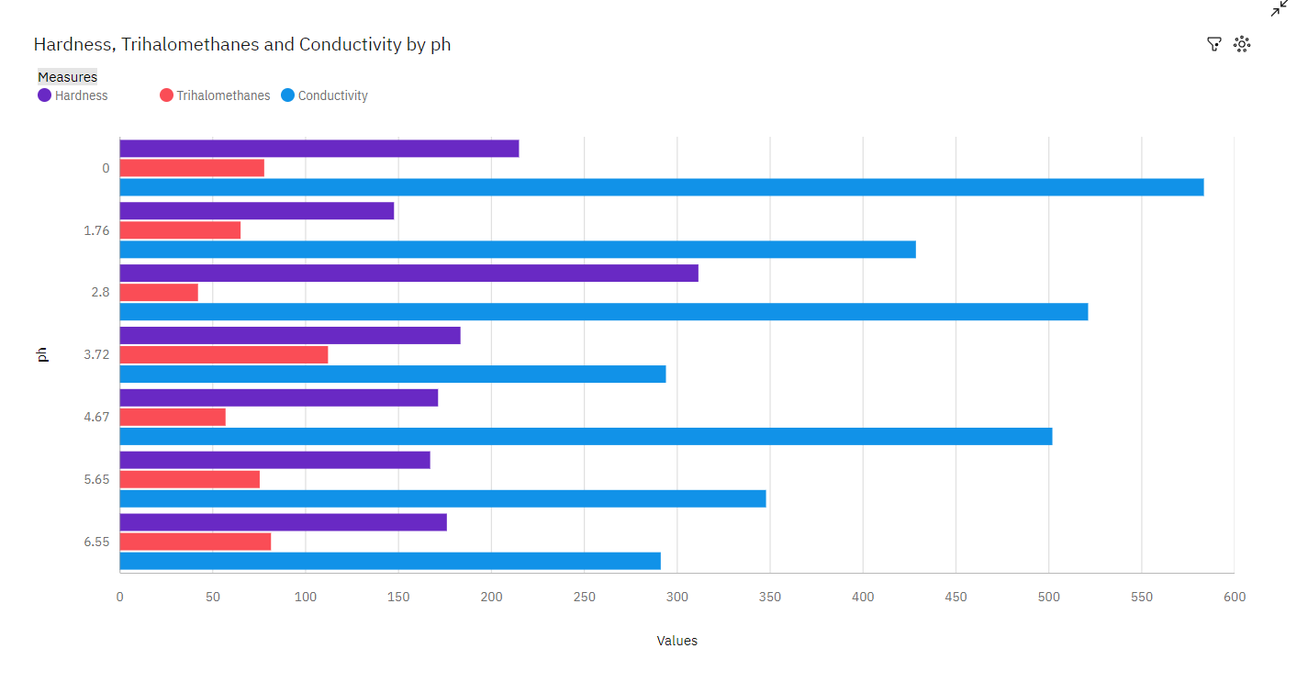

**ANALYSIS OF BAR:**

* **Over all values of ph, the average of Conductivity is 424.**
* **Over all values of ph, the average of Hardness is 195.9.**
* **Over all values of ph, the average of Trihalomethanes is 72.92.**
* **The total number of results for Conductivity, across all ph, is 7.**
* **The total number of results for Hardness, across all ph, is 7.**
* **The total number of results for Trihalomethanes, across all ph, is 7.**
* **Conductivity ranges from 291.1, when ph is 6.548017642485212, to 583.4, when ph is 0.**
* **Hardness ranges from 147.6, when ph is 1.7570371154907827, to 311.4, when ph is 2.798549098862777.**
* **Trihalomethanes ranges from 42.08, when ph is 2.798549098862777, to 112.1, when ph is 3.717703934990307.**

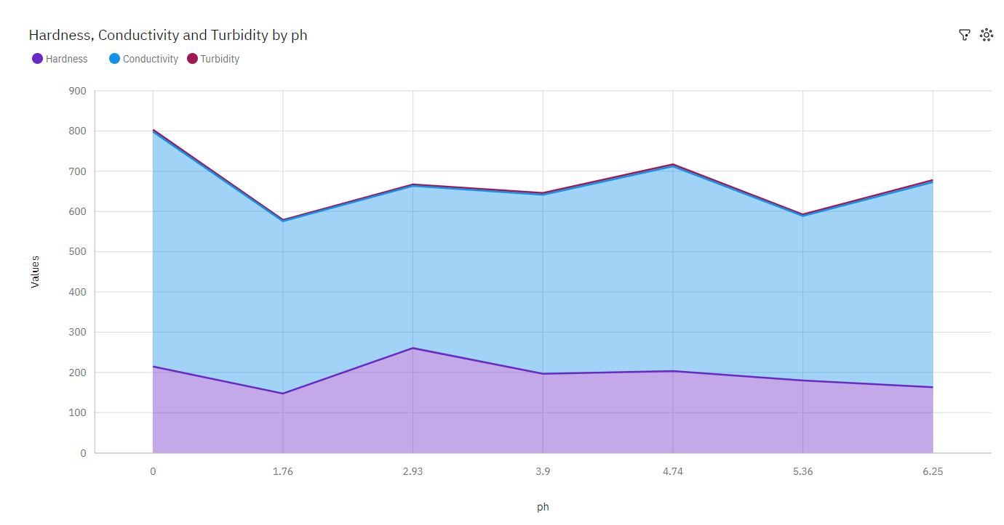

**ANALYSIS OF AREA:**

* **ph 1.7570371154907827 has the highest Total Potability but is ranked #7 in Total Hardness.**
* **ph 2.9251743203391 has the highest Total Hardness but is ranked #4 in Total Potability.**
* **Over all values of ph, the sum of Hardness is almost 1500.**
* **Hardness ranges from 147.6, when ph is 1.7570371154907827, to 260.5, when ph is 2.9251743203391.**

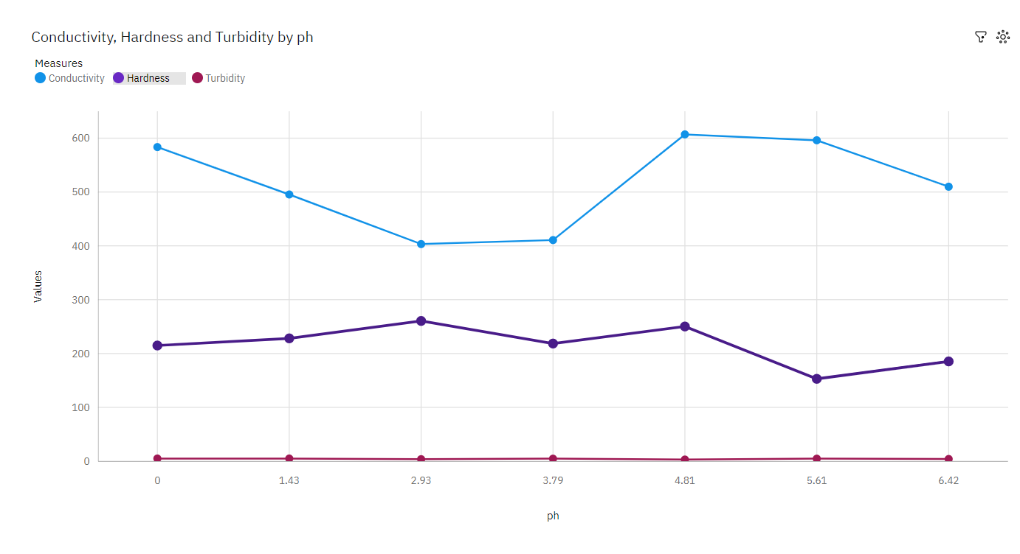

**ANALYSIS OF LINE:**

* **Over all values of ph, the average of Conductivity is 515.1.**
* **Over all values of ph, the average of Hardness is 215.8.**
* **Over all values of ph, the average of Turbidity is 4.27.**
* **The total number of results for Conductivity, across all ph, is 7.**
* **The total number of results for Hardness, across all ph, is 7.**
* **The total number of results for Turbidity, across all ph, is 7.**
* **Conductivity ranges from 403.2, when ph is 2.9251743203391, to 607, when ph is 4.812433652167467.**
* **Hardness ranges from 153, when ph is 5.608745231813571, to 260.5, when ph is 2.9251743203391.**
* **Turbidity ranges from 3.021, when ph is 4.812433652167467, to 4.948, when ph is 1.4317815547427415.**

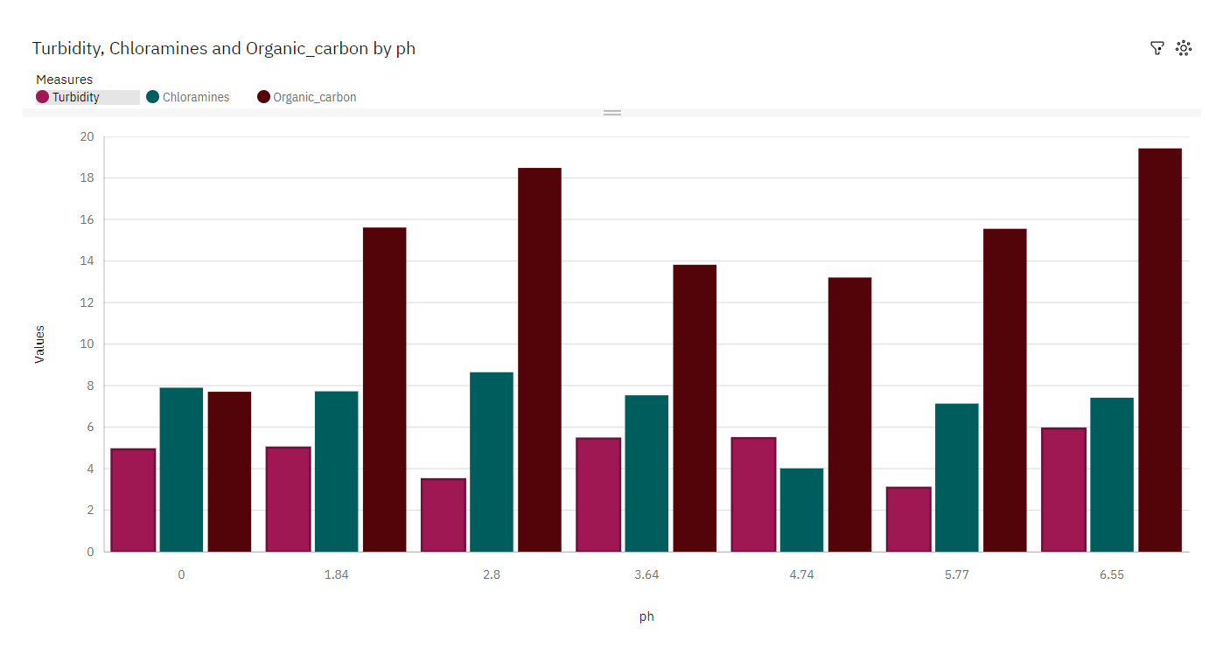

**ANALYSIS OF COLUMN:**

* **Over all values of ph, the average of Chloramines is 7.194.**
* **Over all values of ph, the average of Organic_carbon is 14.83.**
* **Over all values of ph, the average of Turbidity is 4.765.**
* **The total number of results for Chloramines, across all ph, is 7.**
* **The total number of results for Organic_carbon, across all ph, is 7.**
* **The total number of results for Turbidity, across all ph, is 7.**
* **Chloramines ranges from 4.013, when ph is 4.740056688020883, to 8.642, when ph is 2.803563057437167.**
* **Organic_carbon ranges from 7.702, when ph is 0, to 19.42, when ph is 6.548017642485212.**
* **Turbidity ranges from 3.079, when ph is 5.772197393568782, to 5.93, when ph is 6.548017642485212.**

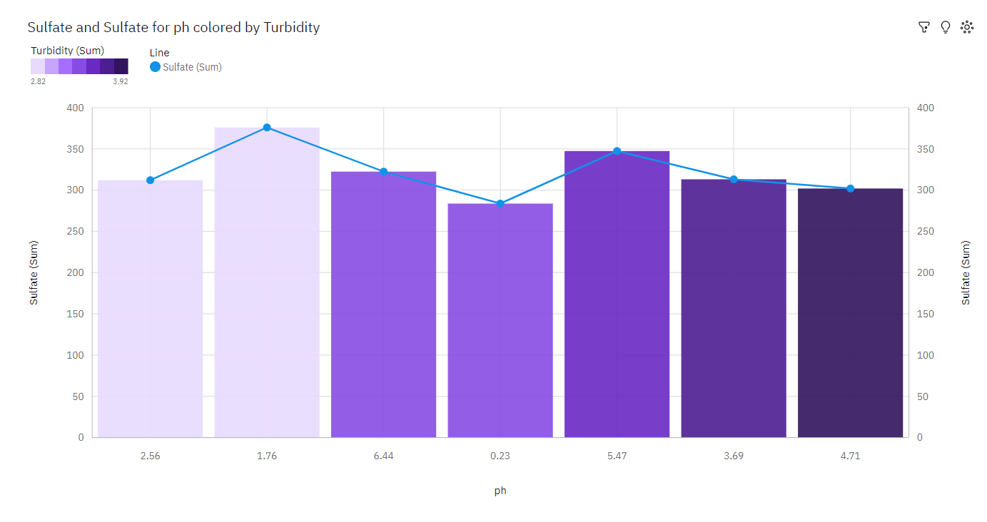

**ANALYSIS OF LINE AND COLUMN:**

* **1.7570371154907827 Sulfate at 376 is 99% higher than the Turbidity of 2.968.**
* **ph 4.713116701054447 has the highest Total Turbidity but is ranked #6 in Total Sulfate.**
* **ph 1.7570371154907827 has the highest Total Sulfate but is ranked #6 in Total Turbidity.**
* **Over all values of ph, the sum of Sulfate is almost 2500.**
* **Sulfate ranges from 283.7, when ph is 0.22749905020219874, to 376, when ph is 1.7570371154907827.**
* **ph 0.22749905020219874 has the highest Total Potability but is ranked #7 in Total Sulfate.**
* **ph 1.7570371154907827 has the highest Total Sulfate but is ranked #1 in Total Potability.**

**CONCLUSION:**

The Water Quality Data Analytics project leverages advanced data analytics and predictive modelling to offer a comprehensive solution for monitoring and managing water quality. By integrating real-time monitoring with historical data analysis, the system provides stakeholders with timely insights and alerts, enabling them to take proactive measures to safeguard water quality. This project not only contributes to environmental conservation but also supports various industries and regulatory bodies in ensuring the availability of safe and clean water resources.